Lesson 13 Practice Problems
- The polynomial function $B\left(x\right)=x^{3}−21x+20$ has a known factor of $\left(x−4\right)$. Rewrite $B\left(x\right)$ as a product of linear factors.
- Let the function $P$ be defined by $P\left(x\right)=x^{3}+7x^{2}−26x−72$ where $\left(x+9\right)$ is a factor. To rewrite the function as the product of two factors, long division was used but an error was made:
- x2+16x+118000x+9x3+7x2−26x−72000−x3+9x2_−26x−72000016x2−26x−720000−16x2+144x_−20000118x−7200−118x+1062_990
- How can we tell by looking at the remainder that an error was made somewhere?
- For the polynomial function $A\left(x\right)=x^{4}−2x^{3}−21x^{2}+22x+40$ we know $\left(x−5\right)$ is a factor. Select all the other linear factors of $A\left(x\right)$.
  - $\left(x+1\right)$
  - $\left(x−1\right)$
  - $\left(x+2\right)$
  - $\left(x−2\right)$
  - $\left(x+4\right)$
  - $\left(x−4\right)$
  - $\left(x+8\right)$
- Match the polynomial function with its constant term.
  - $P\left(x\right)=\left(x−2\right)\left(x−3\right)\left(x+7\right)$
  - $P\left(x\right)=\left(x+2\right)\left(x−3\right)\left(x+7\right)$
  - $P\left(x\right)=\frac{1}{2}\left(x−2\right)\left(x−3\right)\left(x+7\right)$
  - $P\left(x\right)=5\left(x−2\right)\left(x−3\right)\left(x+7\right)$
  - $P\left(x\right)=\text{-}5\left(x−2\right)\left(x−3\right)\left(x+7\right)$
  - -210
  - -42
  - 21
  - 42
  - 210
- (From Unit 2, Lesson 6.)
- What are the solutions to the equation $\left(x−2\right)\left(x−4\right)=8$?
- (From Unit 2, Lesson 11.)
- The graph of a polynomial function $f$ is shown. Which statement is true about the end behavior of the polynomial function?
- 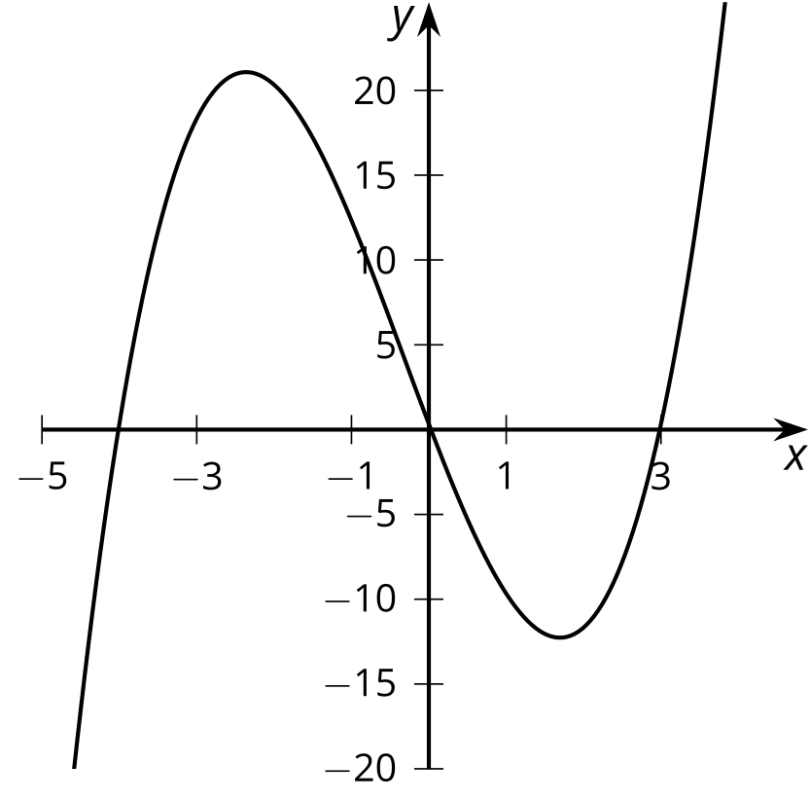
  - As $x$ gets larger and larger in the either the positive or the negative direction, $f\left(x\right)$ gets larger and larger in the positive direction.
  - As $x$ gets larger and larger in the positive direction, $f\left(x\right)$ gets larger and larger in the positive direction. As $x$ gets larger and larger in the negative direction, $f\left(x\right)$ gets larger and larger in the negative direction.
  - As $x$ gets larger and larger in the positive direction, $f\left(x\right)$ gets larger and larger in the negative direction. As $x$ gets larger and larger in the negative direction, $f\left(x\right)$ gets larger and larger in the positive direction.
  - As $x$ gets larger and larger in the either the positive or negative direction, $f\left(x\right)$ gets larger and larger in the negative direction.
- (From Unit 2, Lesson 8.)
- The polynomial function $p\left(x\right)=x^{3}+3x^{2}−6x−8$ has a known factor of $\left(x+4\right)$.
  - Rewrite $p\left(x\right)$ as the product of linear factors.
  - Draw a rough sketch of the graph of the function.
- (From Unit 2, Lesson 12.)
© CC BY 2019 by Illustrative Mathematics®

