Lesson 2 Practice Problems
- Here is a diagram that describes the cups of green and white paint in a mixture.
- 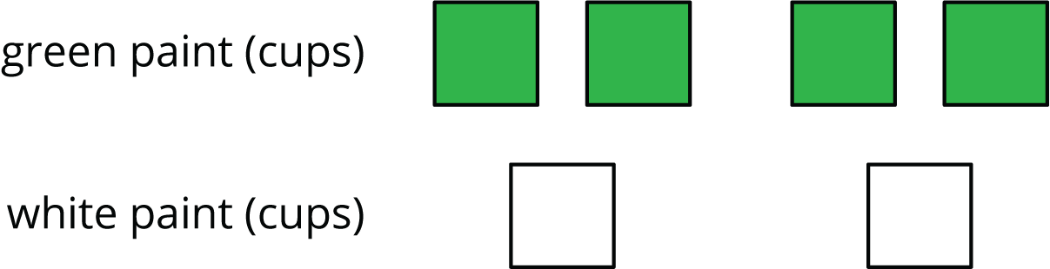
- Select all the statements that correctly describe this diagram
  - The ratio of cups of white paint to cups of green paint is 2 to 4.
  - For every cup of green paint, there are two cups of white paint.
  - The ratio of cups of green paint to cups of white paint is $4:2$.
  - For every cup of white paint, there are two cups of green paint.
  - The ratio of cups of green paint to cups of white paint is $2:4$.
- To make a snack mix, combine 2 cups of raisins with 4 cups of pretzels and 6 cups of almonds.
  - Create a diagram to represent the quantities of each ingredient in this recipe.
  - Use your diagram to complete each sentence.
    - The ratio of __________________ to __________________ to __________________ is ________ : ________ : ________.
    - There are ________ cups of pretzels for every cup of raisins.
    - There are ________ cups of almonds for every cup of raisins.

  - A square is 3 inches by 3 inches. What is its area?
  - A square has a side length of 5 feet. What is its area?
  - The area of a square is 36 square centimeters. What is the length of each side of the square?
- (From Unit 1, Lesson 17.)
- Find the area of this quadrilateral. Explain or show your strategy.
- 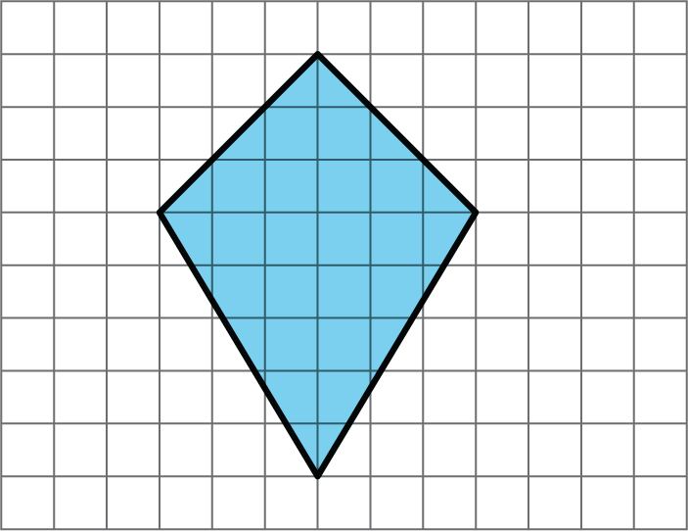

- (From Unit 1, Lesson 11.)
- Complete each equation with a number that makes it true.
  - $\frac{1}{8}⋅8=\text{_______}$
  - $\frac{3}{8}⋅8=\text{_______}$
  - $\frac{1}{8}⋅7=\text{_______}$
  - $\frac{3}{8}⋅7=\text{_______}$
- (From Unit 2, Lesson 1.)
© CC BY Open Up Resources. Adaptations CC BY IM.

