Lesson 16 Practice Problems
- Lin is playing hand ball and wants the ball to bounce off wall $CB$ and land at $D$. Where on the wall should she aim if she's standing at point $A$?
- 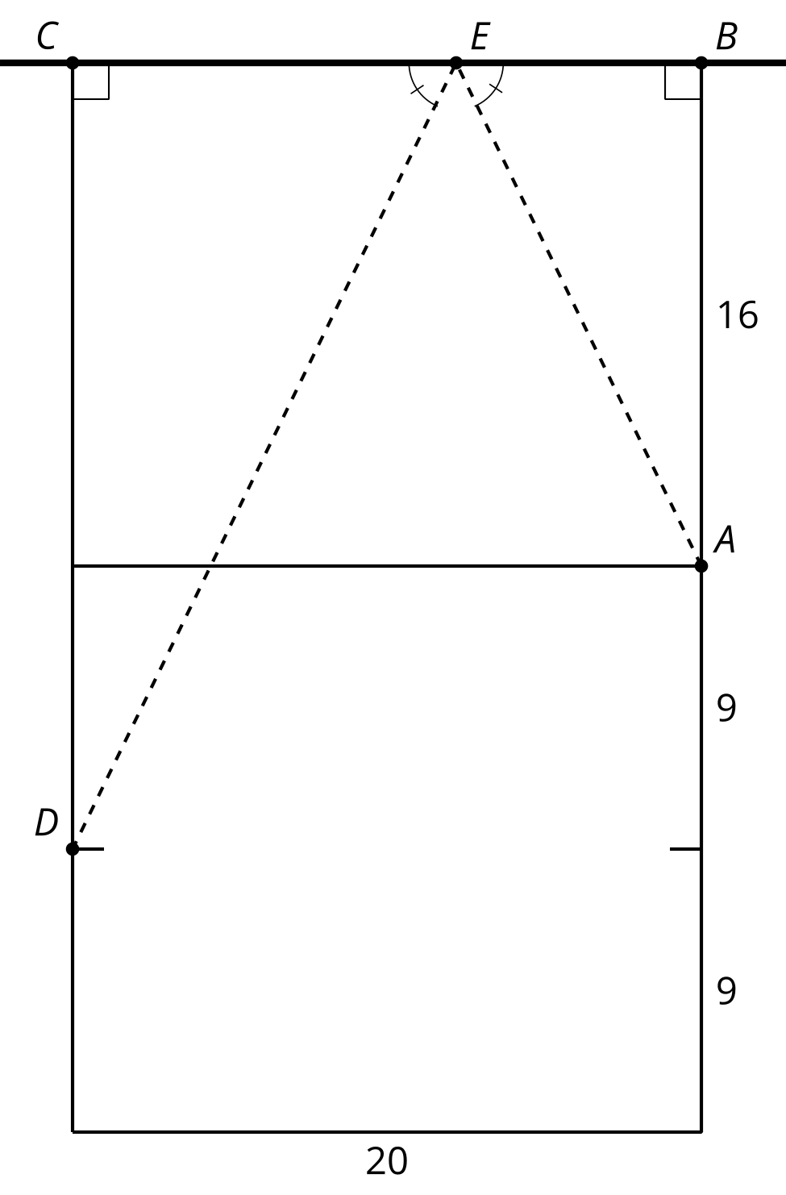
  - 7.8 feet away from point $B$.
  - 13.3 feet away from point $B$.
  - Anywhere along the wall since all of the triangles will be similar.
- You want to make a bank shot. Sketch the path of the cue ball so it will bounce off of the bottom side and knock the yellow stripe 9 ball into the top middle pocket.
- 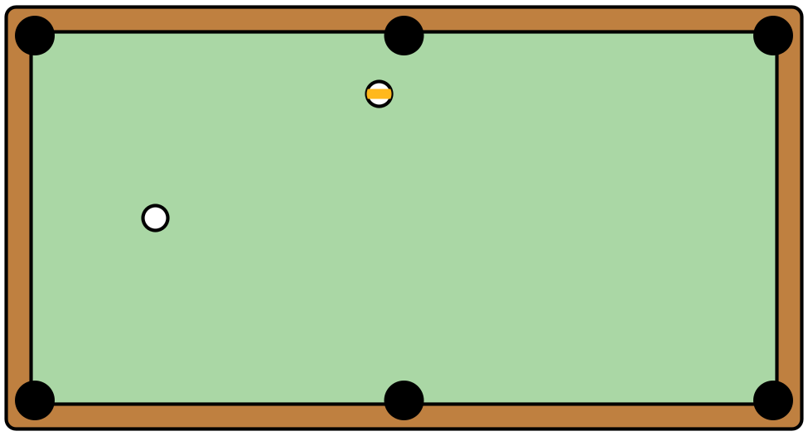
- How can you check to see if your bank shot works?
- Mai is playing a game with a class of second graders. Mai knows she is exactly 120 inches from the mirror on the floor. She has students stand so that she can just see the top of their heads and then guesses their heights. The students are amazed!
- 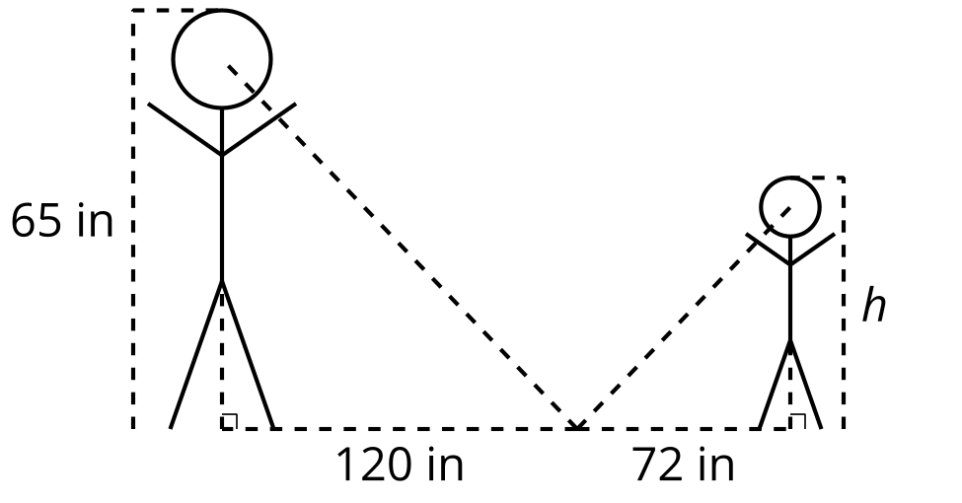
- How is Mai so accurate? What is the height, $h$, of the student?
- In the right triangles shown, the measure of angle $ABC$ is the same as the measure of angle $EBD$​​​​​. What is the length of side $BD$?
- 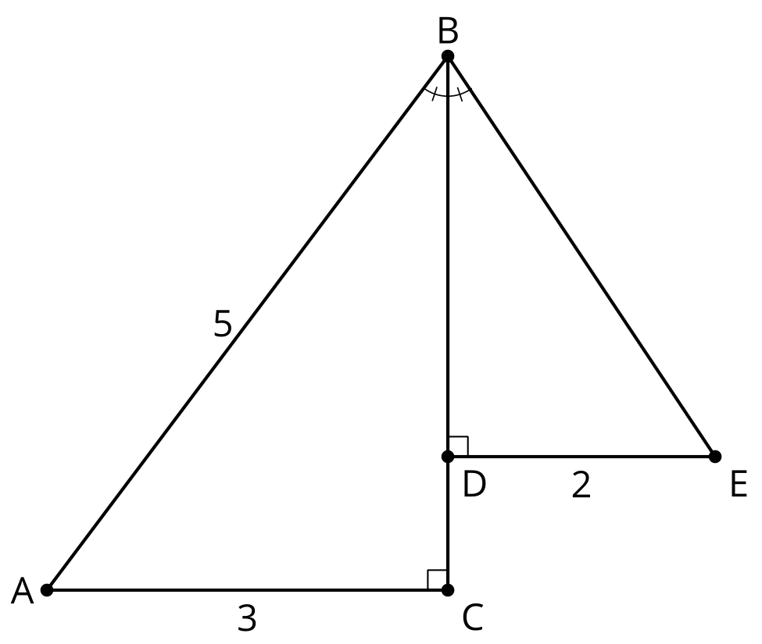
- (From Unit 3, Lesson 15.)
- In right triangle $ABC$, angle $C$ is a right angle, $AB=17$, and $BC=15$. What is the length of $AC$?
- (From Unit 3, Lesson 15.)
- Fill in the blanks to complete the proof of the Pythagorean Theorem:
- 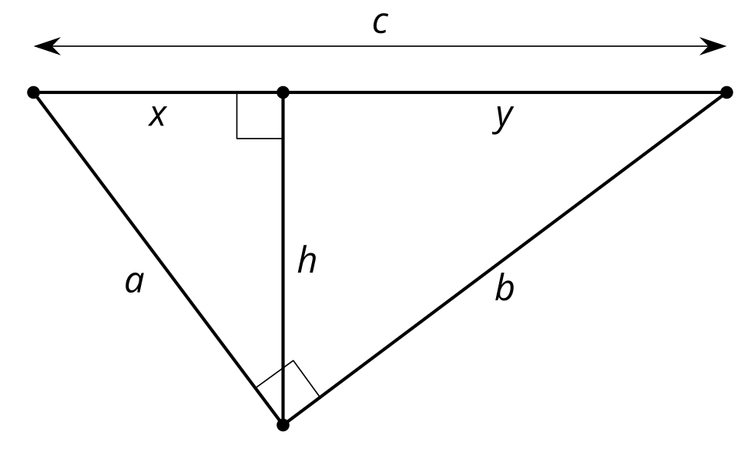
- $\frac{a}{x}=\frac{c}{a}$ can be rewritten as $\underset{_}{1}$ and $\frac{b}{y}=\frac{c}{b}$ can be written as $\underset{_}{2}$. So, $a^{2}+b^{2}=$$\underset{_}{3}$. By factoring, $a^{2}+b^{2}=$ $\underset{_}{4}$. We know that $x+y=$$\underset{_}{5}$. So, $a^{2}+b^{2}=$$\underset{_}{6}$.
- (From Unit 3, Lesson 14.)
- In right triangle $ABC$, altitude $CD$ with length $h$ is drawn to its hypotenuse. We also know $AD=4$ and $DB=16$. What is the length of $AC$?
- 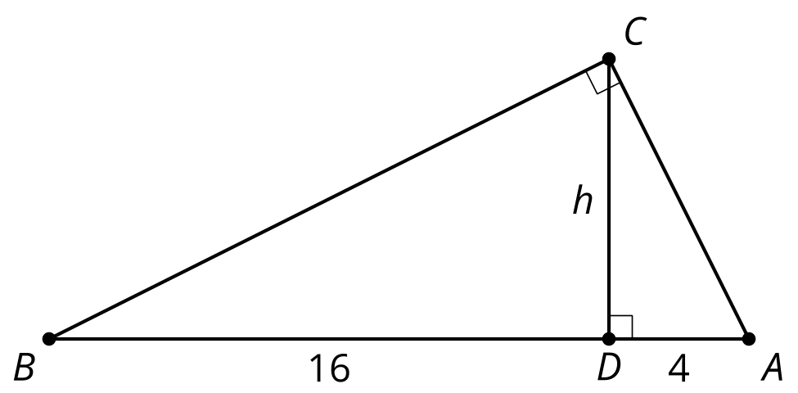
- ​​​​​​
- (From Unit 3, Lesson 13.)
- Match each vocabulary term with its definition.
  - Scale Drawing
  - Scale Factor
  - Dilation
  - Similar Figures
  - Angle-Angle Similarity Theorem
  - There is a sequence of rigid motions and dilations that takes the first figure onto the second.
  - When 2 angles of one triangle are congruent to 2 angles of a second triangle, the 2 triangles will be similar.
  - A transformation using a center $C$ and scale factor $k$ that takes a point $A$ to another point along the ray $CA$ whose distance is $k$ times farther from $C$ than $A$ is.
  - A drawing in which all lengths in the drawing correspond to lengths in the object by the same scale.
  - A constant multiple by which all lengths of the original figure are multiplied.
- (From Unit 3, Lesson 12.)
- Clare and Diego are discussing the quadrilaterals. Clare thinks the quadrilaterals are similar because the side lengths are proportional. Diego thinks they need more information to know for sure if they are similar. Do you agree with either of them? Explain your reasoning.
- (From Unit 3, Lesson 8.)
© CC BY 2019 by Illustrative Mathematics®

