Unit 1 Lesson 19: Evidence, Angles, and Proof

1 Math Talk: Supplementary Angles (Warm up)

Student Task Statement
Mentally evaluate all of the missing angle measures in each figure.

Figure A
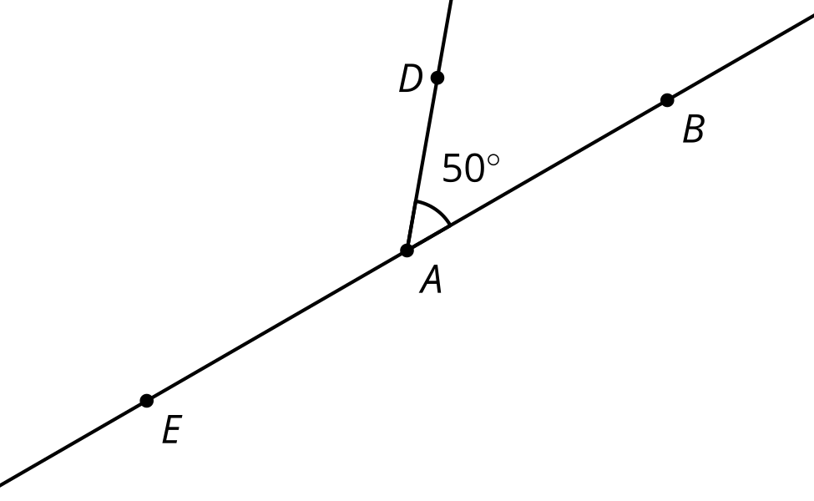

Figure B
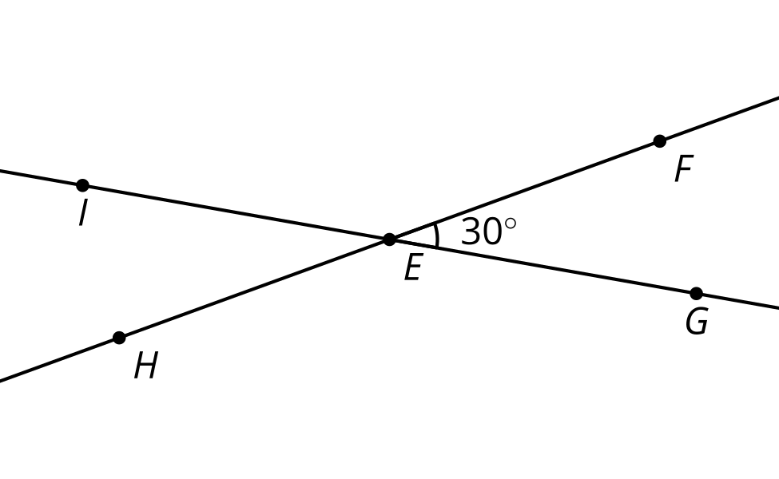

Figure C
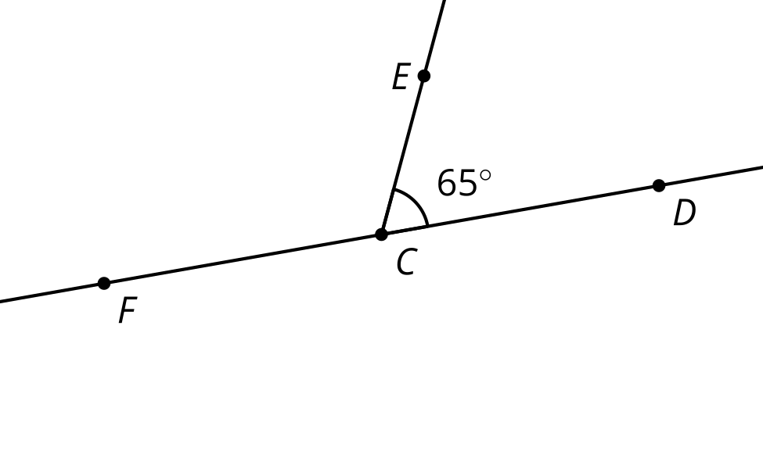

Figure D
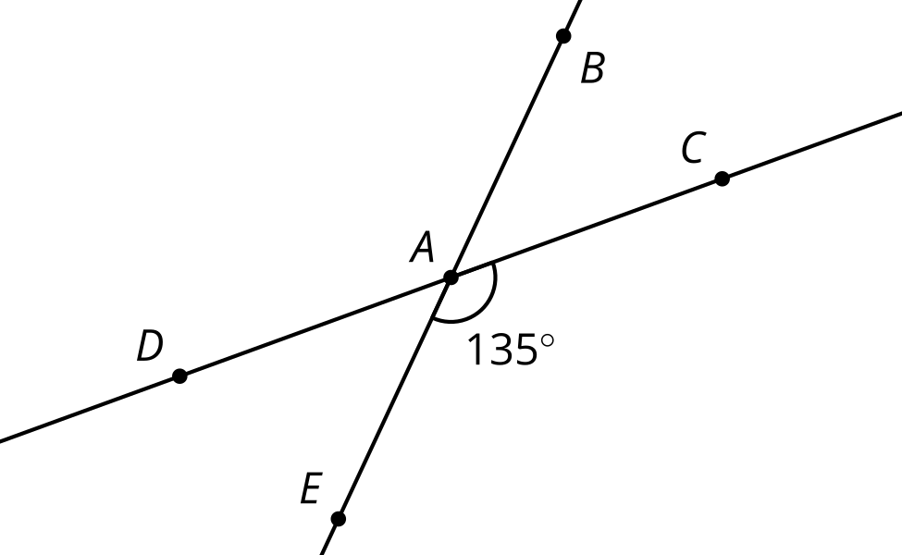

2 That Can’t Be Right, Can It?

Images for Launch
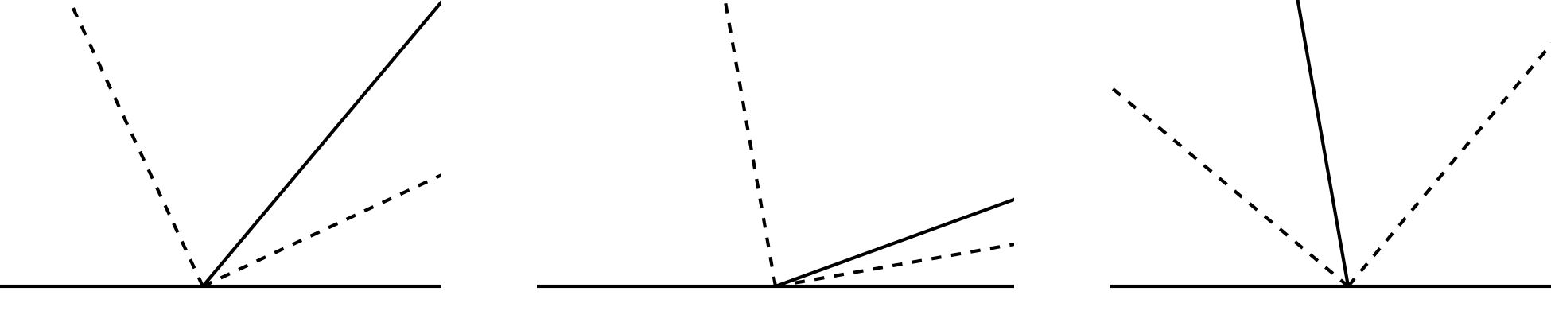

Student Task Statement
Here is a figure where ray $r$ meets line $ℓ$. The dashed rays are angle bisectors.
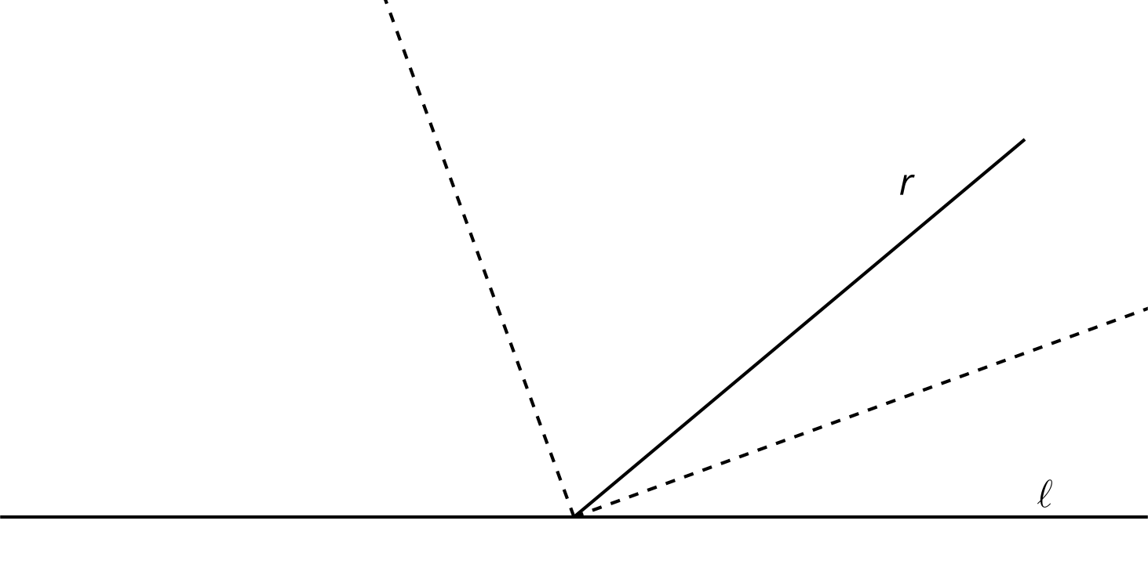
- Diego made the conjecture: “The angle formed between the angle bisectors is always a right angle, no matter what the angle between $r$ and $ℓ$ is.” It is difficult to tell specifically which angles Diego is talking about in his conjecture. Label the diagram and rephrase Diego’s conjecture more precisely using your labels.
- Is the conjecture true? Explain your reasoning.

3 Convince Me

Student Task Statement
Here are 2 intersecting lines that create 2 pairs of vertical angles:
1. What is the relationship between vertical angles? Write down a conjecture. Label the diagram to make it easier to write your conjecture precisely.
2. How do you know your conjecture is true for all possible pairs of vertical angles? Explain your reasoning.

Images for Activity Synthesis
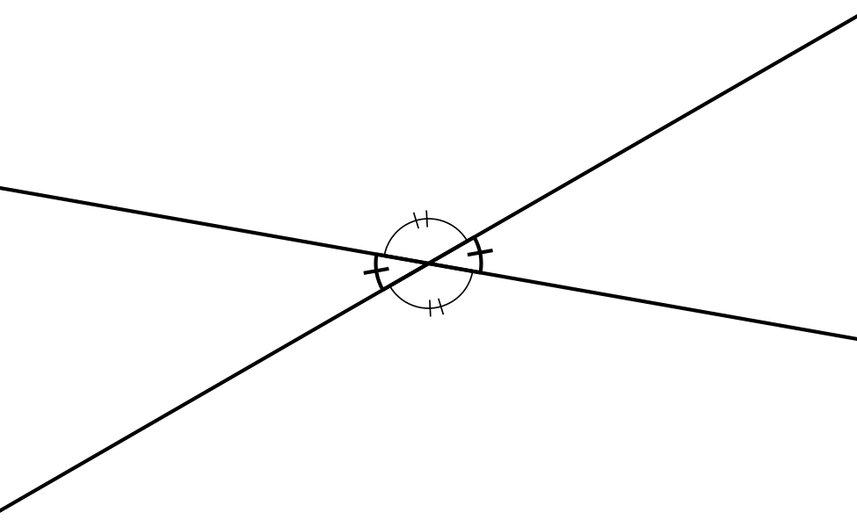
© CC BY 2019 by Illustrative Mathematics®

