Unit 3 Lesson 7: Representations of Linear Relationships

1 Estimation: Which Holds More? (Warm up)

Student Task Statement
Which glass will hold the most water? The least?
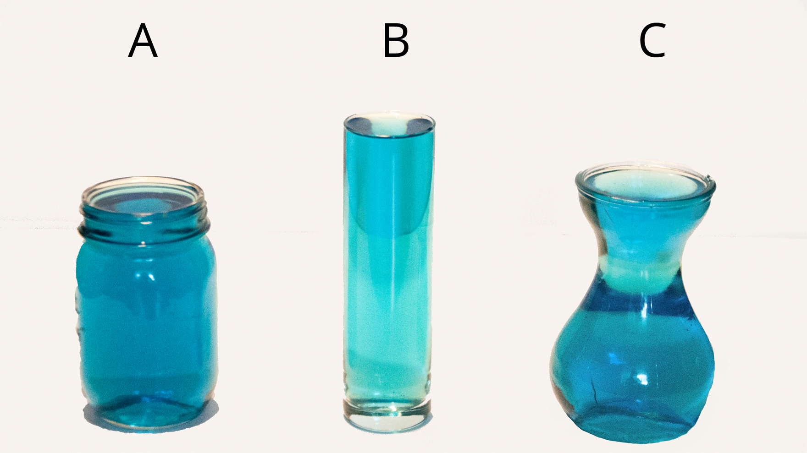

2 Rising Water Levels

Student Task Statement
- Record data from your teacher's demonstration in the table. (You may not need all the rows.)
- What is the volume, $V$, in the cylinder after you add $x$ objects? Explain your reasoning.
- If you wanted to make the water reach the highest mark on the cylinder, how many objects would you need?
- Plot and label points that show your measurements from the experiment.
- The points should fall on a line. Use a ruler to graph this line.
- Compute the slope of the line. What does the slope mean in this situation?
- What is the vertical intercept? What does vertical intercept mean in this situation?
number of objects | volume in ml

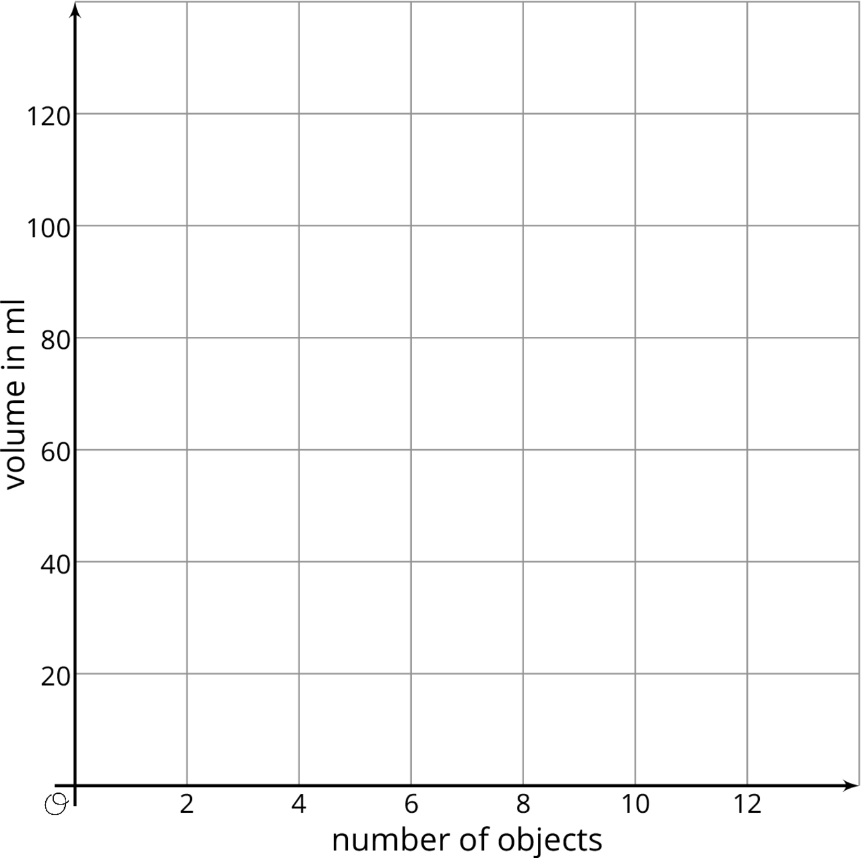

3 Calculate the Slope

Student Task Statement
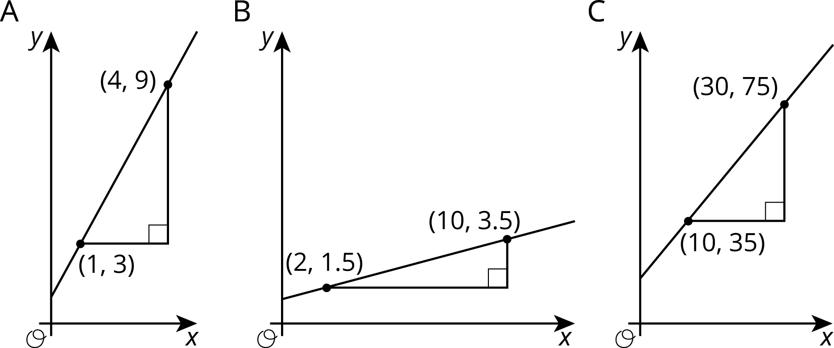
- For each graph, record:
- vertical change | - horizontal change | - slope
- Describe a procedure for finding the slope between any two points on a line.
- Write an expression for the slope of the line in the graph using the letters $u,v,s,$ and $t$.
- 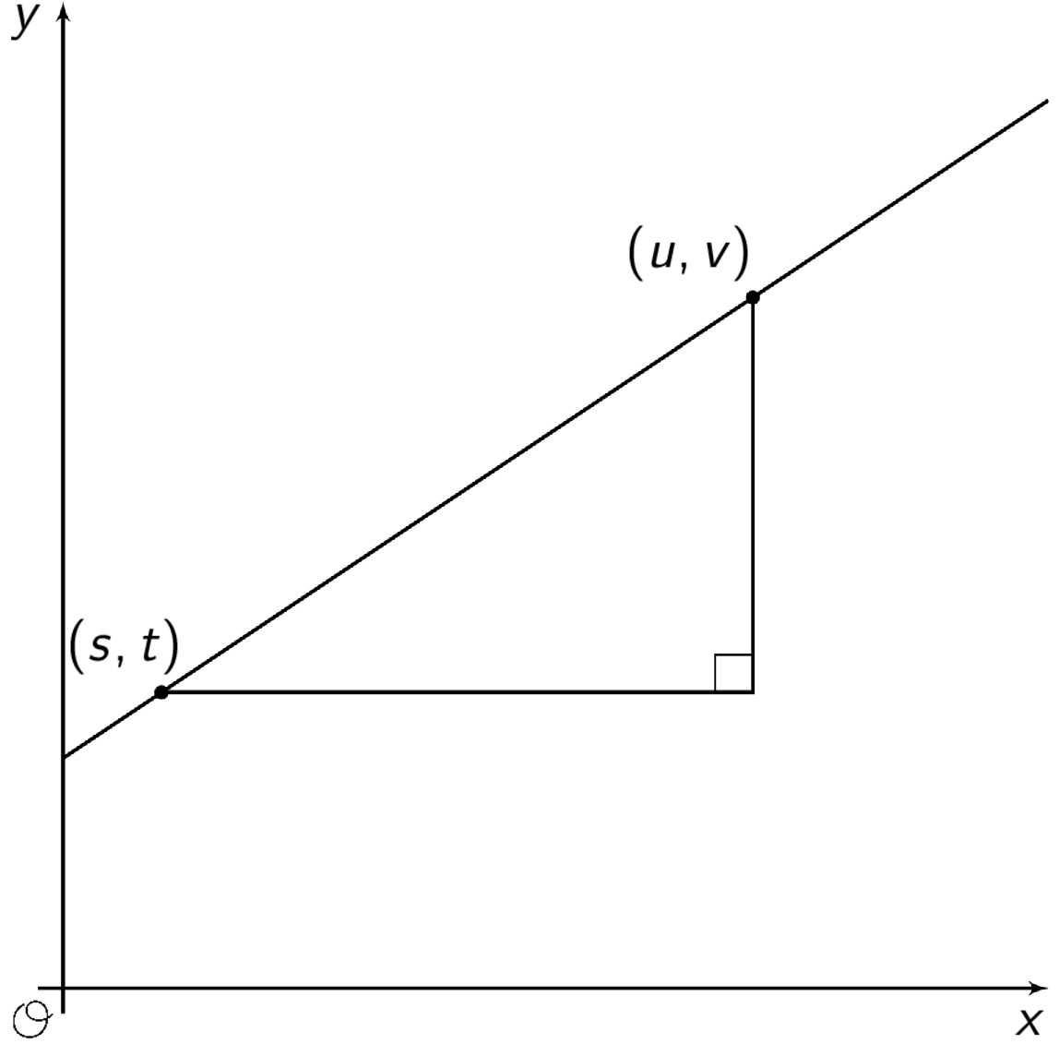

Images for Activity Synthesis
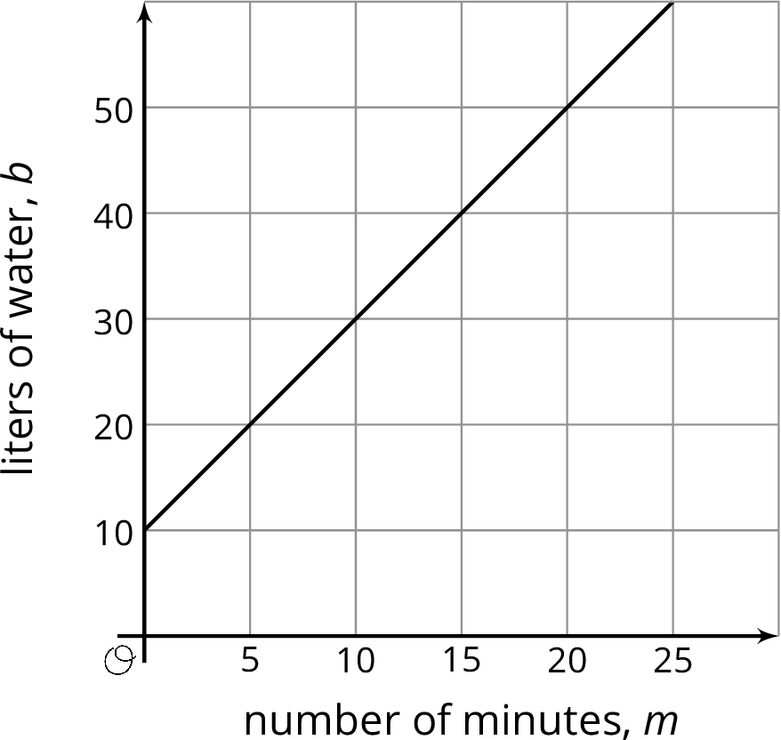
© CC BY Open Up Resources. Adaptations CC BY IM.

