Lesson 11 Practice Problems
- What are the points of intersection between the graphs of the functions $f\left(x\right)=x^{2}\left(x+1\right)$ and $g\left(x\right)=x+1$?
- Select all the points of intersection between the graphs of the functions $f\left(x\right)=\left(x+5\right)\left(x−2\right)$ and $g\left(x\right)=\left(2x+1\right)\left(x−2\right)$.
  - $\left(\text{-}5,0\right)$
  - $\left(\text{-}\frac{1}{2},0\right)$
  - $\left(\text{-}2,\text{-}12\right)$
  - $\left(2,0\right)$
  - $\left(4,18\right)$
  - $\left(5,30\right)$
- What are the solutions to the equation $\left(x−3\right)\left(x+5\right)=\text{-}15$?
- What are the $x$-intercepts of the graph of $y=\left(5x+7\right)\left(2x−1\right)\left(x−4\right)$?
  - $\text{-}\frac{7}{5},\text{-}\frac{1}{2},4$
  - $\frac{5}{7},\frac{1}{2},4$
  - $\text{-}\frac{7}{5},\frac{1}{2},4$
  - $\frac{5}{7},2,4$
- (From Unit 2, Lesson 5.)
- Which polynomial function’s graph is shown here?
- 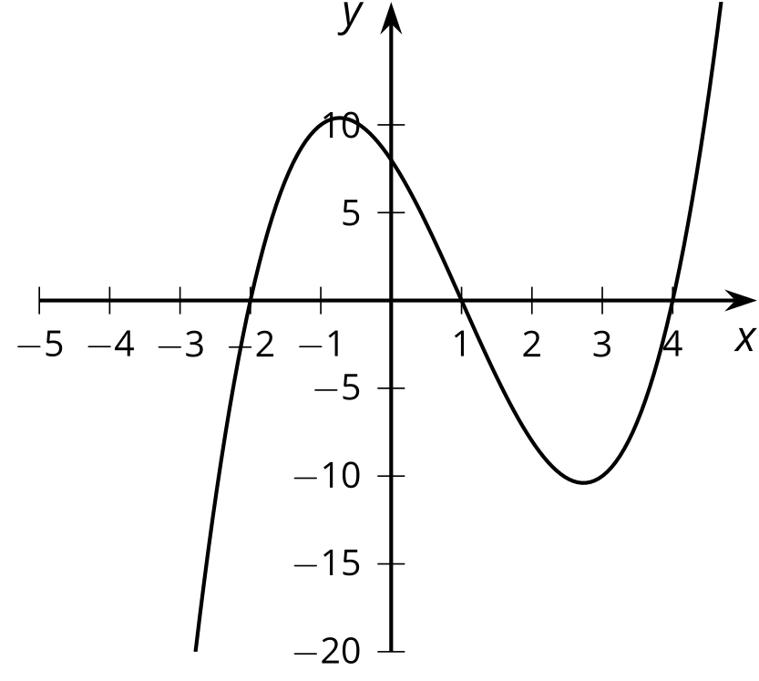
  - $f\left(x\right)=\left(x+1\right)\left(x+2\right)\left(x+4\right)$
  - $f\left(x\right)=\left(x+1\right)\left(x−2\right)\left(x+4\right)$
  - $f\left(x\right)=\left(x−1\right)\left(x+2\right)\left(x−4\right)$
  - $f\left(x\right)=\left(x−1\right)\left(x−2\right)\left(x−4\right)$
- (From Unit 2, Lesson 7.)
- Draw a rough sketch of the graph of $g\left(x\right)=\text{-}x^{2}\left(x+2\right)$.
- (From Unit 2, Lesson 10.)
- The graph of a polynomial function $f$ is shown.
- 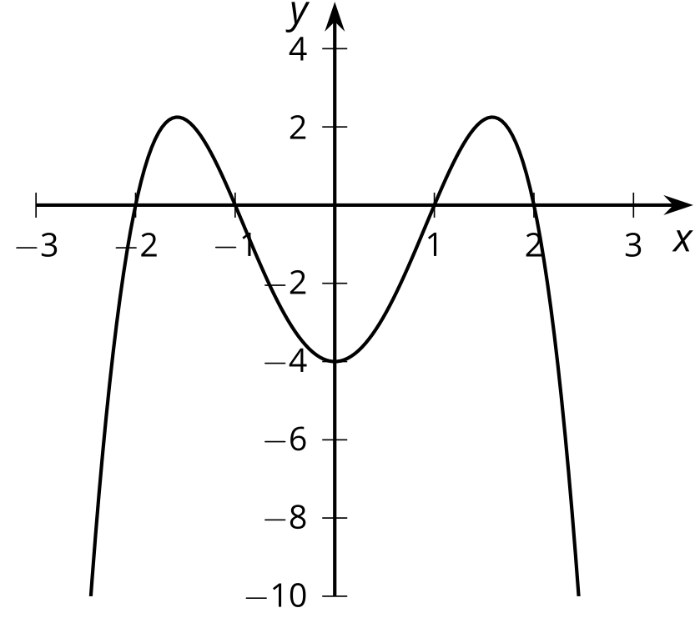
  - Is the degree of the polynomial odd or even? Explain how you know.
  - What is the constant term of the polynomial?
- (From Unit 2, Lesson 9.)
© CC BY 2019 by Illustrative Mathematics®

