Lesson 11: Historias de seda para saris: Collares y pulseras

Standards Alignments
Addressing | 2.MD.B.5, 2.NBT.B.5, 2.OA.A

Teacher-facing Learning Goals
- Solve one-step story problems about length within 100.

Student-facing Learning Goals
- Resolvamos problemas-historia sobre longitud.

Lesson Purpose
The purpose of this lesson is for students to solve Take From story problems within 100 in the context of length.
In previous lessons, students learned how to measure lengths using different units of measure. In this lesson, students solve Take From problems involving length measured in inches. They use the context of length to make sense of tape diagrams that represent the part-part-whole relationships between the quantities in each story (MP2). They also continue to practice adding and subtracting within 100 with and without decomposing a ten.

Access for:

Students with Disabilities
- Representation (Activity 1)

English Learners
- MLR8 (Activity 2)

Instructional Routines
Notice and Wonder (Warm-up)

Materials to Gather
- Base-ten blocks: Activity 1, Activity 2

Lesson Timeline
Warm-up | 10 min
Activity 1 | 20 min
Activity 2 | 15 min
Lesson Synthesis | 10 min
Cool-down | 5 min

Teacher Reflection Question
In previous lessons, students used tape diagrams to represent Compare problems. How did you see students use the structure of part-part-whole tape diagrams to make sense of Take From problems? What connections did you hear students make between the tape diagrams and the measurement context?

Cool-down
(to be completed at the end of the lesson) 5min
Más cintas de sari

Standards Alignments
Addressing | 2.MD.B.5, 2.NBT.B.5

Student-facing Task Statement
Priya tenía un pedazo de cinta que medía 74 pulgadas de largo. Ella cortó 17 in. ¿Cuánto mide la cinta de Priya ahora?
Muestra cómo pensaste. Si te ayuda, usa un diagrama. No olvides la unidad en tu respuesta.
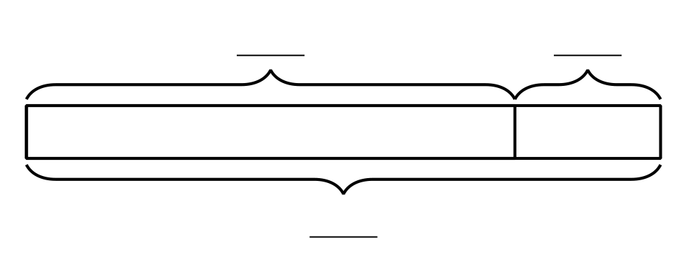

Student Responses
Priya’s ribbon is 57 in long. Sample responses:
- $74−17=?$, $74−10=64$, $64−4=60$, $60−3=57$
- Students draw a base-ten diagram that shows 5 tens and 7 ones. They show decomposing a ten and taking away 1 ten and 7 ones. They label to show the difference is 57.

