Lesson 12 Practice Problems
- Quadrilateral $ABCD$ is similar to quadrilateral $A^{′}B^{′}C^{′}D^{′}$. Select all statements that must be true.
  - $\frac{A^{′}B^{′}}{AB}=\frac{A^{′}C^{′}}{AC}$
  - $\frac{AD}{A^{′}D^{′}}=\frac{BC}{B^{′}C^{′}}$
  - $\frac{BD}{B^{′}D^{′}}=\frac{C^{′}D^{′}}{CD}$
  - $\frac{AB}{CD}=\frac{A^{′}B^{′}}{C^{′}D^{′}}$
  - $\frac{BC}{A^{′}D^{′}}=\frac{B^{′}C^{′}}{AD}$
- Lines $BC$ and $DE$ are both vertical. What is the length of $AD$?
- 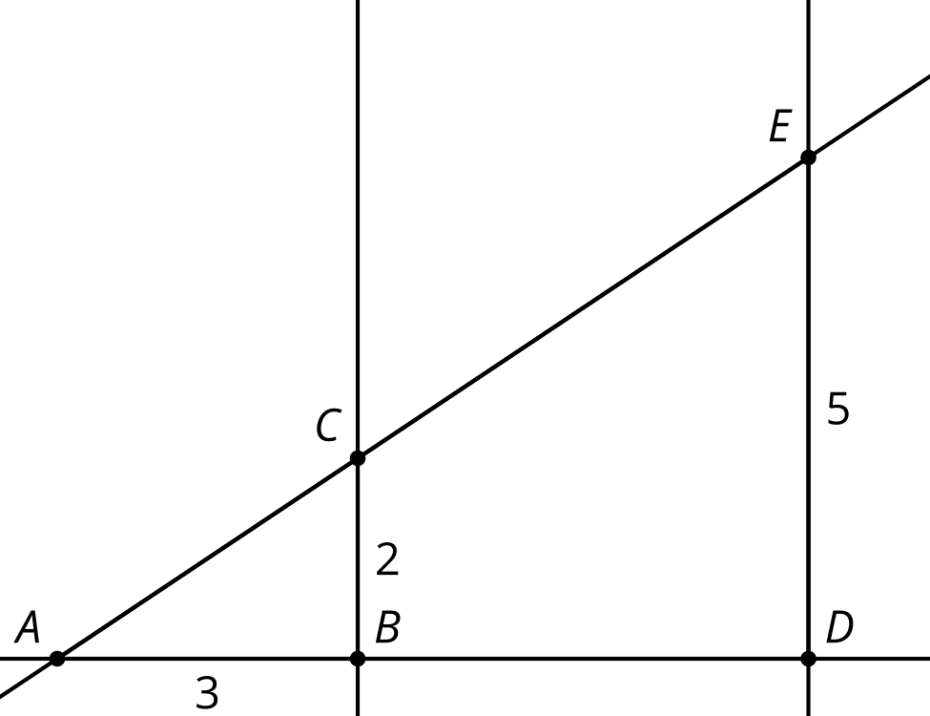
- The quilt is made of squares with diagonals. Side length $AB$ is 2.
  - What is the length of $BD$?
  - What is the area of triangle $AEH$?
- 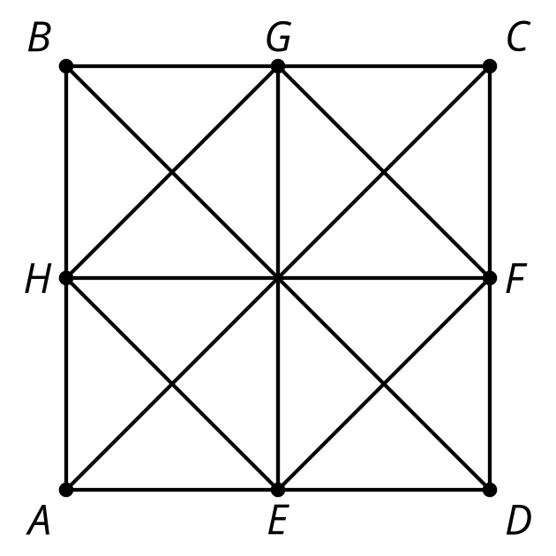
- Segment $A^{′}B^{′}$ is parallel to segment $AB$. What is the length of segment $BB^{′}$?
- 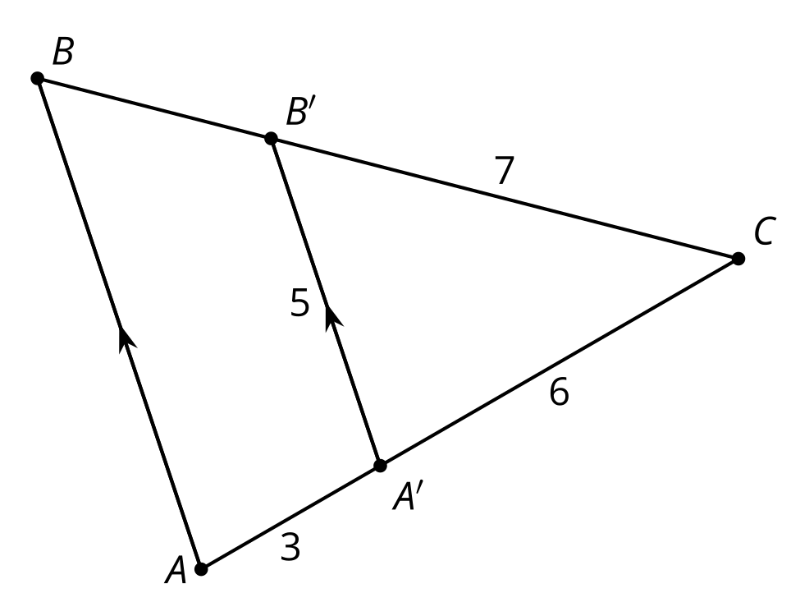
  - 3.5
  - 4
  - 10
  - 10.5
- (From Unit 3, Lesson 11.)
- Elena thinks length $BC$ is 16.5 units. Lin thinks the length of $BC$ is 17.1 units. Do you agree with either of them? Explain or show your reasoning.
- 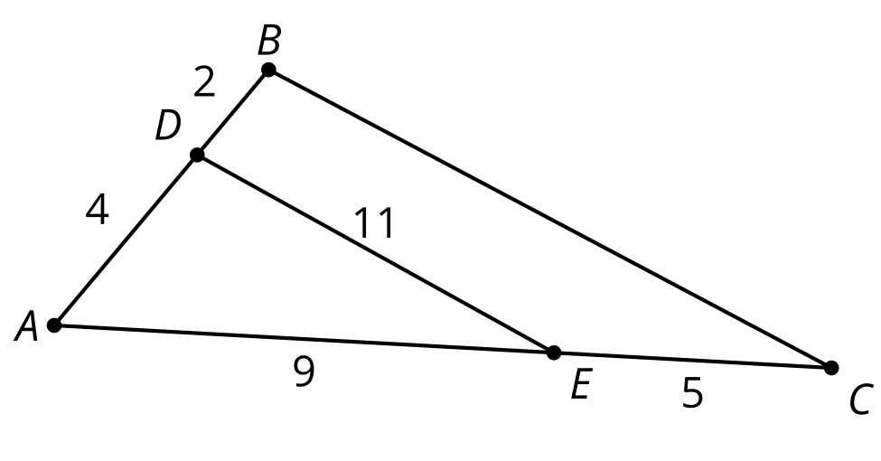
- (From Unit 3, Lesson 11.)
- Mai thinks knowing the measures of 2 sides is enough to show triangle similarity. Do you agree? Explain or show your reasoning.
- (From Unit 3, Lesson 10.)
- Line $g$ is dilated with a center of dilation at $A$. The image is line $f$. Approximate the scale factor.
- 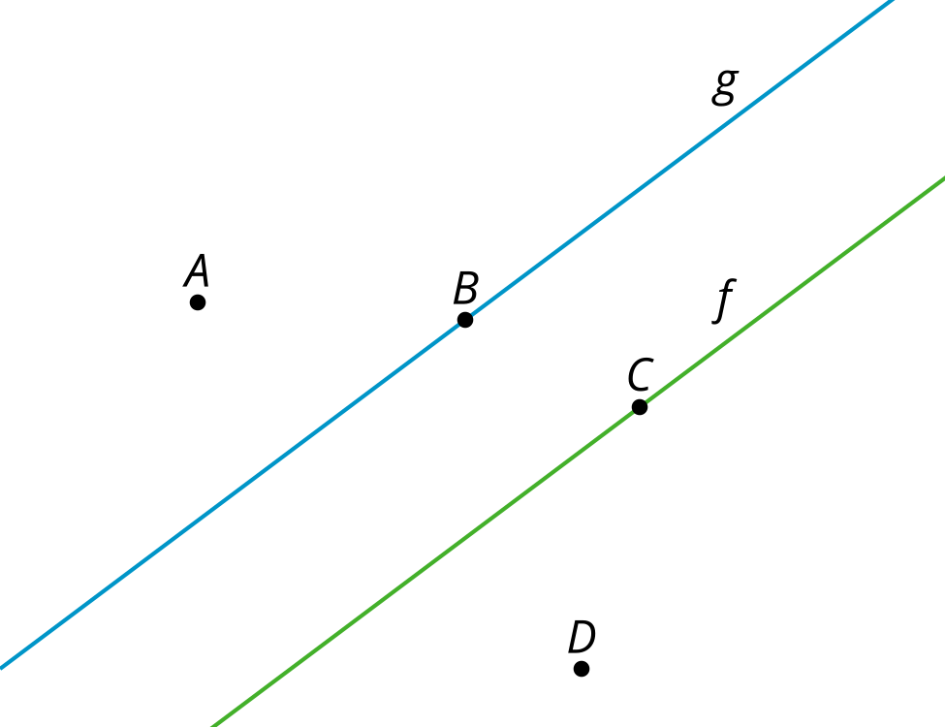
- (From Unit 3, Lesson 4.)
© CC BY 2019 by Illustrative Mathematics®

