Unit 1 Lesson 15: Symmetry

1 Back to the Start (Warm up)

Student Task Statement
Here is a segment $AB$:
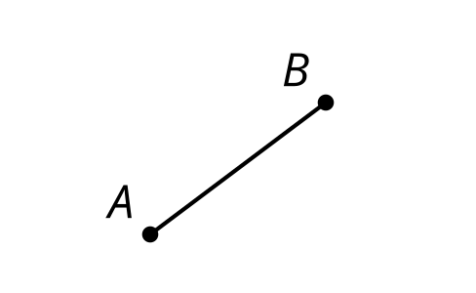
If you translate the segment up 5 units then down 5 units, it looks the same as it did originally.
- What other rigid transformations create an image that fits exactly over the original segment?
- Are there any single rigid motions that do the same thing?

2 Self Reflection

Student Task Statement
Determine all the lines of symmetry for the shape your teacher assigns you. Create a visual display about your shape. Include these parts in your display:
- the name of your shape
- the definition of your shape
- drawings of each line of symmetry
- a description in words of each line of symmetry
- one non-example in a different color (a description and drawing of a reflection not over a line of symmetry)

3 Diabolic Diagonals

Student Task Statement
Kiran thinks both diagonals of a kite are lines of symmetry. Tyler thinks only 1 diagonal is a line of symmetry. Who is correct? Explain how you know.
© CC BY 2019 by Illustrative Mathematics®

