Lesson 7 Practice Problems
- Diego wrote $f\left(x\right)=\left(x+2\right)\left(x−4\right)$ as an example of a function whose graph has $x$-intercepts at $x=\text{-}4,2$. What was his mistake?
- Write a possible equation for a polynomial whose graph has horizontal intercepts at $x=2,\text{-}\frac{1}{2},\text{-}3$.
- Which polynomial function’s graph is shown here?
- 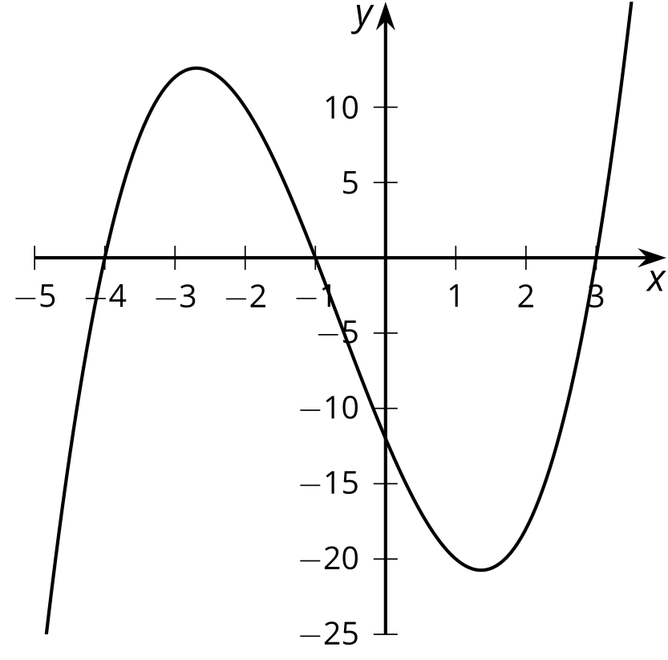
  - $f\left(x\right)=\left(x+1\right)\left(x+3\right)\left(x+4\right)$
  - $f\left(x\right)=\left(x+1\right)\left(x−3\right)\left(x+4\right)$
  - $f\left(x\right)=\left(x−1\right)\left(x+3\right)\left(x−4\right)$
  - $f\left(x\right)=\left(x−1\right)\left(x−3\right)\left(x−4\right)$
- Which expression is equivalent to $\left(3x+2\right)\left(3x−5\right)$?
  - $6x−3$
  - $9x^{2}−10$
  - $9x^{2}−3x−10$
  - $9x^{2}−9x−10$
- (From Unit 2, Lesson 4.)
- What is the value of $6\left(x−2\right)\left(x−3\right)+4\left(x−2\right)\left(x−5\right)$ when $x=\text{-}3$?
- (From Unit 2, Lesson 5.)
- Match each polynomial function with its leading coefficient.
  - $P\left(x\right)=\left(x+2\right)\left(2x−3\right)\left(4x+7\right)$
  - $P\left(x\right)=\frac{1}{2}\left(x−2\right)\left(2x−3\right)\left(4x+7\right)$
  - $P\left(x\right)=5\left(x−2\right)\left(2x−3\right)\left(4x+7\right)$
  - $P\left(x\right)=\text{-}\left(x−2\right)\left(2x−3\right)\left(4x+7\right)$
  - $P\left(x\right)=\frac{1}{4}\left(x+2\right)\left(2x−3\right)\left(4x+7\right)$
  - 40
  - 8
  - 4
  - 2
  - -8
- (From Unit 2, Lesson 6.)
© CC BY 2019 by Illustrative Mathematics®

