Lesson 11 Practice Problems
- Segment $A^{′}B^{′}$ is parallel to segment $AB$.
  - What is the length of segment $AB$?
  - What is the length of segment $B^{′}B$?
- 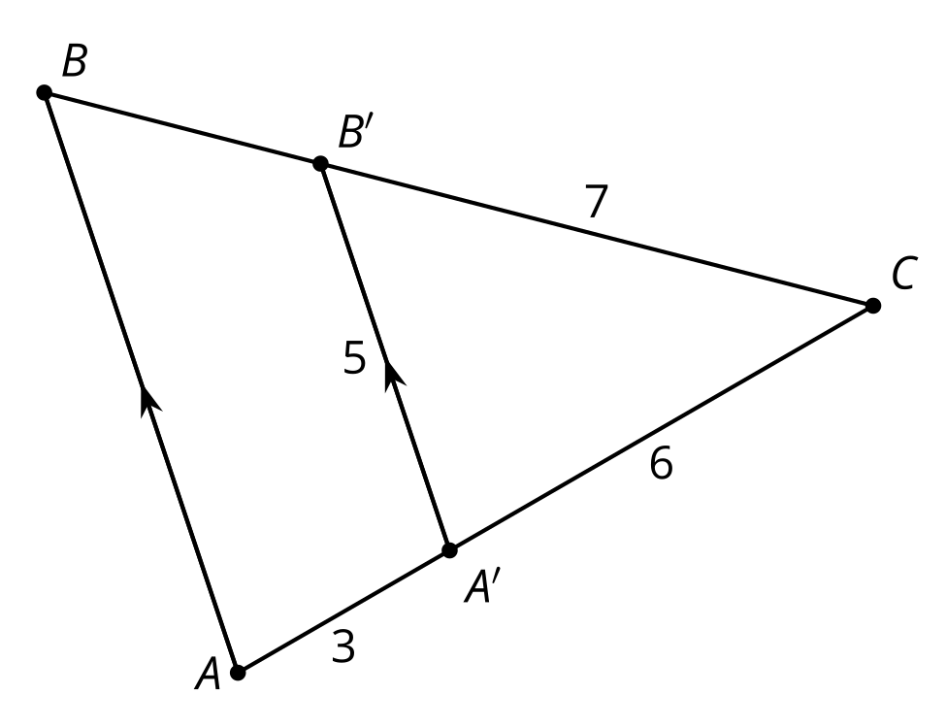
- Explain how you know that segment $DE$ is not parallel to segment $BC$.
- 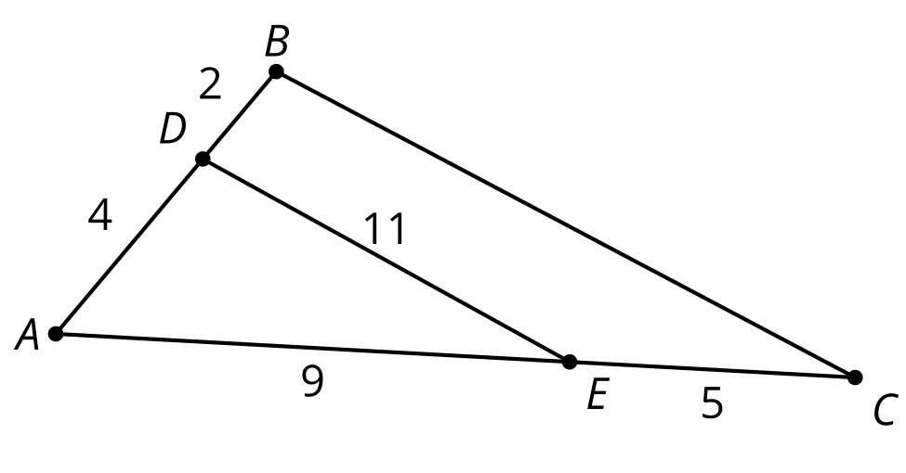
- In right triangle $ABC$, $AC=4$ and $BC=5$. A new triangle $DEC$ is formed by connecting the midpoints of $AC$ and $BC$.
- 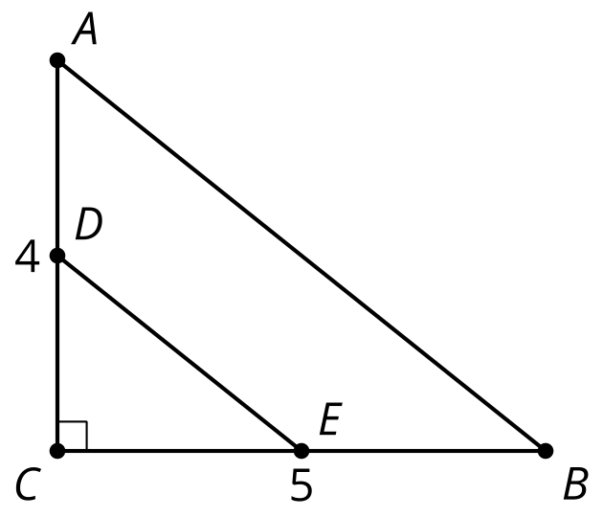
  - What is the area of triangle $ABC$?
  - What is the area of triangle $DEC$?
  - Does the scale factor for the side lengths apply to the area as well?
- Which of these statements is true?
  - To know whether 2 triangles are similar, it is enough to know the measure of 1 angle.
  - To know whether 2 triangles are similar, it is enough to know the length of 1 side.
  - To know whether 2 triangles are similar, it is enough to know the measure of 2 angles in each triangle.
  - To know whether 2 triangles are similar, it is enough to know the measure of 2 sides in each triangle.
- (From Unit 3, Lesson 10.)

  - Are triangles $ABC$ and $DEF$ similar? Show or explain your reasoning.
  - If possible, find the length of $EF$. If not, explain why the length of $EF$ cannot be determined.
- 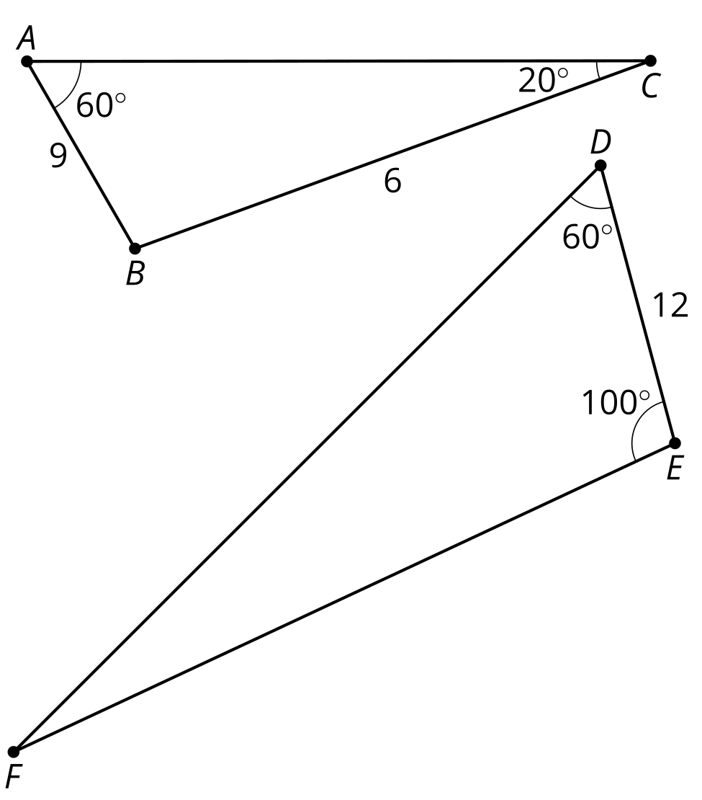
- (From Unit 3, Lesson 10.)
- What is the length of segment $DF$?
- 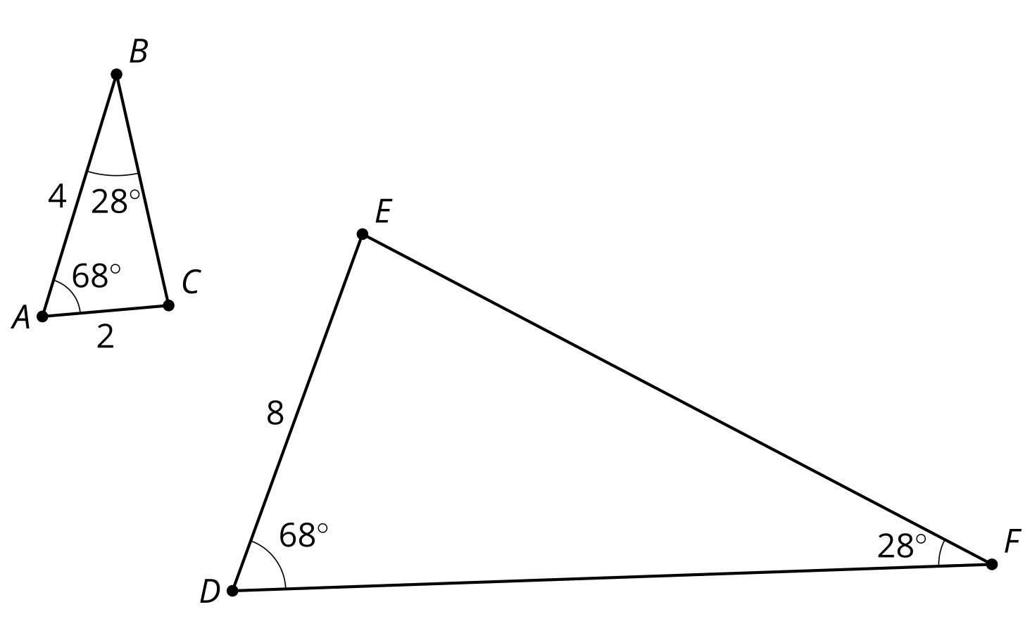
- (From Unit 3, Lesson 9.)
- The triangle $ABC$ is taken to triangle $A^{′}B^{′}C^{′}$ by a dilation. Select all of the scale factors for the dilation that would result in an image that was smaller than the original figure.
  - $\frac{1}{2}$
  - $\frac{8}{9}$
  - 1
  - $\frac{3}{2}$
  - 2
- (From Unit 3, Lesson 3.)
© CC BY 2019 by Illustrative Mathematics®

