Unit 3 Lesson 6: More Linear Relationships

1 Growing (Warm up)

Student Task Statement
Look for a growing pattern. Describe the pattern you see.
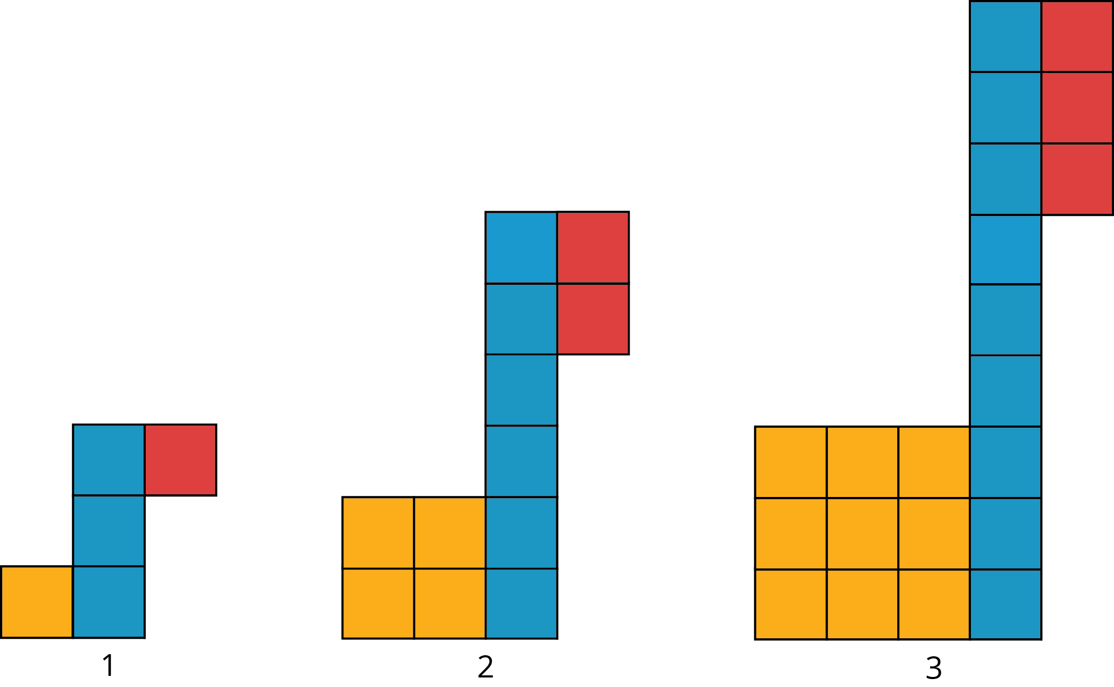
- If your pattern continues growing in the same way, how many tiles of each color will be in the 4th and 5th diagram? The 10th diagram?
- How many tiles of each color will be in the $n$th diagram? Be prepared to explain how your reasoning.

2 Slopes, Vertical Intercepts, and Graphs

Student Task Statement
Your teacher will give you 6 cards describing different situations and 6 cards with graphs.
- Match each situation to a graph.
- Pick one proportional relationship and one non-proportional relationship and answer the following questions about them.
  - How can you find the slope from the graph? Explain or show your reasoning.
  - Explain what the slope means in the situation.
  - Find the point where the line crosses the vertical axis. What does that point tell you about the situation?

3 Summer Reading

Student Task Statement
Lin has a summer reading assignment. After reading the first 30 pages of the book, she plans to read 40 pages each day until she finishes. Lin makes the graph shown here to track how many total pages she'll read over the next few days.
After day 1, Lin reaches page 70, which matches the point $\left(1,70\right)$ she made on her graph. After day 4, Lin reaches page 190, which does not match the point $\left(4,160\right)$ she made on her graph. Lin is not sure what went wrong since she knows she followed her reading plan.
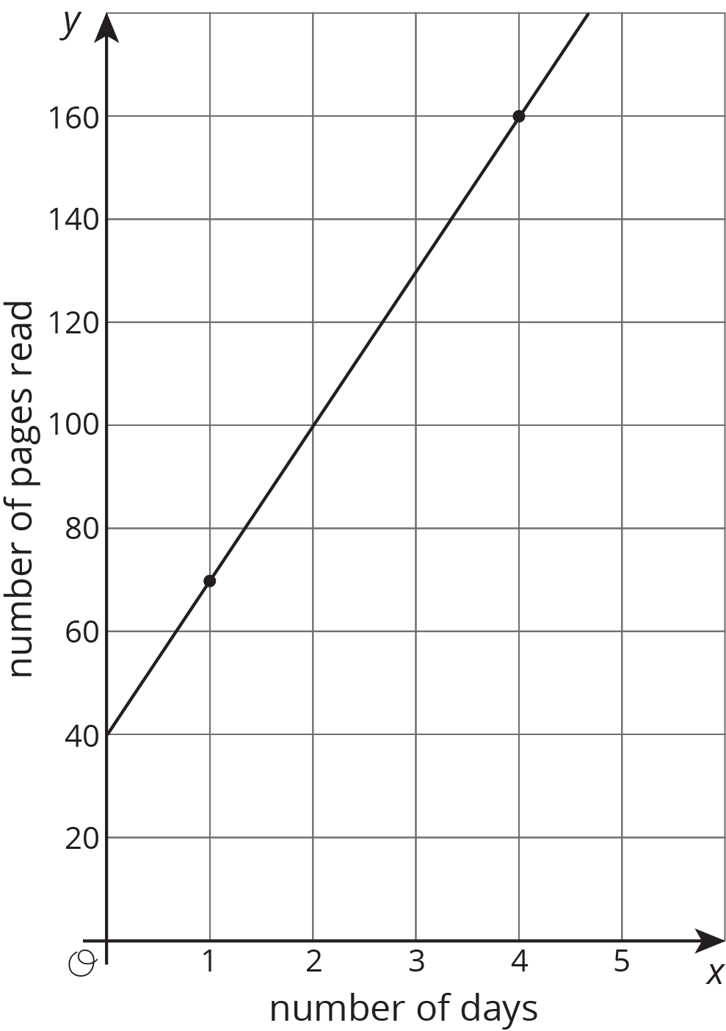
- Sketch a line showing Lin's original plan on the axes.
- What does the vertical intercept mean in this situation? How do the vertical intercepts of the two lines compare?
- What does the slope mean in this situation? How do the slopes of the two lines compare?

Images for Activity Synthesis
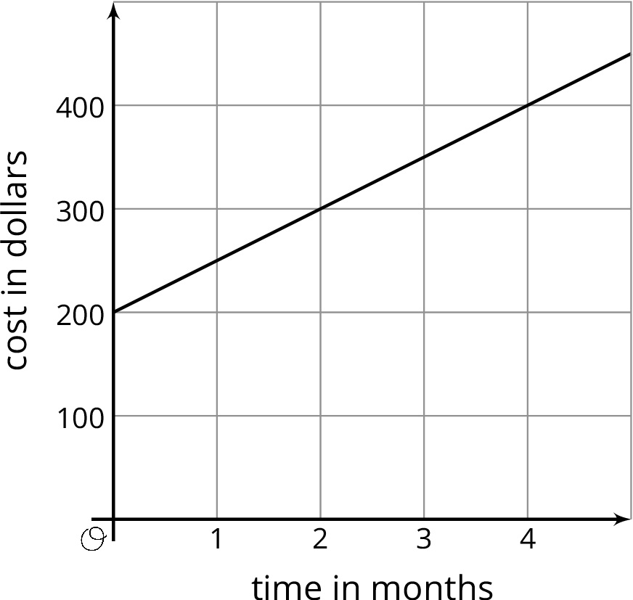
© CC BY Open Up Resources. Adaptations CC BY IM.

