Lesson 13: Dividing Decimals by Decimals
Let’s divide decimals by decimals.

13.1: Same Values
- Use long division to find the value of $5.04÷7$.

- Select all of the quotients that have the same value as $5.04÷7$. Be prepared to explain how you know.
  - $5.04÷70$
  - $50.4÷70$
  - $504,​000÷700$
  - $504,​000÷700,​000$

13.2: Placing Decimal Points in Quotients
- Think of one or more ways to find $3÷0.12$. Show your reasoning.
- Find $1.8÷0.004$. Show your reasoning. If you get stuck, think about what equivalent division expression you could write.
- Diego said, “To divide decimals, we can start by moving the decimal point in both the dividend and divisor by the same number of places and in the same direction. Then we find the quotient of the resulting numbers.”
- Do you agree with Diego? Use the division expression $7.5÷1.25$ to support your answer.

Are you ready for more?
Can we create an equivalent division expression by multiplying both the dividend and divisor by a number that is not a multiple of 10 (for example: 4, 20, or $\frac{1}{2}$)? Would doing so produce the same quotient? Explain or show your reasoning.

13.3: Two Ways to Calculate Quotients of Decimals
- Here are two calculations of $48.78÷9$. Work with your partner to answer the following questions.
- 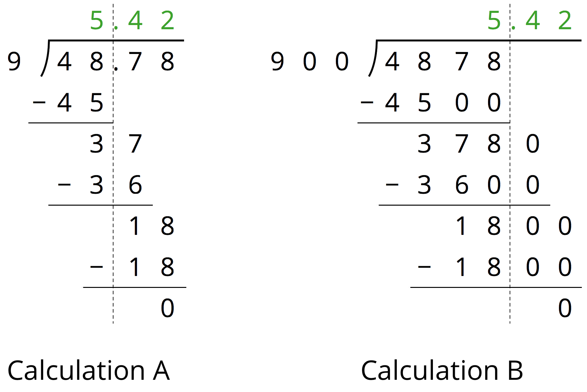
  - How are the two calculations the same? How are they different?
  - Look at Calculation A. Explain how you can tell that the 36 means “36 tenths” and the 18 means “18 hundredths.”
  - Look at Calculation B. What do the 3600 and 1800 mean?
  - We can think of $48.78÷9=5.42$ as saying, “There are 9 groups of 5.42 in 48.78.” We can think of $4878÷900=5.42$ as saying, “There are 900 groups of 5.42 in 4878.” How might we show that both statements are true?

  - Explain why $51.2÷6.4$ has the same value as $5.12÷0.64$.
  - Write a division expression that has the same value as $51.2÷6.4$ but is easier to use to find the value. Then, find the value using long division.

13.4: Practicing Division with Decimals
Find each quotient. Discuss your quotients with your group and agree on the correct answers. Consult your teacher if the group can't agree.
- $106.5÷3$
- $58.8÷0.7$
- $257.4÷1.1$
- Mai is making friendship bracelets. Each bracelet is made from 24.3 cm of string. If she has 170.1 cm of string, how many bracelets can she make? Explain or show your reasoning.

Lesson 13 Summary
One way to find a quotient of two decimals is to multiply each decimal by a power of 10 so that both products are whole numbers.
If we multiply both decimals by the same power of 10, this does not change the value of the quotient. For example, the quotient $7.65÷1.2$ can be found by multiplying the two decimals by 10 (or by 100) and instead finding $76.5÷12$ or $765÷120$.
To calculate $765÷120$, which is equivalent to $76.5÷12$, we could use base-ten diagrams, partial quotients, or long division. Here is the calculation with long division:
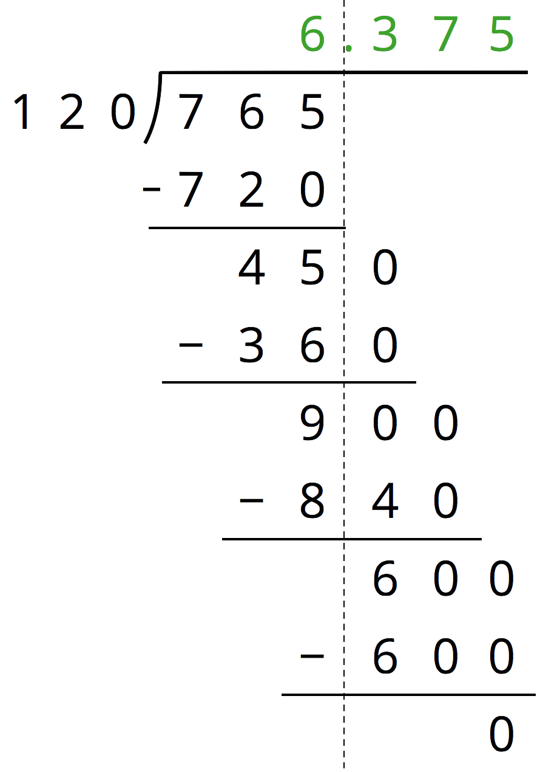
© CC BY Open Up Resources. Adaptations CC BY IM.

