Unit 1 Lesson 17: Working with Rigid Transformations

1 Math Talk: From Here to There (Warm up)

Student Task Statement
Segment $CD$ is the perpendicular bisector of segment $AB$. Find each transformation mentally.
A transformation that takes $A$ to $B$.
A transformation that takes $B$ to $A$.
A transformation that takes $C$ to $D$.
A transformation that takes $D$ to $C$.
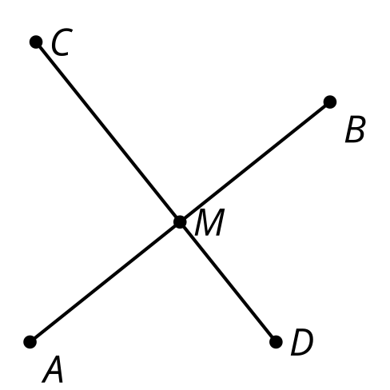

2 Card Sort: How Did This Get There?

Student Task Statement
- Your teacher will give you a set of cards that show transformations of figures.
  - Sort the cards into categories of your choosing. Be prepared to explain the meaning of your categories.
  - Then sort the cards into categories in a different way. Be prepared to explain the meaning of your new categories.
- For each card with a rigid transformation: write a sequence of rotations, translations, and reflections to get from the original figure to the image. Be precise.

3 Reflecting on Reflection

Student Task Statement
Diego says, “I see why a reflection could take $RSTU$ to $R^{′}S^{′}T^{′}U^{′}$, but I’m not sure where the line of reflection is. I’ll just guess.”
- How could Diego see that a reflection could work without knowing where the line of reflection is?
- How could Diego find an exact line of reflection that would work?

Images for Activity Synthesis
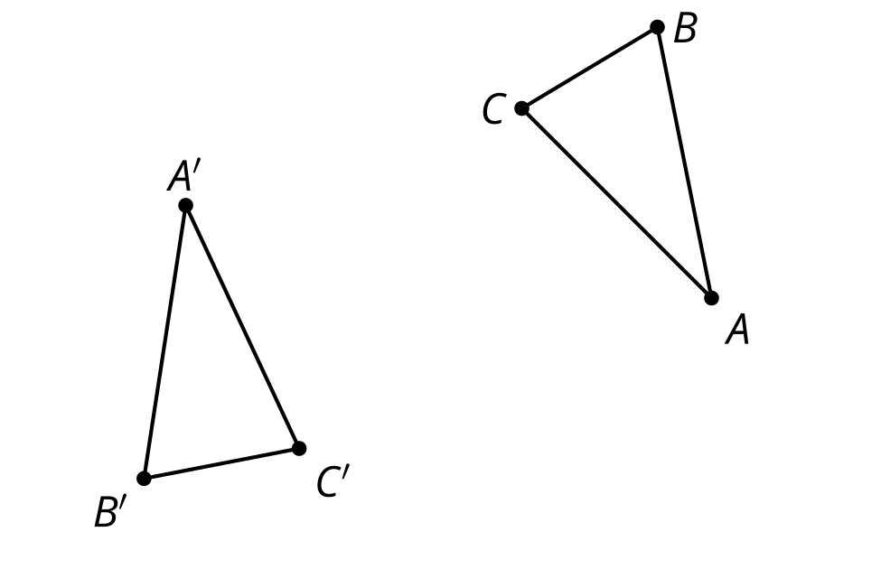
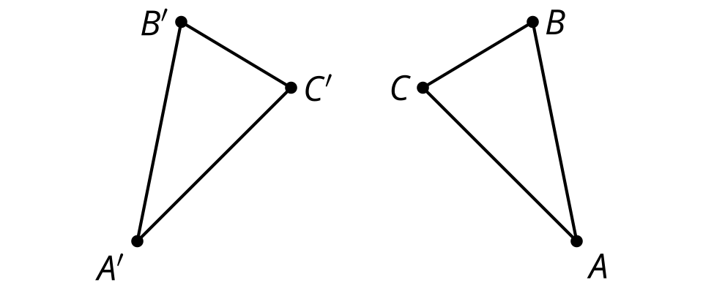
© CC BY 2019 by Illustrative Mathematics®

