Lesson 1: Compartamos sándwiches

Standards Alignments
Building On | 3.NF.A.1, 3.OA.A.2
Addressing | 5.NF.B.3
Building Towards | 5.NF.B.3

Teacher-facing Learning Goals
- Interpret and represent contexts relating division and fractions in a way that makes sense to them.

Student-facing Learning Goals
- Compartamos sándwiches.

Lesson Purpose
The purpose of this lesson is for students to relate equal shares of objects to division and to fractions.
In previous grades, students learned to interpret products of whole numbers, such as $3×5$, as the total number of objects in 3 groups each containing 5 objects. They interpreted division, such as $15÷3$, to be either the number of groups when 15 things are put in groups of 3 or as the number of things in each group when 15 things are put in 3 equal groups. They also solve word problems posed with whole numbers and having whole-number answers, including problems in which remainders must be interpreted. The goal of the next several lessons is to extend this understanding of division to quotients like $15÷6$ where the result is not a whole number. Students learned to interpret fractions such as $\frac{15}{6}$ in a previous grade and this unit will establish that $\frac{15}{6}$ is the value of the quotient $15÷6$.
In this lesson, students use what they know about division to make sense of situations where people equally share sandwiches. This lesson is meant to be an invitation to explore the relationships between division and fractions. The problems were written so students can revisit the meaning of division and be curious about how division applies to situations when the quotient represents a fractional quantity without having to name the quantity. Although students discuss how the situations in the lesson can be represented with division expressions, they do not need to write them or formally explain them, as that will be the focus of upcoming lessons. Throughout this unit, it is assumed that the sharing is always equal sharing, whether explicitly stated or not.

Access for:

Students with Disabilities
- Representation (Activity 2)

English Learners
- MLR1 (Activity 1)

Instructional Routines
5 Practices (Activity 1), MLR2 Collect and Display (Activity 2), Which One Doesn’t Belong? (Warm-up)

Lesson Timeline
Warm-up | 10 min
Activity 1 | 20 min
Activity 2 | 15 min
Lesson Synthesis | 10 min
Cool-down | 5 min

Teacher Reflection Question
What evidence did you see that each student felt they belonged in math class today?

Cool-down
(to be completed at the end of the lesson) 5min
¿Qué cantidad?

Standards Alignments
Addressing | 5.NF.B.3

Student-facing Task Statement
- Dibuja un diagrama que muestre la cantidad de sándwich que recibirá cada persona.
- 3 sándwiches se comparten equitativamente entre 4 personas.

- Explica o muestra cómo sabes que cada persona recibe la misma cantidad de sándwich.

Student Responses
- Sample pictures:
- 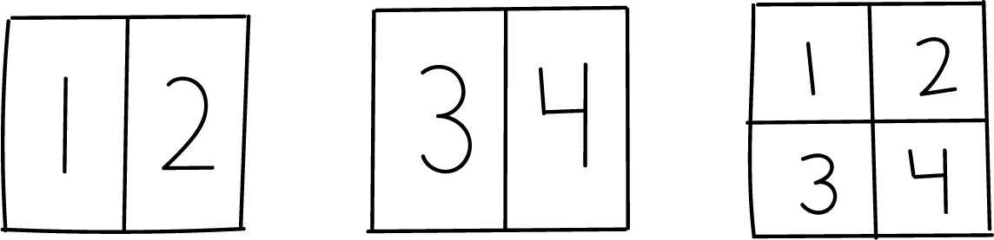
- 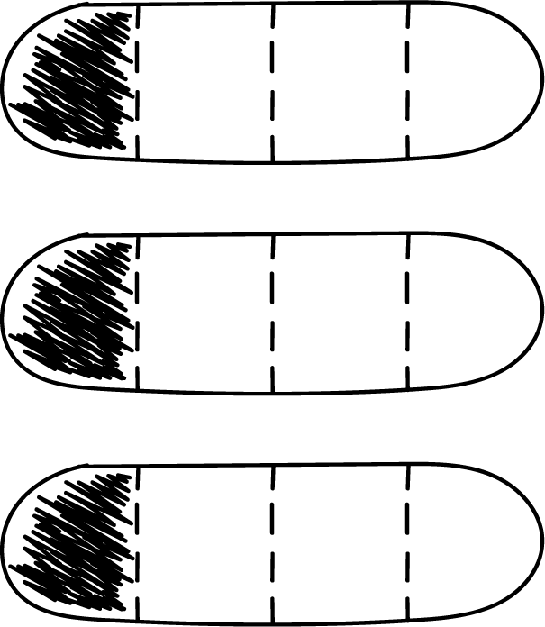
- Sample responses
  - Each person gets one fourth of each sandwich.
  - Each person gets one half plus one fourth of each sandwich.
  - Each person gets $\frac{3}{4}$ of a sandwich.

