Unit 3 Lesson 2: Graphs of Proportional Relationships

1 An Unknown Situation (Warm up)

Student Task Statement
Here is a graph that could represent a variety of different situations.
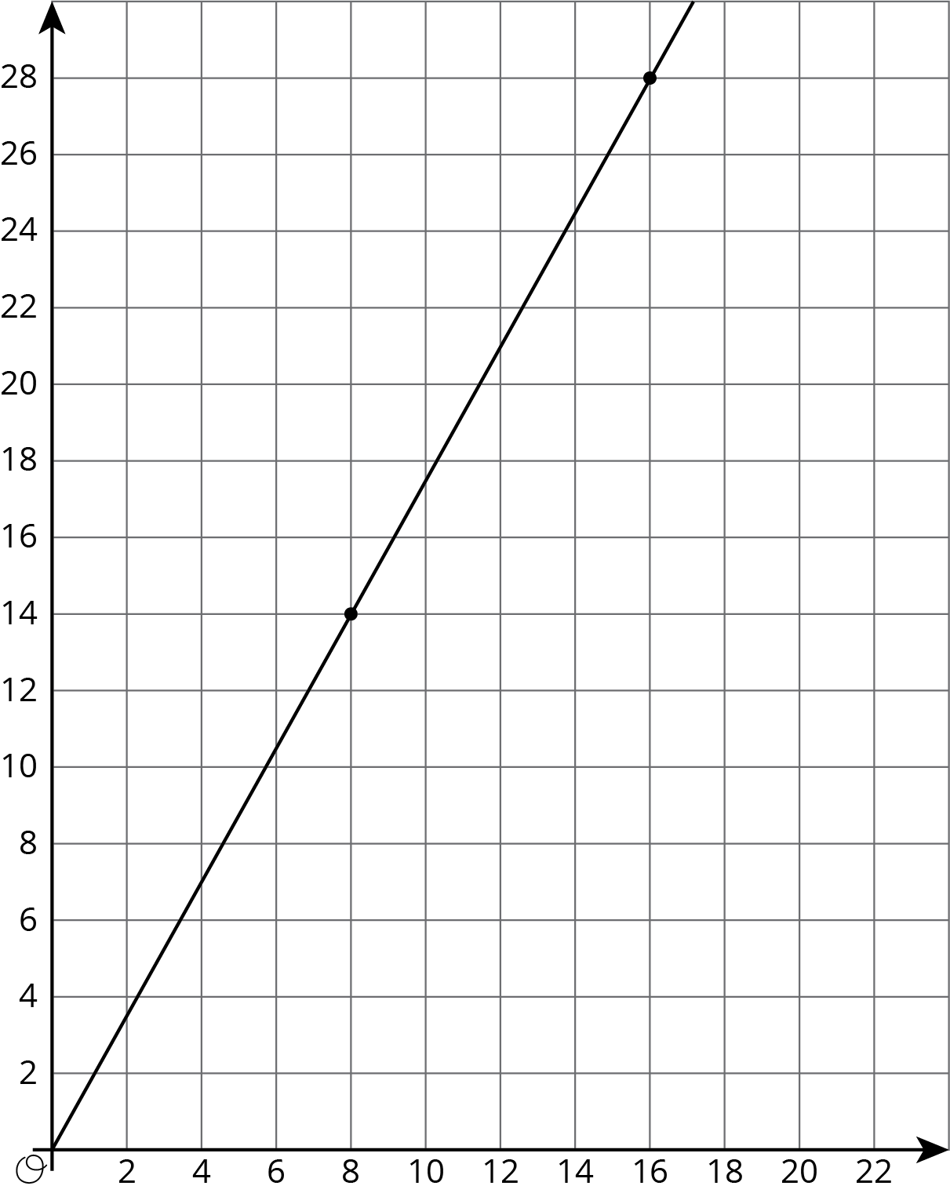
- Write an equation for the graph.
- Sketch a new graph of this relationship.
- 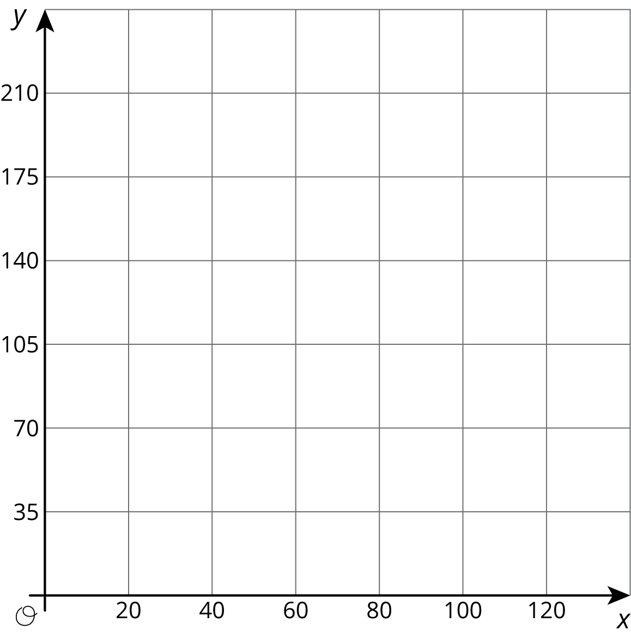

2 Card Sort: Proportional Relationships

Student Task Statement
Your teacher will give you 12 graphs of proportional relationships.
- Sort the graphs into groups based on what proportional relationship they represent.
- Write an equation for each different proportional relationship you find.

3 Different Scales

Student Task Statement
Two large water tanks are filling with water. Tank A is not filled at a constant rate, and the relationship between its volume of water and time is graphed on each set of axes. Tank B is filled at a constant rate of $\frac{1}{2}$ liters per minute. The relationship between its volume of water and time can be described by the equation $v=\frac{1}{2}t$, where $t$ is the time in minutes and $v$ is the total volume in liters of water in the tank.
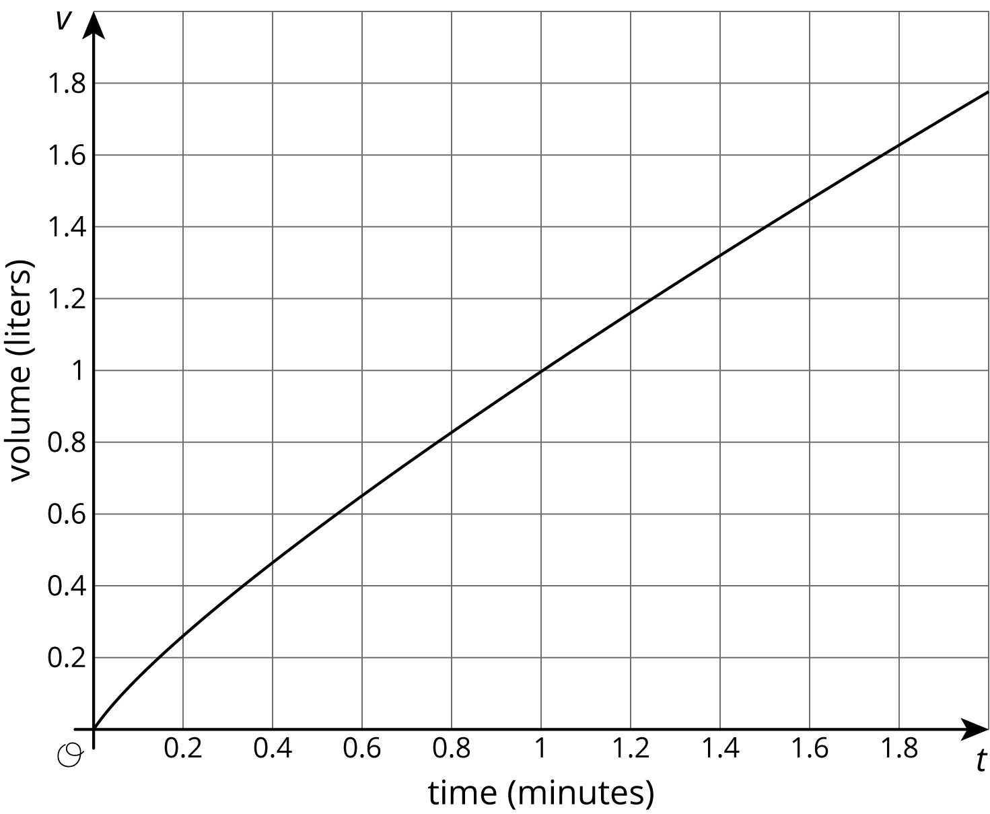
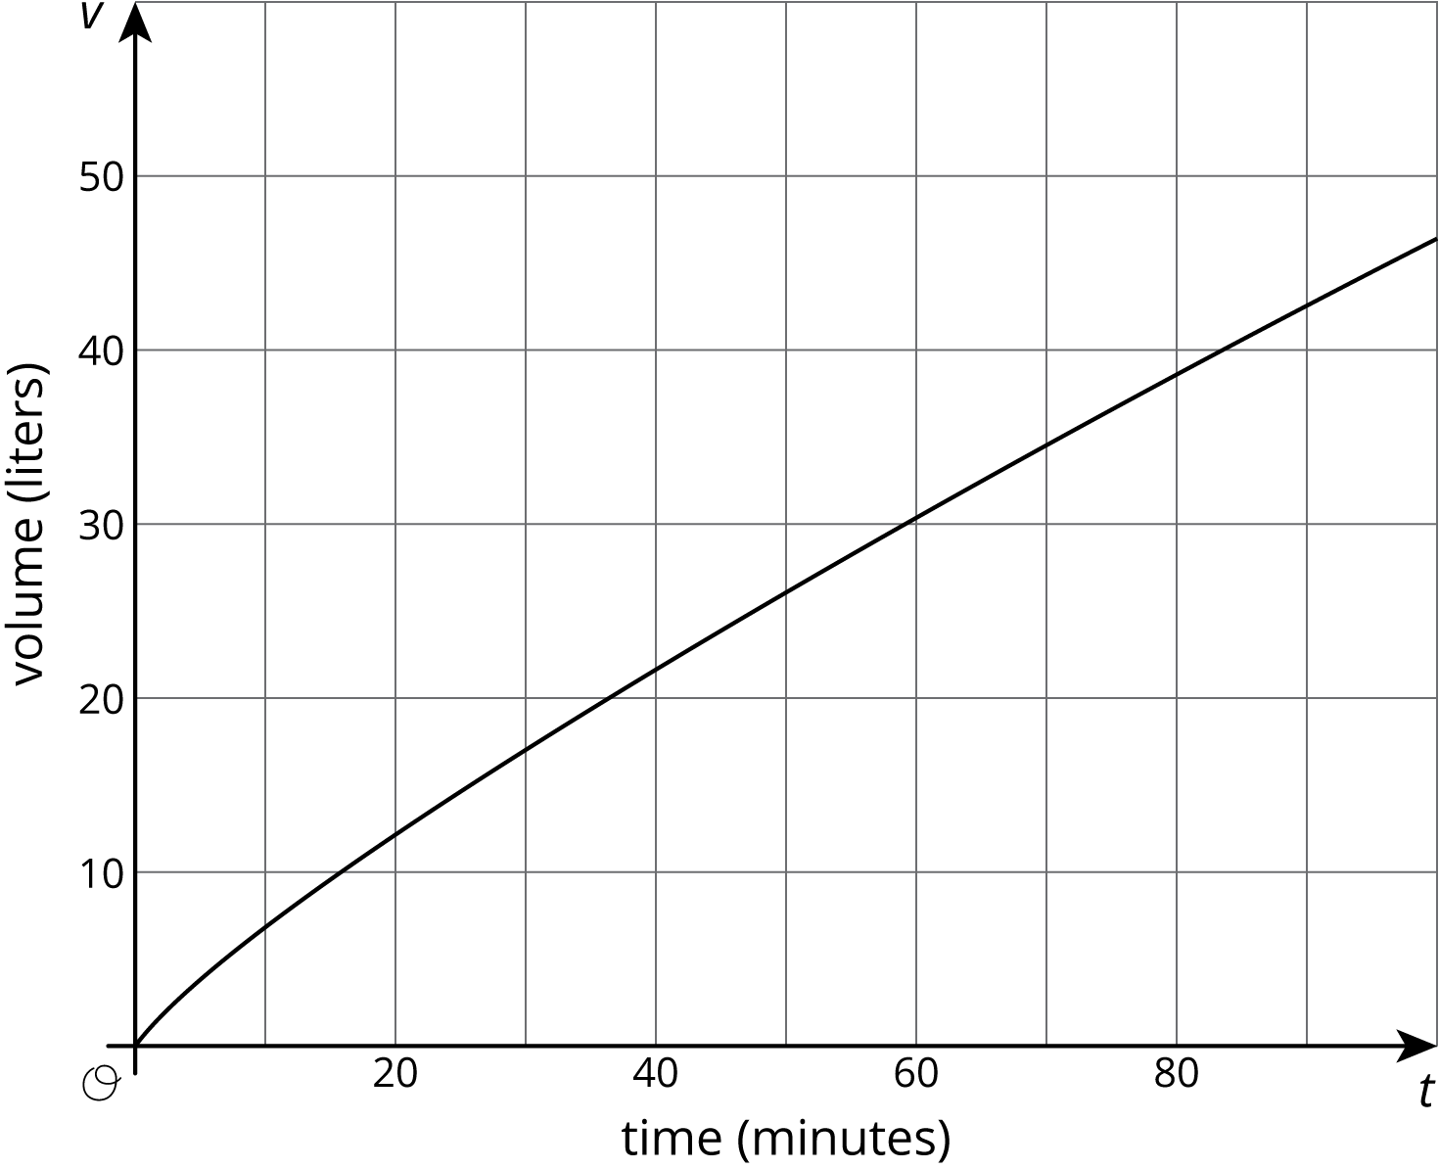
- Sketch and label a graph of the relationship between the volume of water $v$ and time $t$ for Tank B on each of the axes.
- Answer the following questions and say which graph you used to find your answer.
  - After 30 seconds, which tank has the most water?
  - At approximately what times do both tanks have the same amount of water?
  - At approximately what times do both tanks contain 1 liter of water? 20 liters?

Images for Activity Synthesis
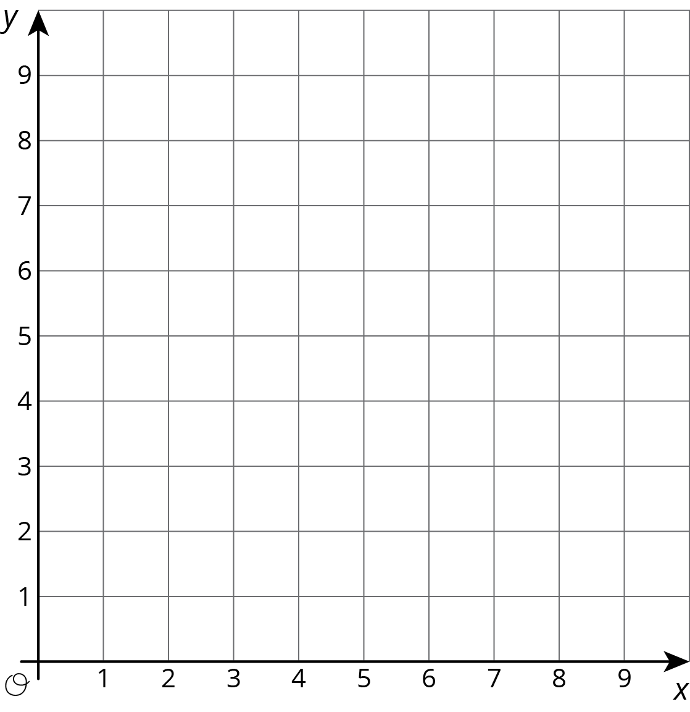
© CC BY Open Up Resources. Adaptations CC BY IM.

