Lesson 10 Practice Problems

  - Explain how we know that triangle $ABC$ and triangle $DEF$ are similar.
  - What does that tell us about angle $D$?
- 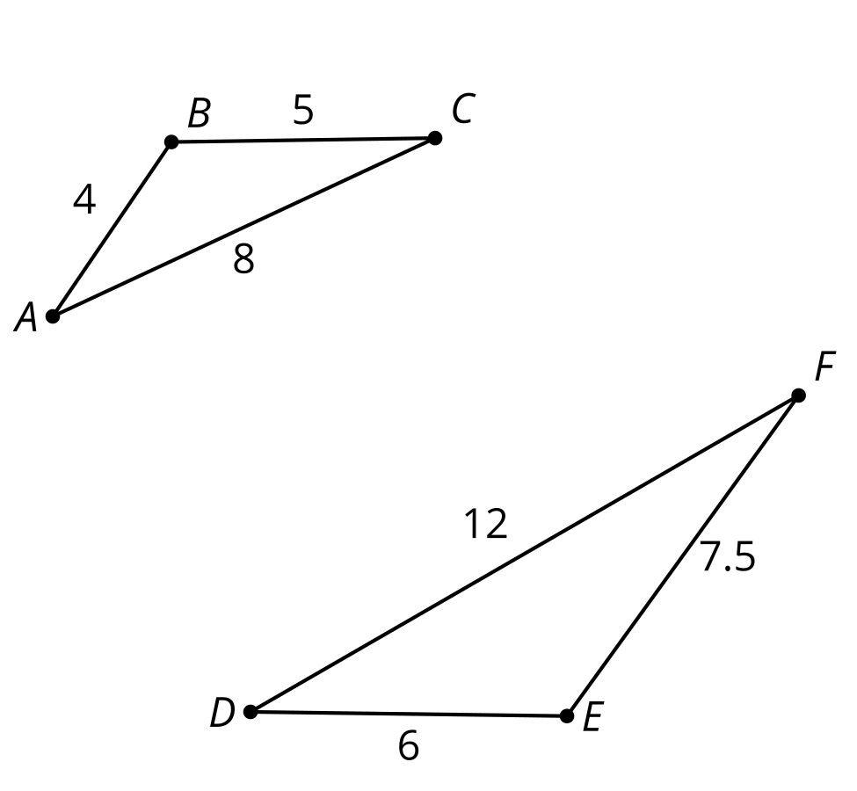

  - Find the length of $EF$.
  - Find the measure of angle $E$.
  - Find the measure of angle $F$.
- 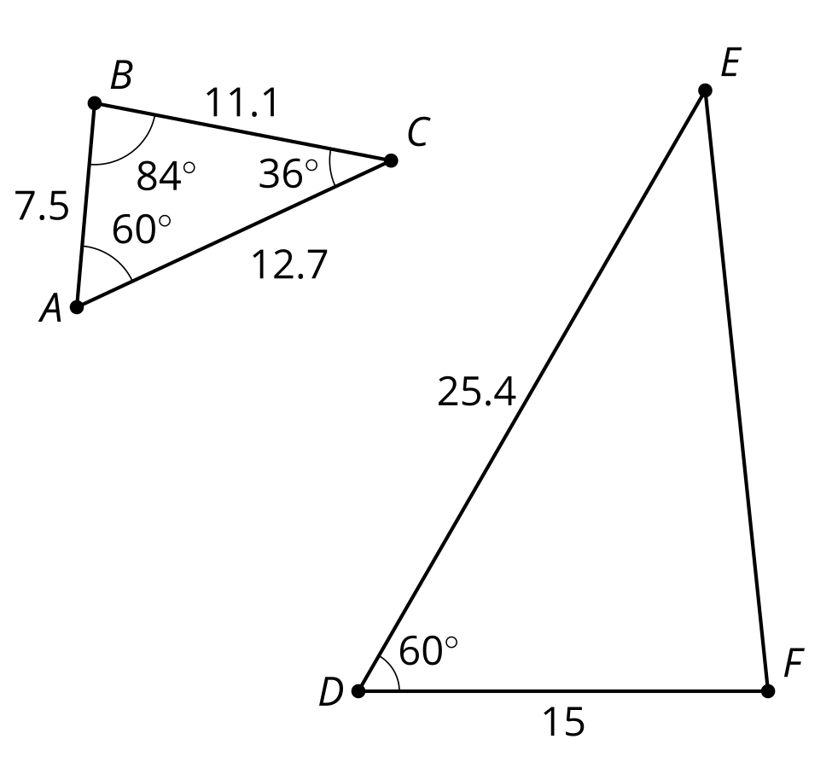
- Decide whether triangles $ABC$ and $DEC$ are similar. Explain or show your reasoning.
- 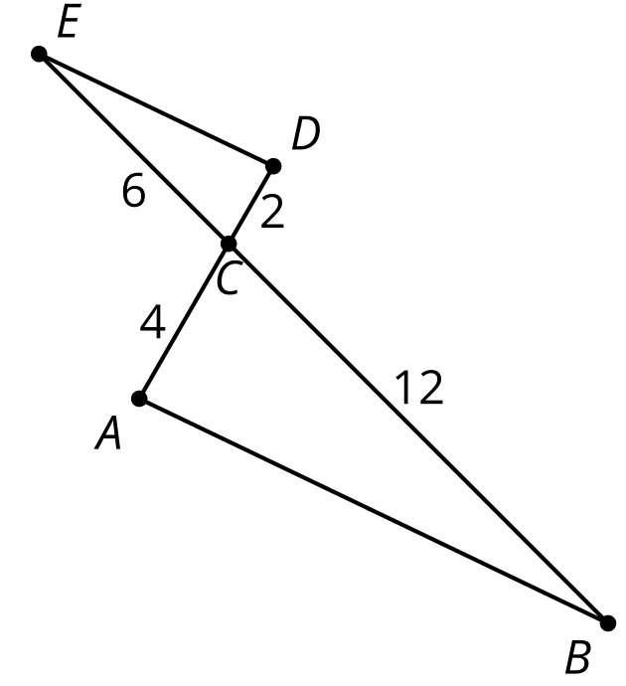
- What is the length of segment $DF$?
- 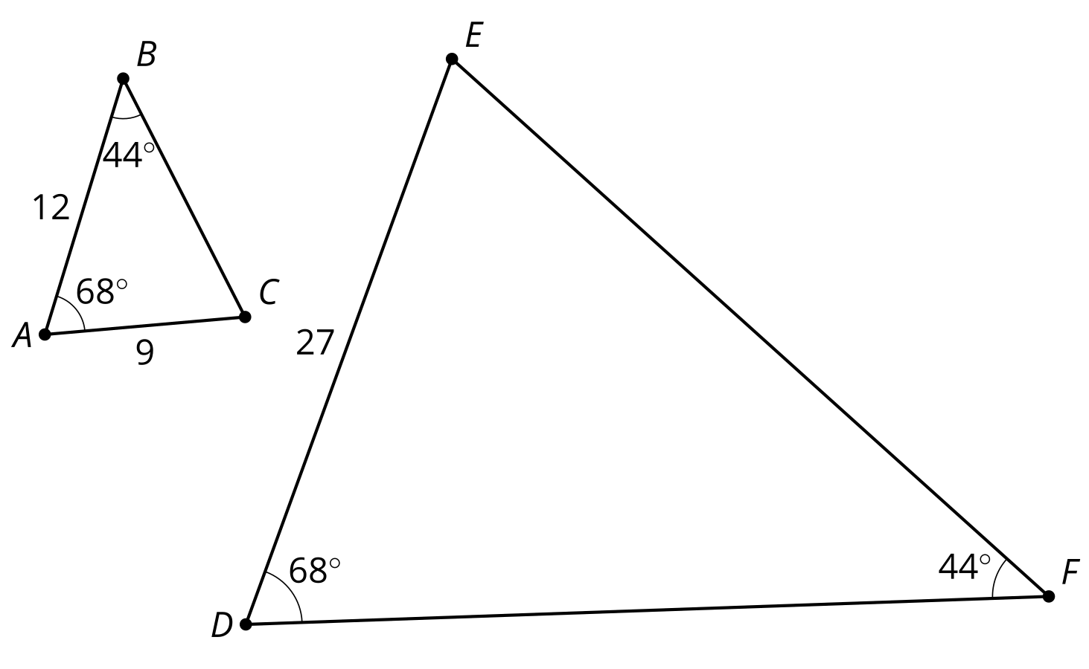
  - 3 units
  - $\frac{81}{4}$ units
  - 36 units
  - 48 units
- (From Unit 3, Lesson 9.)
- In triangle $ABC$, angle $A$ is 75º and angle $B$ is 20º. Select the triangle that is similar to triangle $ABC$.
  - triangle $DEF$ where angle $D$ is 75º and angle $E$ is 20º
  - triangle $DEF$ where angle $D$ is 20º and angle $E$ is 75º
  - triangle $DEF$ where angle $D$ is 85º and angle $E$ is 20º
  - triangle $DEF$ where angle $D$ is 20º and angle $F$ is 85º
- (From Unit 3, Lesson 9.)
- Sketch a pair of rectangles that are similar.
- (From Unit 3, Lesson 8.)
- Determine if each statement must be true, could possibly be true, or definitely can't be true. Explain or show your reasoning.
  - Two line segments are similar.
  - Two angles are similar.
- (From Unit 3, Lesson 7.)
- Figure $G^{′}$ is the image of Figure $G$ by a dilation.
  - Where is the center of this dilation?
  - Estimate the scale factor.
- 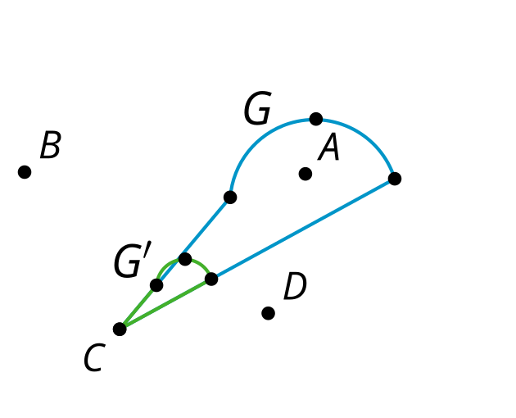
- (From Unit 3, Lesson 2.)
© CC BY 2019 by Illustrative Mathematics®

