Unit 1 Lesson 13: Incorporating Rotations

1 Left to Right (Warm up)

Images for Launch
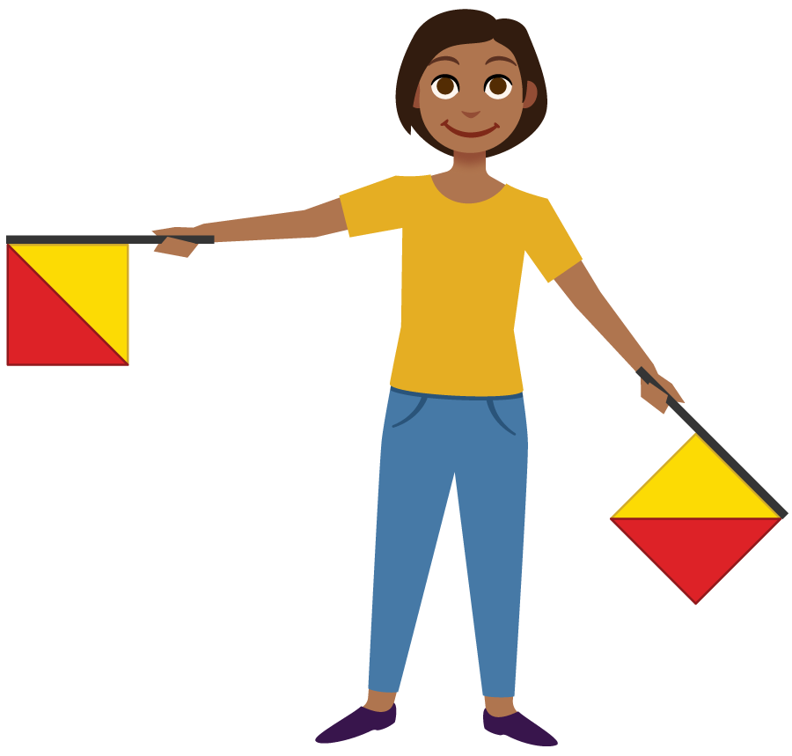

Student Task Statement
The semaphore alphabet is a way to use flags to signal messages. Here's how to signal the letters Z and J. For each, precisely describe a rotation that would take the left hand flag to the right hand flag.

Z
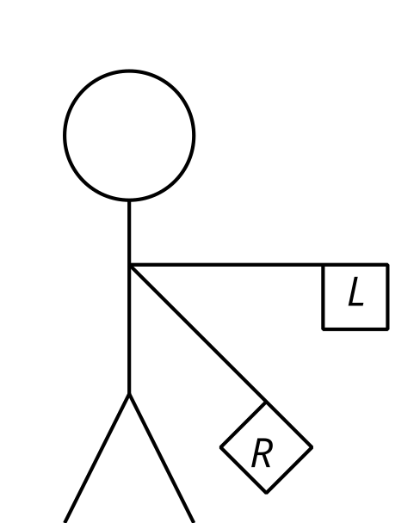

J
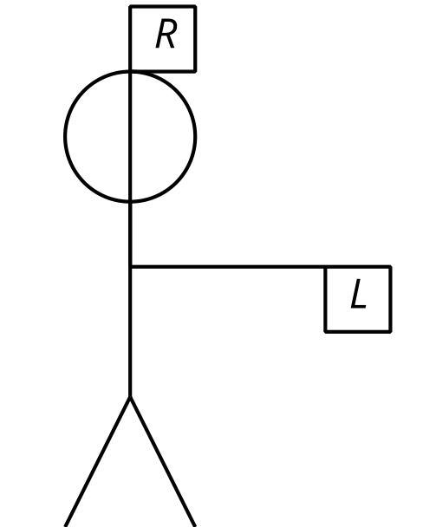

Activity Synthesis
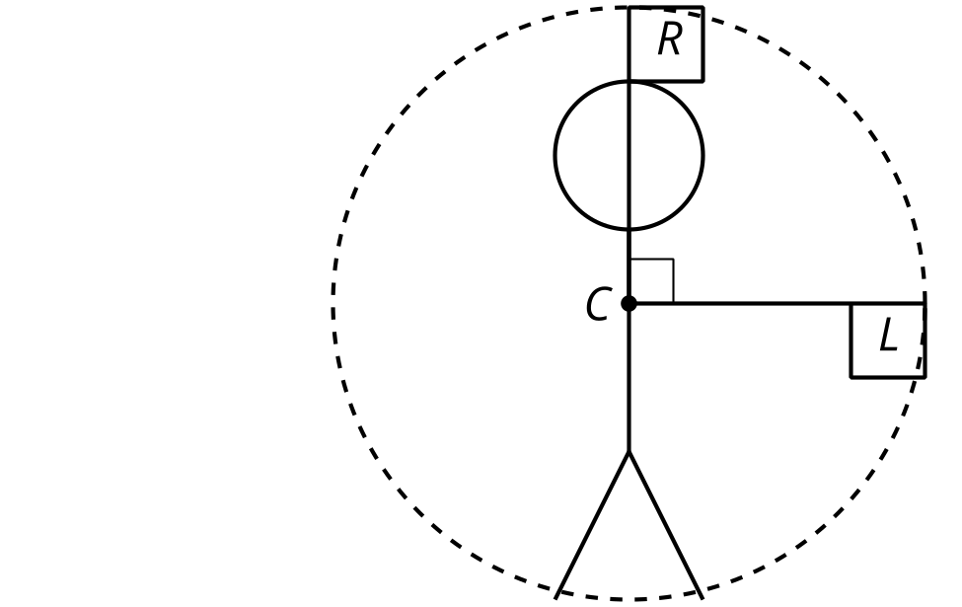

2 Turning on a Grid

Student Task Statement
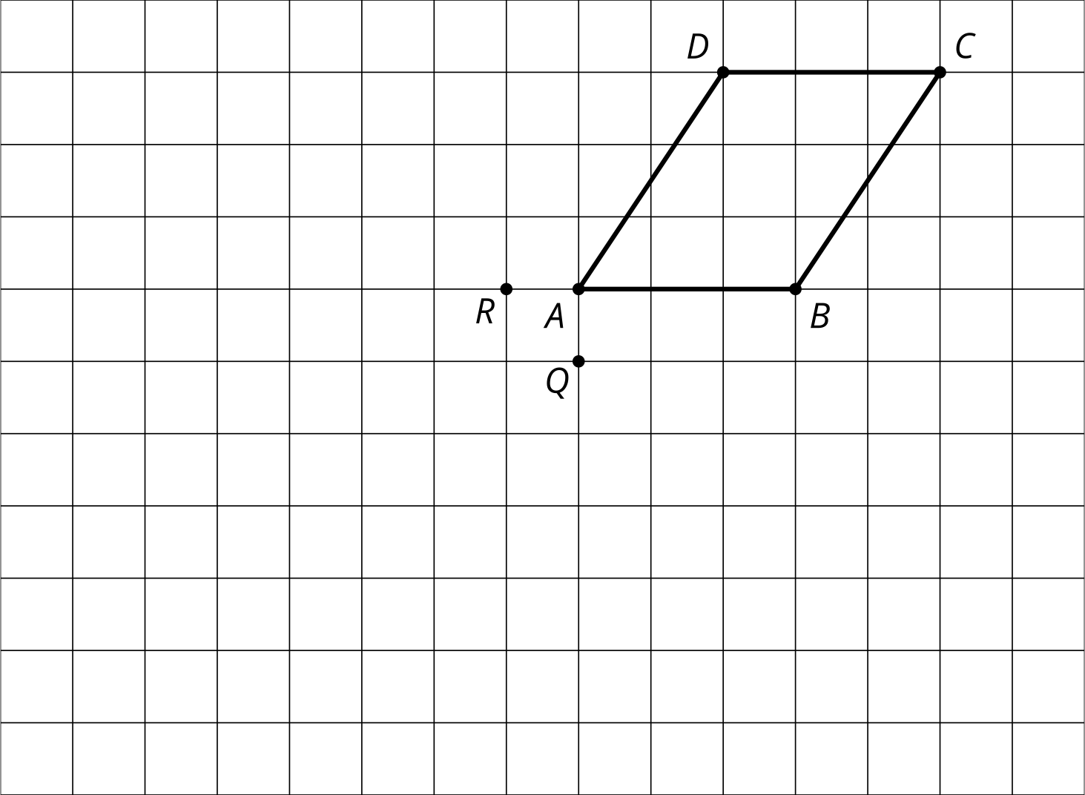
- Rotate $ABCD$ 90 degrees clockwise around $Q$.
- Rotate $ABCD$ 180 degrees around $R$.
- Rotate $HJKLMN$ 120 degrees clockwise around $O$.
- Rotate $HJKLMN$ 60 degrees counterclockwise around $P$.
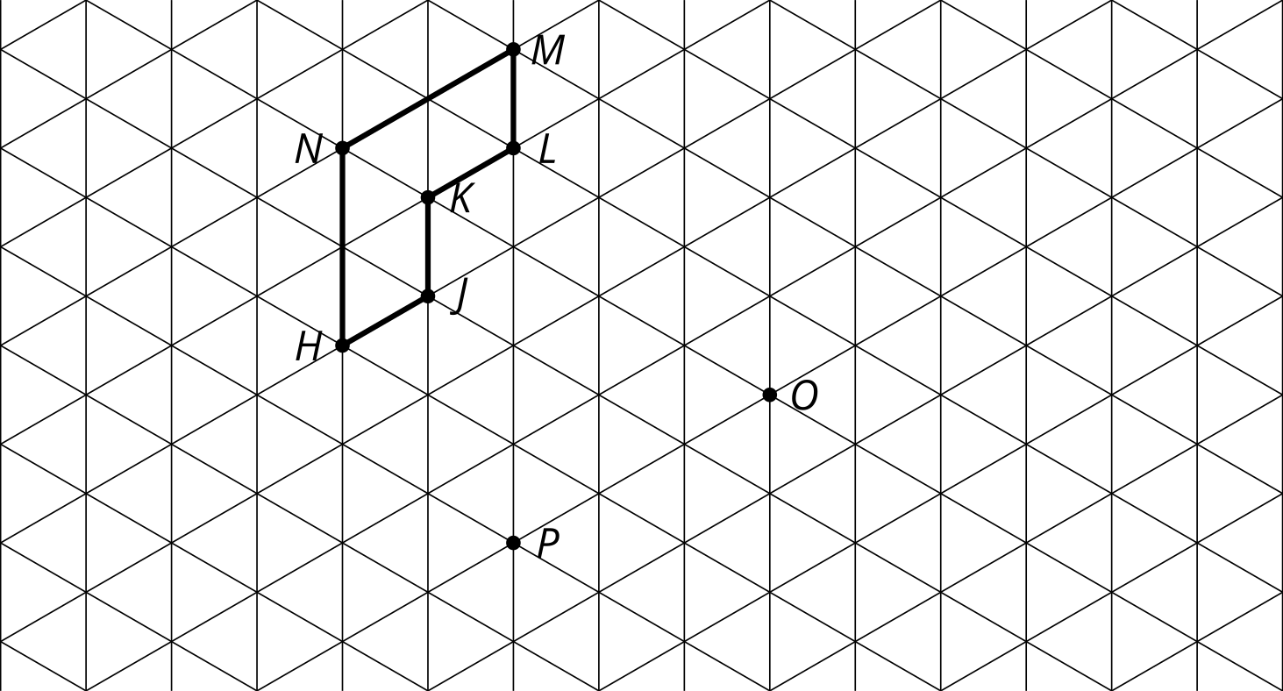

3 Translate, Rotate, Reflect

Student Task Statement
Mai suspects triangle $ABC$ is congruent to triangle $DEF$. She thinks these steps will work to show there is a rigid transformation from $ABC$ to $DEF$.
- Translate by directed line segment $v$.
- Rotate the image ____ degrees clockwise around point $D$.
- Reflect that image over line $DE$.
Draw each image and determine the angle of rotation needed for these steps to take $ABC$ to $DEF$.
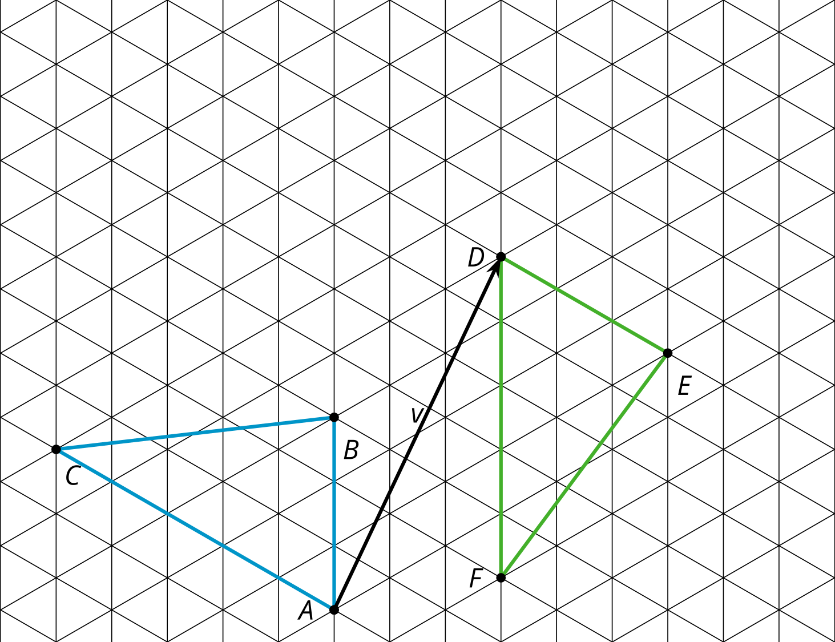

Images for Activity Synthesis

S
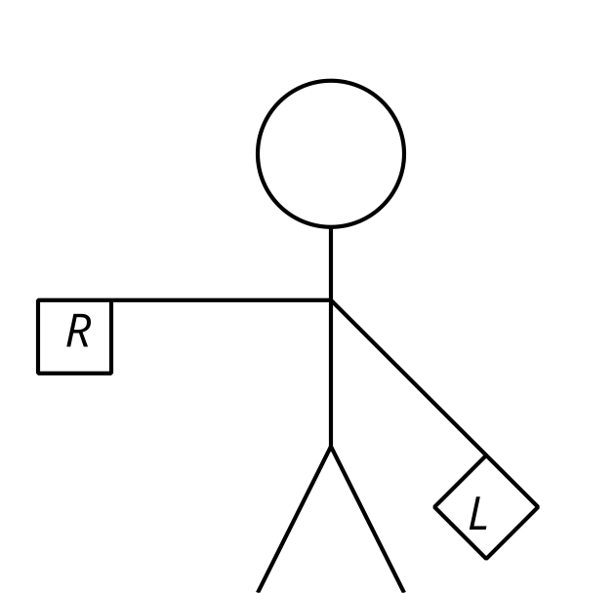

N
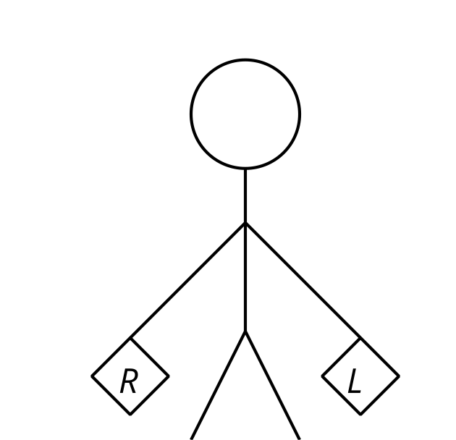

O
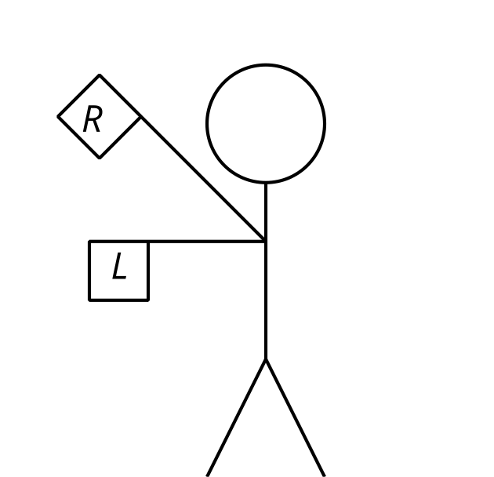
© CC BY 2019 by Illustrative Mathematics®

