Lesson 8: Calculating Products of Decimals
Let’s multiply decimals.

8.1: Number Talk: Twenty Times a Number
Evaluate mentally.
$20⋅5$
$20⋅\left(0.8\right)$
$20⋅\left(0.04\right)$
$20⋅\left(5.84\right)$

8.2: Calculating Products of Decimals
- A common way to find a product of decimals is to calculate a product of whole numbers, then place the decimal point in the product.
- 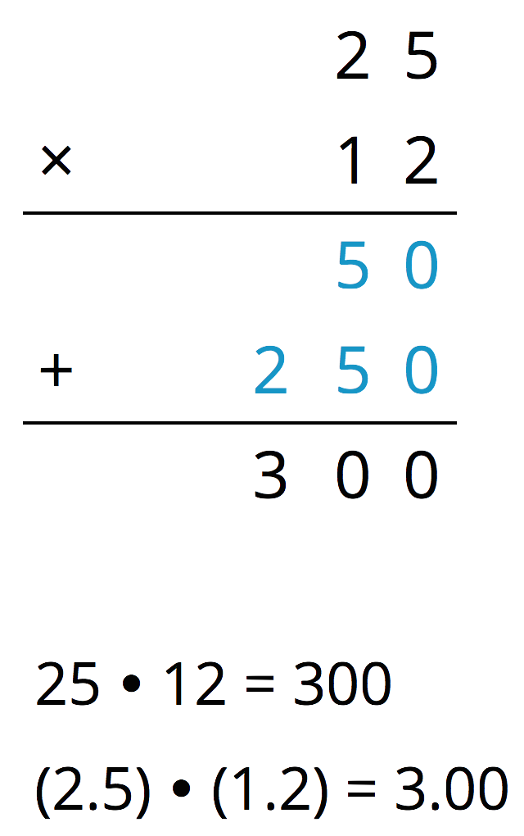
- Here is an example for $\left(2.5\right)⋅\left(1.2\right)$.
- Use what you know about decimals and place value to explain why the decimal point of the product is placed where it is.
- Use the method shown in the first question to calculate each product.
  - $\left(4.6\right)⋅\left(0.9\right)$
  - $\left(16.5\right)⋅\left(0.7\right)$
- Use area diagrams to check your earlier calculations. For each problem:
  - Decompose each number into its base-ten units and write them in the boxes on each side of the rectangle.
  - Write the area of each lettered region in the diagram. Then find the area of the entire rectangle. Show your reasoning.
  - $\left(4.6\right)⋅\left(0.9\right)$
  - $\left(16.5\right)⋅\left(0.7\right)$
- About how many centimeters are in 6.25 inches if 1 inch is about 2.5 centimeters? Show your reasoning.

8.3: Practicing Multiplication of Decimals
- Calculate each product. Show your reasoning. If you get stuck, consider drawing an area diagram to help.
  - $\left(5.6\right)⋅\left(1.8\right)$
  - $\left(0.008\right)⋅\left(7.2\right)$
- A rectangular playground is 18.2 meters by 12.75 meters.
  - Find its area in square meters. Show your reasoning.
  - If 1 meter is approximately 3.28 feet, what are the approximate side lengths of the playground in feet? Show your reasoning.

Are you ready for more?
- Write the following expressions as decimals.
  - $1−0.1$
  - $1−0.1+10−0.01$
  - $1−0.1+10−0.01+100−0.001$
- Describe the decimal that results as this process continues.
- What would happen to the decimal if all of the addition and subtraction symbols became multiplication symbols? Explain your reasoning.

Lesson 8 Summary
We can use $84⋅43$ and what we know about place value to find $\left(8.4\right)⋅\left(4.3\right)$.
Since 8.4 is 84 tenths and 4.3 is 43 tenths, then:
$\left(8.4\right)⋅\left(4.3\right)=\frac{84}{10}⋅\frac{43}{10}=\frac{84⋅43}{100}$
That means we can compute $84⋅43$ and then divide by 100 to find $\left(8.4\right)⋅\left(4.3\right)$.
$84⋅43=3612$ $\left(8.4\right)⋅\left(4.3\right)=36.12$
Using fractions such as $\frac{1}{10}$, $\frac{1}{100}$, and $\frac{1}{1,000}$ allows us to find the product of two decimals using the following steps:
- Write each decimal factor as a product of a whole number and a fraction.
- Multiply the whole numbers.
- Multiply the fractions.
- Multiply the products of the whole numbers and fractions.
We know multiplying by fractions such as $\frac{1}{10}$, $\frac{1}{100}$, and $\frac{1}{1,000}$ is the same as dividing by 10, 100, and 1,000, respectively. This means we can move the decimal point in the whole-number product to the left the appropriate number of spaces to correctly place the decimal point.
© CC BY Open Up Resources. Adaptations CC BY IM.

