Unit 1 Lesson 12: Defining Translations

1 Notice and Wonder: Two Triangles and an Arrow (Warm up)

Student Task Statement
What do you notice? What do you wonder?
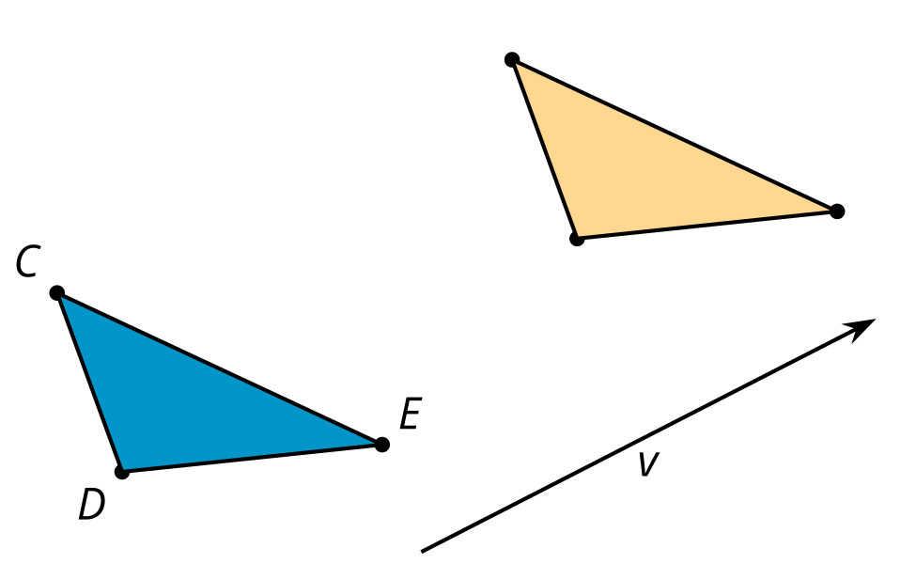

2 What’s the Point: Translations

Student Task Statement
- After a translation, the image of $V$ is $W$. Find at least 3 other points that are taken to a labeled point by that translation.
- Write at least 1 conjecture about translations.
- In a new translation, the image of $V$ is $Z$. Find at least 3 other points that are taken to a labeled point by the new translation.
- Are your conjectures still true for the new translation?

3 Translating Triangles

Student Task Statement
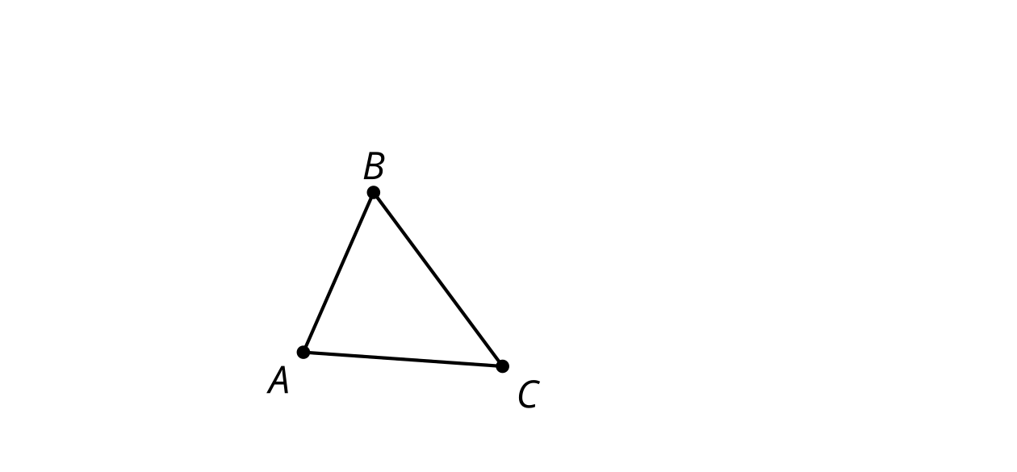
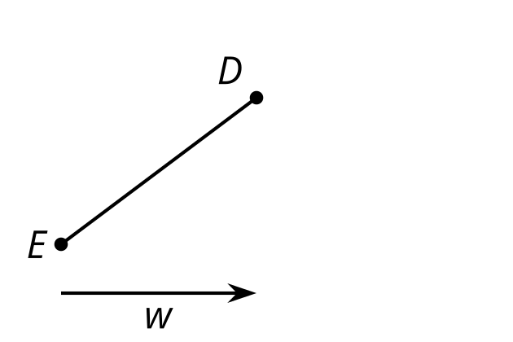
- Translate triangle $ABC$ by the directed line segment from $A$ to $C$.
  - What is the relationship between line $BC$ and line $B^{′}C^{′}$? Explain your reasoning.
  - How does the length of segment $BC$ compare to the length of segment $B^{′}C^{′}$? Explain your reasoning.
- Translate segment $DE$ by directed line segment $w$. Label the new endpoints $D^{′}$ and $E^{′}$.
  - Connect $D$ to $D^{′}$ and $E$ to $E^{′}$.
  - What kind of shape did you draw? What properties does it have? Explain your reasoning.

Images for Activity Synthesis

Translate $A$ by the directed line segment $v$.
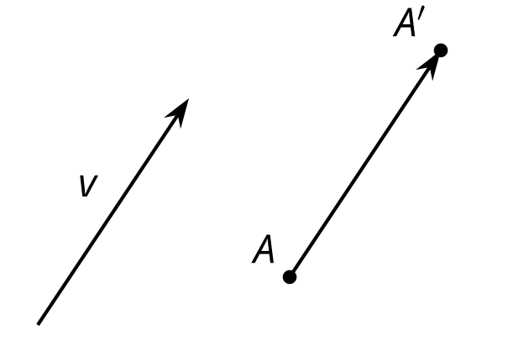
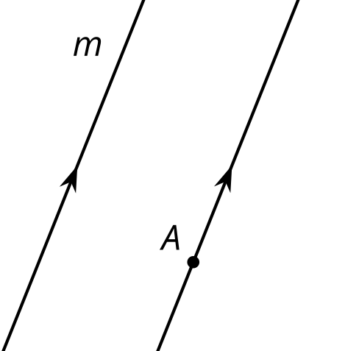

$m∥m^{′}$
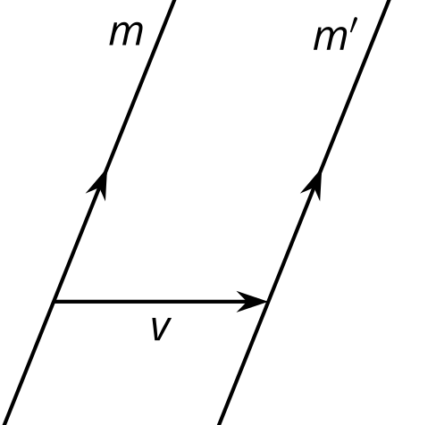
© CC BY 2019 by Illustrative Mathematics®

