### Lesson 7 Practice Problems

1. Sketch a figure that is similar to this figure. Label side and angle measures.

* 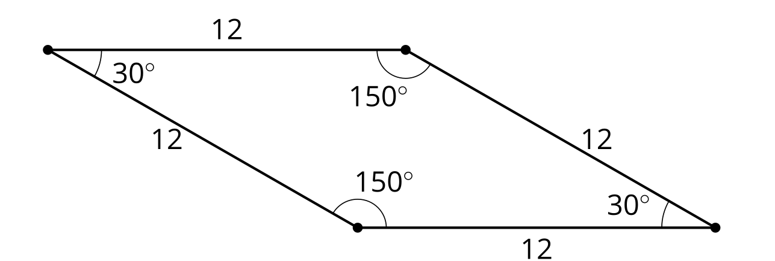

1. Write 2 different sequences of transformations that would show that triangles and are similar. The length of  is 6 units.

* 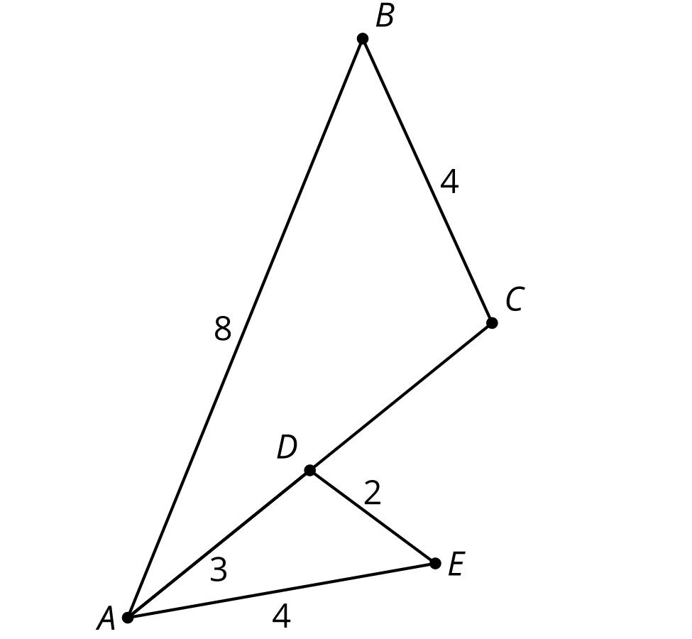

1. What is the definition of similarity?

* (From Unit 3, Lesson 6.)

1. Select **all** figures which are similar to Parallelogram .

* Parallelogram
* 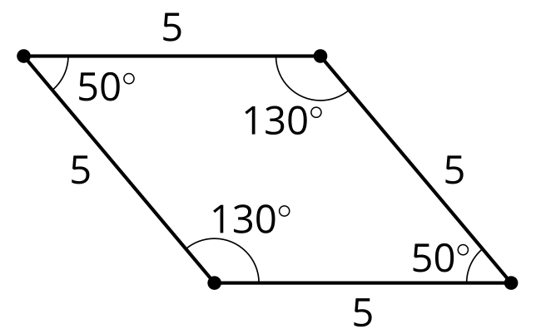
* Figure
* 
* Figure
* 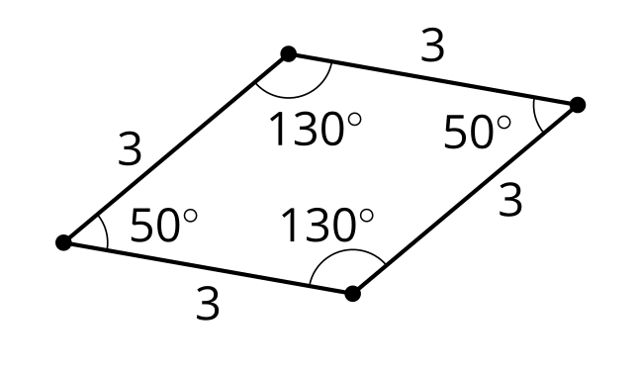
* Figure
* 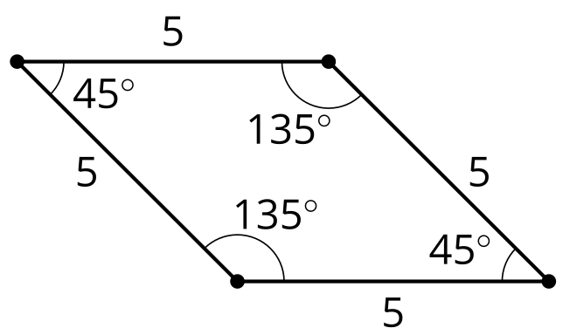
* Figure
* 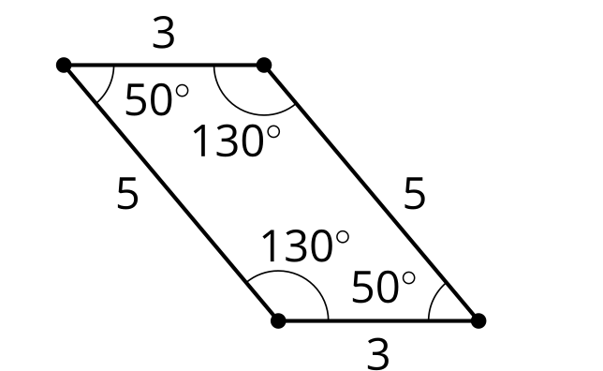
* Figure
* 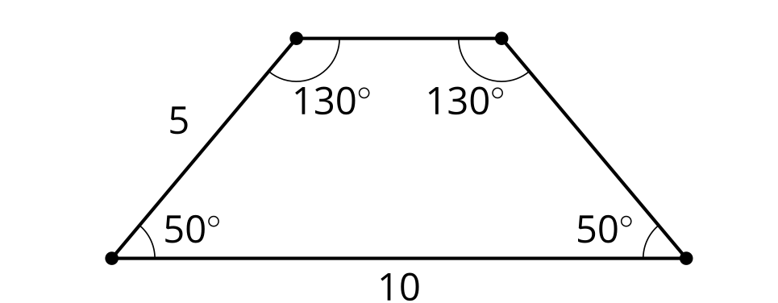
  1. Figure
  2. Figure
  3. Figure
  4. Figure
  5. Figure

1. Find a sequence of rigid transformations and dilations that takes square to square .

* 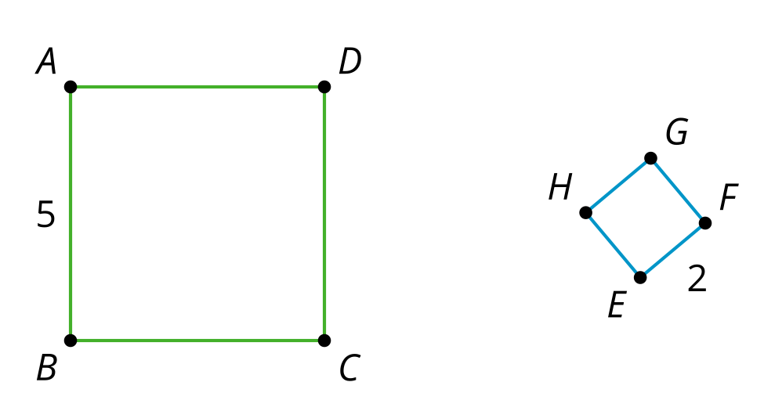
  1. Translate by the directed line segment , which will take to a point . Then rotate with center by angle . Finally, dilate with center by scale factor .
  2. Translate by the directed line segment , which will take to a point . Then rotate with center by angle . Finally, dilate with center by scale factor .
  3. Dilate using center by scale factor .
  4. Dilate using center by scale factor .
* (From Unit 3, Lesson 6.)

1. Triangle is formed by connecting the midpoints of the sides of triangle . What is the perimeter of triangle ?

* 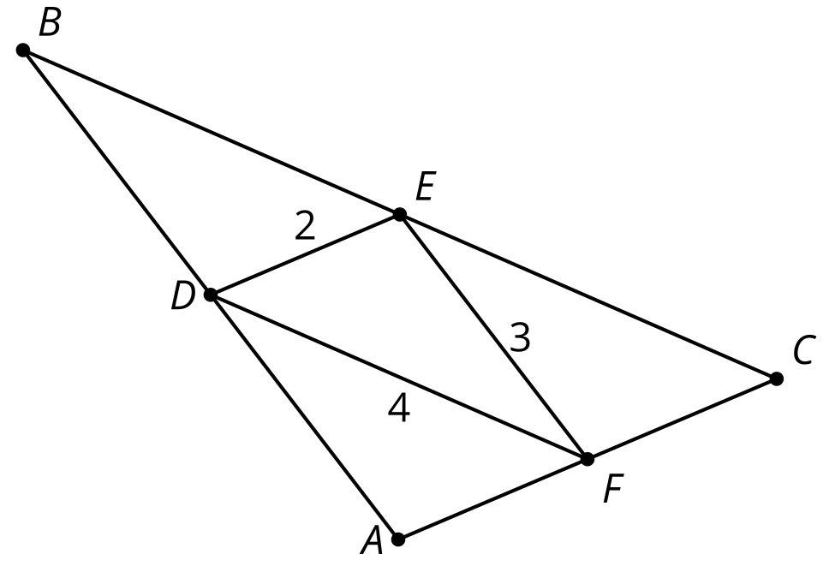
* (From Unit 3, Lesson 5.)

1. Select the quadrilateral for which the diagonal is a line of symmetry.
   1. parallelogram
   2. square
   3. trapezoid
   4. isosceles trapezoid

* (From Unit 2, Lesson 14.)

1. Triangles and  are each translations of triangle

* 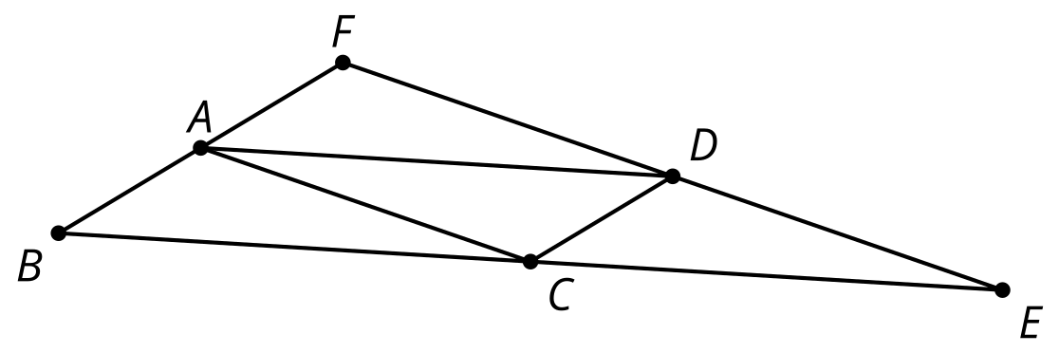
* Explain why angle has the same measure as angle .
* (From Unit 1, Lesson 21.)



© CC BY 2019 by Illustrative Mathematics®