Unit 1 Lesson 10: Rigid Transformations

1 Notice and Wonder: Transformed (Warm up)

Student Task Statement
What do you notice? What do you wonder?
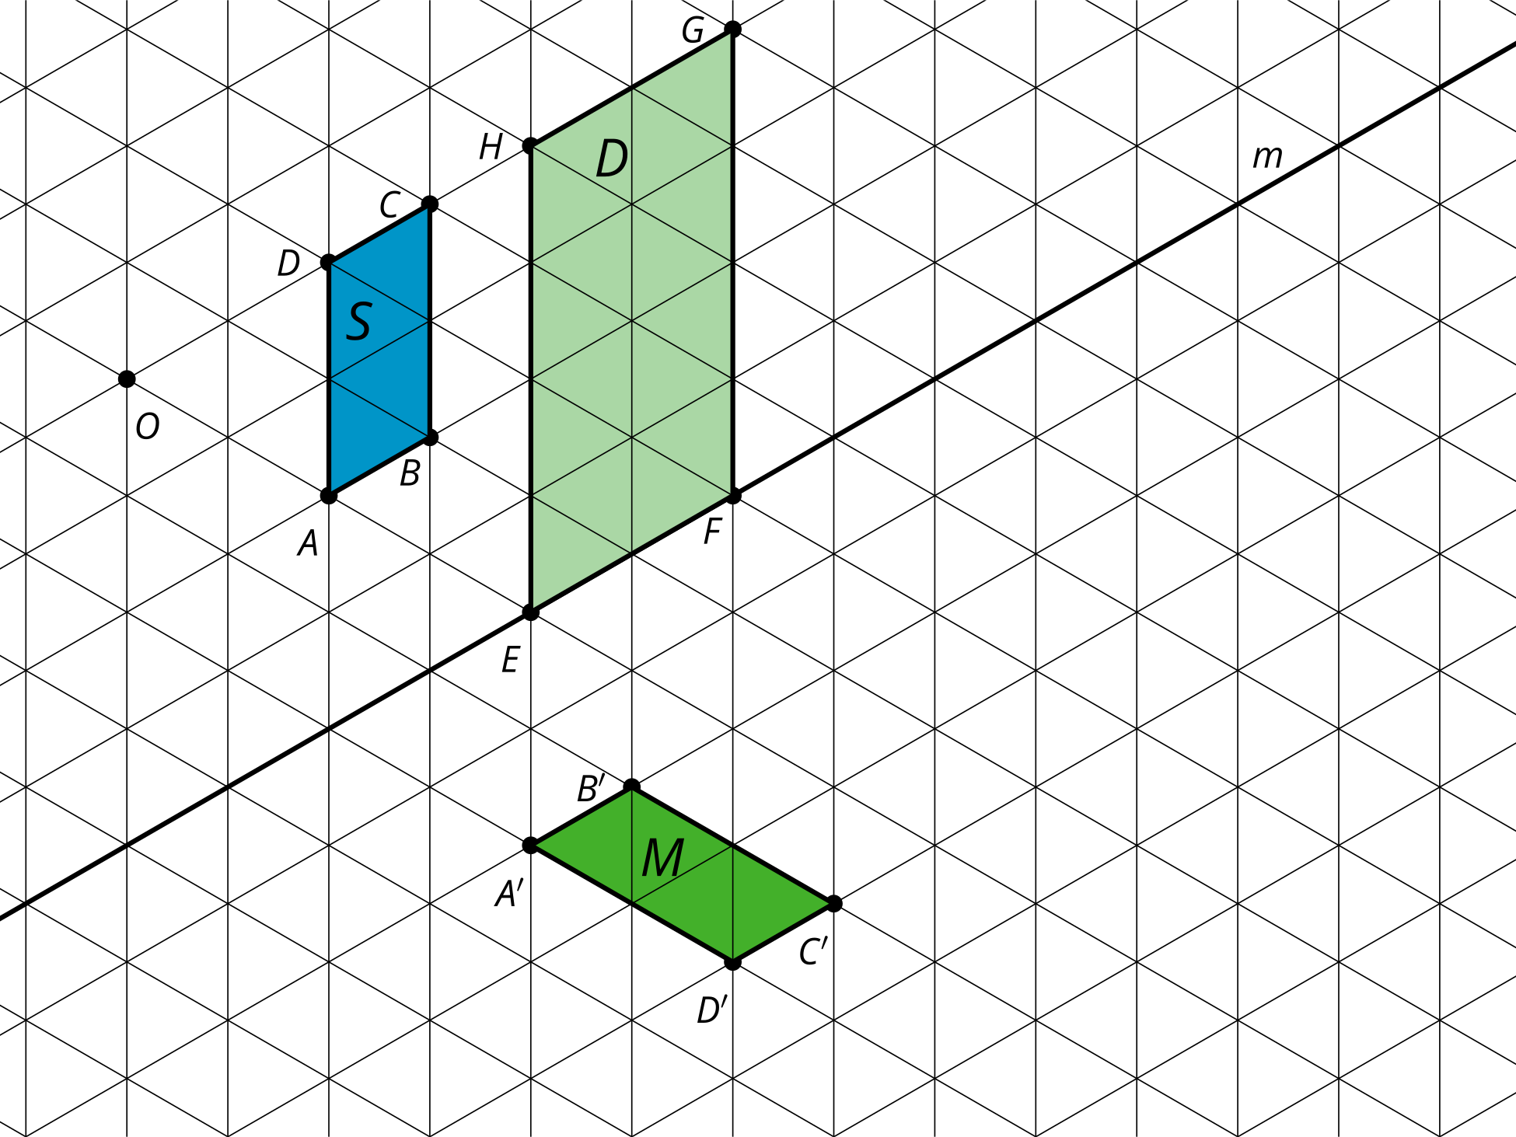

2 What’s the Same?

Images for Launch
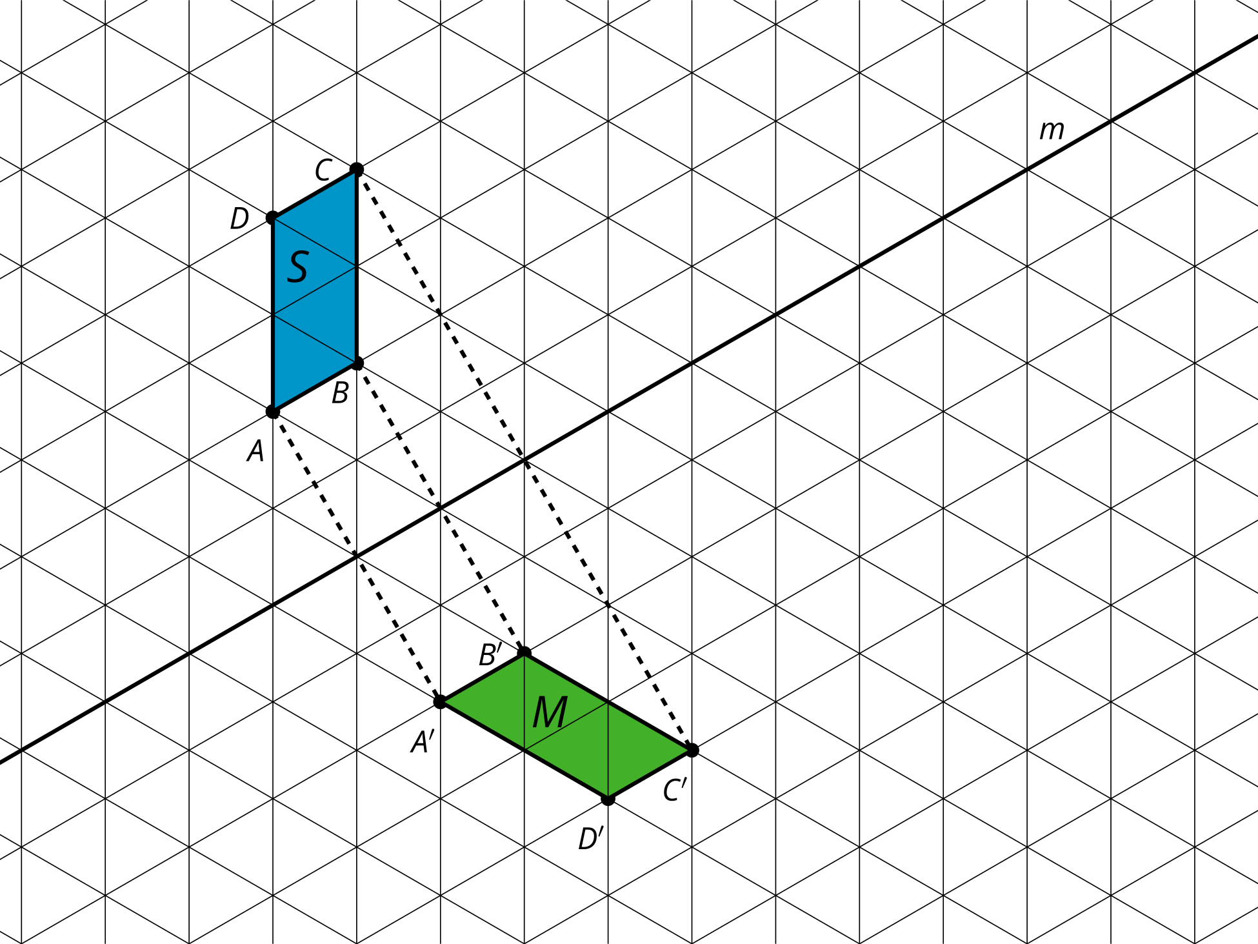

Student Task Statement
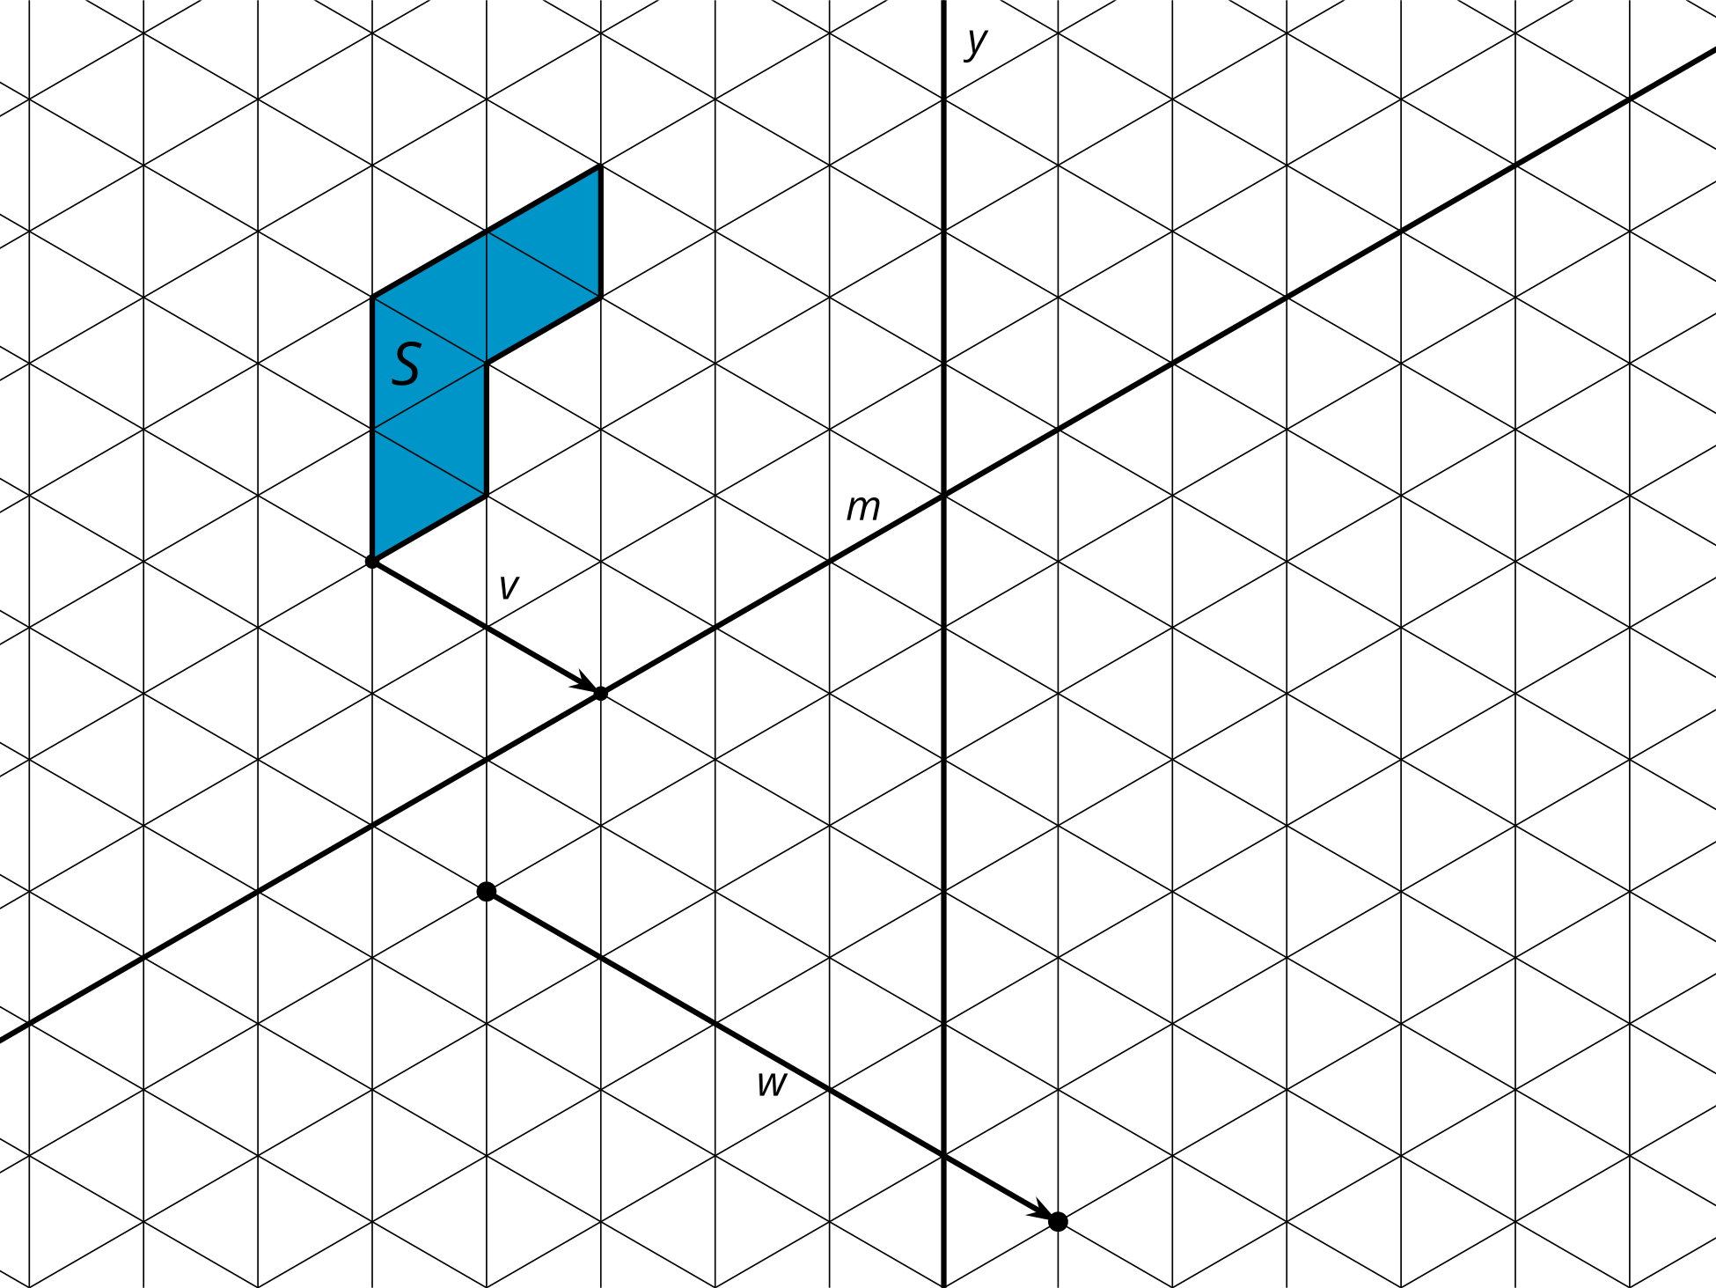
Draw each rigid transformation in a different color.
- Translate figure $S$ along the line segment $v$ in the direction shown by the arrow. Color: _____________
- Reflect figure $S$ across line $y$. Color: _____________
- Reflect figure $S$ across line $m$. Color: _____________
- Translate figure $S$ along the line segment $w$ in the direction shown by the arrow. Reflect this image across line $y$. Color: _____________
- How are the images the same? How are they different?

3 Does Order Matter?

Student Task Statement
Here are 3 congruent L shapes on a grid.
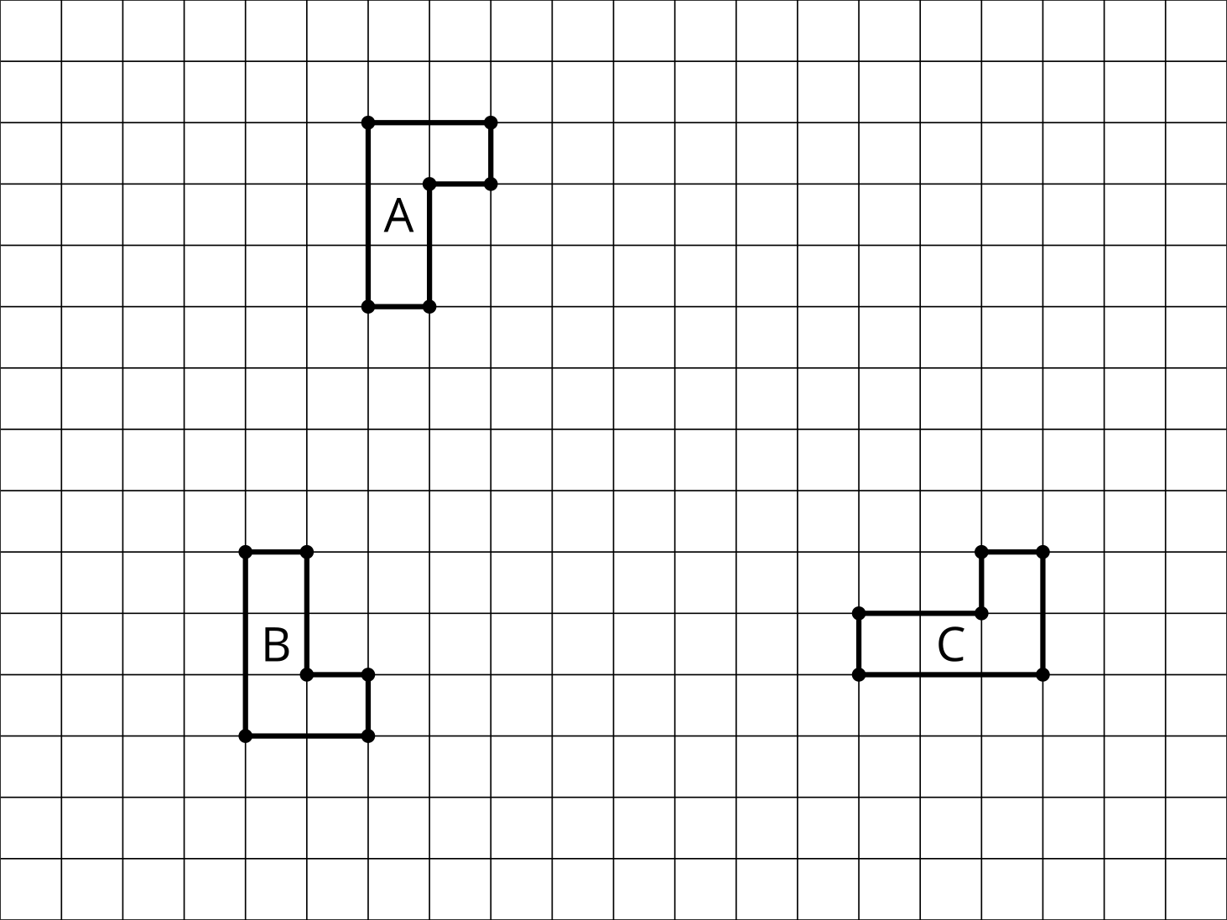
- Describe a sequence of transformations that will take Figure $A$ onto Figure $B$.
- If you reverse the order of your sequence, will the reverse sequence still take $A$ onto $B$?
- Describe a sequence of transformations that will take Figure $A$ onto Figure $C$.
- If you reverse the order of your sequence, will the reverse sequence still take $A$ onto $C$?

Images for Activity Synthesis
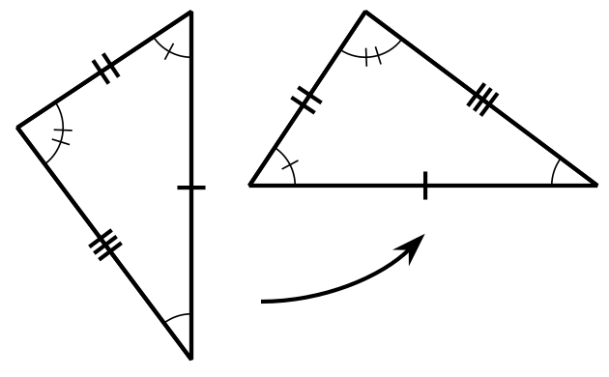

$△EDC≅△E^{′}D^{′}C^{′}$
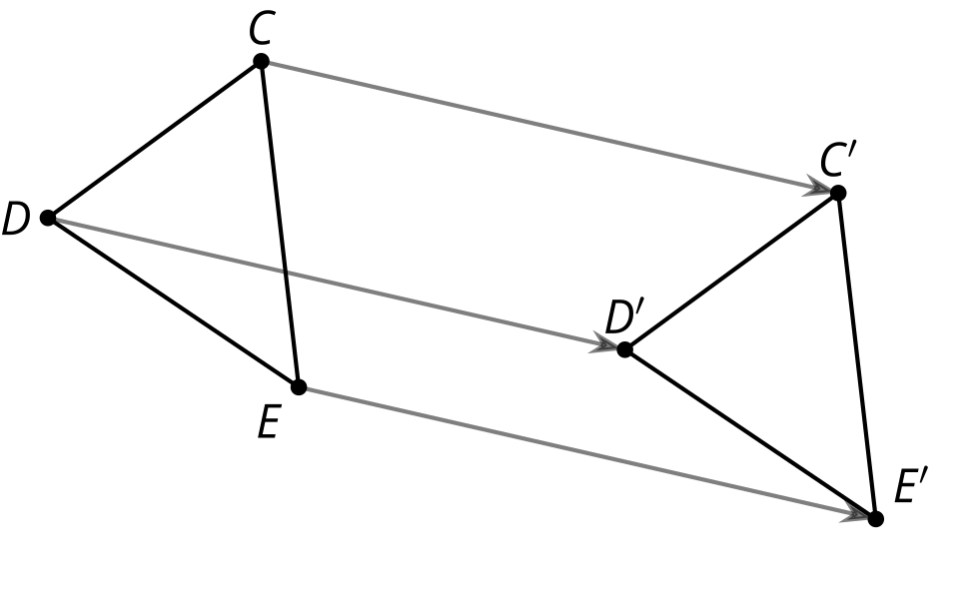
© CC BY 2019 by Illustrative Mathematics®

