Lesson 2: Representemos datos y resolvamos problemas

Standards Alignments
Building On | 2.MD.D.10, 2.OA.C.3
Addressing | 3.MD.B, 3.MD.B.3
Building Towards | 3.MD.B.3

Teacher-facing Learning Goals
- Represent data using bar graphs and picture graphs.
- Solve one- and two-step problems using addition and subtraction within 20.

Student-facing Learning Goals
- Hagamos gráficas y respondamos preguntas.

Lesson Purpose
The purpose of this lesson is for students to solve one- and two-step problems about data represented in bar graphs.
Students solved one-step problems about data in grade 2. In this lesson, students first create a picture graph and bar graph that represent how they get home from school. Then, they solve one- and two- step “how many more” and “how many fewer” problems using data presented in a bar graph. Consider launching the lesson with a read-a-loud of Last Stop on Market Street by Matt de la Peña and Christian Robinson.
Math Community
Tell students they will have a chance to revise their math community ideas at the end of this lesson. As they work today they should think about actions that may be missing from the current list.

Access for:

Students with Disabilities
- Representation (Activity 2)

English Learners
- MLR8 (Activity 1)

Instructional Routines
How Many Do You See? (Warm-up)

Materials to Gather
- Sticky notes: Activity 1

Lesson Timeline
Warm-up | 10 min
Activity 1 | 15 min
Activity 2 | 20 min
Lesson Synthesis | 10 min
Cool-down | 5 min

Teacher Reflection Question
Think about who participated in math class today. What assumptions are you making about those who did not participate? How can you leverage each of your students’ ideas to support them in being seen and heard in tomorrow’s math class?

Cool-down
(to be completed at the end of the lesson) 5min
Preguntas sobre una gráfica de barras

Standards Alignments
Addressing | 3.MD.B.3
Building Towards | 3.MD.B.3

Student-facing Task Statement
A unos estudiantes les preguntaron: “¿Cuál es tu lugar favorito para leer?”.
Sus respuestas se muestran en esta gráfica de barras:
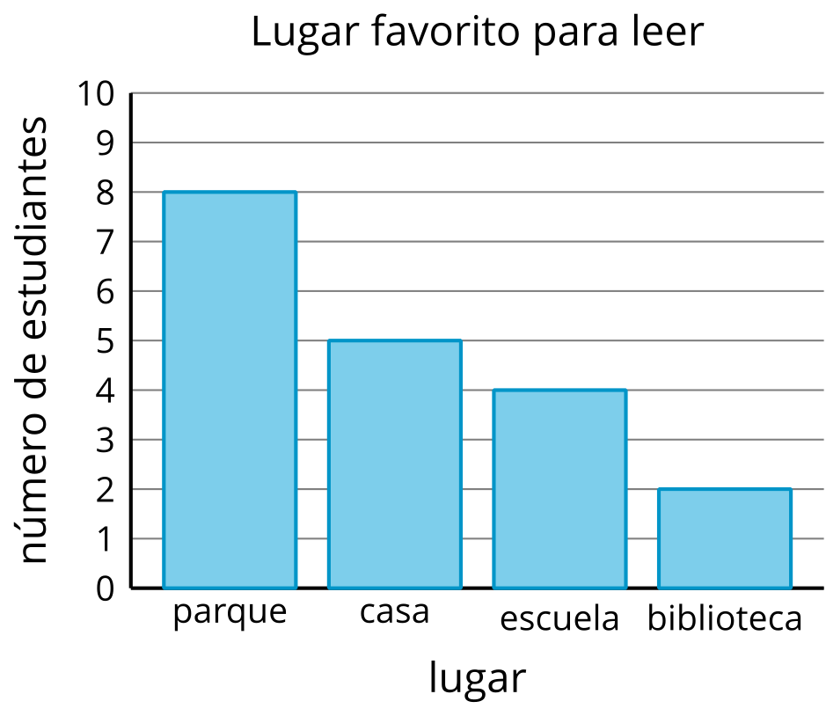
- ¿Cuántos estudiantes más escogieron el parque que su casa como su lugar favorito para leer?
- Verdadero o falso: A más estudiantes les gusta leer en la escuela o en la biblioteca que en el parque. Explica o muestra cómo pensaste.

Student Responses
- 3 more students
- False. Sample response: Six students $\left(4+2\right)$ like to read at the school or library, and 8 students like to read at the park.

