Lesson 2 Practice Problems
- Select all polynomial expressions that are equivalent to $6x^{4}+4x^{3}−7x^{2}+5x+8$.
  - $16x^{10}$
  - $6x^{5}+4x^{4}−7x^{3}+5x^{2}+8x$
  - $6x^{4}+4x^{3}−7x^{2}+5x+8$
  - $8+5x+7x^{2}−4x^{3}+6x^{4}$
  - $8+5x−7x^{2}+4x^{3}+6x^{4}$
- Each year a certain amount of money is deposited in an account which pays an annual interest rate of $r$ so that at the end of each year the balance in the account is multiplied by a growth factor of $x=1+r$. $500 is deposited at the start of the first year, an additional $200 is deposited at the start of the next year, and $600 at the start of the following year.
  - Write an expression for the value of the account at the end of three years in terms of the growth factor $x$.
  - What is the amount (to the nearest cent) in the account at the end of three years if the interest rate is 2%?
- Consider the polynomial function $p$ given by $p\left(x\right)=5x^{3}+8x^{2}−3x+1$. Evaluate the function at $x=\text{-}2$.
- An open-top box is formed by cutting squares out of a 5 inch by 7 inch piece of paper and then folding up the sides. The volume $V\left(x\right)$ in cubic inches of this type of open-top box is a function of the side length $x$ in inches of the square cutouts and can be given by $V\left(x\right)=\left(7−2x\right)\left(5−2x\right)\left(x\right)$. Rewrite this equation by expanding the polynomial.
- A rectangular playground space is to be fenced in using the wall of a daycare building for one side and 200 meters of fencing for the other three sides. The area $A\left(x\right)$ in square meters of the playground space is a function of the length $x$ in meters of each of the sides perpendicular to the wall of the daycare building.
  - What is the area of the playground when $x=50$?
  - Write an expression for $A\left(x\right)$.
  - What is a reasonable domain for $A$ in this context?
- (From Unit 2, Lesson 1.)
- Tyler finds an expression for $V\left(x\right)$ that gives the volume of an open-top box in cubic inches in terms of the length $x$ in inches of the square cutouts used to make it. This is the graph Tyler gets if he allows $x$ to take on any value between -1 and 7.
- 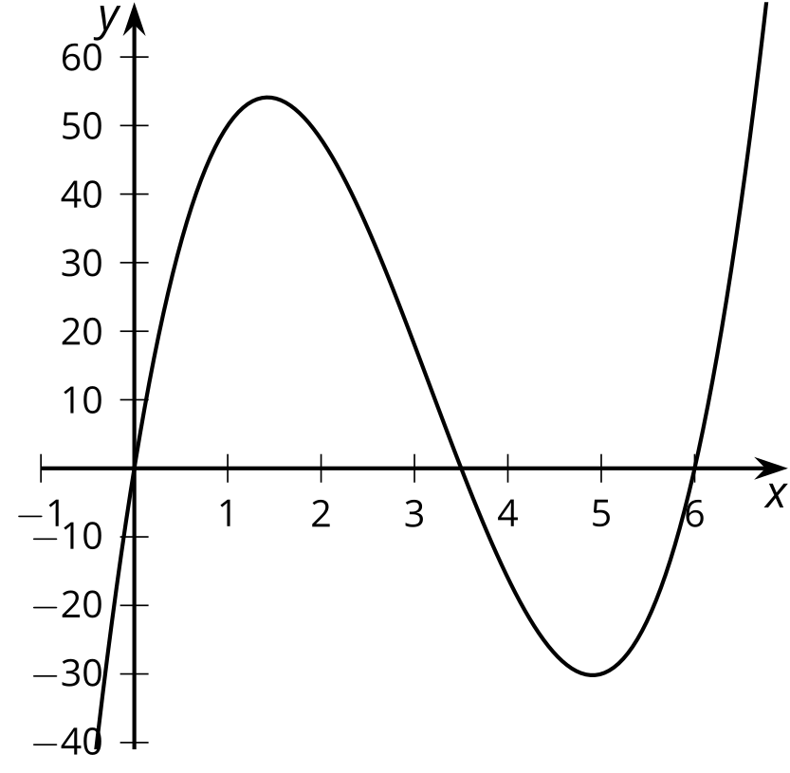
  - What would be a more appropriate domain for Tyler to use instead?
  - What is the approximate maximum volume for his box?
- (From Unit 2, Lesson 1.)
© CC BY 2019 by Illustrative Mathematics®

