Lesson 15: Putting All the Solids Together
- Let’s calculate volumes of prisms, cylinders, cones, and pyramids.

15.1: Math Talk: Volumes
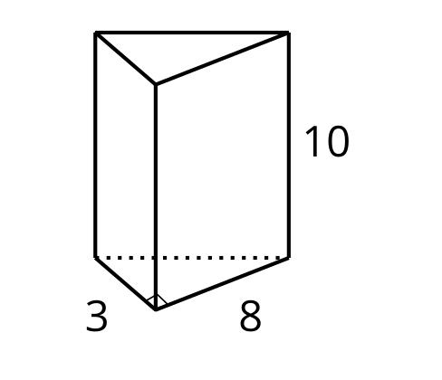
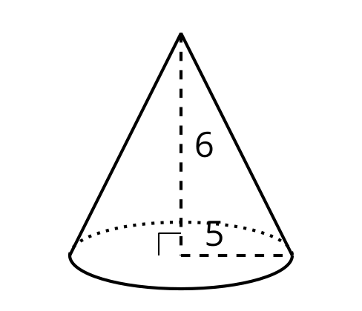
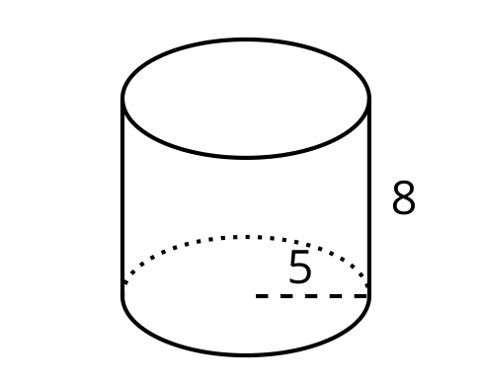
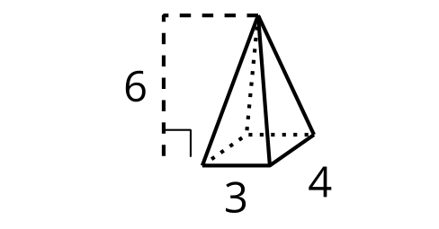
Evaluate the volume of each solid mentally.

15.2: Missing Measurements
- Answer the questions for each of the two solids shown.

- A
- 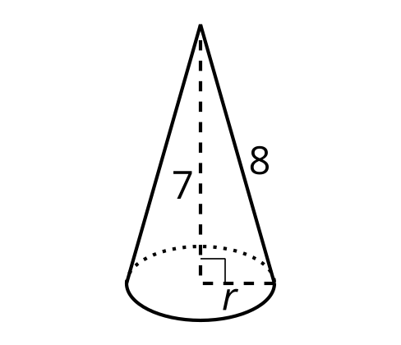

- B
- 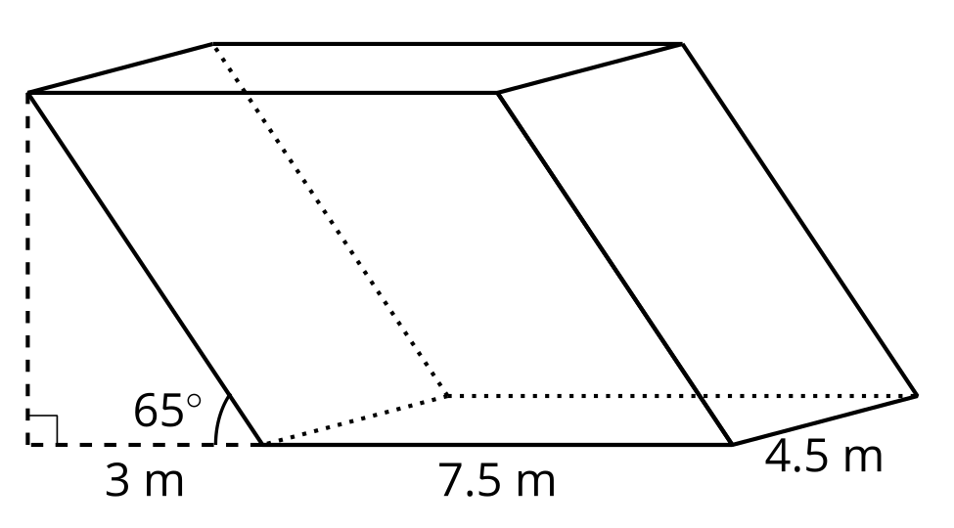
  - Which measurement that you need to calculate the volume isn’t given?
  - How can you find the value of the missing measurement?
  - What volume formula applies?
  - Calculate the volume of the solid, rounding to the nearest tenth if necessary.
- Calculate the volume of each solid, rounding to the nearest tenth if necessary.

- A
- 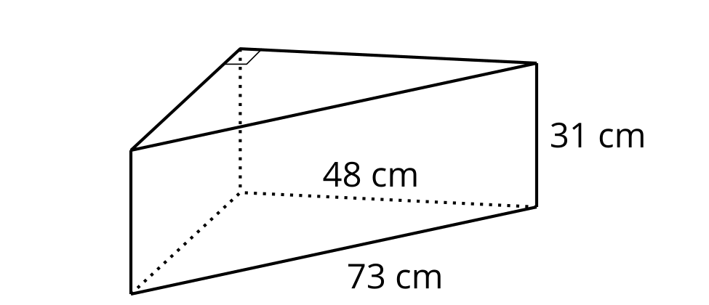

- B
- 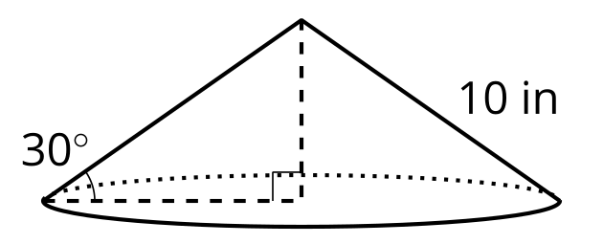

Are you ready for more?
For a sphere with radius $r$, its volume is $\frac{4}{3}πr^{3}$ and its surface area is $4πr^{2}$. Here is a half-sphere bowl pressed out of a piece of sheet metal with area 1 square foot. What is the volume of the bowl?
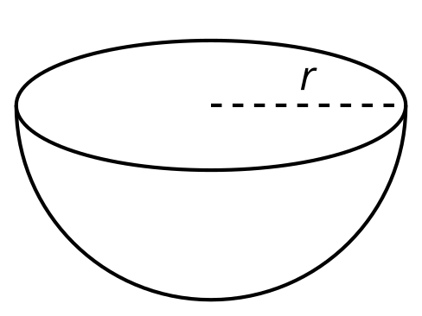

15.3: Spinning into Three Dimensions
Suppose this two-dimensional figure is rotated 360 degrees using the vertical axis shown. Each small square on the grid represents 1 square inch.
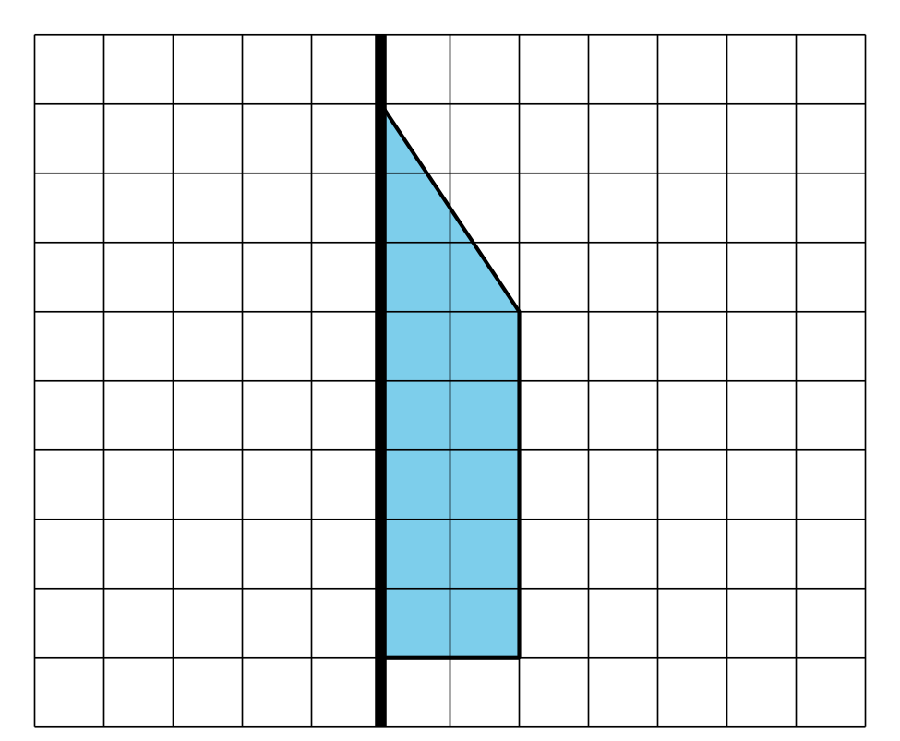
- Draw the solid that would be traced out. Label the dimensions of the solid.
- Find the volume of the solid. Round your answer to the nearest tenth if needed.

Lesson 15 Summary
Before computing volume, it’s important to select the right formula and find all the dimensions represented in the formula. For example, consider a company that makes two chew toys for dogs. One toy is in the shape of a cylinder with radius 9 cm and height 2.5 cm. The other looks like the cone in the image. The company wants to know which toy uses more material. The toys are solid, not hollow.
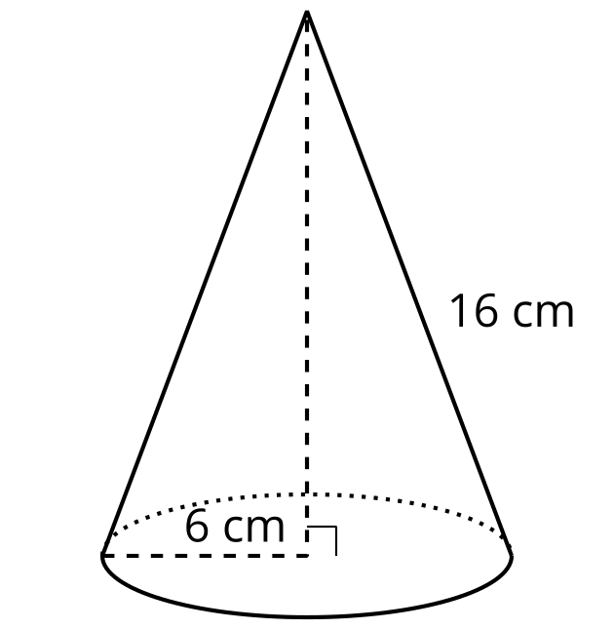
To calculate the cylinder toy’s volume, use the expression $Bh$. The radius measures 9 cm, so the area of the base, $B$, is $81π$ cm². The volume is $202.5π$, or approximately 636 cm³, because $81π⋅2.5=202.5π$.
For the cone, the height is unknown. A right triangle is formed by the radius 6 cm and the height $h$, with hypotenuse 16 cm. By the Pythagorean Theorem, $6^{2}+h^{2}={16}^{2}$. Solving, we get $h=\sqrt{220}$.
Since this is a cone, use the expression $\frac{1}{3}Bh$. The area of the base, $B$, is $36π$ cm². The volume is approximately 559 cm³ because $\frac{1}{3}⋅36π⋅\sqrt{220}≈559$. The cylinder-shaped toy uses more material.
© CC BY 2019 by Illustrative Mathematics®

