Unit 1 Lesson 9: Speedy Delivery

1 Notice and Wonder: Dots in a Square (Warm up)

Student Task Statement
What do you notice? What do you wonder?
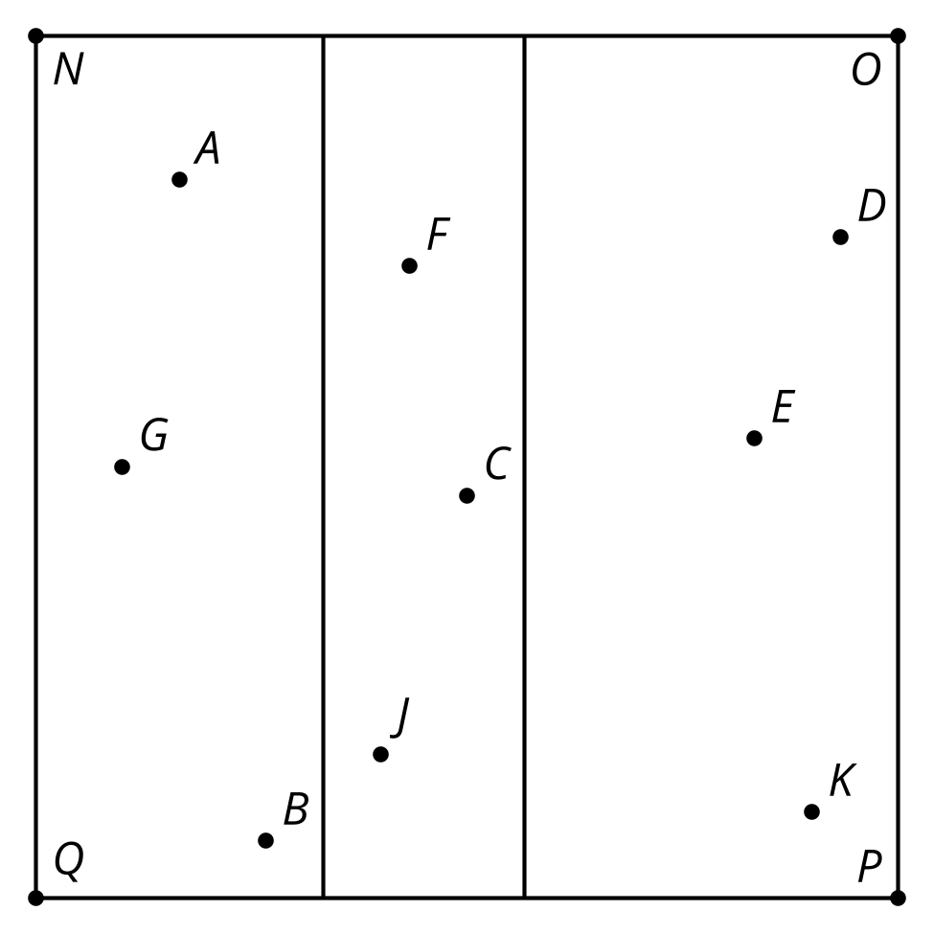

2 Who Is Closest?

Student Task Statement
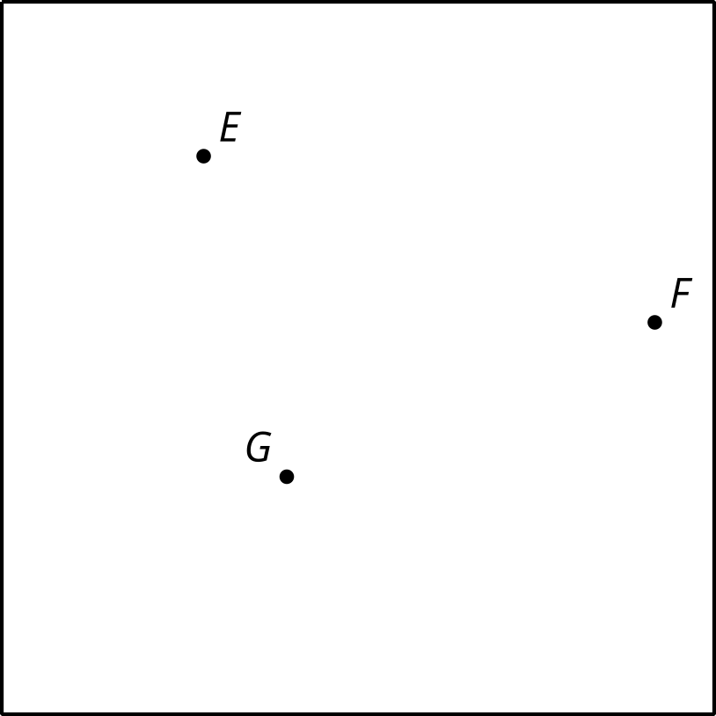
Here is a square city with 3 locations of the same store.
- The company wants to break the city down into regions so that whenever someone orders from an address, their order is sent to the store closest to their home. They have hired you to decide how to partition the city between the 3 stores. Explain or show your reasoning.
- If there are 100 employees, how should they be distributed among the 3 locations?
- Is there anywhere in the city that has the same distance to all 3 stores?
- Now a fourth store opens. Partition the city again.
- 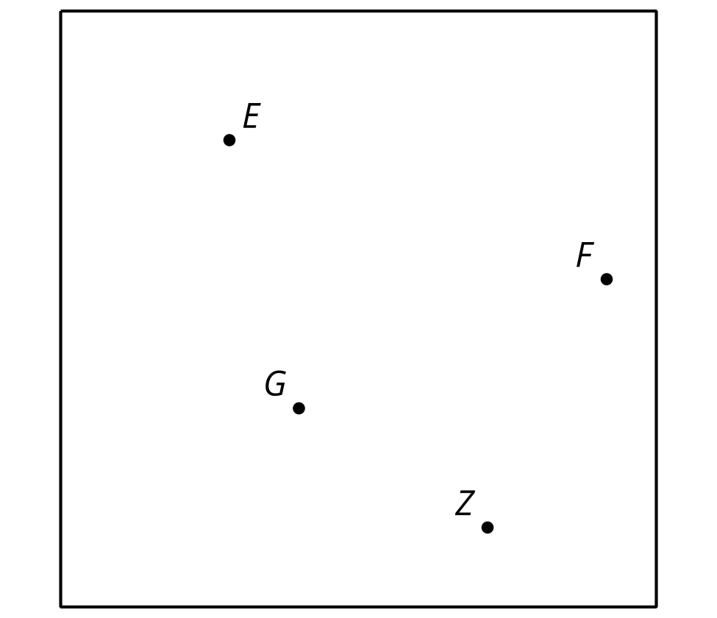

3 Now Who is Closest? (Optional)

Student Task Statement
Use technology to explore the same type of problem from the earlier activity, “Who Is Closest?”, with a larger number of points, such as all major airports in the U.S.

4 Another Layer

Student Task Statement
Your teacher will give you a tessellation.
- Mark the intersection points on the tessellation.
- Imagine that each point is a store from the “Who Is Closest?” activity. Repeat the process you used there to define the regions that are closest to each of the points.
- Use color or shading to enhance your design.
© CC BY 2019 by Illustrative Mathematics®

