Lesson 17 Practice Problems
- Find the solution or solutions to each equation.
  - $x^{2}+0.5x−14=0$
  - $x^{2}+12x+36=0$
  - $x^{2}−3x+8=0$
  - $x^{2}+4=0$
- Which describes the solutions to the equation $x^{2}+7=0$?
  - One real solution
  - Two real solutions
  - One non-real solution
  - Two non-real solutions
- Explain how you know $\sqrt{3x+2}=\text{-}16$ has no solutions.
- (From Unit 3, Lesson 7.)
- Determine the number of real solutions and non-real solutions to each equation. Use the graphs; don't do any calculations to find the solutions.
  - $x^{2}−6x+7=0$
  - $3x^{2}+2x+1=0$
  - $\text{-}x^{2}−3x+2=0$
  - $x^{2}−6x+7=\text{-}2$
  - $\text{-}x^{2}−3x+2=6$
  - $3x^{2}+2x+1=2$

- $y=x^{2}−6x+7$
- 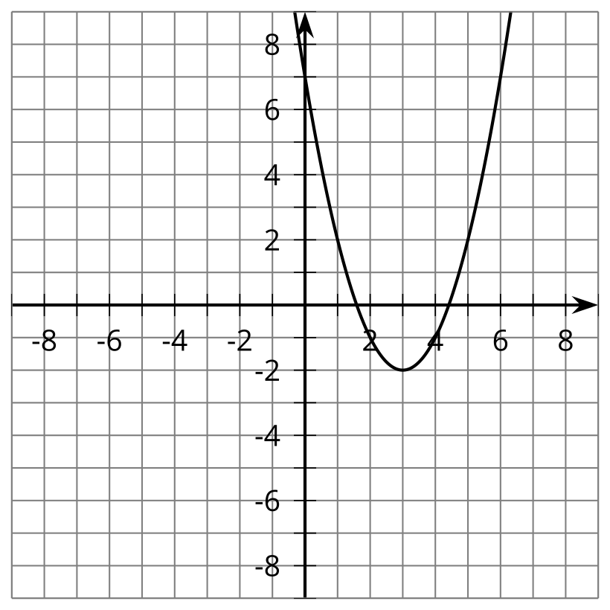

- $y=3x^{2}+2x+1$
- 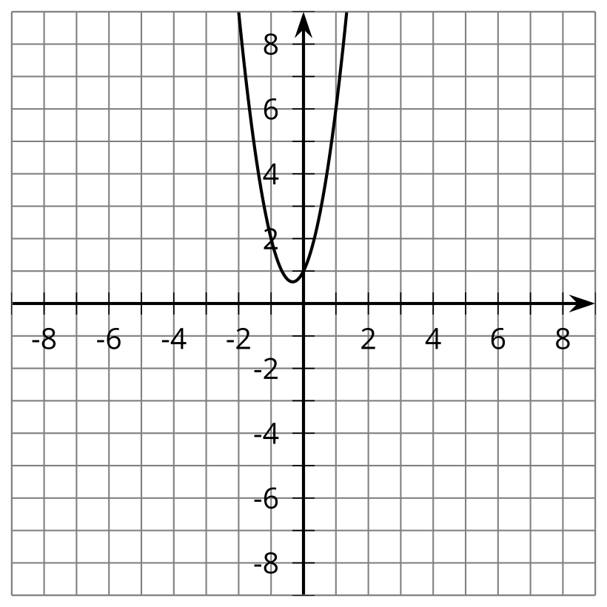

- $y=\text{-}x^{2}−3x+2$
- 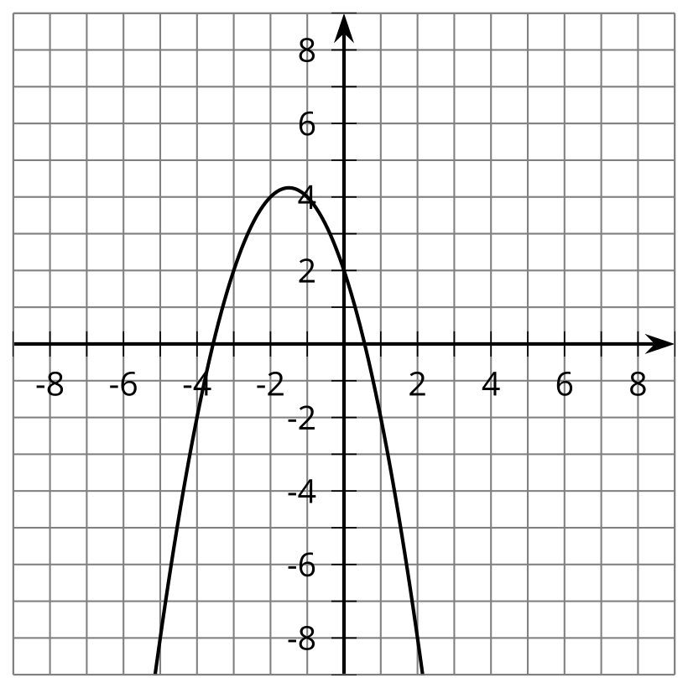

  - Write ${\left(5−5i\right)}^{2}$ in the form $a+bi$, where $a$ and $b$ are real numbers.
  - Write ${\left(5−5i\right)}^{4}$ in the form $a+bi$, where $a$ and $b$ are real numbers.
- (From Unit 3, Lesson 14.)
- What number $n$ makes this equation true?
- $x^{2}+11x+\frac{121}{4}={\left(x+n\right)}^{2}$
  - $\frac{11}{4}$
  - $\frac{11}{2}$
  - 11
  - $\frac{121}{4}$
- (From Unit 3, Lesson 16.)
© CC BY 2019 by Illustrative Mathematics®

