Lesson 14: Working with Pyramids
- Let’s use the pyramid volume formula to solve problems.

14.1: Volume Matching
Here is a pyramid.
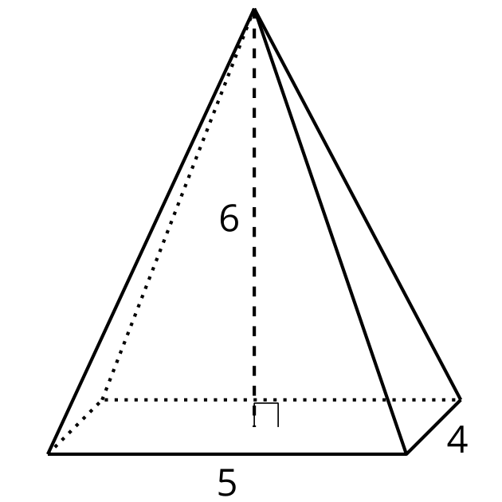
Which, if either, of these solids has the same volume as the pyramid?

A
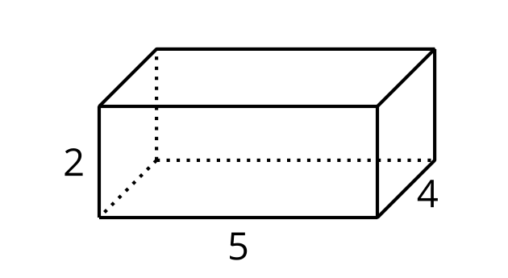

B
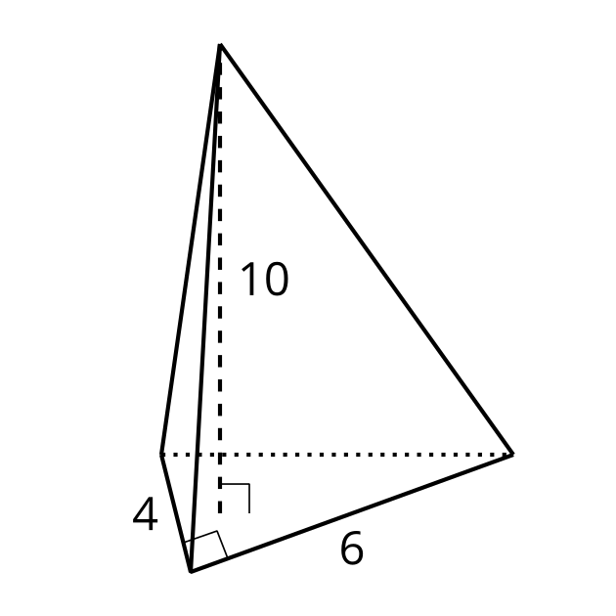

14.2: Practice with Pyramids
- Calculate the volume of each solid. Round your answers to the nearest tenth if necessary.

- A
- 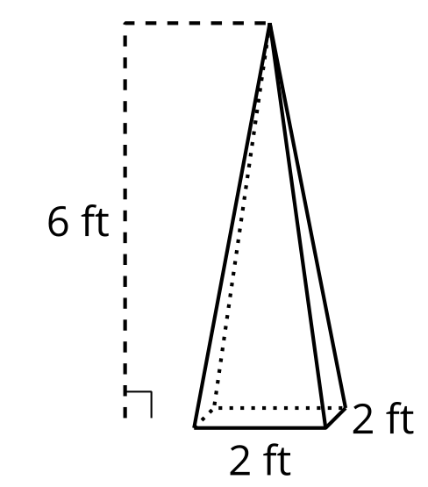

- B
- 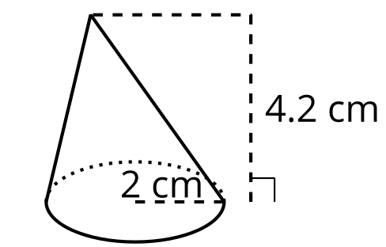

- C
- 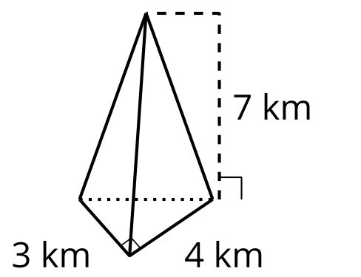

- D: height 12 cm; area of base 32 cm²
- 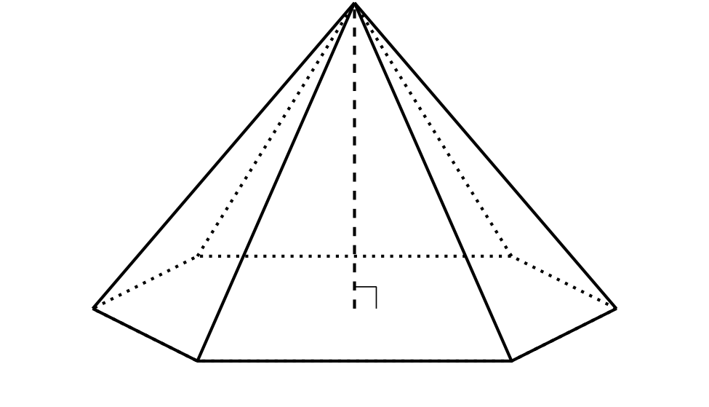
- A particular cone has radius $r$ and height $h$.
  - Write an expression for the volume of this cone in terms of $r$ and $h$.
  - What is the height of a cone whose volume is $16π$ cubic units and whose radius is 3 units?
  - What is the radius of a cone whose volume is $16π$ cubic units and whose height is 3 units?

Are you ready for more?
The Pyramid of Giza is 455 feet tall. The base is square with a 756-foot side length. How many Olympic-size swimming pool volumes of water can fit inside the Pyramid of Giza? Explain or show your reasoning.

14.3: An Icy Pyramid
A caterer is making an ice sculpture in the shape of a pyramid for a party. The caterer wants to use 12 liters of water, which is about 720 cubic inches. The sculpture must be 15 inches tall. The caterer needs to decide how large to make the base, which can be any shape. Draw and label the dimensions of 2 different bases that would work.

Lesson 14 Summary
We can work backward from a given volume to find possible dimensions for a cone or pyramid.
Suppose we want to find dimensions for a cone so it has a volume of $900π$ cubic inches. Start by substituting the volume into the pyramid volume formula to get $900π=\frac{1}{3}Bh$. The base of a cone is a circle, so we can write $900π=\frac{1}{3}πr^{2}h$. Multiply both sides of the equation by 3 and divide both sides by $π$ to get $2,​700=r^{2}h$.
Now consider different possible values for $r$ and $h$. If we can find a perfect square that divides evenly into 2,700, we can set the square root of that number to be the radius. The number 25 is a perfect square and divdes into 2,700, so choose $r=5$. Now $2,​700=25h$. This tells us that if the pyramid’s radius is 5 inches, its height is 108 inches because $2,​700÷25=108$.
These aren’t the only possible values. Suppose we set the radius to be 20 inches. Substitute this into the original equation and rearrange to find the value of $h$.
$900π=\frac{1}{3}π{\left(20\right)}^{2}h$
$900π=\frac{1}{3}π⋅400h$
$2,​700=400h$
$6.75=h$
A height of 6.75 inches together with a radius of 20 inches gives the cone a volume of $900π$ cubic inches.
© CC BY 2019 by Illustrative Mathematics®

