Lesson 9 Practice Problems
- A scientist wants to know if the color of the water affects how much animals drink. The average amount of water each animal drinks was recorded in milliliters for a week and then graphed. Is there evidence to suggest an association between water color and animal?
 | - cat intake (ml) | - dog intake (ml) | - total (ml)
- blue water | - 210 | - 1200 | - 1410
- green water | - 200 | - 1100 | - 1300
- total | - 410 | - 2300 | - 2710
- 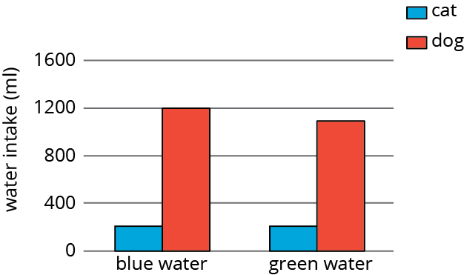
- A farmer brings his produce to the farmer’s market and records whether people buy lettuce, apples, both, or something else.
 | - bought apples | - did not buy apples
- bought lettuce | - 14 | - 58
- did not buy lettuce | - 8 | - 29
- Make a table that shows the relative frequencies for each row. Use this table to decide if there is an association between buying lettuce and buying apples.
- Researchers at a media company want to study news-reading habits among different age groups. They tracked print and online subscription data and made a 2-way table.
 | - internet media | - print media
- 18-25 year olds | - 151 | - 28
- 26-45 year olds | - 132 | - 72
- 46-65 year olds | - 48 | - 165
  - Create a segmented bar graph using one bar for each row of the table.
  - Is there an association between age groups and the method they use to read articles? Explain your reasoning.
- Using the data in the scatter plot, what is a reasonable slope of a model that fits this data?
- 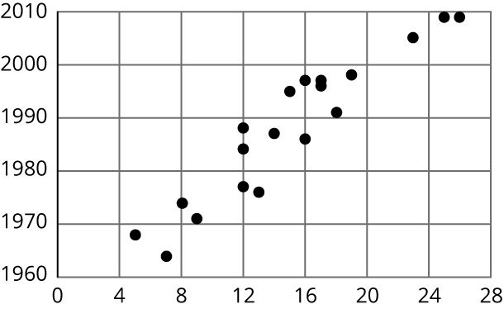
  - -2.5
  - -1
  - 1
  - 2.5
- (From Unit 6, Lesson 6.)
© CC BY Open Up Resources. Adaptations CC BY IM.

