Lesson 8 Practice Problems
- This is an invalid proof that all isosceles triangles are similar. Explain which step is invalid and why.
- 1. Draw 2 isosceles triangles $ABC$ and $DEF$ where $AC=BC$ and $DF=EF$.
- 2. Dilate triangle $ABC$ to a new triangle $A^{′}B^{′}C$ using center $C$ and scale factor $\frac{DF}{AC}$ so that $A^{′}C=B^{′}C=DF=EF$.
- 3. Translate by directed line segment $CF$ to take $A^{′}B^{′}C$ to a new triangle $A^{″}B^{″}F$. Since translation preserves distance, $A^{″}F=A^{′}C=DF$ and $B^{″}F=B^{′}C=EF$.
- 4. Since $A^{″}F=DF$, we can rotate using center $F$ to take $A^{″}$ to $D$.
- 5. Since $B^{″}F=EF$, we can rotate using center $F$ to take $B^{″}$ to $E$.
- 6. We have now established a sequence of dilations, translations, and rotations that takes $A$ to $D$, $B$ to $E$, and $C$ to $F$, so the triangles are similar.
- Which statement provides a valid justification for why all circles are similar?
  - All circles have the same shape—a circle—so they must be similar.
  - All circles have no angles and no sides, so they must be similar.
  - I can translate any circle exactly onto another, so they must be similar.
  - I can translate the center of any circle to the center of another, and then dilate from that center by an appropriate scale factor, so they must be similar.
- Which pair of polygons is similar?
  - 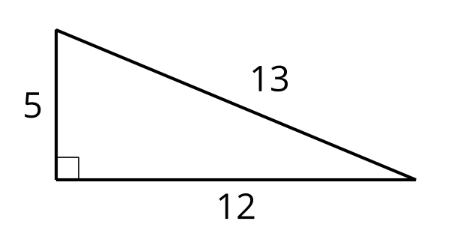
  - 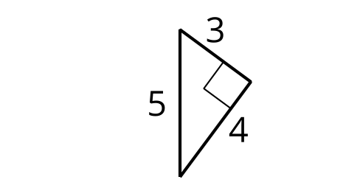
  - 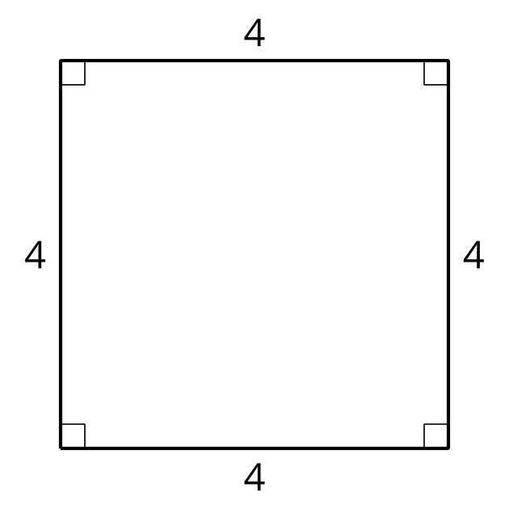
  - 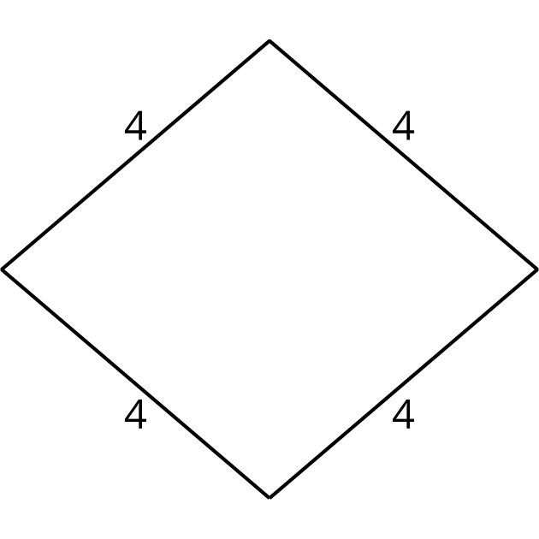
  - 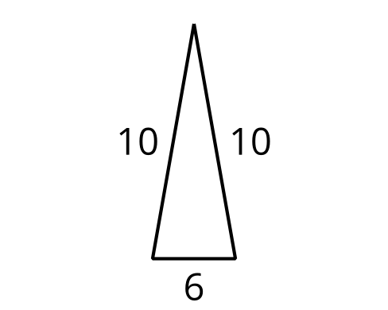
  - 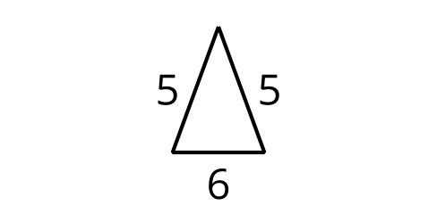
- Select all sequences of transformations that would show that triangles $ABC$ and $AED$ are similar. The length of $AC$ is $6$ units.

- $AC=6$
- 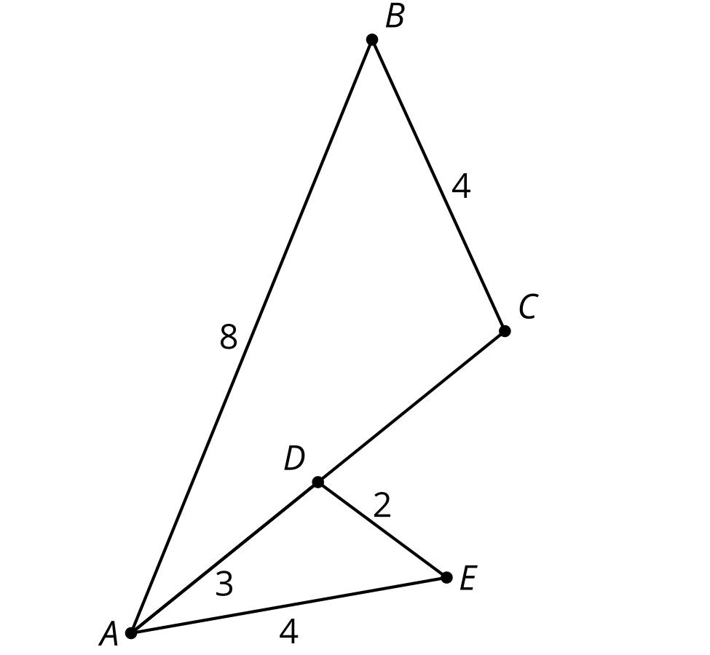
  - Dilate triangle $ABC$ using center $A$ by a scale factor of $\frac{1}{2}$, then reflect over line $AC$.
  - Dilate triangle $AED$ using center $A$ by a scale factor of $2$, then reflect over line $AC$.
  - Reflect triangle $ABC$ over line $AC$, then dilate using center $A$ by a scale factor of $\frac{1}{2}$.
  - Reflect triangle $AED$ over line $AC$, then dilate using center $A$ by a scale factor of $2$.
  - Translate triangle $AED$ by directed line segment $DC$, then dilate using center $C$ by scale factor $2$.
  - Translate either triangle $ABC$ or $AED$ by directed line segment $DC$, then reflect over line $AC$.
- (From Unit 3, Lesson 7.)
- Determine if each statement must be true, could possibly be true, or definitely can't be true. Explain or show your reasoning.
  - Two equilateral triangles are similar.
  - An equilateral triangle and a square are similar.
- (From Unit 3, Lesson 7.)
- Find a sequence of rigid transformations and dilations that takes square $EFGH$ to square $ABCD$.
- 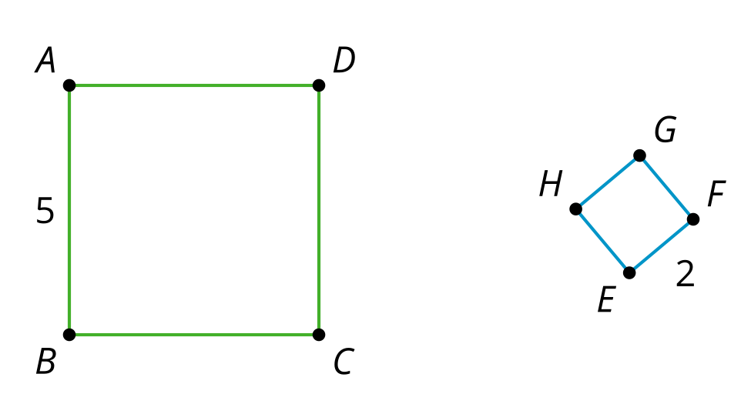
- (From Unit 3, Lesson 6.)
- Select all true statements given that angle $AED$ is congruent to angle $ABC$
- 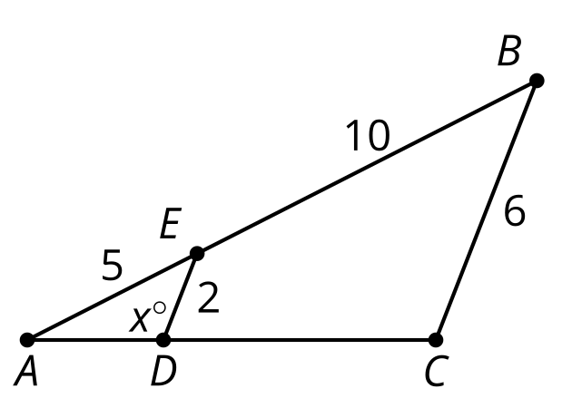
  - Angle $ACB$ is $180−x^{∘}$
  - Angle $ACB$ is $x^{∘}$
  - Triangle $ACB$ is similar to triangle $ADE$
  - $AD=\frac{1}{3}AC$
  - $AD=\frac{1}{2}DC$
- (From Unit 3, Lesson 5.)
© CC BY 2019 by Illustrative Mathematics®

