Unit 1 Lesson 11: Defining Reflections

1 Which One Doesn’t Belong: Crossing the Line (Warm up)

Student Task Statement
Which one doesn’t belong?

Figure 1
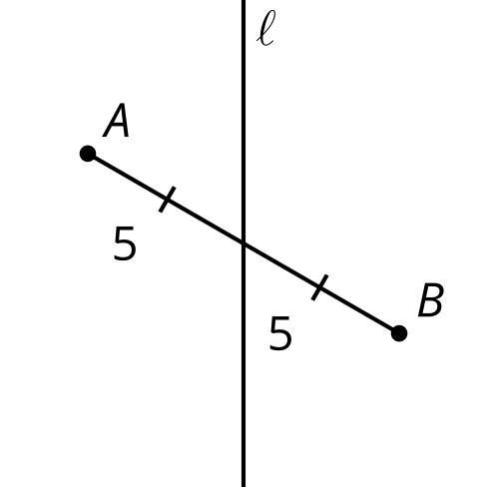

Figure 2
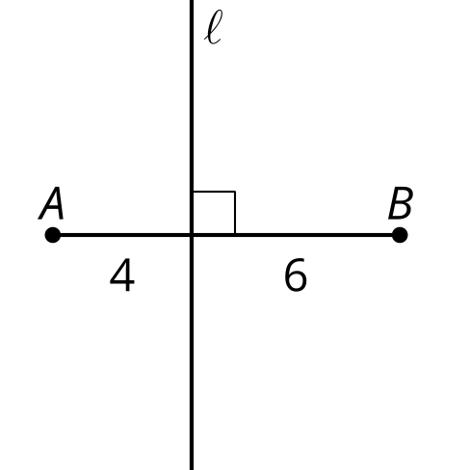

Figure 3
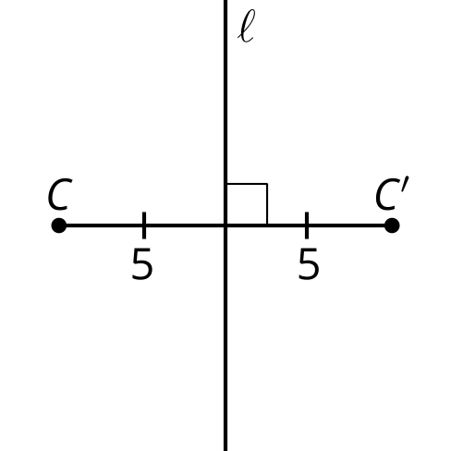

Figure 4
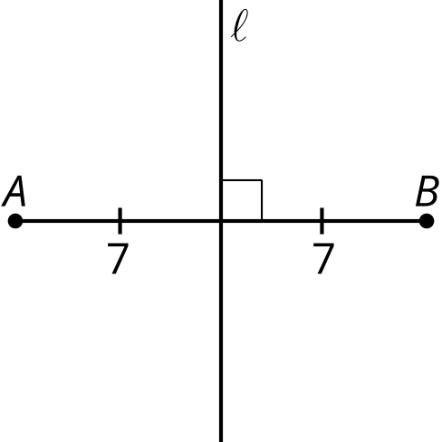

2 Info Gap: What’s the Point: Reflections

Images for Launch
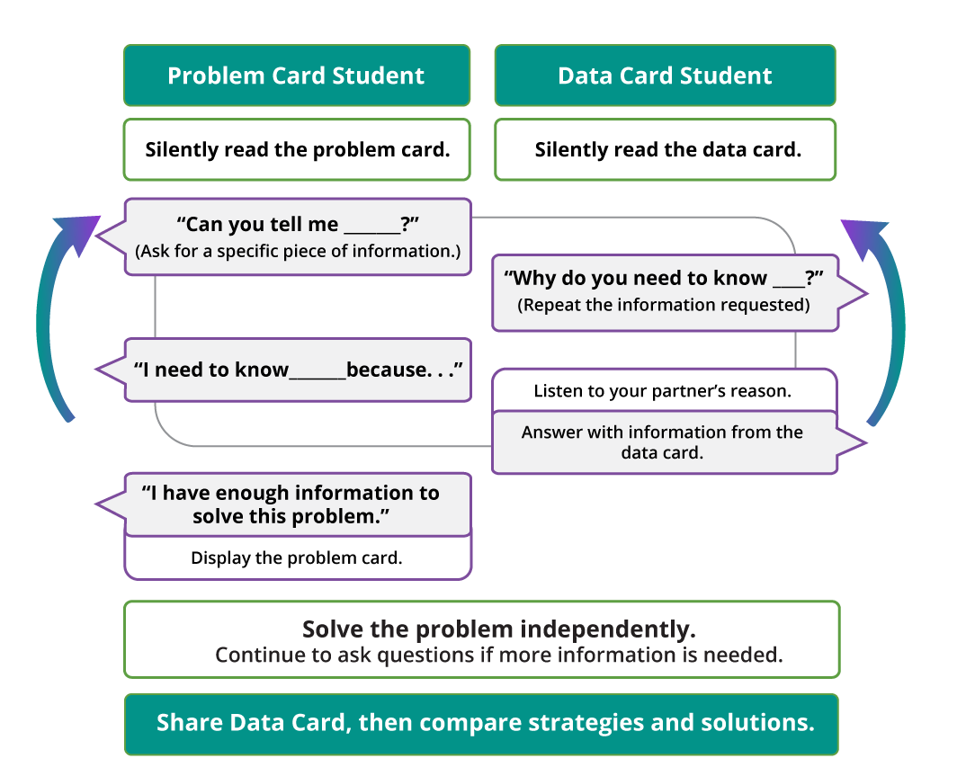

Student Task Statement
Your teacher will give you either a problem card or a data card. Do not show or read your card to your partner.
If your teacher gives you the data card:
- Silently read the information on your card.
- Ask your partner “What specific information do you need?” and wait for your partner to ask for information. Only give information that is on your card. (Do not figure out anything for your partner!)
- Before telling your partner the information, ask “Why do you need to know (that piece of information)?”
- Read the problem card, and solve the problem independently.
- Share the data card, and discuss your reasoning.
If your teacher gives you the problem card:
- Silently read your card and think about what information you need to answer the question.
- Ask your partner for the specific information that you need.
- Explain to your partner how you are using the information to solve the problem.
- When you have enough information, share the problem card with your partner, and solve the problem independently.
- Read the data card, and discuss your reasoning.
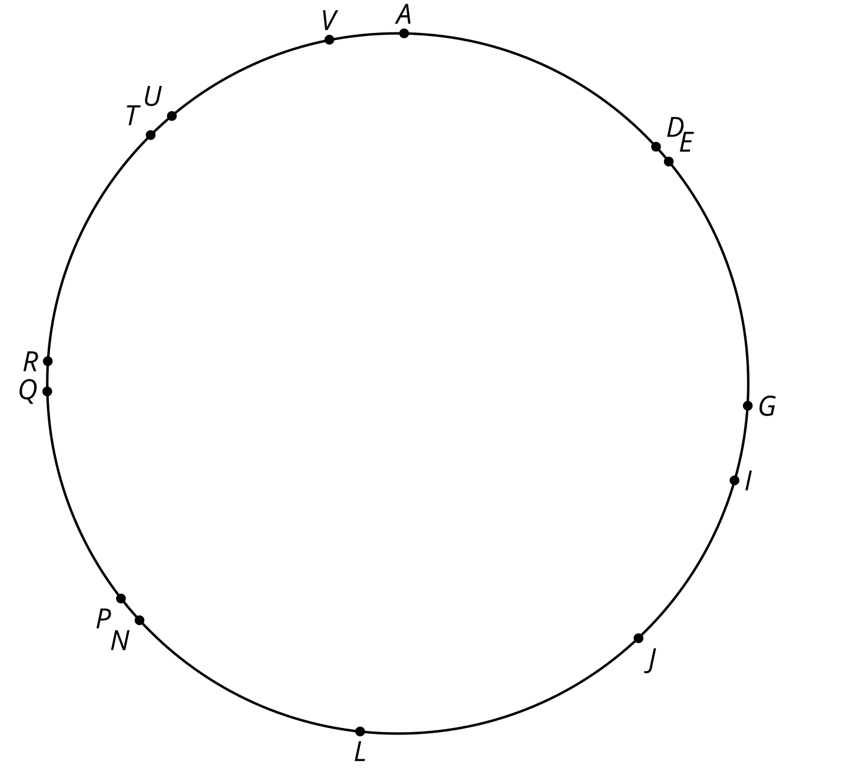

3 Triangle in the Mirror

Student Task Statement
Kiran started reflecting triangle $CDE$ across line $m$. So far, he knows the image of $D$ is $D^{′}$ and the image of $E$ is $E^{′}$.
- Annotate Kiran's diagram to show how he reflected point $D$.
- Use straightedge and compass moves to determine the location of $C^{′}.$ Then lightly shade in triangle $C^{′}D^{′}E^{′}$.
- Write a set of instructions for how to reflect any point $P$ across a given line $ℓ$.
- Elena found $C^{′}$ incorrectly. Elena is convinced that triangle $C^{′}D^{′}E^{′}$ “looks fine.” Explain to Elena why her $C^{′}$ is not a reflection of point $C$ across line $m$.

Kiran's Diagram
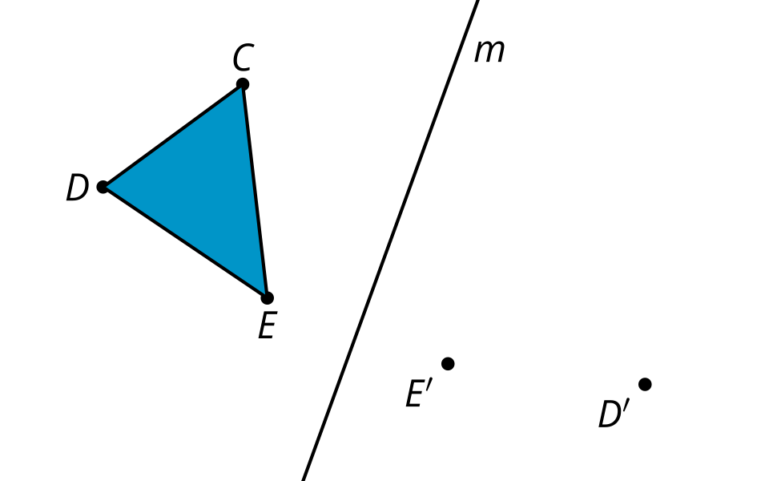

Elena's Diagram
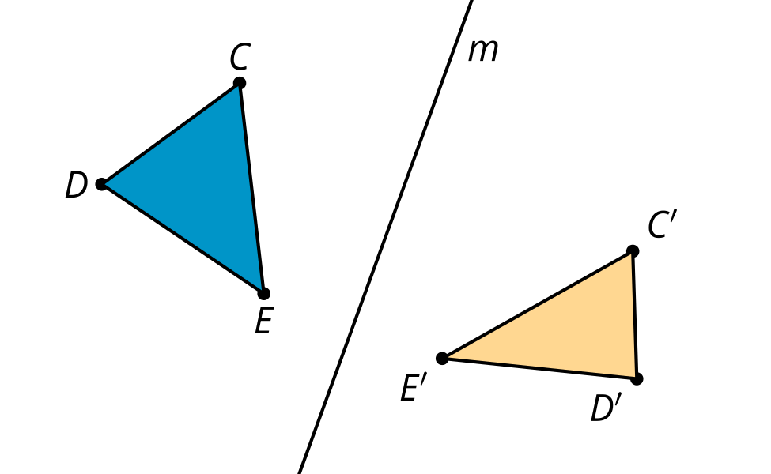

Images for Activity Synthesis

Reflect $A$ across line $m$.
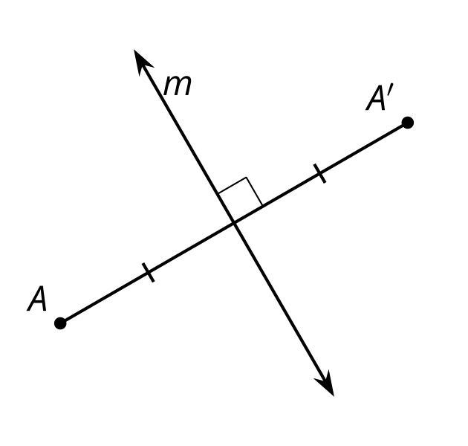
© CC BY 2019 by Illustrative Mathematics®

