Unit 7 Lesson 15: Is a Smartphone Smart Enough to Go to the Moon?

1 Old Hardware, New Hardware

Student Task Statement
In 1966, the Apollo Guidance Computer was developed to make the calculations that would put humans on the Moon.
Your teacher will give you advertisements for different devices from 1966 to 2016. Choose one device and compare that device with the Apollo Guidance Computer. If you get stuck, consider using scientific notation to help you do your calculations.
For reference, storage is measured in bytes, processor speed is measured in hertz, and memory is measured in bytes. Kilo stands for 1,000, mega stands for 1,000,000, giga stands for 1,000,000,000, and tera stands for 1,000,000,000,000.
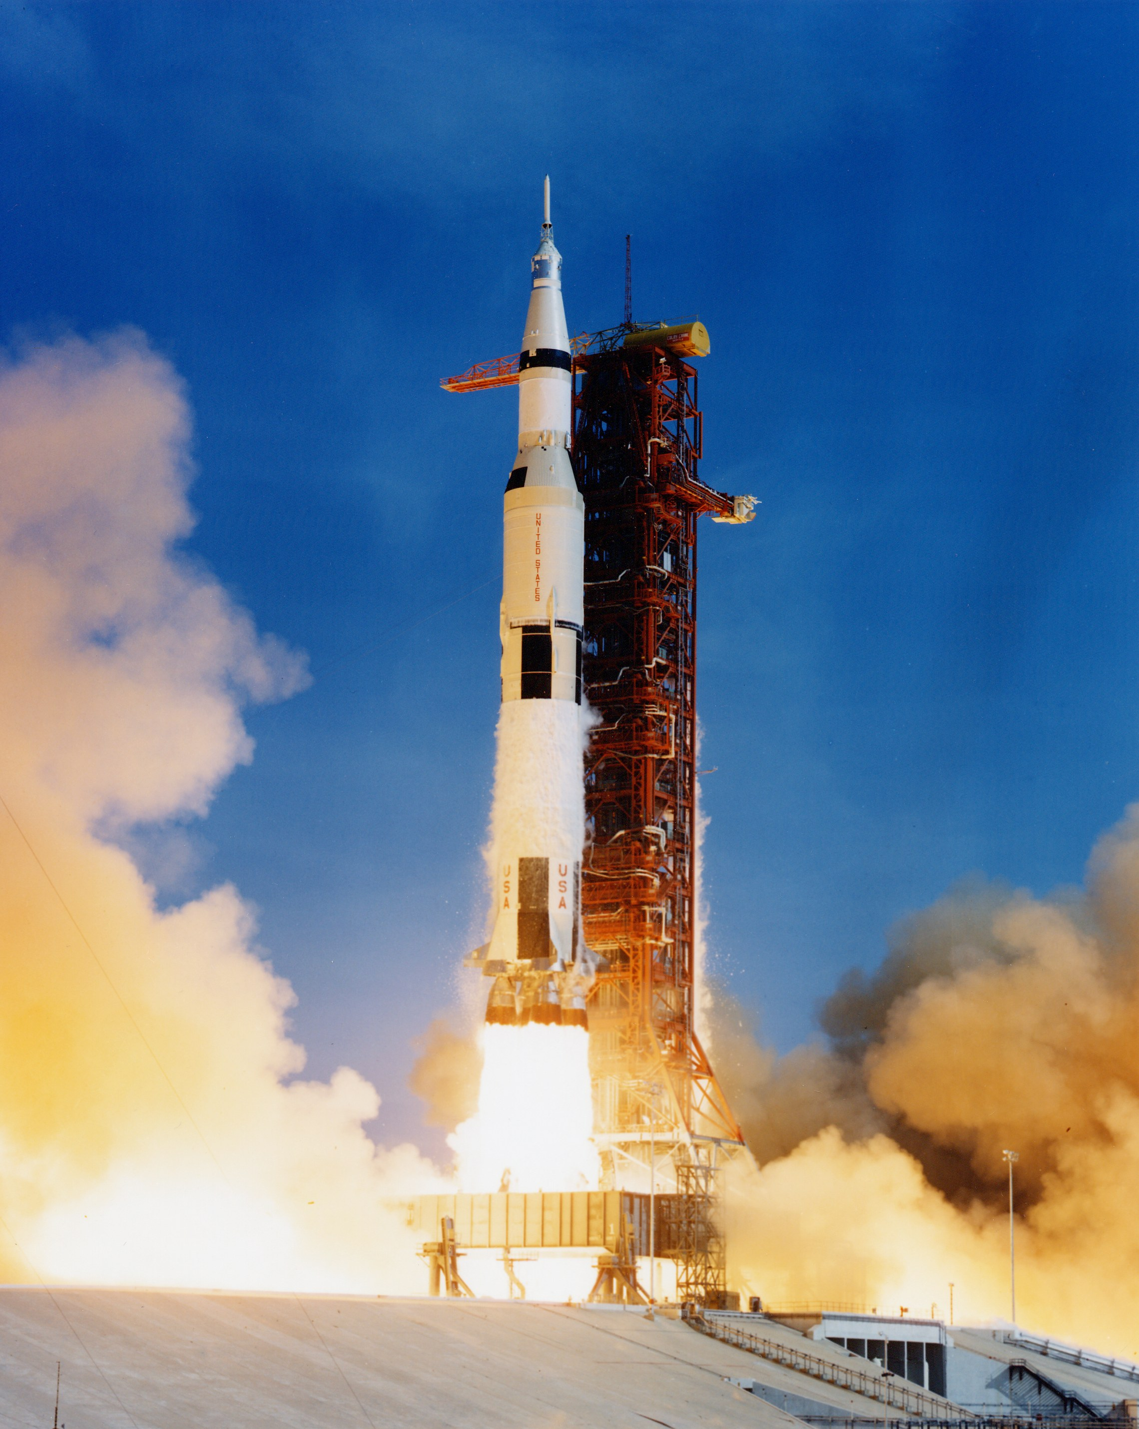
- Which one can store more information? How many times more information?
- Which one has a faster processor? How many times faster?
- Which one has more memory? How many times more memory?

2 A Bit More on Bytes

Student Task Statement
For each question, think about what information you would need to figure out an answer. Your teacher may provide some of the information you ask for. Give your answers using scientific notation.
- Mai found an 80’s computer magazine with an advertisement for a machine with hundreds of kilobytes of storage! Mai was curious and asked, “How many kilobytes would my dad’s new 2016 computer hold?”
- The old magazine showed another ad for a 750-kilobyte floppy disk, a device used in the past to store data. How many gigabytes is this?
- Mai and her friends are actively involved on a social media service that limits each message to 140 characters. She wonders about how the size of a message compares to other media.
- Estimate how many messages it would take for Mai to fill up a floppy disk with her 140-character messages. Explain or show your reasoning.
- Estimate how many messages it would take for Mai to fill a floppy disk with messages that only use emojis (each message being 140 emojis). Explain or show your reasoning.
- Mai likes to go to the movies with her friends and knows that a high-definition film takes up a lot of storage space on a computer.
- Estimate how many floppy disks it would take to store a high-definition movie. Explain or show your reasoning.
- How many seconds of a high-definition movie would one floppy disk be able to hold?
- If you fall asleep watching a movie streaming service and it streams movies all night while you sleep, how many floppy disks of information would that be?
© CC BY Open Up Resources. Adaptations CC BY IM.

