Unit 3 Lesson 11: Equations of All Kinds of Lines

1 Which One Doesn’t Belong: Pairs of Lines (Warm up)

Student Task Statement
Which one doesn’t belong?
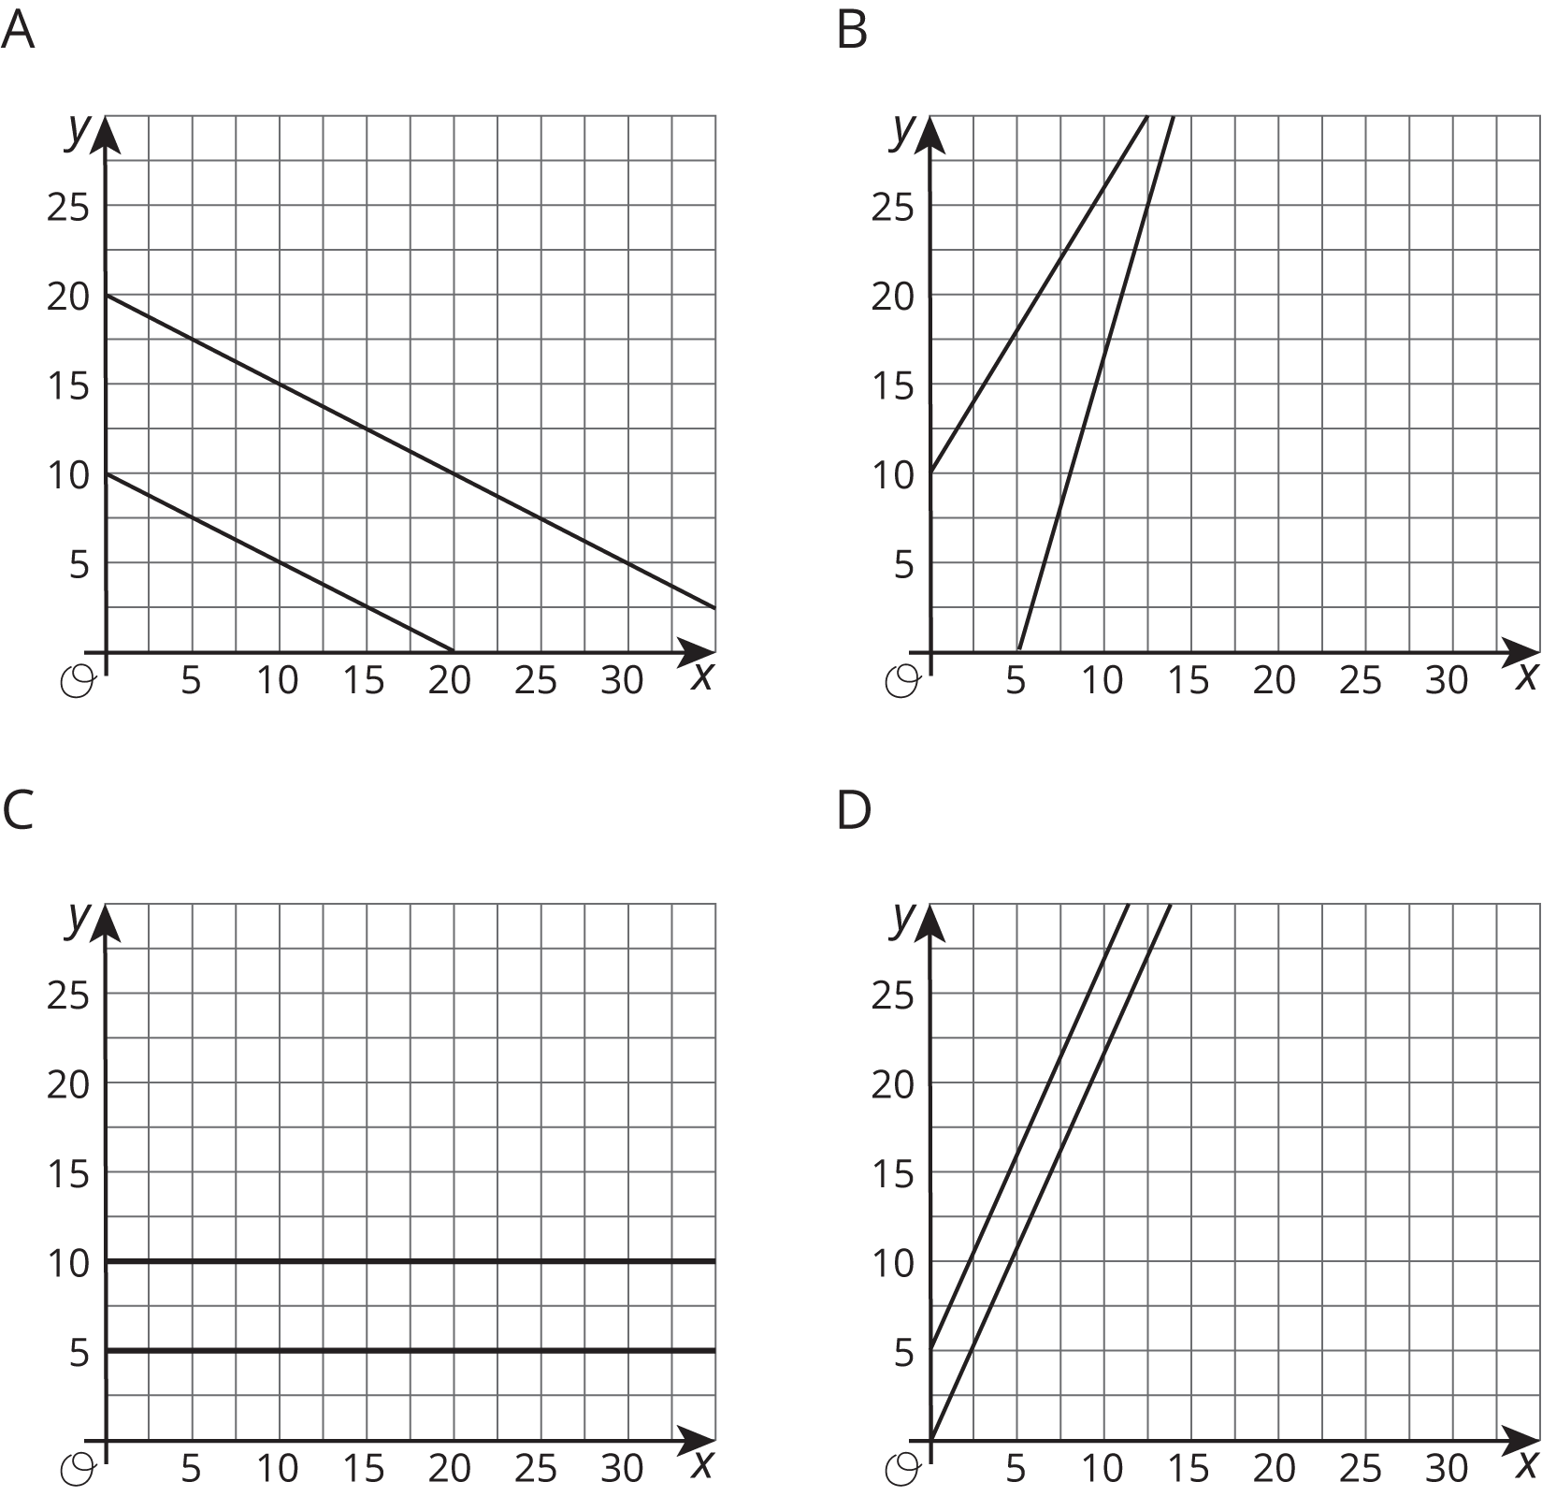

2 All the Same

Student Task Statement
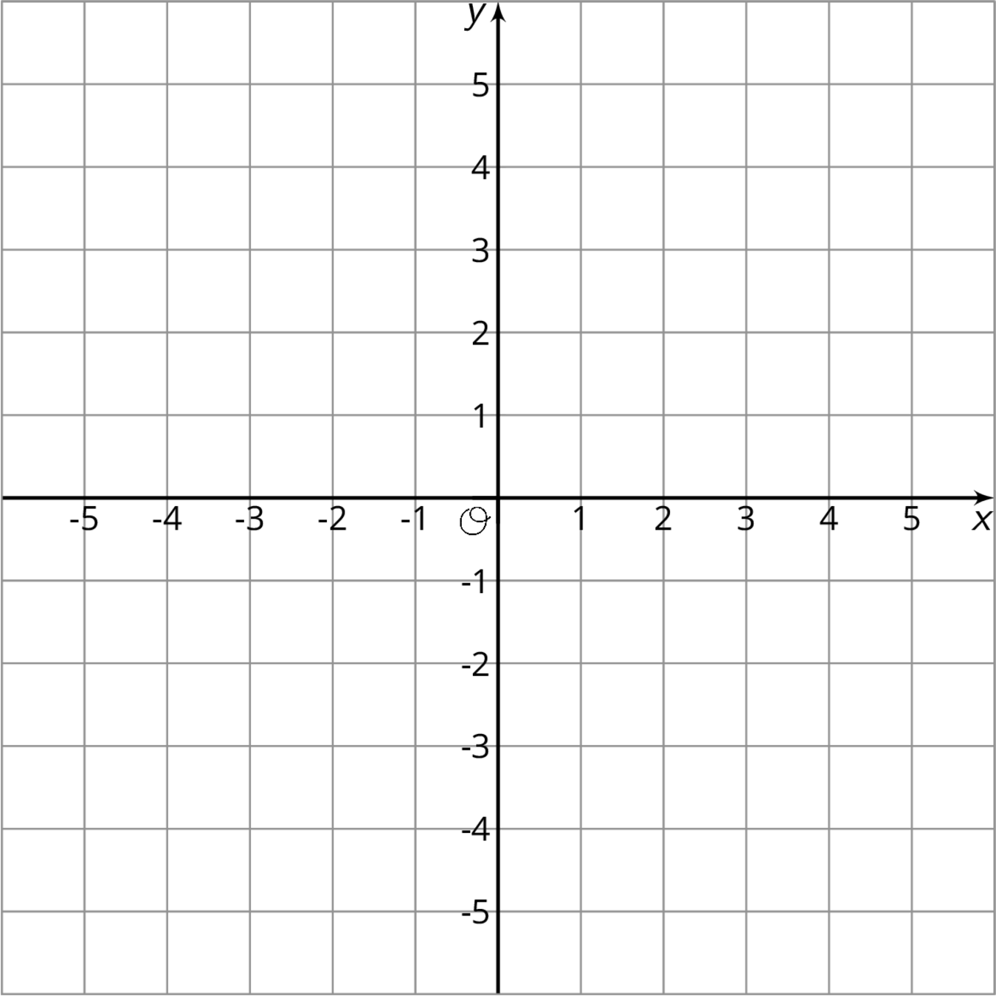
- Plot at least 10 points whose $y$-coordinate is -4. What do you notice about them?
- Which equation makes the most sense to represent all of the points with $y$-coordinate -4? Explain how you know.
- $x=\text{-}4$
- $y=\text{-}4x$
- $y=\text{-}4$
- $x+y=\text{-}4$
- Plot at least 10 points whose $x$-coordinate is 3. What do you notice about them?
- Which equation makes the most sense to represent all of the points with $x$-coordinate 3? Explain how you know.
- $x=3$
- $y=3x$
- $y=3$
- $x+y=3$
- Graph the equation $x=\text{-}2$.
- Graph the equation $y=5$.

3 Same Perimeter

Student Task Statement
- There are many possible rectangles whose perimeter is 50 units. Complete the table with lengths, $ℓ$, and widths, $w$, of at least 10 such rectangles.
- $ℓ$
- $w$
- The graph shows one rectangle whose perimeter is 50 units, and has its lower left vertex at the origin and two sides on the axes.
- On the same graph, draw more rectangles with perimeter 50 units using the values from your table. Make sure that each rectangle has a lower left vertex at the origin and two sides on the axes.
- 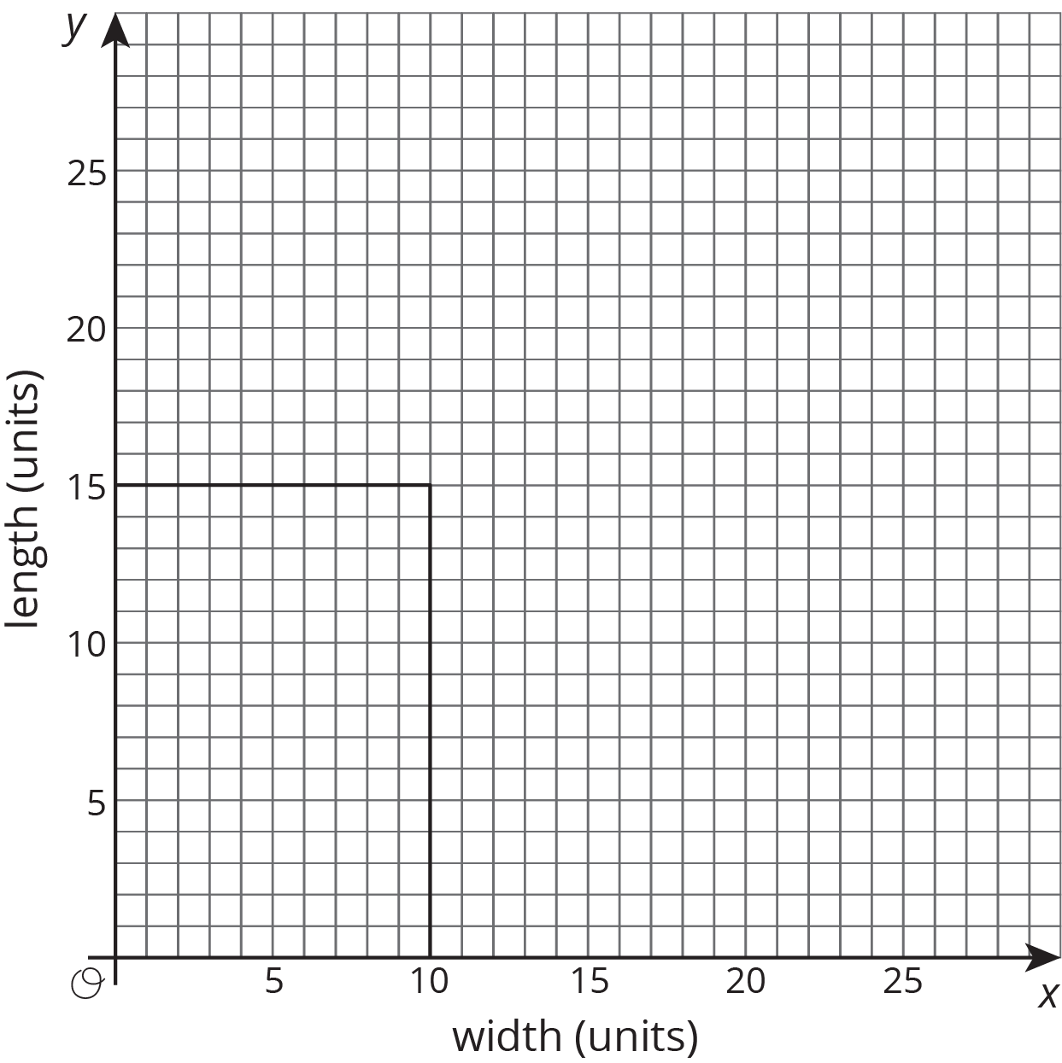
- Each rectangle has a vertex that lies in the first quadrant. These vertices lie on a line. Draw in this line and write an equation for it.
- What is the the slope of this line? How does the slope describe how the width changes as the length changes (or vice versa)?
© CC BY Open Up Resources. Adaptations CC BY IM.

