Unit 3 Lesson 10: Calculating Slope

1 Number Talk: Integer Operations (Warm up)

Student Task Statement
Find values for $a$ and $b$ that make each side have the same value.
$\frac{a}{b}=\text{-}2$
$\frac{a}{b}=2$
$a−b=\text{-}2$

2 Toward a More General Slope Formula

Student Task Statement
- Plot the points $\left(1,11\right)$ and $\left(8,2\right)$, and use a ruler to draw the line that passes through them.
- Without calculating, do you expect the slope of the line through $\left(1,11\right)$ and $\left(8,2\right)$ to be positive or negative? How can you tell?
- Calculate the slope of this line.
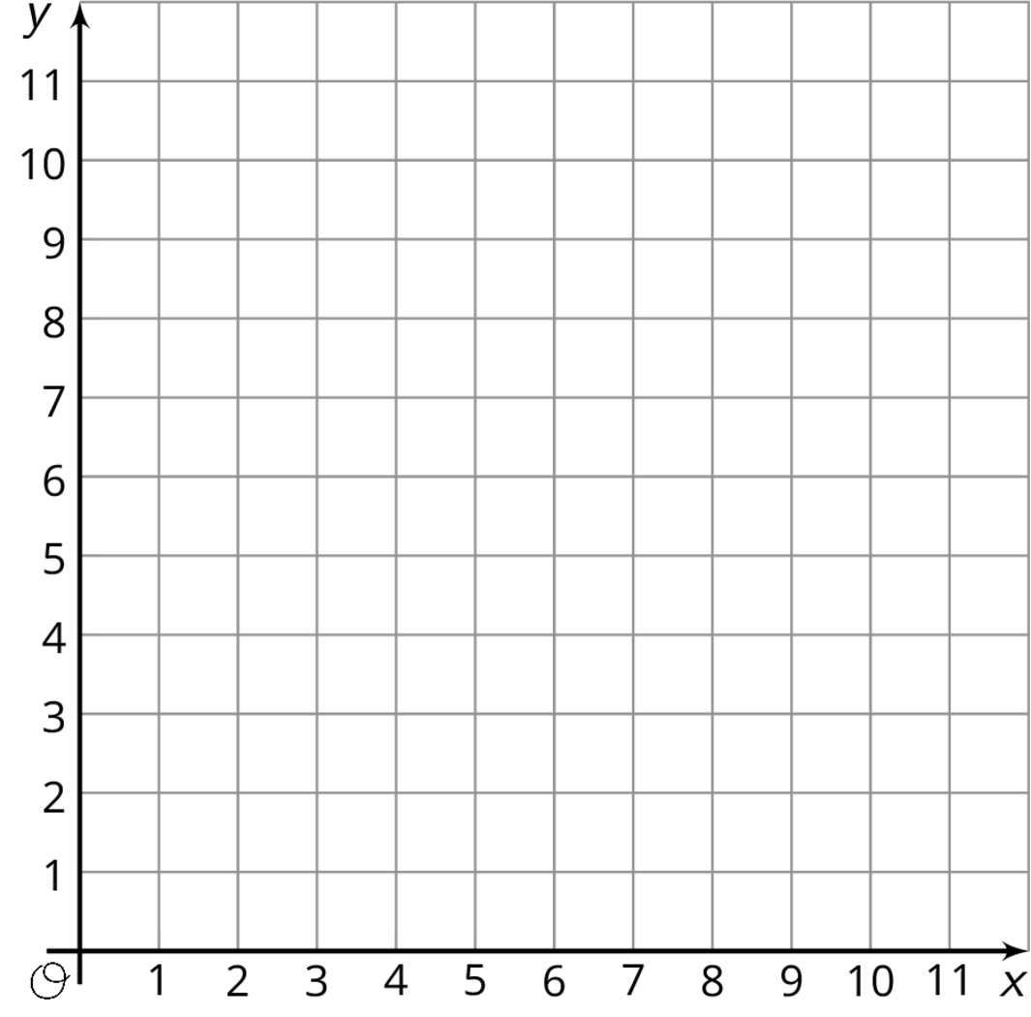

3 Making Designs

Student Task Statement
Your teacher will give you either a design or a blank graph. Do not show your card to your partner.
If your teacher gives you the design:
- Look at the design silently and think about how you could communicate what your partner should draw. Think about ways that you can describe what a line looks like, such as its slope or points that it goes through.
- Describe each line, one at a time, and give your partner time to draw them.
- Once your partner thinks they have drawn all the lines you described, only then should you show them the design.
If your teacher gives you the blank graph:
- Listen carefully as your partner describes each line, and draw each line based on their description.
- You are not allowed to ask for more information about a line than what your partner tells you.
- Do not show your drawing to your partner until you have finished drawing all the lines they describe.
When finished, place the drawing next to the card with the design so that you and your partner can both see them. How is the drawing the same as the design? How is it different? Discuss any miscommunication that might have caused the drawing to look different from the design.
Pause here so your teacher can review your work. When your teacher gives you a new set of cards, switch roles for the second problem.
© CC BY Open Up Resources. Adaptations CC BY IM.

