Unit 1 Lesson 21: One Hundred and Eighty

1 What Went Wrong? (Warm up)

Student Task Statement
Here are 2 lines $ℓ$ and $m$ that are not parallel that have been cut by a transversal.
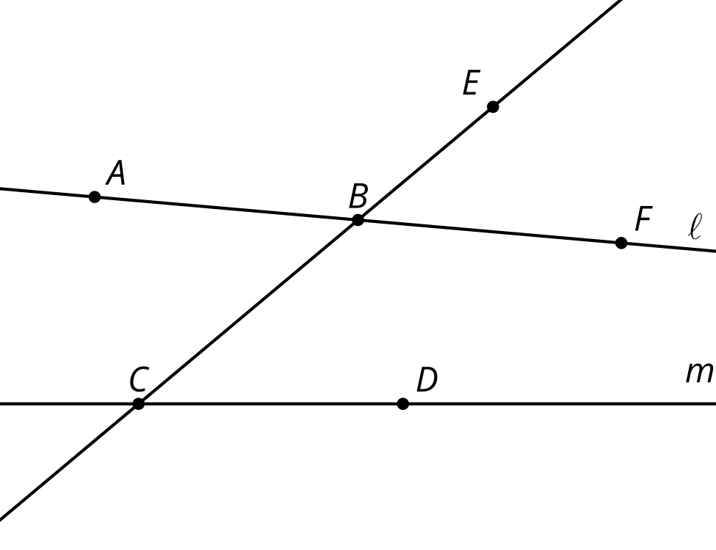
Tyler thinks angle $EBF$ is congruent to angle $BCD$ because they are corresponding angles and a translation along the directed line segment from $B$ to $C$ would take one angle onto the other. Here are his reasons.
- The translation takes $B$ onto $C$, so the image of $B$ is $C$.
- The translation takes $E$ somewhere on ray $CB$ because it would need to be translated by a distance greater than $BC$ to land on the other side of $C$.
- The image of $F$ has to land somewhere on line $m$ because translations take lines to parallel lines and line $m$ is the only line parallel to $ℓ$ that goes through $B^{′}$.
- The image of $F$, call it $F^{′}$, has to land on the right side of line $BC$ or else line $FF^{′}$ wouldn’t be parallel to the directed line segment from $B$ to $C$.
- Your teacher will assign you one of Tyler’s statements to think about. Is the statement true? Explain your reasoning.
- In what circumstances are corresponding angles congruent? Be prepared to share your reasoning.

2 Triangle Angle Sum One Way

Student Task Statement
- Use a straightedge to create a triangle. Label the 3 angle measures as $a^{∘}$, $b^{∘}$, and $c^{∘}$.
- Use paper folding to mark the midpoints of 2 of the sides.
- Extend the side of the triangle without the midpoint in both directions to make a line.
- Use what you know about rotations to create a line parallel to the line you made that goes through the opposite vertex.
- What is the value of $a+b+c$? Explain your reasoning.

3 Triangle Angle Sum Another Way

Student Task Statement
Here is triangle $ABC$ with angle measures $a^{∘}$, $b^{∘}$, and $c^{∘}$. Each side has been extended to a line.
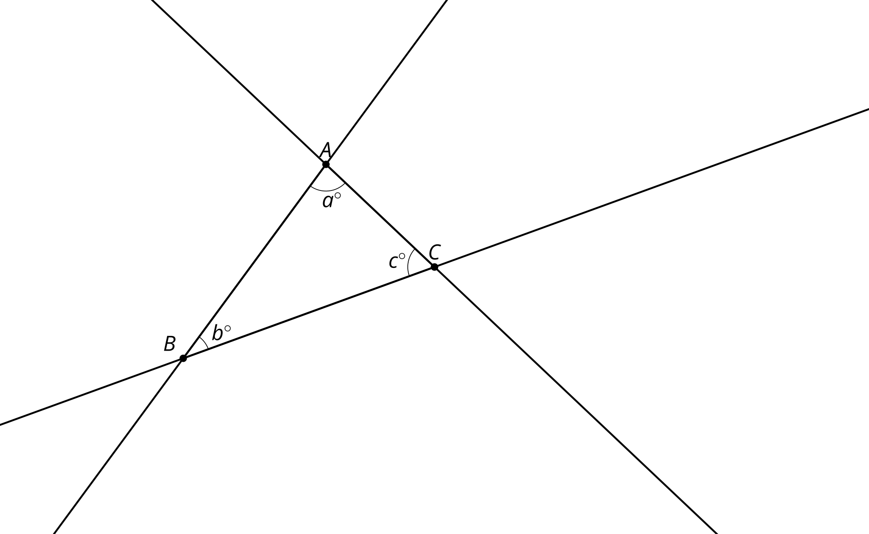
- Translate triangle $ABC$ along the directed line segment from $B$ to $C$ to make triangle $A^{′}B^{′}C^{′}$. Label the measures of the angles in triangle $A^{′}B^{′}C^{′}$.
- Translate triangle $A^{′}B^{′}C^{′}$ along the directed line segment from $A^{′}$ to $C$ to make triangle $A^{″}B^{″}C^{″}$. Label the measures of the angles in triangle $A^{″}B^{″}C^{″}$.
- Label the measures of the angles that meet at point $C$. Explain your reasoning.
- What is the value of $a+b+c$? Explain your reasoning.

Images for Activity Synthesis

$a+b+c=180$
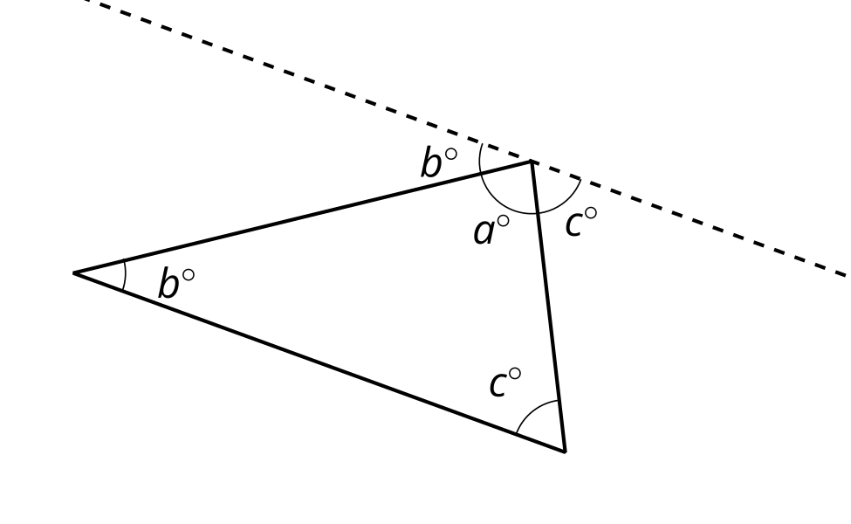
© CC BY 2019 by Illustrative Mathematics®

