Unit 6 Lesson 15: Vertex Form

1 Notice and Wonder: Two Sets of Equations (Warm up)

Student Task Statement
What do you notice? What do you wonder?
Set 1:
$f\left(x\right)=x^{2}+4x$
$g\left(x\right)=x\left(x+4\right)$
$h\left(x\right)={\left(x+2\right)}^{2}−4$
Set 2:
$p\left(x\right)=\text{-}x^{2}+6x−5$
$q\left(x\right)=\left(5−x\right)\left(x−1\right)$
$r\left(x\right)=\text{-}1{\left(x−3\right)}^{2}+4$

2 A Whole New Form

Student Task Statement
Here are two sets of equations for quadratic functions you saw earlier. In each set, the expressions that define the output are equivalent.
Set 1:
$f\left(x\right)=x^{2}+4x$
$g\left(x\right)=x\left(x+4\right)$
$h\left(x\right)={\left(x+2\right)}^{2}−4$
Set 2:
$p\left(x\right)=\text{-}x^{2}+6x−5$
$q\left(x\right)=\left(5−x\right)\left(x−1\right)$
$r\left(x\right)=\text{-}1{\left(x−3\right)}^{2}+4$
The expression that defines $h$ is written in vertex form. We can show that it is equivalent to the expression defining $f$ by expanding the expression:
$\begin{matrix}{\left(x+2\right)}^{2}−4 & =\left(x+2\right)\left(x+2\right)−4 \\ & =x^{2}+2x+2x+4−4 \\ & =x^{2}+4x\end{matrix}$
- Show that the expressions defining $r$ and $p$ are equivalent.
- Here are graphs representing the quadratic functions. Why do you think expressions such as those defining $h$ and $r$ are said to be written in vertex form?

- Graph of $h$
- 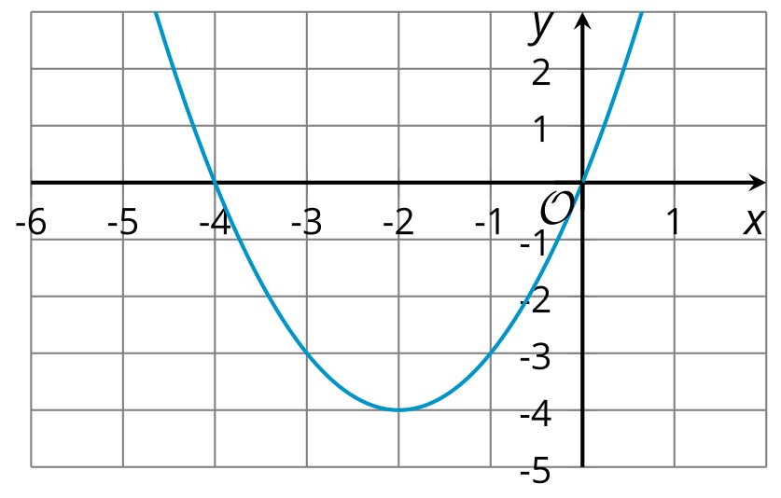

- Graph of $r$
- 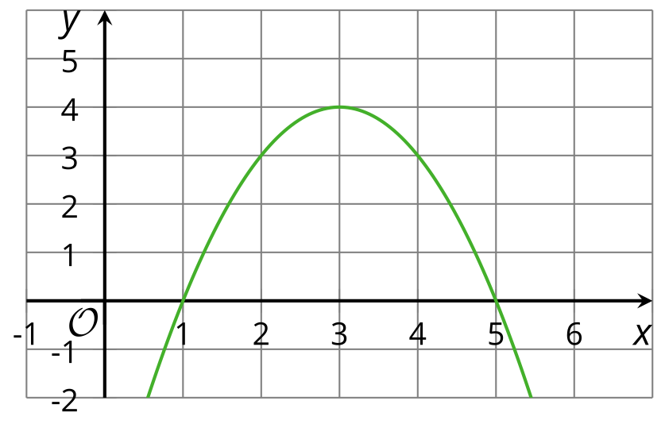

3 Playing with Parameters

Student Task Statement
- Using graphing technology, graph $y=x^{2}$. Then, add different numbers to $x$ before it is squared (for example, $y={\left(x+4\right)}^{2}$, $y={\left(x−3\right)}^{2}$) and observe how the graph changes. Record your observations.
- Graph $y={\left(x−1\right)}^{2}$. Then, experiment with each of the following changes to the function and see how they affect the graph and the vertex:
  - Adding different constant terms to ${\left(x−1\right)}^{2}$ (for example: ${\left(x−1\right)}^{2}+5$, ${\left(x−1\right)}^{2}−9$).
  - Multiplying ${\left(x−1\right)}^{2}$ by different coefficients (for example: $y=3{\left(x−1\right)}^{2}$, $y=\text{-}2{\left(x−1\right)}^{2}$).
- Without graphing, predict the coordinates of the vertex of the graphs of these quadratic functions, and predict whether the graph opens up or opens down. Ignore the last row until the next question.
- equations | - coordinates of vertex | - graph opens up or down?
- $y={\left(x+10\right)}^{2}$
- $y={\left(x−4\right)}^{2}+8$
- $y=\text{-}{\left(x−4\right)}^{2}+8$
- $y=x^{2}−7$
- $y=\frac{1}{2}{\left(x+3\right)}^{2}−5$
- $y=\text{-}{\left(x+100\right)}^{2}+50$
- $y=a{\left(x+m\right)}^{2}+n$
- Use graphing technology to check your predictions. If they are incorrect, revise them. Then, complete the last row of the table.
© CC BY 2019 by Illustrative Mathematics®

