Lesson 13: Ecuaciones de multiplicación

Standards Alignments
Addressing | 3.OA.A.1, 3.OA.A.3

Teacher-facing Learning Goals
- Relate equations to multiplication situations and diagrams.
- Write equations for multiplication situations and diagrams using a symbol for the unknown number.

Student-facing Learning Goals
- Aprendamos sobre ecuaciones de multiplicación.

Lesson Purpose
The purpose of this lesson is for students to relate multiplication equations to situations and diagrams and write equations.
In previous lessons students represented situations and diagrams with multiplication expressions. In this lesson, students learn the meaning of factor and product. Students do not have to use the vocabulary in this lesson as they will continue to have opportunities to do so throughout the year. In future lessons, students will represent situations and diagrams with equations that use a symbol for the unknown number, which may be either a factor or the product.
Consider continuing to use the convention of groups as the first factor and the size of the groups as the second factor when writing equations. However, it is not necessary for students to write the factors in this order. It is important that students connect their equations to the corresponding situations and representations (MP2). They should be able to correctly explain what each factor represents in their equations. If students ask questions about the idea of commutativity, consider recording the questions publicly for future investigation.

Access for:

Students with Disabilities
- Engagement (Activity 2)

English Learners
- MLR7 (Activity 2)

Instructional Routines
Which One Doesn’t Belong? (Warm-up)

Lesson Timeline
Warm-up | 10 min
Activity 1 | 20 min
Activity 2 | 15 min
Lesson Synthesis | 10 min
Cool-down | 5 min

Teacher Reflection Question
How were the terms factor and product helpful as students began working with multiplication equations?

Cool-down
(to be completed at the end of the lesson) 5min
¿Cuáles corresponden a la ecuación?

Standards Alignments
Addressing | 3.OA.A.1

Student-facing Task Statement
Selecciona todos los dibujos, diagramas y situaciones que puedan representar esta situación.
$80=8×10$

- 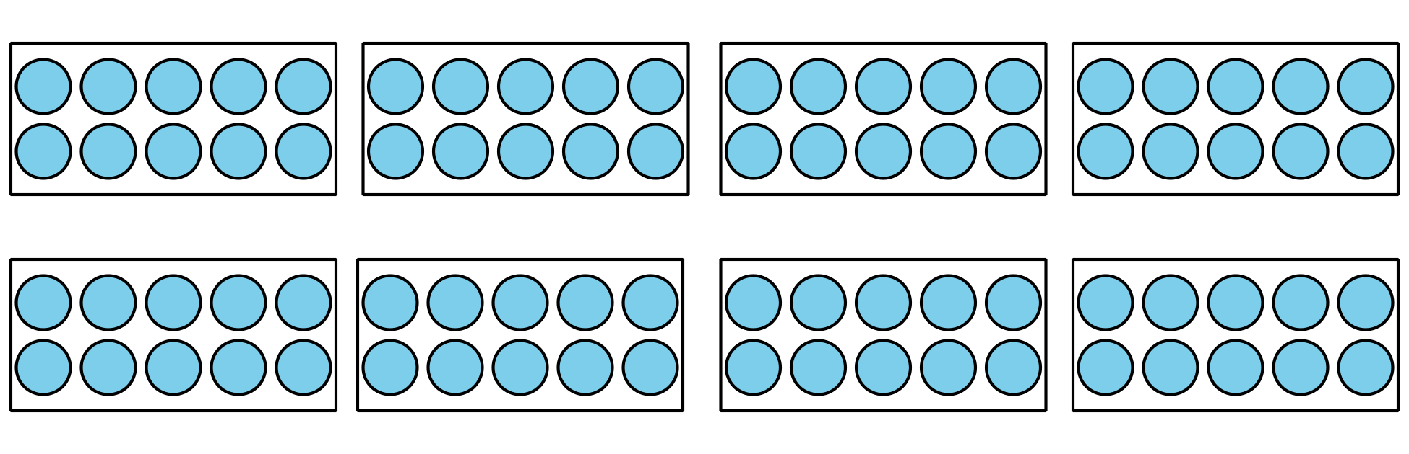
- Andre tiene 8 cajas. Cada caja contiene 10 autos. Andre tiene 80 autos en total.

- 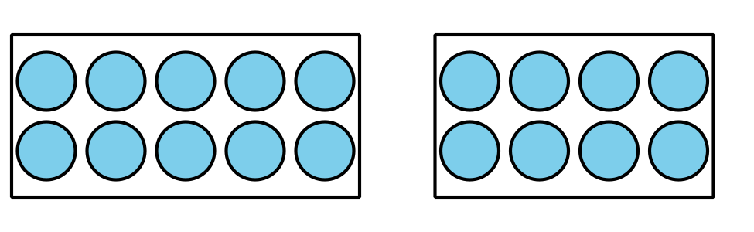

- 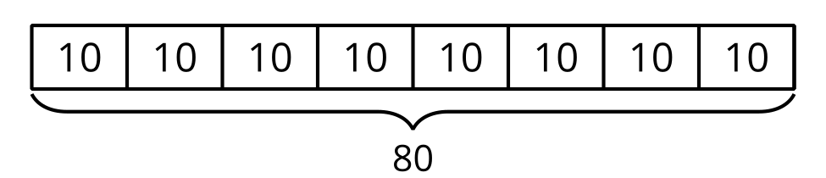
- Andre tenía 8 cajas. Después, encontró 10 cajas más. ¿Cuántas cajas tiene Andre?

- 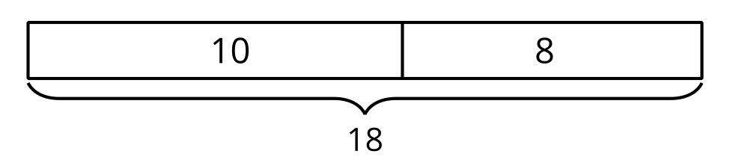

Student Responses
A, B, and D

