Lesson 1 Practice Problems
- What is the probability of the spinner landing on the section labeled G?
- 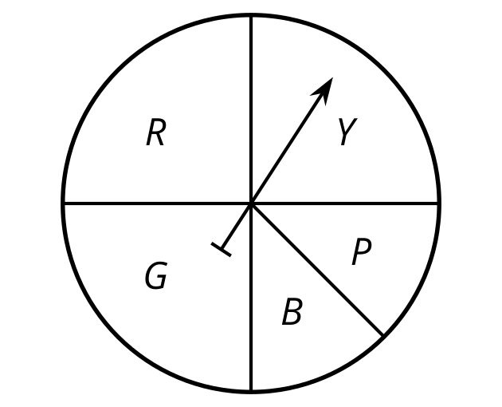
  - $\frac{1}{2}$
  - $\frac{1}{4}$
  - $\frac{1}{5}$
  - $\frac{1}{8}$
- This spinner is spun 1,000 times. Which of these is the best estimate for the number of times it would be expected to land on the section labeled B?
- 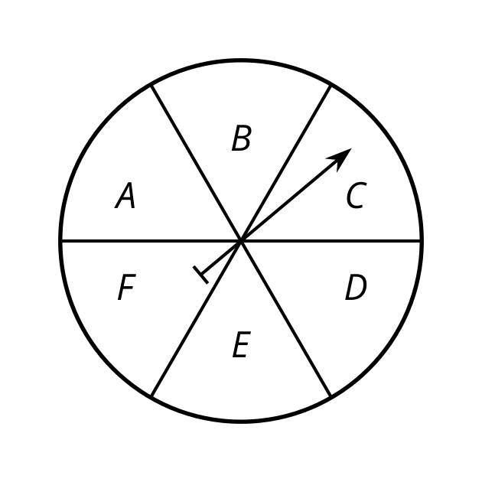
  - 16
  - 60
  - 160
  - 600
- On an assignment, there are two true or false questions. You have no idea what the correct answer is to either one so you guess.
  - What is the probability that you get both of them right by guessing? Explain your answer.
  - What is the probability that you get exactly one of them right by guessing? Explain your answer.

  - Find the length of an arc with central angle $\frac{2π}{3}$ radians and a radius of 7 units.
  - Find the length of an arc with central angle $\frac{π}{4}$ radians and a circumference of $10π$ units.
  - Find the measure (in radians) of a central angle of an arc with arc length 12 units and radius 3 units.
- (From Unit 7, Lesson 13.)
- In the circle, sketch a central angle that measures $\frac{π}{2}$ radians.
- (From Unit 7, Lesson 12.)
- The circle in the image has been divided into congruent sectors. What is the measure of the central angle of the shaded region in radians?
- 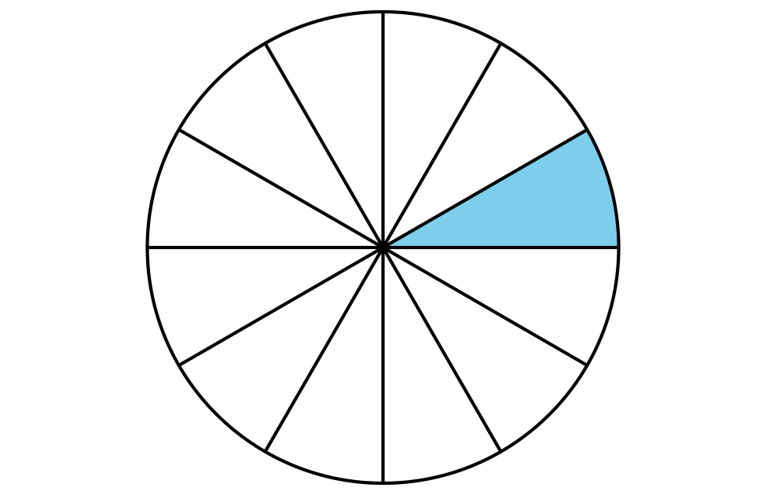
  - $\frac{1}{12}$ radians
  - $\frac{π}{12}$ radians
  - $\frac{1}{6}$ radians
  - $\frac{π}{6}$ radians
- (From Unit 7, Lesson 12.)
- Select all true statements.
  - The incenter of a triangle is the intersection of the angle bisectors.
  - The incenter is the same distance from all the vertices of the triangle.
  - The incenter is the same distance from all sides of the triangle.
  - In order to construct the incenter, all 3 angle bisectors must be constructed.
  - The incenter is the intersection of the perpendicular bisectors of each side.
- (From Unit 7, Lesson 6.)
© CC BY 2019 by Illustrative Mathematics®

