Lesson 10: Cross Sections and Volume
- Let’s look at how cross sections and volume are related.

10.1: Two Stacks of Coins
The images show the same number of coins arranged in different ways.

A
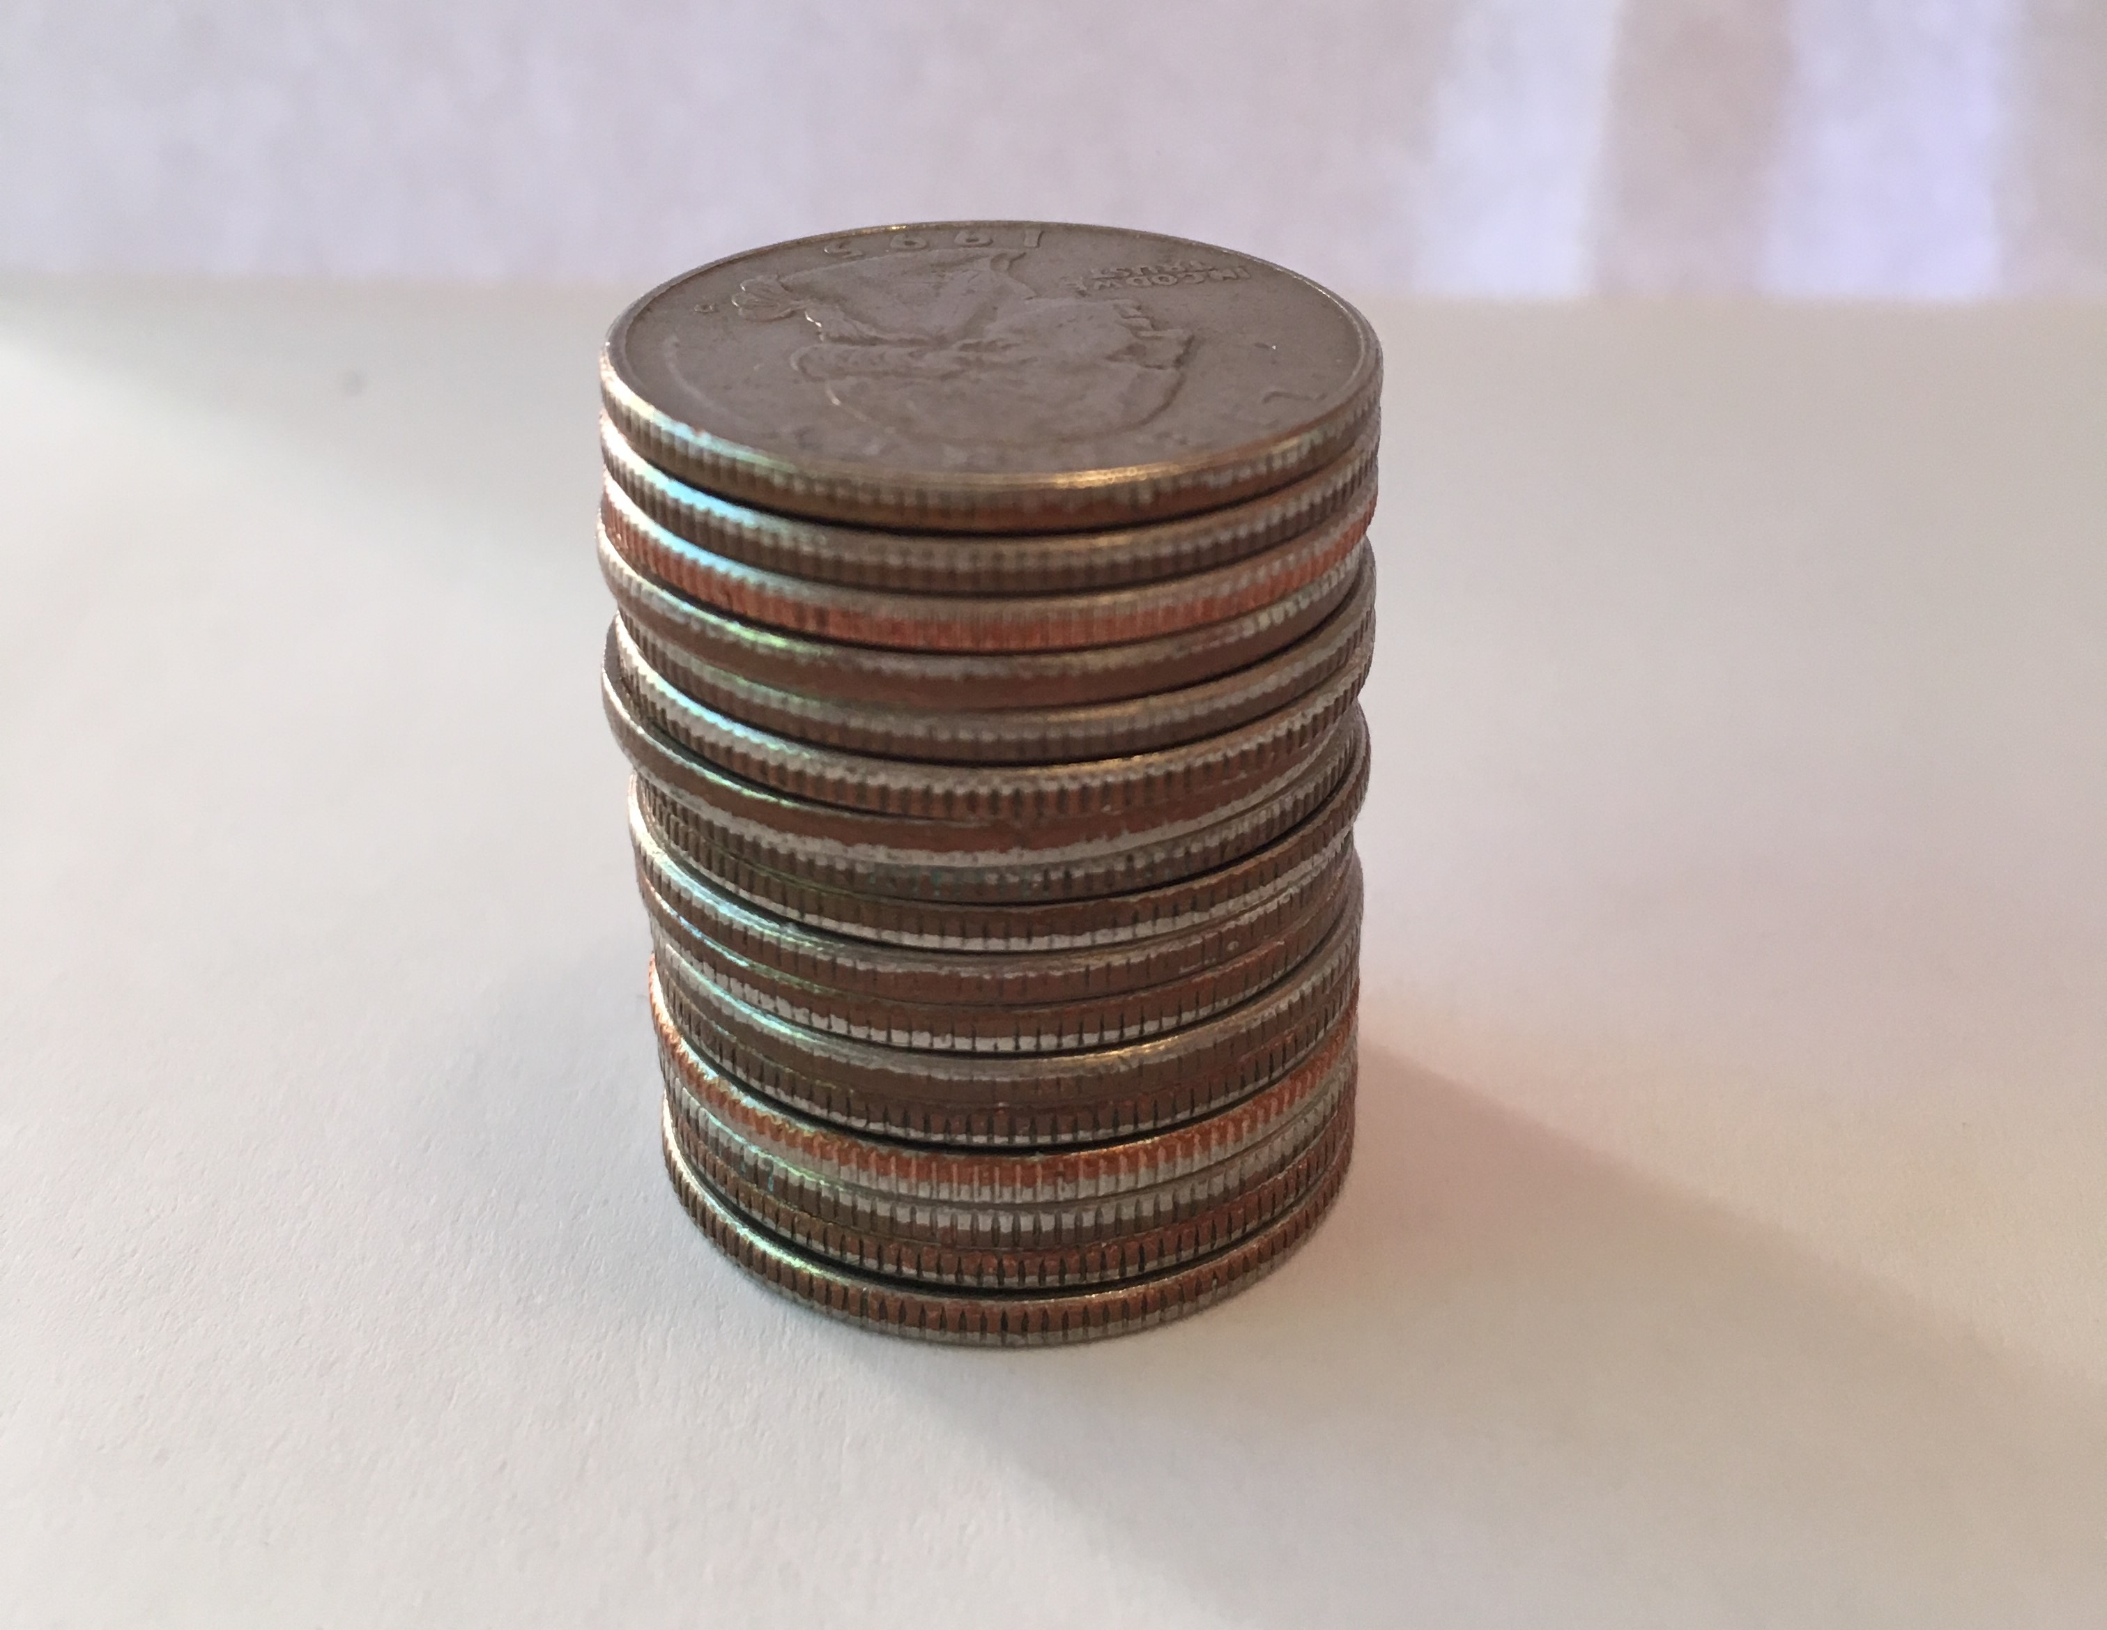

B
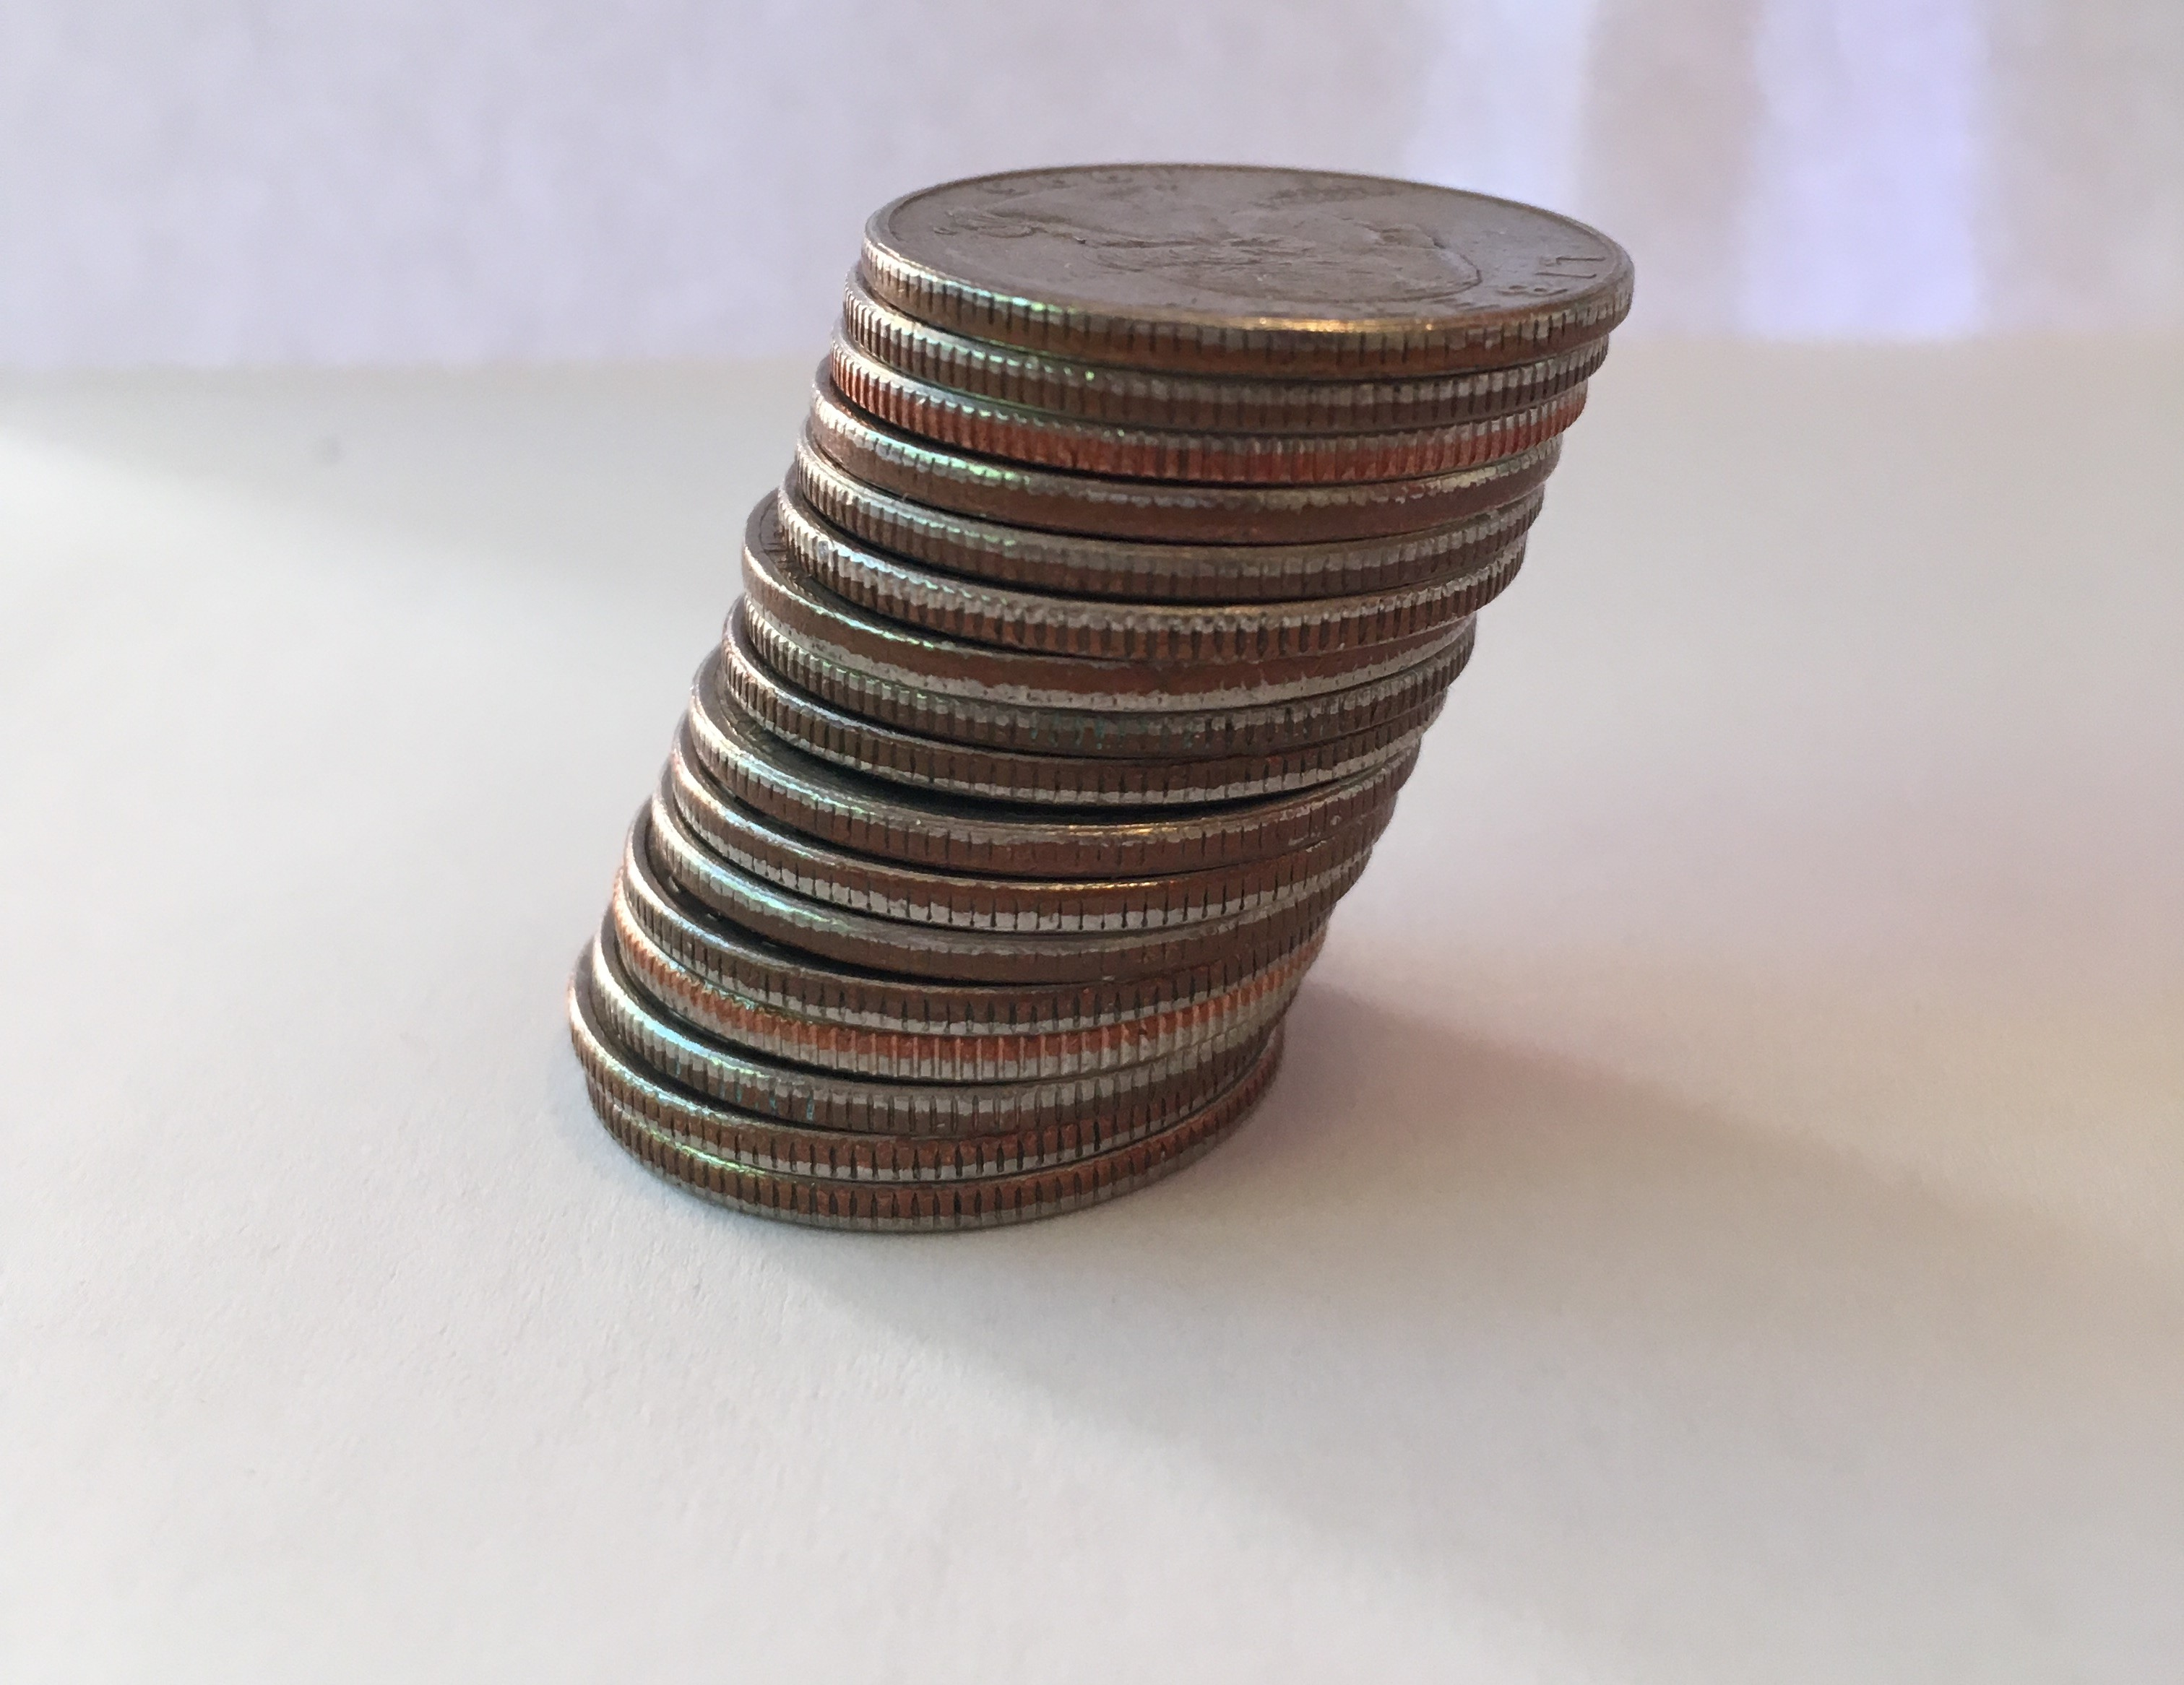
- How are the two coin stacks different from each other?
- Does either stack of coins resemble a geometric solid? If so, which stack and what solid?
- How do the heights of the two stacks compare?
- How do the volumes of the two stacks compare? Explain your reasoning.

10.2: Rectangular Prism, Shifted
The image shows two rectangular prisms. The bases of the prisms are congruent. Each base has area $B$ square units, and the prisms are the same height. A plane intersects the two prisms parallel to their bases, creating cross sections.
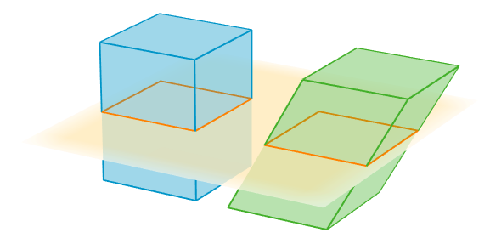
- Sketch the two cross sections. How do their shapes and areas compare to each other?
- How would the shape or area of the cross sections change if we moved the plane up or down?
- How do the volumes of the two prisms compare? Explain your reasoning.

Are you ready for more?
The image shows a recomposition of a solid.
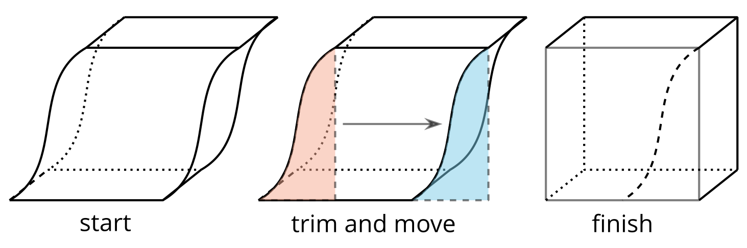
How does this demonstrate Cavalieri's Principle?

10.3: Equal Volumes?
For each pair of solids, decide whether the volumes of the two solids are equal. Explain your reasoning. If you and your partner disagree, discuss each other’s approach until you reach agreement.
- 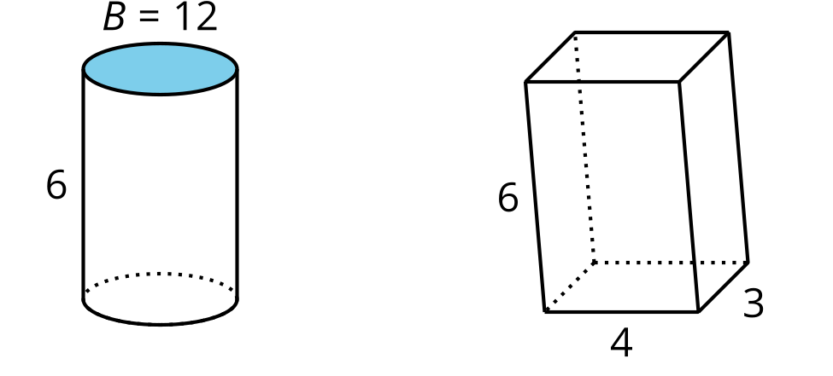
- 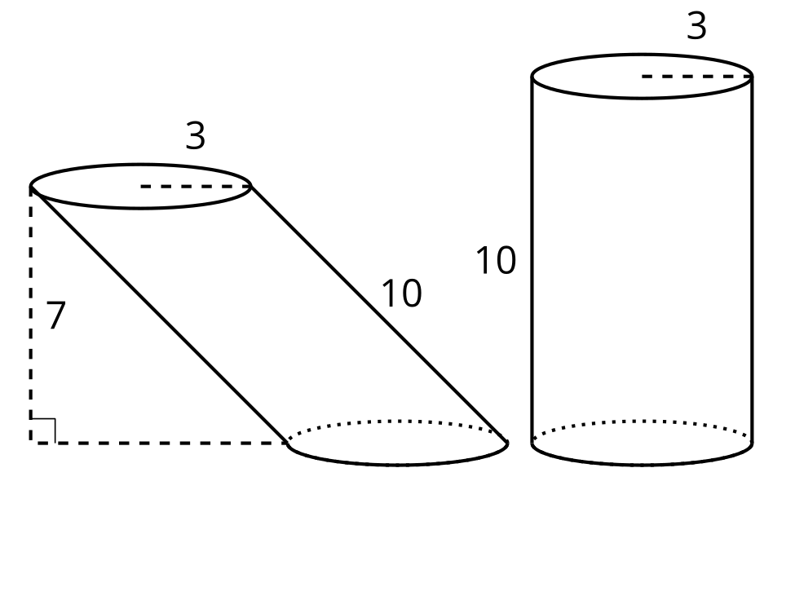
- 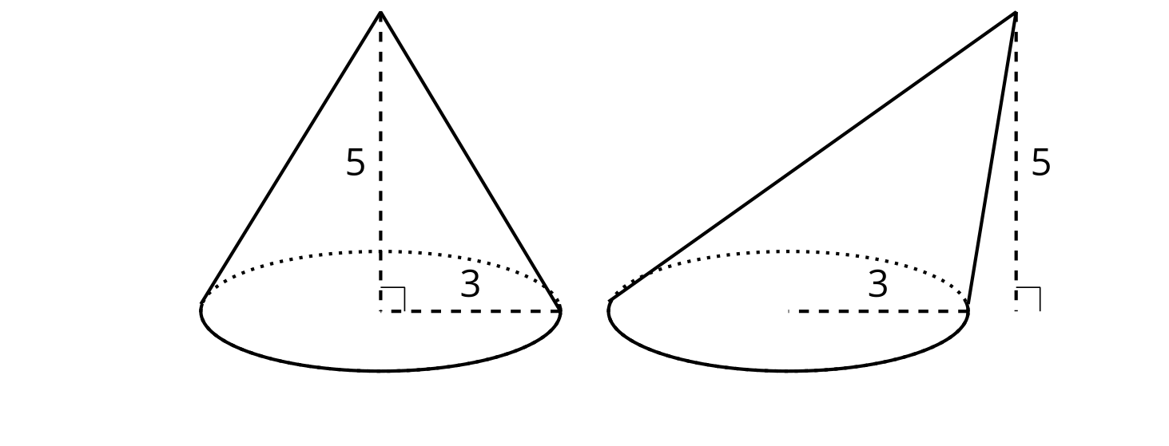
- 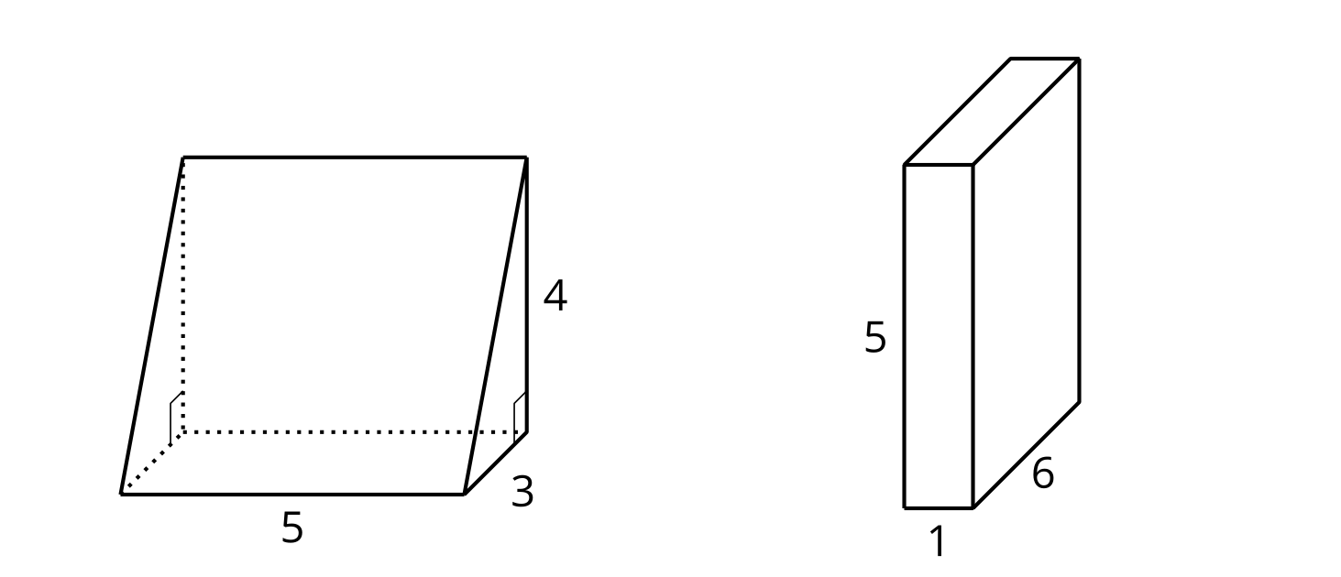
- 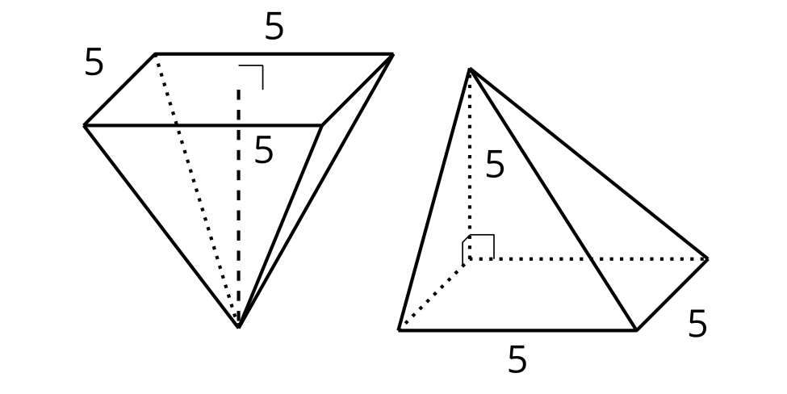
- 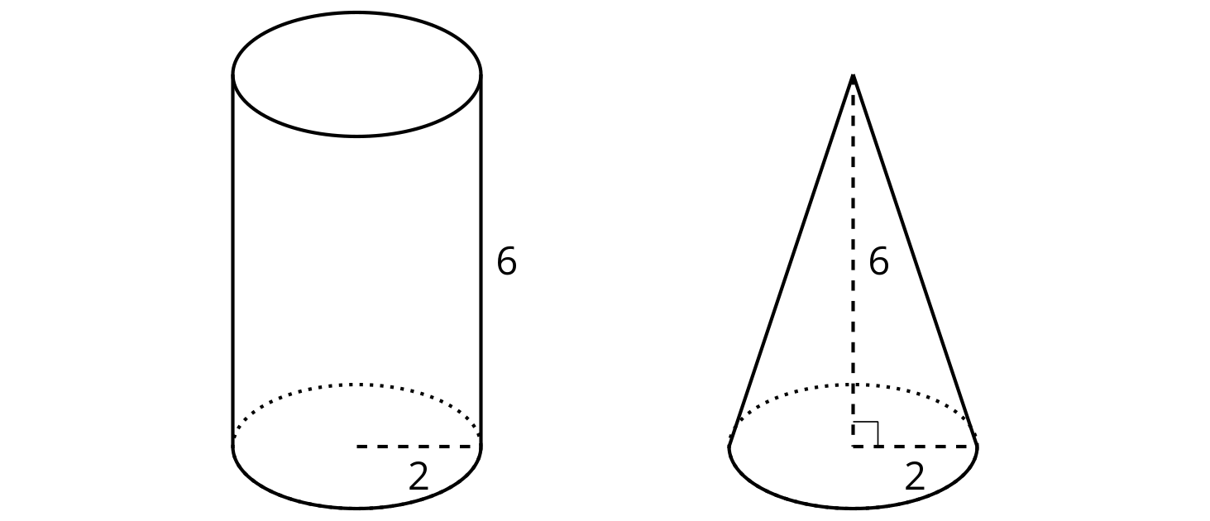

Lesson 10 Summary
Suppose we have a stack of paper in the shape of a rectangular prism. Then we shift the paper so the prism slants to the side. The first is called a right prism because its sides are at right angles to its base. The second one, without right angles between the sides and the base, is called an oblique prism. The volume of the prism doesn’t change when we shift it—the amount of paper stays the same.
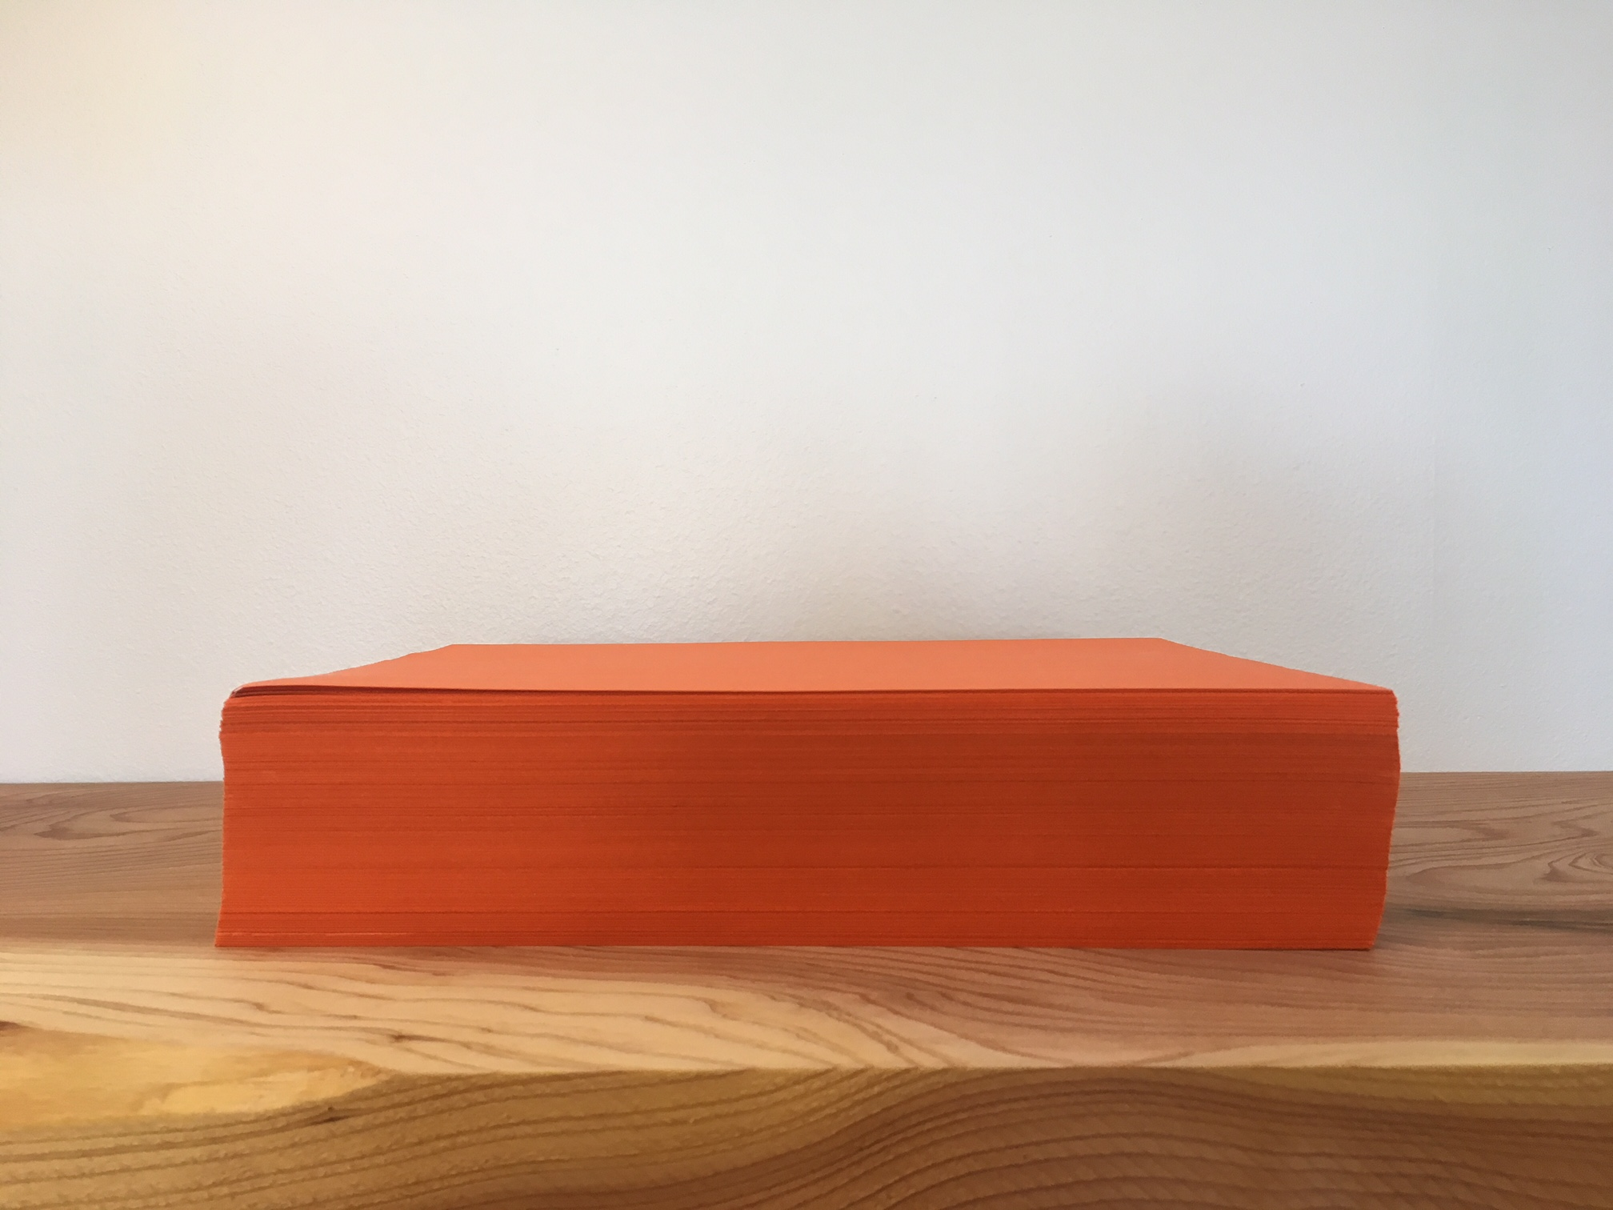
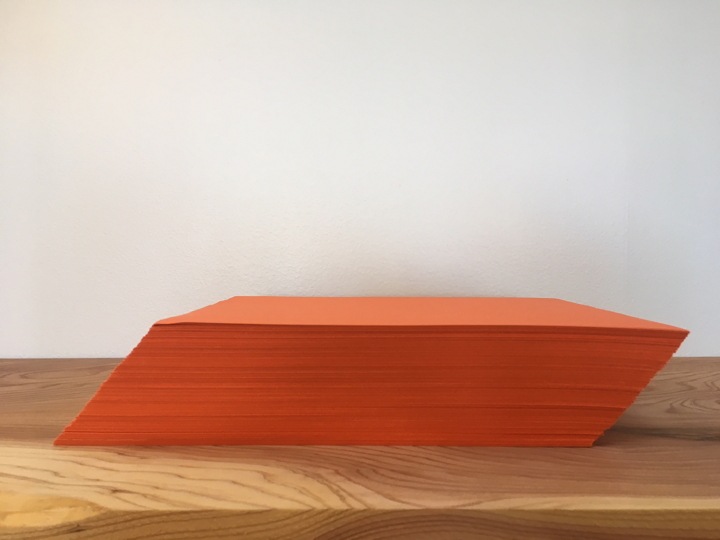
In fact, Cavalieri’s Principle says that if any two solids are cut into cross sections by parallel planes, and the corresponding cross sections at all heights all have equal areas, then the solids have the same volume.
In this image, all measurements are in centimeters. The oblique cylinder and the right prism have equal volumes because they have the same height and their cross sections at all heights have the same area of 6 square centimeters.
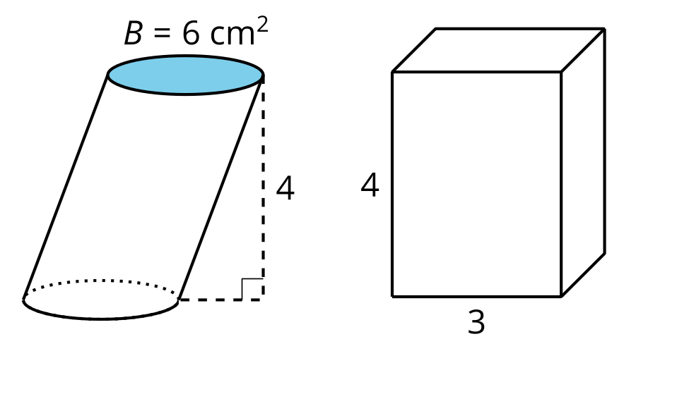
These two pyramids also have equal volumes. Their bases are congruent, and they have the same height. Shifting a solid from right to oblique doesn’t change its volume.
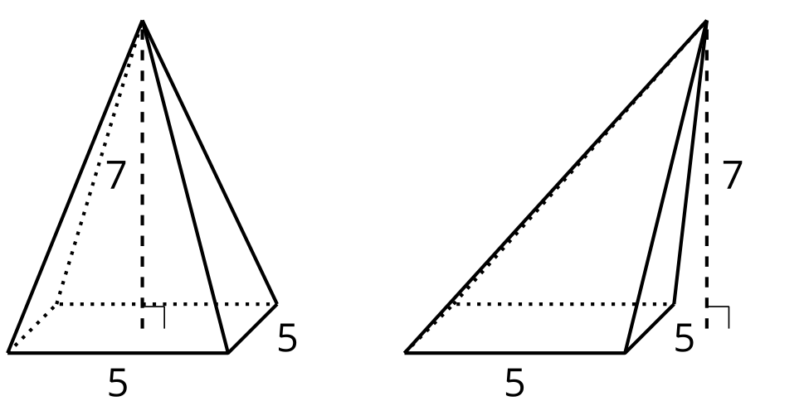
© CC BY 2019 by Illustrative Mathematics®

