Unit 1 Lesson 4: Construction Techniques 2: Equilateral Triangles

1 Notice and Wonder: Circles Circles Circles (Warm up)

Student Task Statement
What do you notice? What do you wonder?
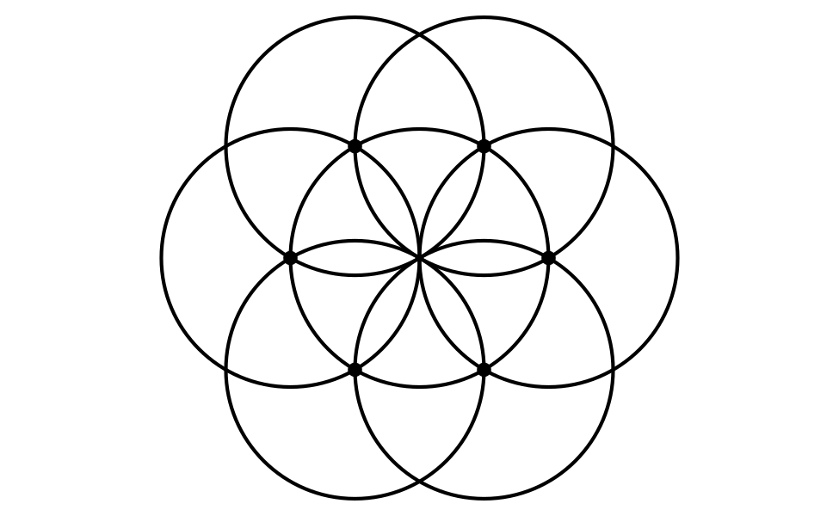

2 What Polygons Can You Find?

Images for Launch
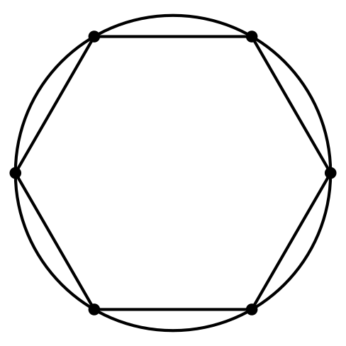

Student Task Statement
Here is a straightedge and compass construction of a regular hexagon inscribed in a circle just before the last step of drawing the sides:
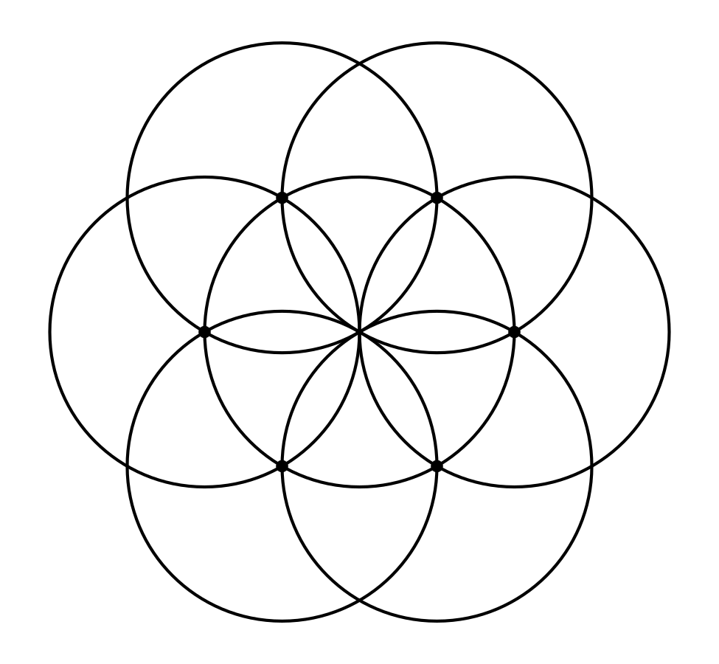
- Use a straightedge to draw at least 2 polygons on the figure. The vertices of your polygon should be intersection points in the figure. Lightly shade in your polygons using different colored pencils to make them easier to see.
- Write at least 2 conjectures about the polygons you made.

3 Spot the Equilaterals

Student Task Statement
Use straightedge and compass moves to construct at least 2 equilateral triangles of different sizes.
© CC BY 2019 by Illustrative Mathematics®

