Lesson 9: Cylinder Volumes
- Let’s analyze cylinder volumes.

9.1: The Same But Different
Here are two solids.
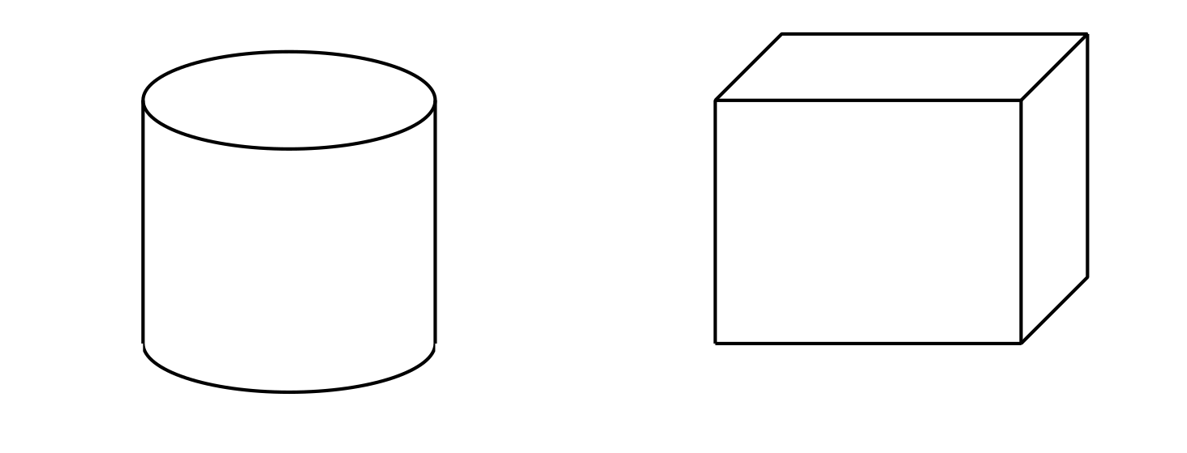
- What information would you need to calculate the volume of each solid?
- What is the same and different about how you would find the volume of each solid?

9.2: Water Transfer
Here are two containers. All measurements are in centimeters.
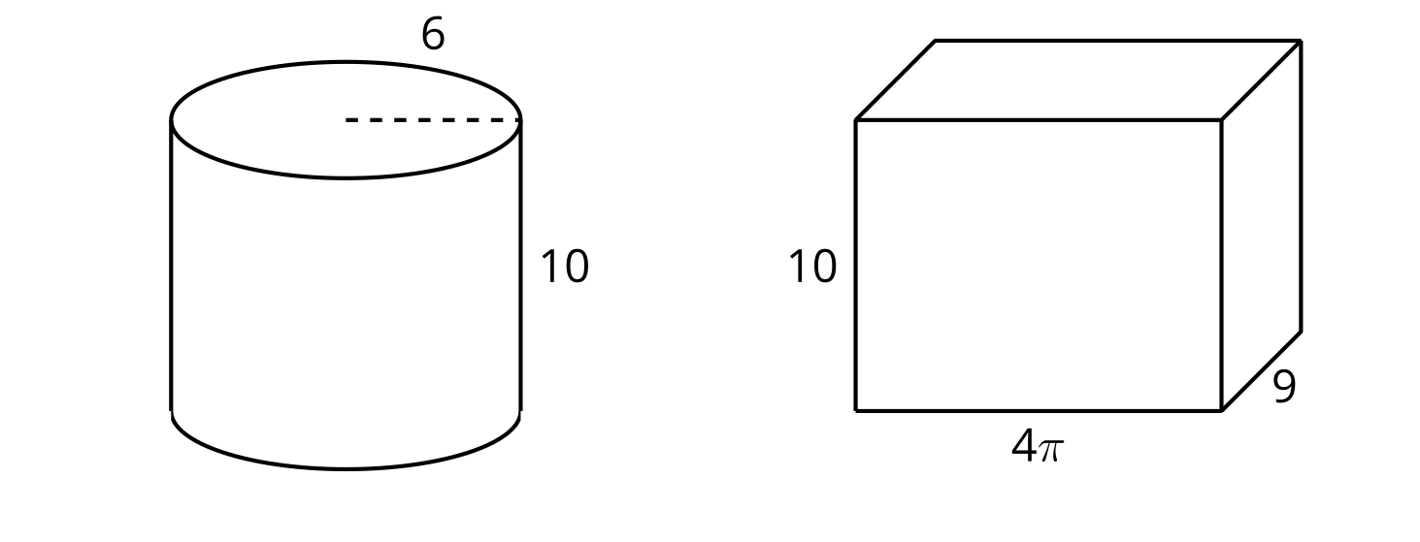
- Suppose the prism contains water that reaches a height of 1 cm.
  - Draw a representation of this situation.
  - The water is poured from the prism into the cylinder. What is the height of the water in the cylinder? Explain your reasoning.
- Suppose the prism contained water that reached a height of 3 cm instead of 1 cm. If the water were poured into the empty cylinder, what would the height of the water in the cylinder be?

9.3: Revisiting Rotation
Suppose each two-dimensional figure is rotated around the vertical axis shown. Each small square in the grid represents 1 square centimeter.

A
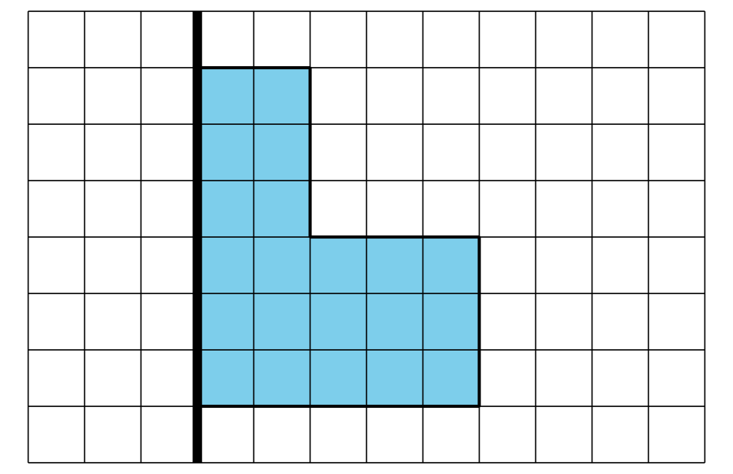

B
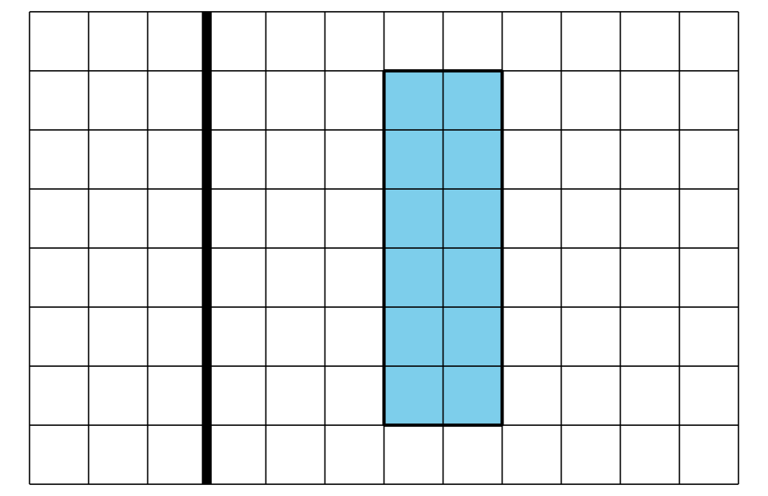
For each solid:
- Either sketch or describe in words the three-dimensional solid that would form.
- Find the solid’s volume.

Are you ready for more?
- Given a cylinder with radius $r$ and height $h$, write an expression for the volume if each of these changes were made.
  - The height is tripled to $3h$ and the radius remains $r$.
  - The radius is tripled to $3r$ and the height remains $h$.
- Given a cube of side length $s$, write an expression for the volume if the side length were tripled to $3s$.
- Which change affected the shape’s volume the most? The least? Explain or show your reasoning.

Lesson 9 Summary
Cylinder and prism volumes can be found by multiplying the area of the figure’s base by its height. The formula $V=Bh$, where $V$ represents volume, $B$ is the area of the base, and $h$ is height, captures this concept. Consider the solid formed by rotating this rectangle around the horizontal axis shown. The result is a hollow cylinder of height 5 units with inner radius 1 unit and outer radius 4 units.
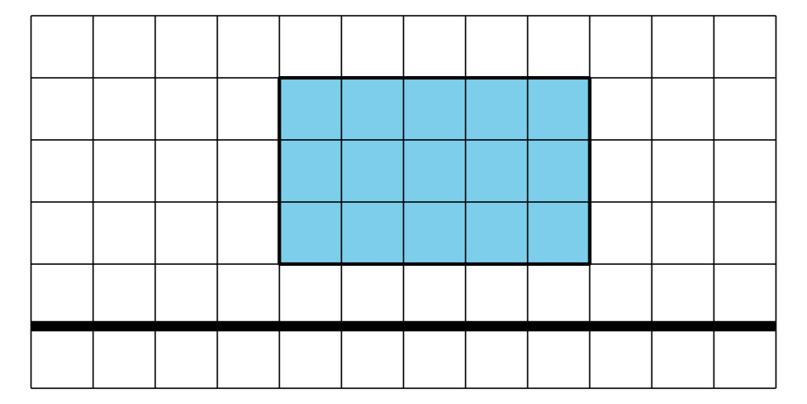
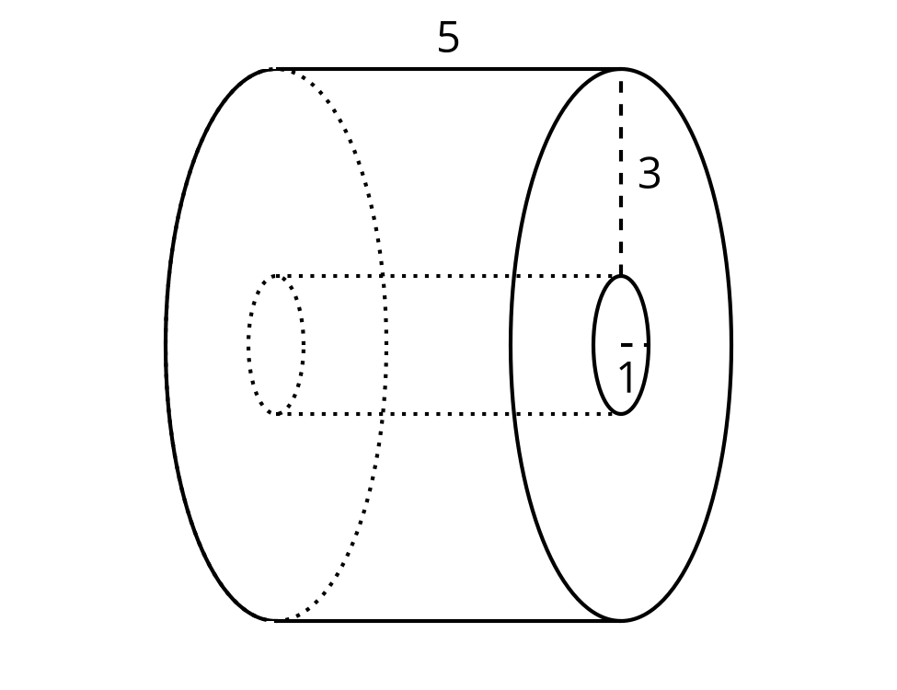
To calculate the volume of the outer cylinder, start by finding the area of the circular base. The circle’s radius measures 4 units, so its area is $16π$ square units because $π{\left(4\right)}^{2}=16π$. Multiply that by the cylinder’s height of 5 units to get $80π$ cubic units.
For the inner cylinder, the area of the base is $π$ square units, because $π{\left(1\right)}^{2}=π$. The volume is therefore $5π$ cubic units. Now subtract the volume of the inner, hollow part from the volume of the outer cylinder to get the volume of the solid: $75π$ cubic units because $80π−5π=75π$ .
© CC BY 2019 by Illustrative Mathematics®

