Lesson 17: Quadratic Meanings
- Let’s explore the meaning of quadratics.

17.1: Area Between Triangles
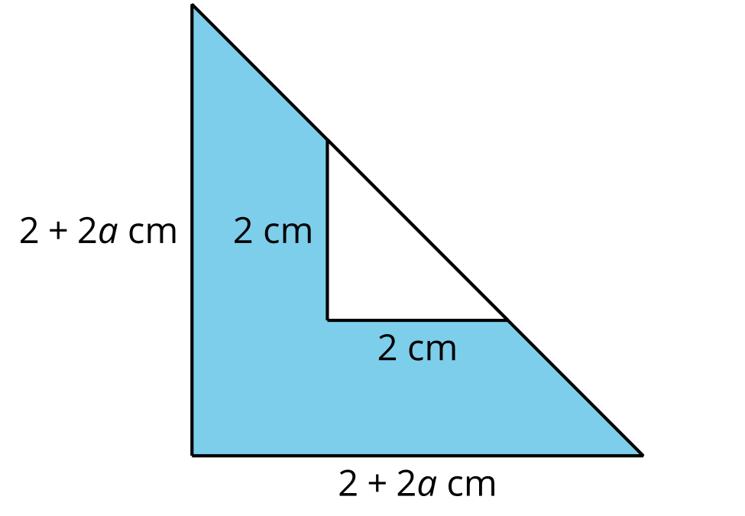
The area of the shaded region from the image can be represented by the expression $\frac{1}{2}\left(2+2a\right)\left(2+2a\right)−\frac{1}{2}⋅2^{2}$ which can be rearranged to $2a^{2}+4a$. To find the value of $a$ when the shaded area is 30 square centimeters, Mai sets up the equation $2a^{2}+4a=30$.
- One solution to the equation is $a=\text{-}5$. Find another solution. Explain or show your reasoning.
- What do the 2 solutions to the equation represent in this situation? Do the values make sense?

17.2: Getting the Ball Off the Roof
A ball is kicked off the roof of a building so that its height above the ground, given in feet, $t$ seconds after it is kicked is represented by the equation $h\left(t\right)=\text{-}16t^{2}+33t+37$.
- At what height is the ball when it is kicked? Explain or show your reasoning.
- At what height is the ball 2 seconds after it is kicked? Explain or show your reasoning.
- What does it mean for the situation when $h\left(t\right)=8$?
- What does it mean for the situation when $t=1.3$?
- Graph the function.
  - Approximate the number of seconds after the ball is kicked when it will hit the ground. Explain how you know.
  - Approximate the number of seconds after the ball is kicked when it will reach its highest point. Explain how you know.
  - Approximate the number of seconds after the ball is kicked when it will reach its starting height again. Explain how you know.
- Write an equation that represents the exact moment when the ball hits the ground.

17.3: Kicking the Field Goal
Andre kicks a football for a field goal. The height above ground, given in feet, $t$ seconds after it is kicked, is represented by the equation $g\left(t\right)=\text{-}16t^{2}+56t+0.5$.
- At what height is the ball when it is kicked? Explain or show your reasoning.
- At what height is the ball 2 seconds after it is kicked?
- What does it mean for the situation when $g\left(t\right)=10$?
- What does it mean for the situation when $t=1.7$?
- Graph the function.
  - Approximate the number of seconds after the ball is kicked when it will hit the ground. Explain how you know.
  - Approximate the number of seconds after the ball is kicked when it will reach its highest point. Explain how you know.
  - Approximate the number of seconds after the ball is kicked when it will be 10 feet above the ground for the second time. Explain how you know.
- Write an equation that would give the exact time when the ball is 10 feet above the ground.
© CC BY 2019 by Illustrative Mathematics®

