Unit 1 Lesson 2: Constructing Patterns

1 Math Talk: Why Is That True? (Warm up)

Student Task Statement
Here are 2 circles with centers $A$ and $B$.
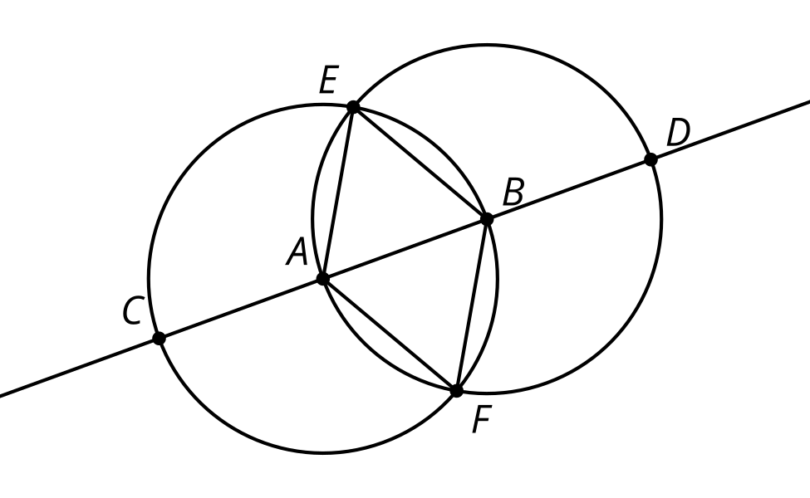
Based on the diagram, explain how you know each statement is true.
The length of segment $EA$ is equal to the length of segment $EB$.
Triangle $ABF$ is equilateral.
$AB=\frac{1}{3}CD$
$CB=DA$

2 Make Your Own

Images for Launch
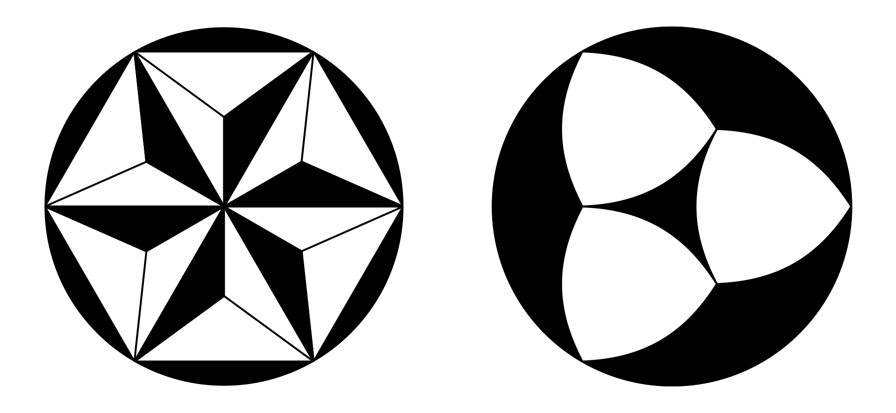

Student Task Statement
Use straightedge and compass moves to build your own pattern using the circle and radius as a place to start. As you make your pattern, record each move on a separate sheet of blank paper. Use precise vocabulary so someone can make a perfect copy without seeing the original. Include instructions about how to shade or color your pattern.
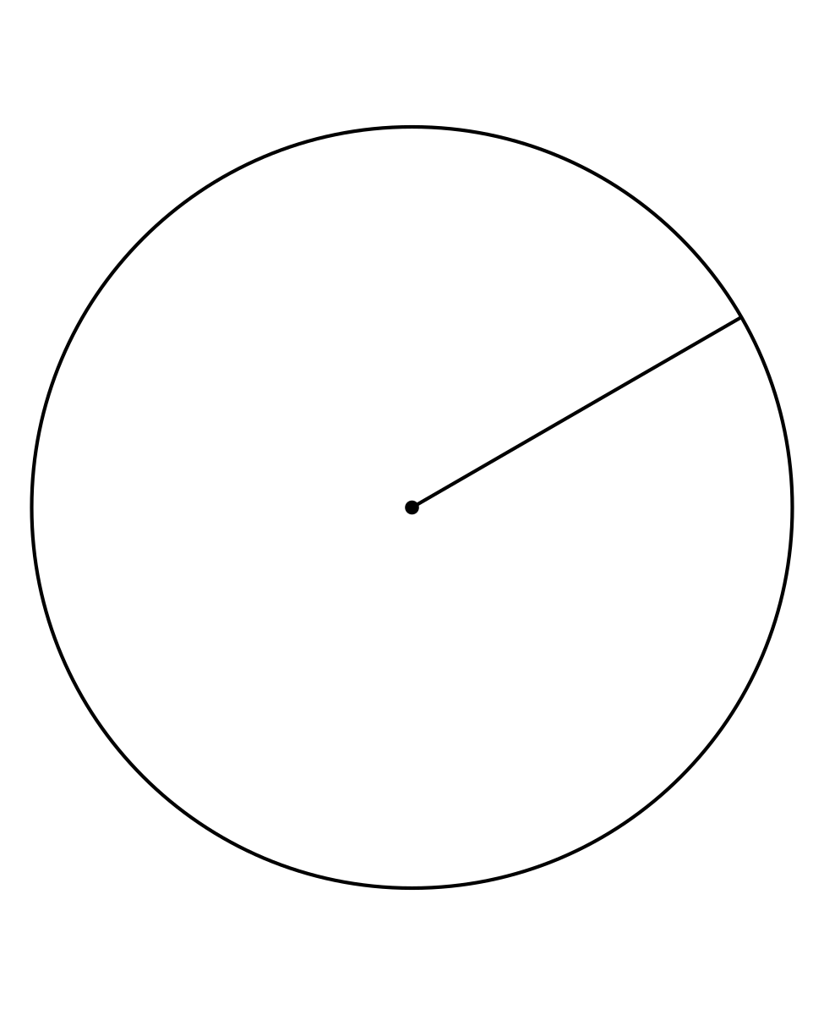

3 Make Someone Else’s

Student Task Statement
Follow the instructions precisely to recreate the pattern.

© CC BY 2019 by Illustrative Mathematics®

