Lesson 6: Scaling Solids
- Let’s see how the surface area and volume of solids change when we dilate them.

6.1: Math Talk: Cube Volumes
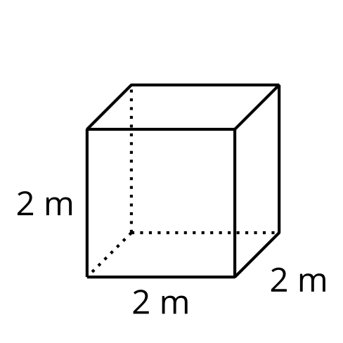
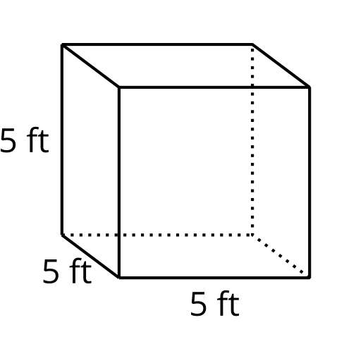
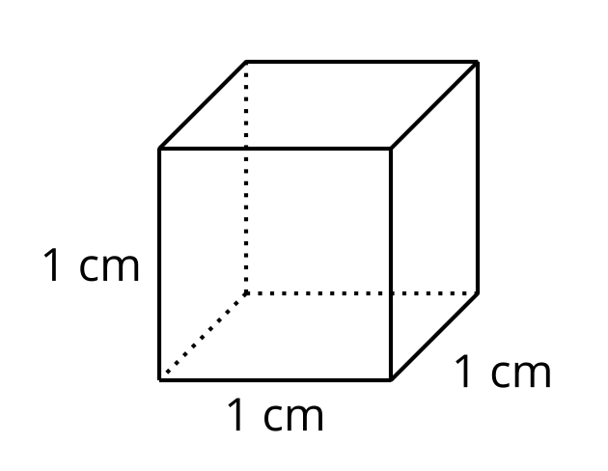
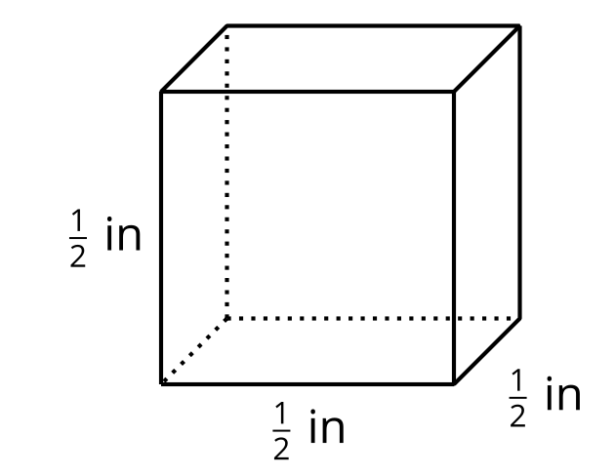
Find the volume of each cube mentally.

6.2: How Do Surface Area and Volume Change with Scaling?
- Use unit cubes to build cubes that result from dilating a unit cube by each scale factor shown in the table. Then, complete the table with the surface area and volume of each dilated cube.
- scale factor | - surface area in square units | - volume in cubic units
- 1
- 2
- 3
- 4
- Suppose a unit cube is dilated by some scale factor $k$.
  - Write an expression for the surface area of the dilated cube.
  - Write an expression for the volume of the dilated cube.
  - Compare and contrast the expression for surface area and the expression for volume.

6.3: Scaling All Solids
Clare says, “We know that if we dilate a cube by a factor of $k$, the cube’s volume is multiplied by $k^{3}$. It seems like that must apply to all solids, but I’m not sure how to prove it.”
Elena says, “Earlier in the unit, we showed that we can cover any two-dimensional shape with rectangles, so the property that area changes by $k^{2}$ when we dilate a figure by $k$ applies to all shapes, not just rectangles. Can we do something similar here?”
- Use Elena’s line of reasoning to argue that for any solid, if it’s dilated by a factor of $k$, the volume is multiplied by $k^{3}$.
- Suppose a triangular prism has surface area 84 square centimeters and volume 36 cubic centimeters. The prism is dilated by scale factor $k=4$. Calculate the surface area and volume of the dilated prism.

Are you ready for more?
The image shows a figure called Sierpinski’s triangle. It’s formed by starting with an equilateral triangle, then repeatedly removing equilateral triangles created by joining the midpoints of the existing triangle’s sides. The first few stages are shown.

stage 1
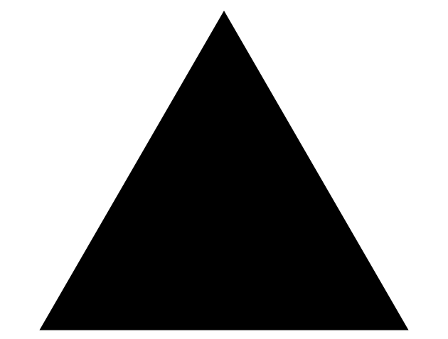

stage 2
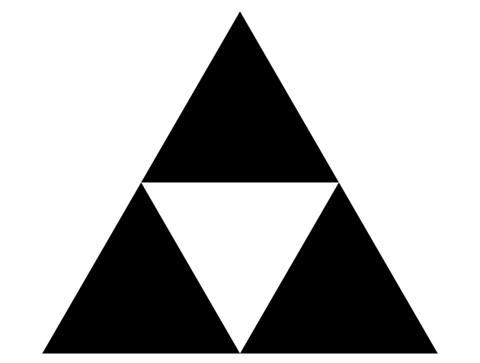

stage 3
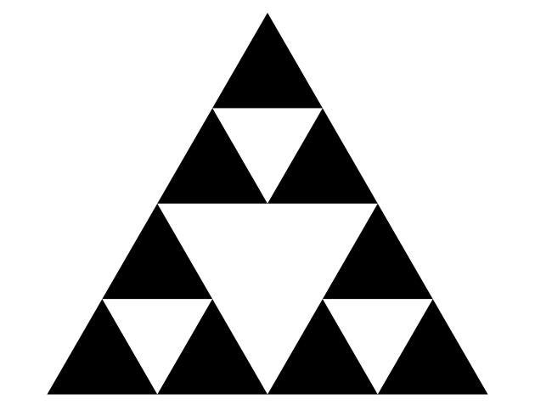
If we continue this process of removal forever, we are left with some points that never get removed from the triangle. The remaining points are what we call Sierpinski’s triangle. At any given stage, the triangle at the top of the figure is a scaled copy of the triangle at the previous stage.

stage 4
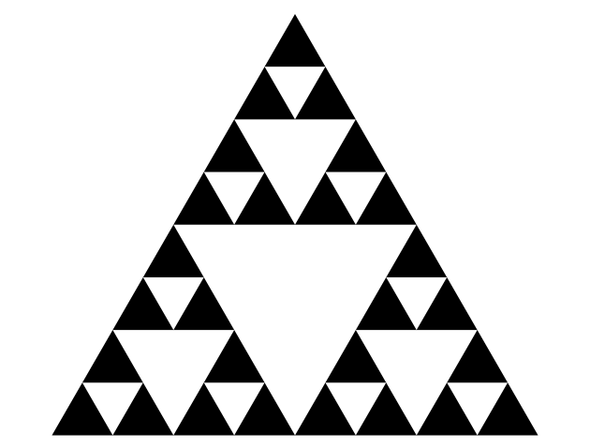

top triangle
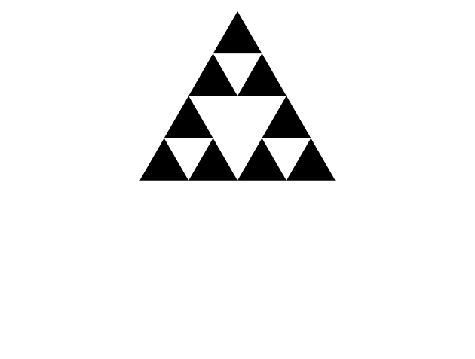
For the completed Sierpinski’s triangle, though, the top triangle is a scaled copy not of the previous stage, but of the full Sierpinski’s triangle.
- For the completed figure, what scale factor takes Sierpinski’s triangle to its scaled copy at the top?
- Based on the scale factor, what fraction of the original shaded region should be contained in the scaled copy at the top?
- The scaled copy at the top actually contains $\frac{1}{3}$ of the shading of the original. Provide reasoning that shows that this is true.

Lesson 6 Summary
In earlier activities, we saw that if we dilate a two-dimensional shape, the area of the dilated shape is the area of the original shape multiplied by the square of the scale factor. What happens when we dilate three-dimensional solids?
Here is a rectangular prism with side lengths 3, 4, and 5 units. When we dilate the prism using a scale factor of 3, the lengths become 9, 12, and 15 units.
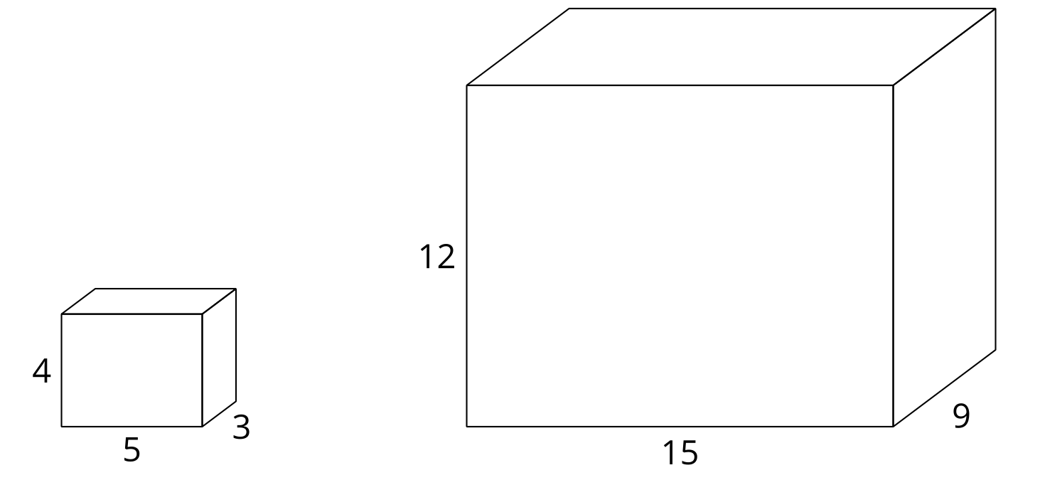
Since these are three-dimensional shapes, we can look at both volume and surface area. The volume of the original prism is 60 cubic units because $3⋅4⋅5=60$. The volume of the dilated prism is 1,620 cubic units because $9⋅12⋅15=1,​620$. The volume became 27 times larger! Why? Since the side lengths tripled, when we calculated the volume we were really finding $\left(3⋅3\right)⋅\left(4⋅3\right)⋅\left(5⋅3\right)=\left(3⋅4⋅5\right)⋅3^{3}$. The volume was multiplied by the cube of the scale factor, or by $3^{3}=27$.
Now let’s look at surface area. How do you think the surface area will change when the prism is dilated?
In the original prism, 2 faces have area 12 square units, 2 have area 20 square units, and 2 have area 15 square units for a total surface area of 94 square units. The corresponding faces of the dilated prism have areas 108, 180, and 135 square units. The surface area of the new prism totals 846 square units, 9 times that of the original. Just like the area of two-dimensional shapes, the surface area of the prism changed by the square of the scale factor.
In general, when you dilate any three-dimensional solid by scale factor $k$, the surface area is multiplied by $k^{2}$ and the volume is multiplied by $k^{3}$.
© CC BY 2019 by Illustrative Mathematics®

