Unit 7 Lesson 15: Shapes on the Coordinate Plane

1 Figuring Out The Coordinate Plane (Warm up)

Student Task Statement
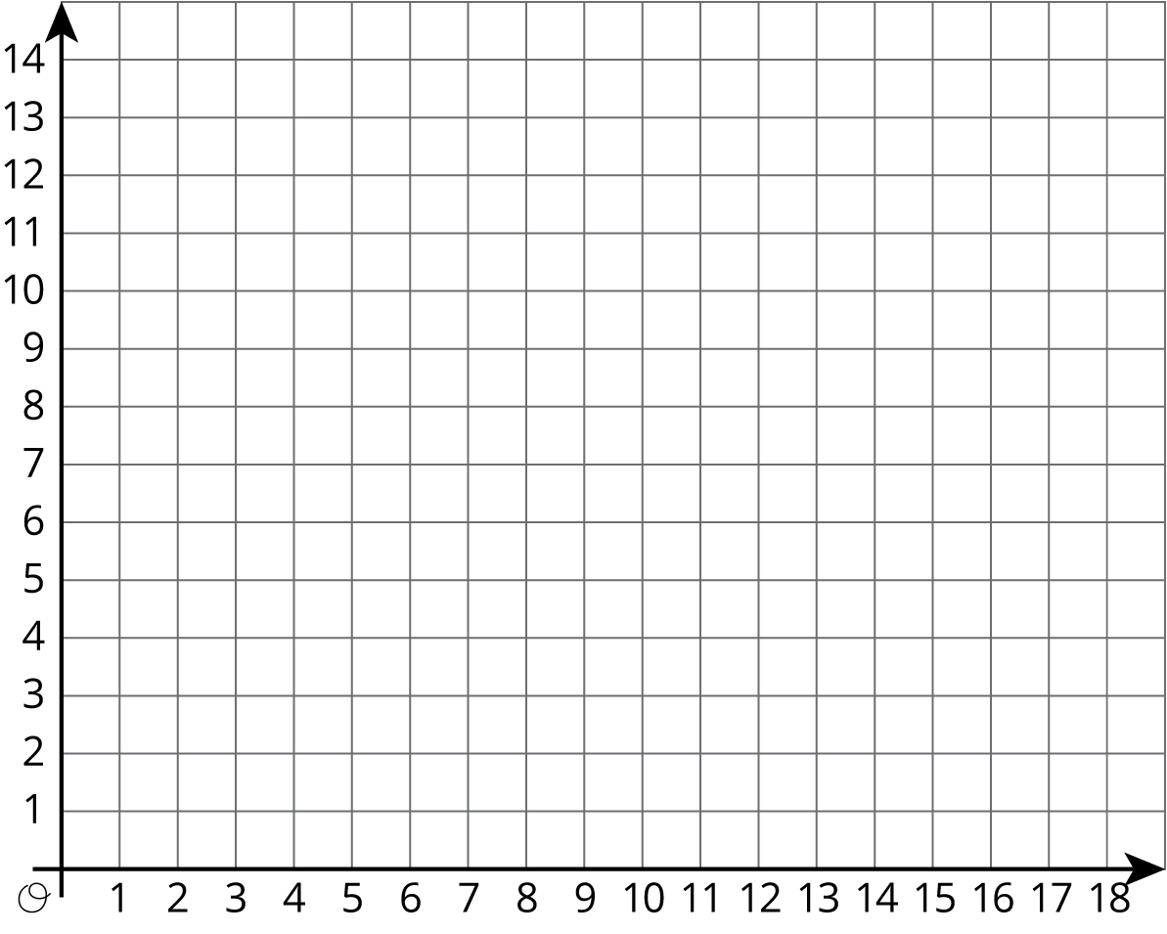
- Draw a figure in the coordinate plane with at least three of following properties:
  - 6 vertices
  - Exactly 1 pair of parallel sides
  - At least 1 right angle
  - 2 sides with the same length
- Is your figure a polygon? Explain how you know.

2 Plotting Polygons

Student Task Statement
Here are the coordinates for four polygons. Plot them on the coordinate plane, connect the points in the order that they are listed, and label each polygon with its letter name.
- Polygon A: $\left(\text{-}7,4\right),\left(\text{-}8,5\right),\left(\text{-}8,6\right),\left(\text{-}7,7\right),\left(\text{-}5,7\right),\left(\text{-}5,5\right),\left(\text{-}7,4\right)$
- Polygon B: $\left(4,3\right),\left(3,3\right),\left(2,2\right),\left(2,1\right),\left(3,0\right),\left(4,0\right),\left(5,1\right),\left(5,2\right),\left(4,3\right)$
- Polygon C: $\left(\text{-}8,\text{-}5\right),\left(\text{-}8,\text{-}8\right),\left(\text{-}5,\text{-}8\right),\left(\text{-}5,\text{-}5\right),\left(\text{-}8,\text{-}5\right)$
- Polygon D: $\left(\text{-}5,1\right),\left(\text{-}3,\text{-}3\right),\left(\text{-}1,\text{-}2\right),\left(0,3\right),\left(\text{-}3,3\right),\left(\text{-}5,1\right)$
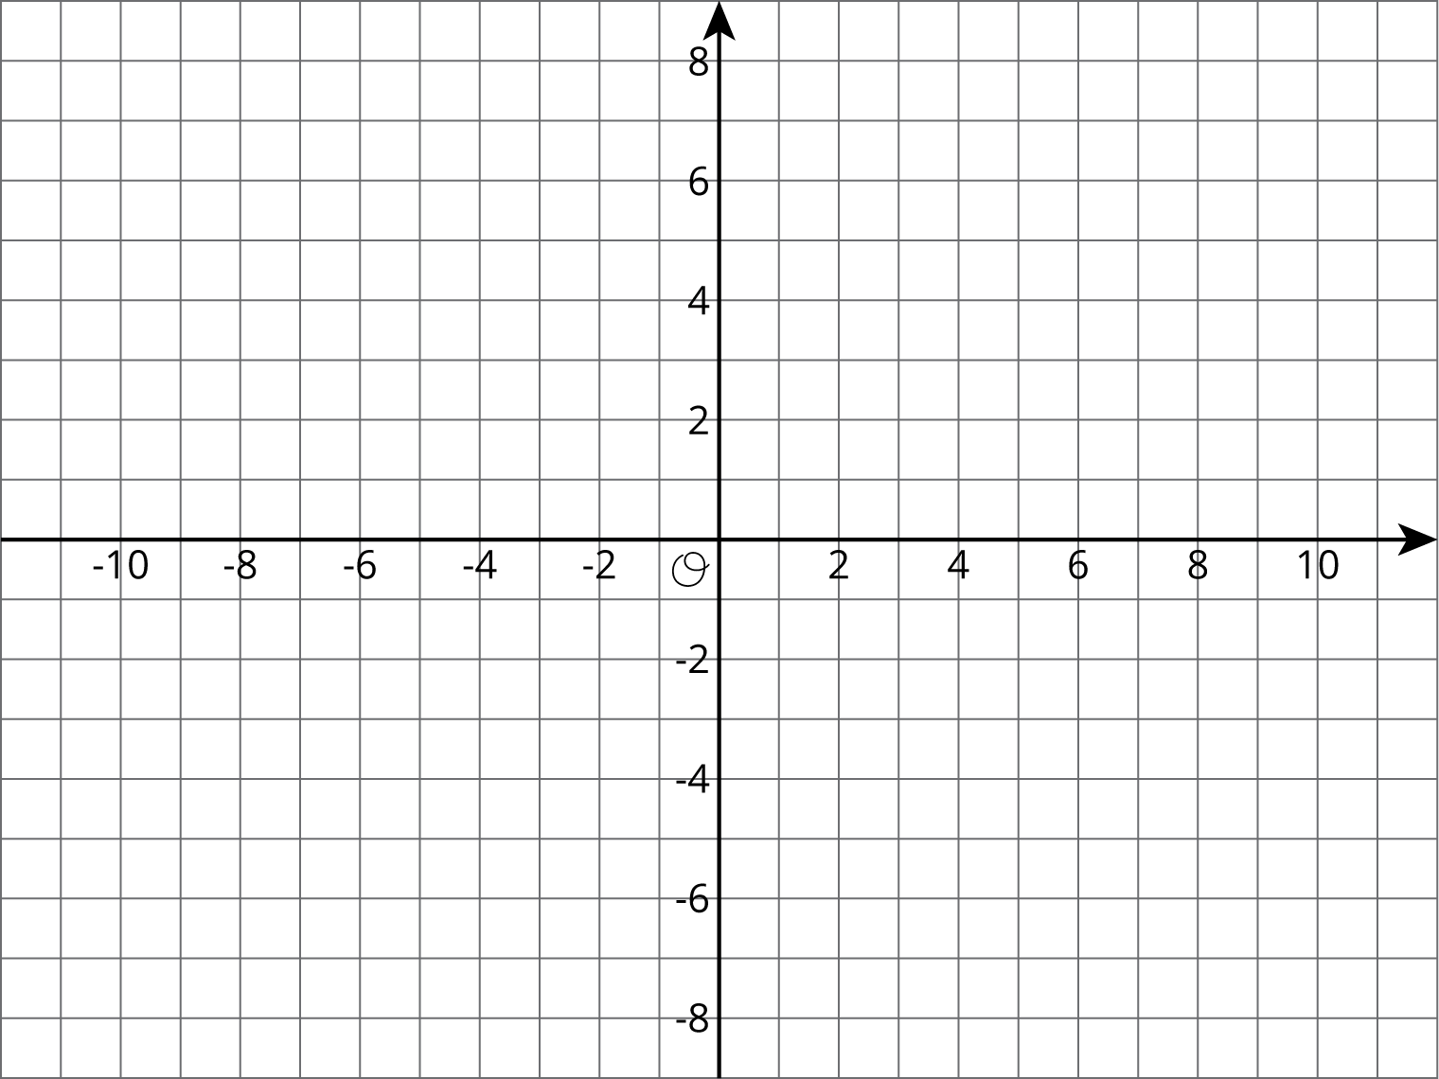

3 Four Quadrants of A-Maze-ing

Student Task Statement
- The following diagram shows Andre’s route through a maze. He started from the lower right entrance.
- 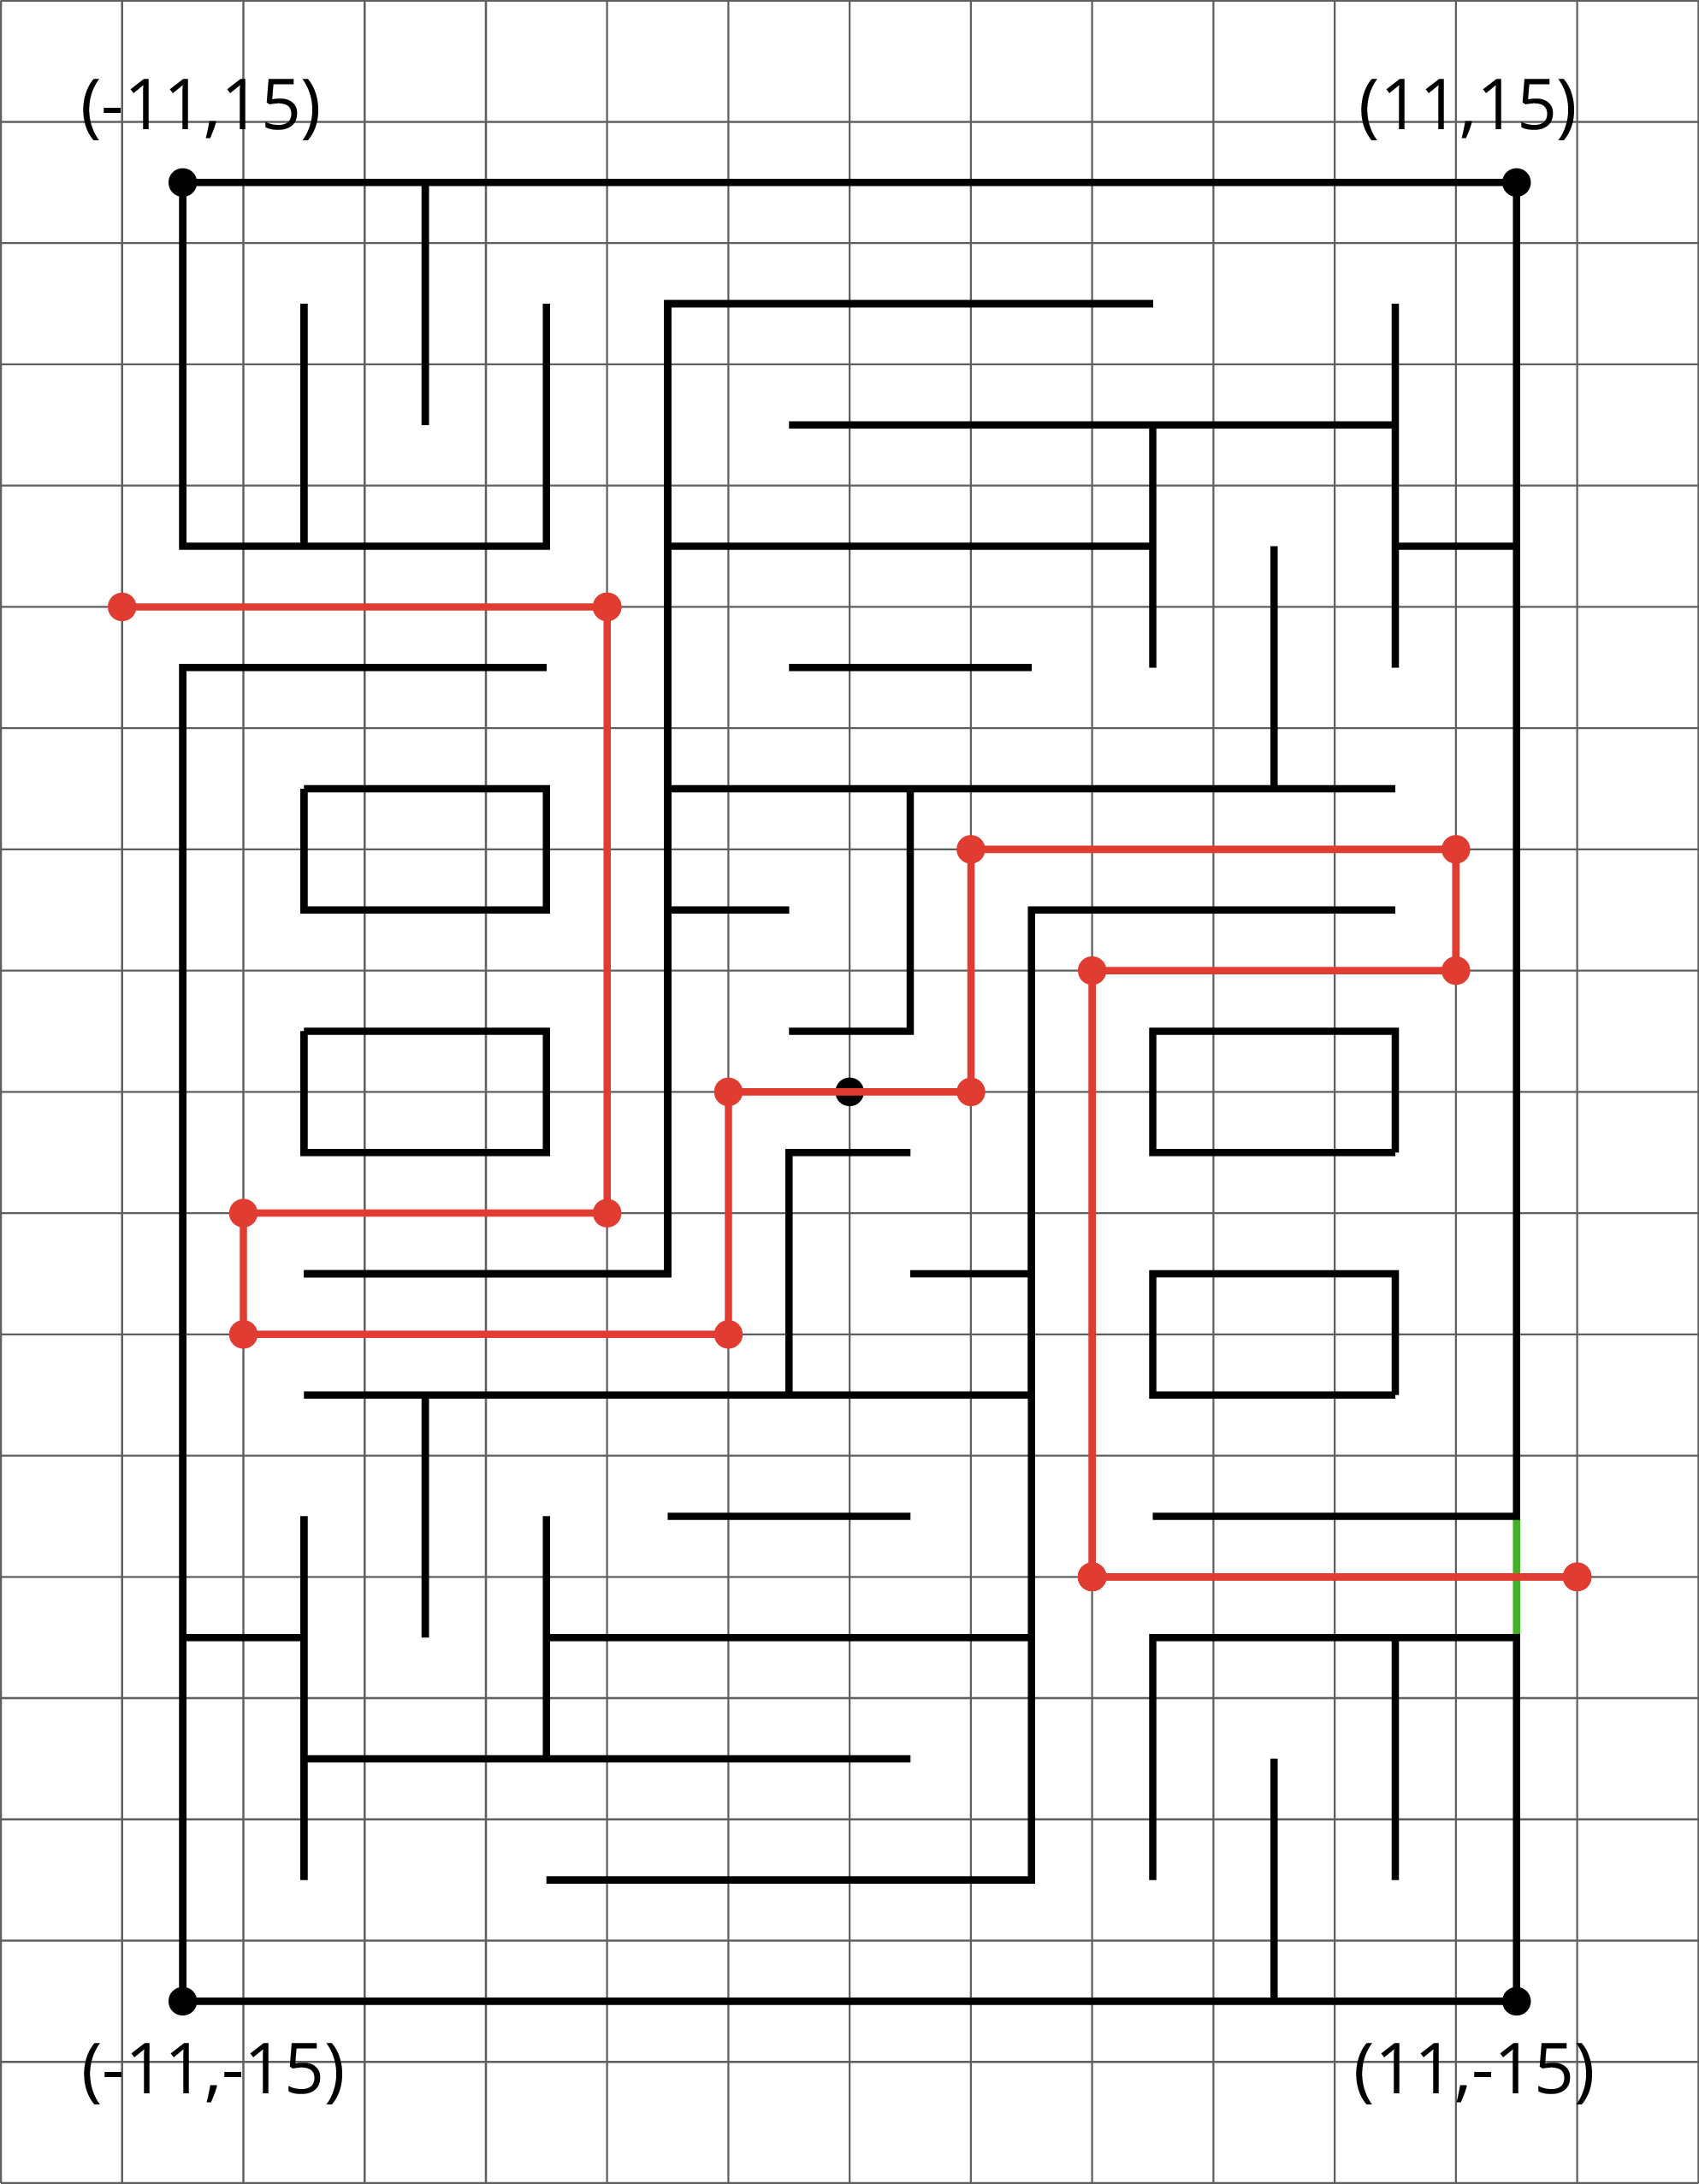
  - What are the coordinates of the first two and the last two points of his route?
  - How far did he walk from his starting point to his ending point? Show how you know.
- Jada went into the maze and stopped at $\left(\text{-}7,2\right)$.
  - Plot that point and other points that would lead her out of the maze (through the exit on the upper left side).
  - How far from $\left(\text{-}7,2\right)$ must she walk to exit the maze? Show how you know.
© CC BY Open Up Resources. Adaptations CC BY IM.

