Lesson 4: Scaling and Area
- Let’s see how the area of shapes changes when we dilate them.

4.1: Squares and Roots
- What number times itself equals 25?
- What number times itself equals 81?
- What number times itself equals 10?

4.2: Scaling Up a Rectangle
Here is a rectangle with length 5 units and width 2 units.
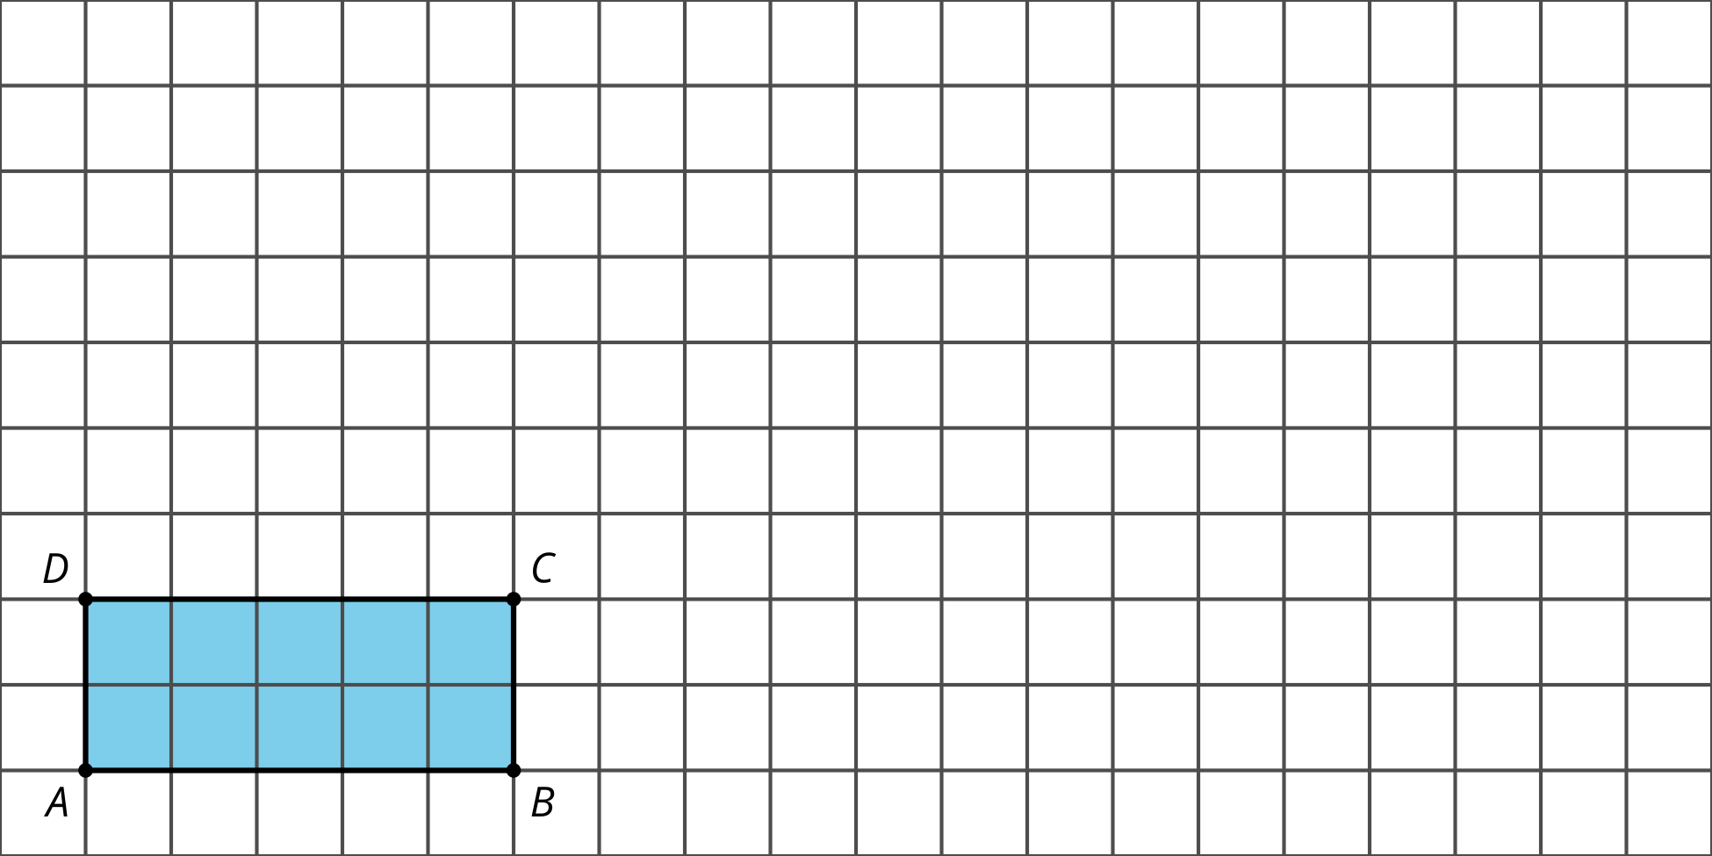
- What is the area of the rectangle?
- Dilate rectangle $ABCD$ from point $A$ by a scale factor of 2. Calculate the area of the image.
- Dilate rectangle $ABCD$ from point $A$ by a scale factor of 3. Calculate the area of the image.
- Complete the table.
- scale factor | - area of image in square units | - factor by which the area changed
- 0.5
- 1
- 2
- 2.5
- 3
- 4
- Write an expression for the area of a rectangle with length $ℓ$ and width $w$.
- Imagine dilating the rectangle with length $ℓ$ and width $w$ by a factor of $k$. Write expressions for the dimensions of the dilated rectangle.
- Write an expression for the area of the dilated rectangle.
- Use your work to draw a conclusion about what happens to the area of a rectangle when it’s dilated by a scale factor of $k$.

Are you ready for more?
The image shows a dilation of an equilateral triangle by scale factors of 1, 2, 3, and 4. At each stage, the dilated shape is partitioned into triangles congruent to the original.
- Why is the difference in the number of original triangles that fit into the image between 2 successive scale factors always odd?
- What does this image tell us about the sum of the first $n$ odd numbers?
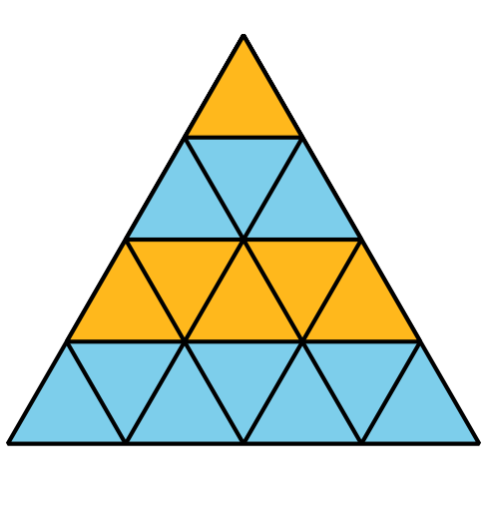

4.3: What About Other Shapes?
Andre says, “We know that if a rectangle is scaled by a factor of $k$, the area scales by a factor of $k^{2}$. Does this apply to other shapes?”
Jada says, “Here’s a shape that’s not a rectangle. Say its area is $A$ square units. Let’s draw some rectangles on it that get smaller and smaller to fit the remaining empty space. With enough rectangles we can come close to covering the whole blob.”
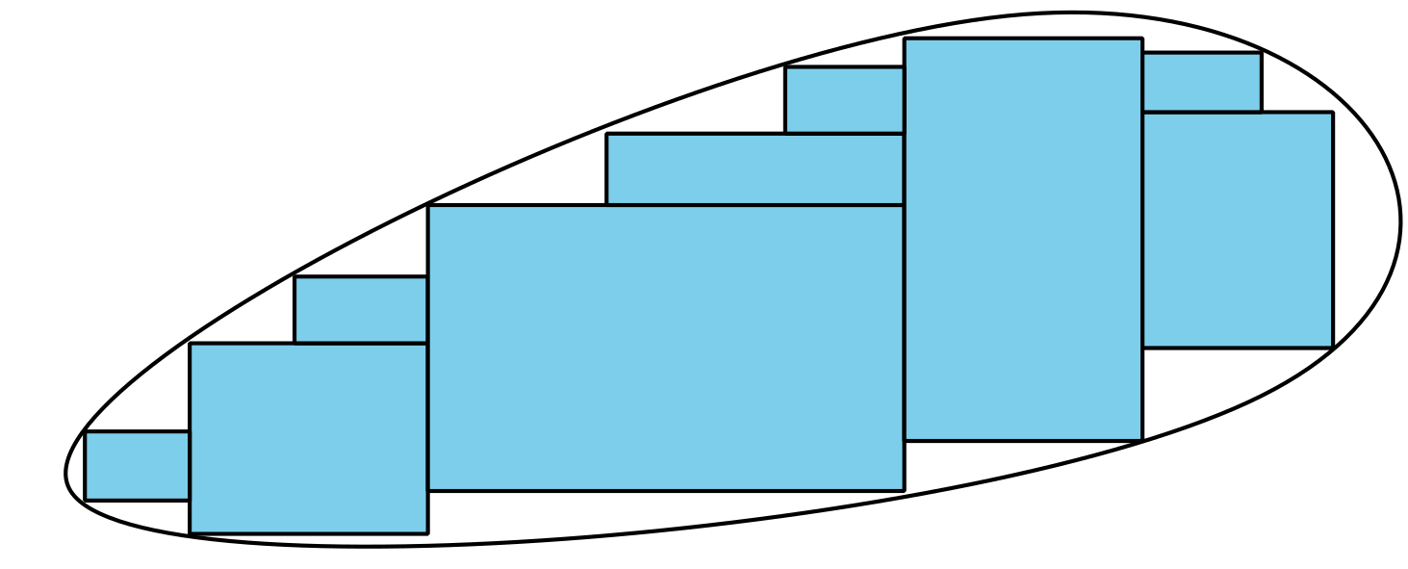
Andre says, “These rectangles start to make a nice approximation of the blob. If we wanted to get closer, we could add even more rectangles. The sum of the areas of all the rectangles would add up to the area of the blob. I think we’re almost there!”
- Suppose the blob is dilated by a factor of $k$. In doing this, the rectangles covering the blob also get dilated by a factor of $k$. How does the area of each dilated rectangle compare to the area of each original rectangle?
- What does this tell you about the area of the dilated image? Explain your reasoning.
- Suppose a circle has area 20 square inches and it’s dilated using a scale factor of 6. What is the area of the image? Explain or show your reasoning.

Lesson 4 Summary
Say you have a 5 inch by 4 inch rectangle. Its area is 20 square inches. If you dilate the rectangle by a scale factor of 3, what do you think the area of the new rectangle will be?
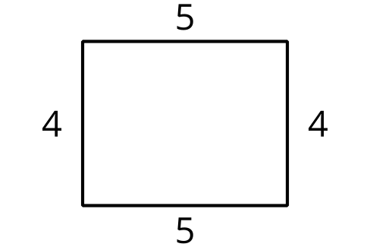
The dilated rectangle’s dimensions can be written as $3⋅5$ and $3⋅4$. Substitute these values into the area expression $ℓ⋅w$ to get $\left(3⋅5\right)\left(3⋅4\right)$. Rearrange the numbers to get $\left(3⋅3\right)\left(5⋅4\right)$. This can be rewritten $\left(3^{2}\right)\left(5⋅4\right)$ or $9⋅20$. So the area of the dilated rectangle is 180 square inches, or 9 times the original. The diagram confirms that 9 of the original rectangles fit into the dilated rectangle.
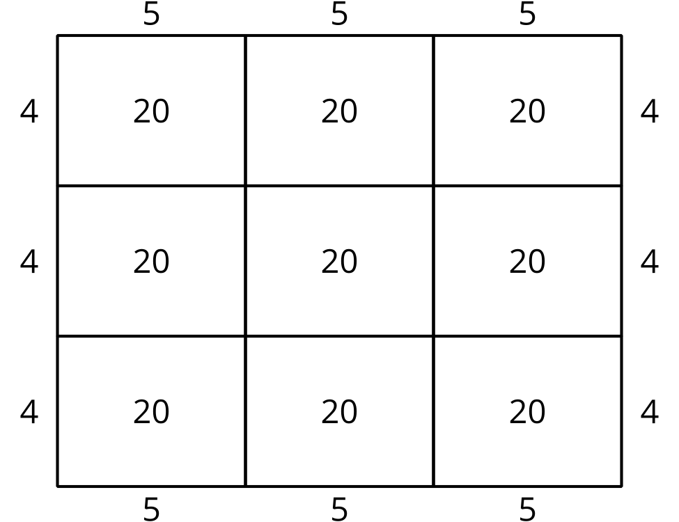
In general, when you scale a rectangle by a factor of $k$, the length and the width are both multiplied by $k$, so the area is multiplied by $k^{2}$.
What if you dilate a shape that is not a rectangle by a scale factor of $k$? Consider the rounded shape called an ellipse in the image. You can approximate the area of an ellipse by filling it with many rectangles. The sum of the areas of the rectangles will be a little less than the area of the ellipse because they don’t fill it entirely. If you want to get closer to the area of the ellipse, draw in more rectangles. If you continued the process infinitely, you could find the exact area of the ellipse this way.
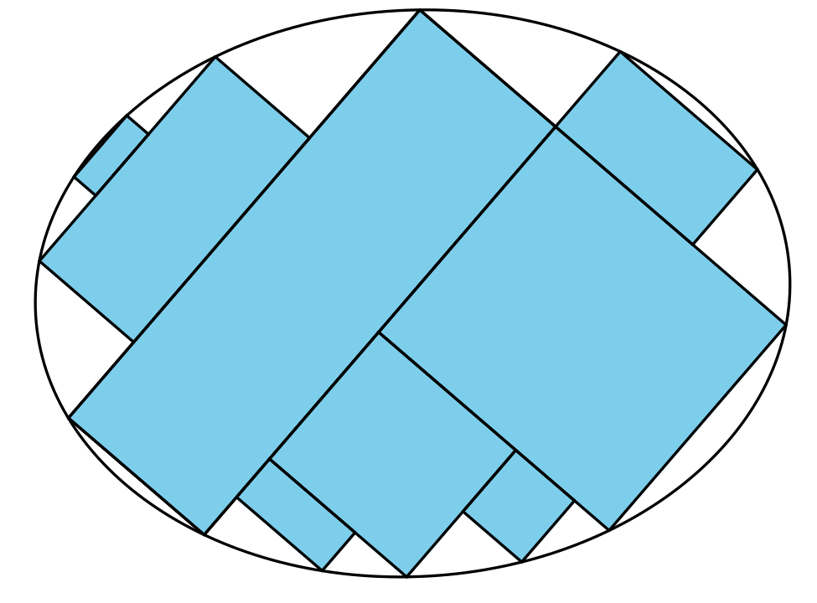
If you dilated this ellipse using a scale factor of 4, each rectangle would become 16 times larger. This means that the area of the ellipse will increase by a factor of 16 as well. Any closed shape can be filled with rectangles that approximate its area. Because of this, when you scale any shape by a factor of $k$, its area is multiplied by a factor of $k^{2}$.
© CC BY 2019 by Illustrative Mathematics®

