Lesson 7: The Root of the Problem
- Let’s look at relationships between volumes, areas, and scale factors using graphs and situations.

7.1: The Number That Cubes
A cube whose side lengths measure 1 unit has been dilated by several scale factors to make new cubes.
- For what scale factor will the volume of the dilated cube be 27 cubic units?
- For what scale factor will the volume of the dilated cube be 1,000 cubic units?
- Estimate the scale factor that would be needed to make a cube with volume of 1,001 cubic units.
- Estimate the scale factor that would be needed to make a cube with volume of 7 cubic units.

7.2: Thinking Inside the Box
A shipping company makes cube-shaped boxes. Their basic box measures 1 foot per side. They want to know how to scale the basic box to build new boxes of various volumes.
- If the company wants a box with a volume of 8 cubic feet, by what scale factor do they need to dilate the box?
- If they want a box with a volume of 10 cubic feet, approximately what scale factor do they need?
- The company decides to create a graph to help analyze the relationship between volume ($x$) and scale factor ($y$). Complete the table, rounding values to the nearest hundredth if needed.
- Then, on graph paper, plot the points and connect them with a smooth curve.
- volume in cubic feet | - scale factor
- 0
- 1
- 5
- 8
- 10
- 15
- 20
- 27
- The graph shows the relationship between the volume of the dilated box and the scale factor. Write an equation that describes this relationship.
- Suppose the company builds a box with volume 21 cubic feet, then decides to build another with volume 25 cubic feet. Use your graph to estimate how much the scale factor changes between these 2 dilated boxes.
- Use your graph to estimate how the scale factor changes between a box with volume of 1 cubic foot and one with volume of 5 cubic feet.

7.3: Satellite Scale Factors
A government agency is redesigning a satellite, or an object that goes in orbit around Earth. The surface of the satellite is covered with solar panels that supply the satellite with energy. The interior of the satellite is filled with scientific instruments. In the current design, the satellite has a surface area of 5.4 square feet and a volume of 1.2 cubic feet.
- If the agency wants to increase the surface area to 21.6 square feet so the satellite can generate more energy, by what scale factor do they need to dilate the satellite?
- If the agency instead wants to increase the volume to 4.05 cubic feet to fit in more scientific instruments, by what scale factor do they need to dilate the satellite?

Are you ready for more?
Is it possible to dilate the satellite in the activity so that the number of square feet of surface area is equal to the number of cubic feet of volume? Explain or show your reasoning.

Lesson 7 Summary
Suppose a prism has a volume of 5 cubic units. The prism is dilated, and the resulting solid has volume 320 cubic units. If we want to find the scale factor that was used in the dilation, we start by dividing the new volume, 320 cubic units, by the original volume, 5 cubic units, to find that the prism’s volume increased by a factor of 64. We know that when a solid is dilated by a scale factor $k$, the volume is multiplied by $k^{3}$. So, we need to find the number whose cube is 64. This number is called the cube root of 64 and is written $\sqrt[3]{64}$. We know $\sqrt[3]{64}=4$ because $4⋅4⋅4=64$. That is, the prism was dilated by a scale factor of $k=4$.
We can create a graph that shows the relationship between the volume, $V$, of a dilated solid and the scale factor, $k$, needed to achieve it. Let’s use the prism with volume 5 cubic units as an example. Create a table of values, then plot the points and connect them with a smooth curve.
dilated volume in cubic units ($V$) | scale factor ($k$)
0 | 0
5 | 1
40 | 2
135 | 3
320 | 4
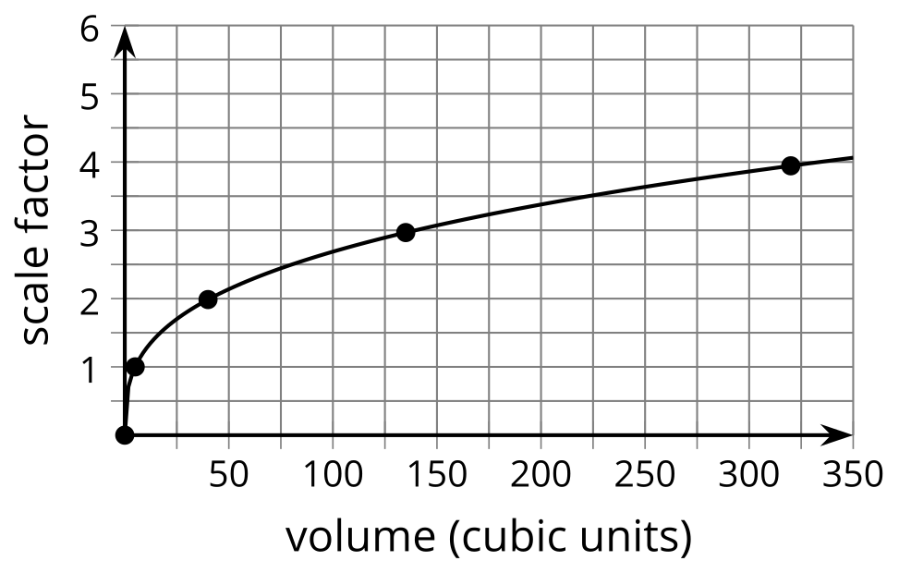
This graph represents the equation $k=\sqrt[3]{\frac{V}{5}}$. The graph rises relatively steeply from $\left(0,0\right)$ but quickly flattens out.
We can also find the scale factor of dilation if we know the surface areas of the original and dilated solids. Suppose a cylinder has surface area 35 square units, and is dilated resulting in a surface area of 218.75 square units. Divide the numbers to find that the surface area increased by a factor of 6.25. Take the square root of 6.25 to conclude that the solid was dilated by a factor of 2.5.
© CC BY 2019 by Illustrative Mathematics®

