Lesson 7 Practice Problems
- Write a formula you could type into a spreadsheet to compute the value of each expression.
  - $\left(19.2\right)⋅73$
  - ${1.1}^{5}$
  - $2.34÷5$
  - $\frac{91}{7}$
- A long-distance runner jogs at a constant speed of 7 miles per hour for 45 minutes. Which spreadsheet formula would give the distance she traveled?
  - = 7 * 45
  - = 7 / 45
  - = 7 * (3 / 4)
  - = 7 / (3 / 4)
- In a right triangle, the lengths of the sides that make a right angle are 3.4 meters and 5.6 meters. Select all the spreadsheet formulas that would give the area of this triangle.
  - = 3.4 * 5.6
  - = 3.4 * 5.6 * 2
  - = 3.4 * 5.6 / 2
  - = 3.4 * 5.6 * (1/2)
  - = (3.4 * 5.6) / 2
- This spreadsheet should compute the total ounces of sparkling grape juice based on the number of batches, ounces of grape juice in a single batch, and ounces of sparkling water in a single batch.
- 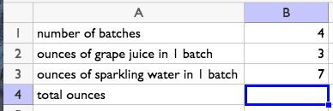
  - Write a formula for cell B4 that uses the values in cells B1, B2, and B3, to compute the total ounces of sparkling grape juice.
  - How would the output of the formula change if the value in cell B1 was changed to 10?
  - What would change about the sparkling grape juice if the value in B3 was changed to 10?
- The dot plot and the box plot represent the same distribution of data.
- 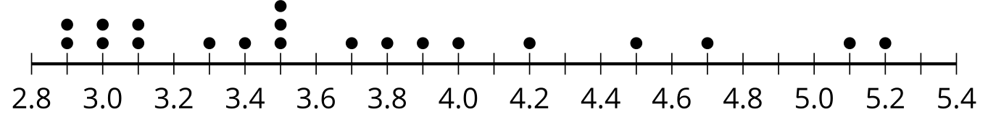
- 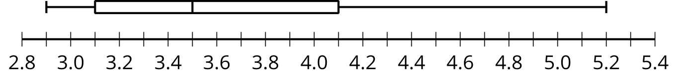
  - How does the median change when the highest value, 5.2, is removed?
  - How does the IQR change when the highest value, 5.2, is removed?
- (From Unit 1, Lesson 5.)
- Describe the shape of the distribution shown in the histogram which displays the light output, in lumens, of various light sources.
- 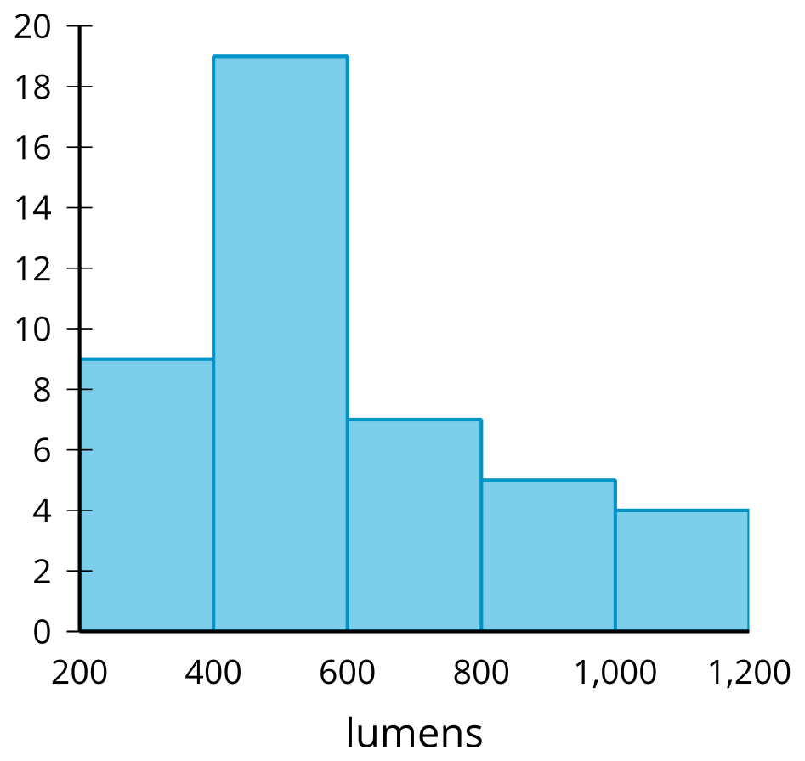

- (From Unit 1, Lesson 4.)
- The dot plot represents the distribution of the number of goals scored by a soccer team in 10 games.
- 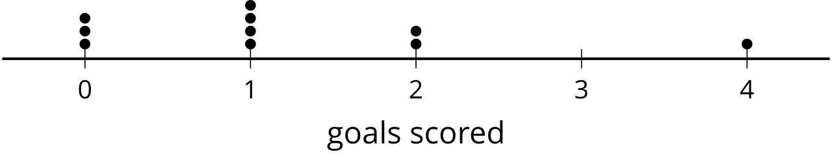
  - If possible, find the mean. If not possible, explain why not.
  - If possible, find the median. If not possible, explain why not.
  - Did the soccer team ever score exactly 3 goals in one of the games?
- (From Unit 1, Lesson 2.)
© CC BY 2019 by Illustrative Mathematics®

