Unit 1 Lesson 5: The Size of the Scale Factor

1 Number Talk: Missing Factor (Warm up)

Student Task Statement
Solve each equation mentally.
$16x=176$
$16x=8$
$16x=1$
$\frac{1}{5}x=1$
$\frac{2}{5}x=1$

2 Card Sort: Scaled Copies

Student Task Statement
Your teacher will give you a set of cards. On each card, Figure A is the original and Figure B is a scaled copy.
- Sort the cards based on their scale factors. Be prepared to explain your reasoning.
- Examine cards 10 and 13 more closely. What do you notice about the shapes and sizes of the figures? What do you notice about the scale factors?
- Examine cards 8 and 12 more closely. What do you notice about the figures? What do you notice about the scale factors?

3 Scaling A Puzzle (Optional)

Student Task Statement
Your teacher will give you 2 pieces of a 6-piece puzzle.
- If you drew scaled copies of your puzzle pieces using a scale factor of $\frac{1}{2}$, would they be larger or smaller than the original pieces? How do you know?
- Create a scaled copy of each puzzle piece on a blank square, with a scale factor of $\frac{1}{2}$.
- When everyone in your group is finished, put all 6 of the original puzzle pieces together like this:
- 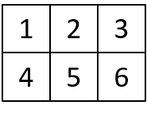
- Next, put all 6 of your scaled copies together. Compare your scaled puzzle with the original puzzle. Which parts seem to be scaled correctly and which seem off? What might have caused those parts to be off?
- Revise any of the scaled copies that may have been drawn incorrectly.
- If you were to lose one of the pieces of the original puzzle, but still had the scaled copy, how could you recreate the lost piece?

4 Missing Figure, Factor, or Copy (Optional)

Student Task Statement
- What is the scale factor from the original triangle to its copy? Explain or show your reasoning.
- 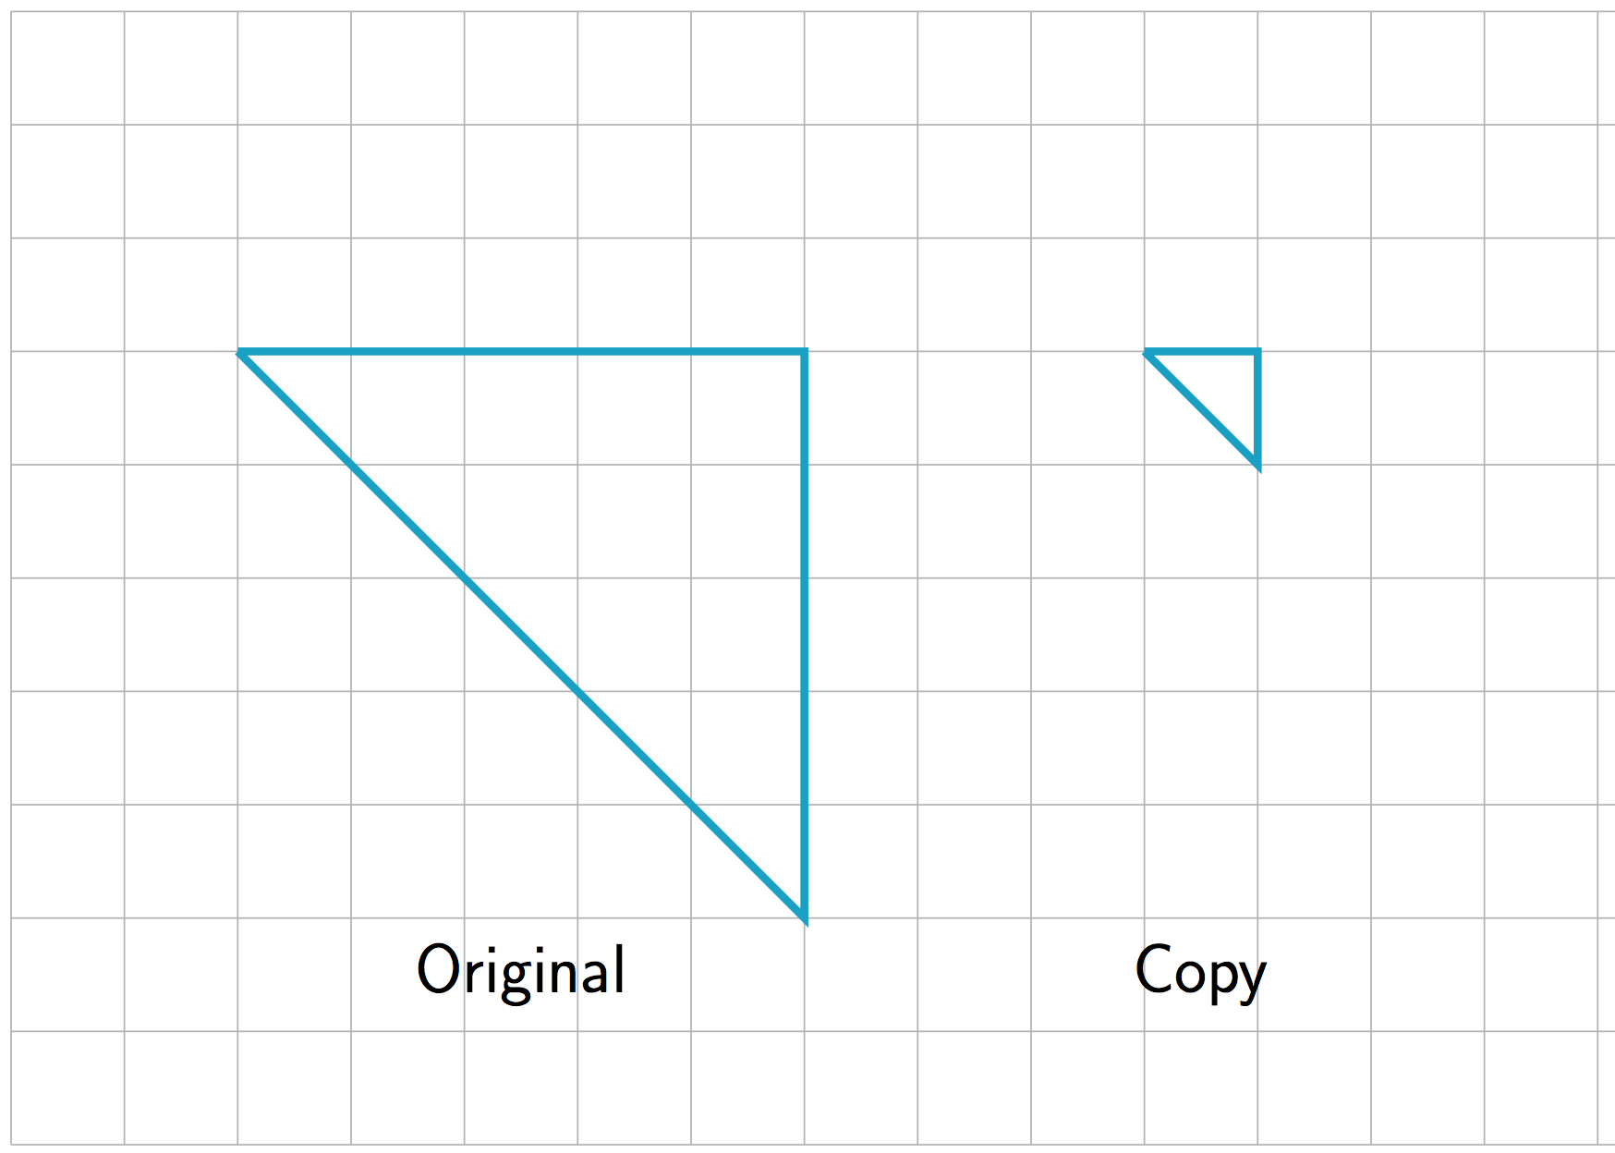
- ​
- The scale factor from the original trapezoid to its copy is 2. Draw the scaled copy.
- 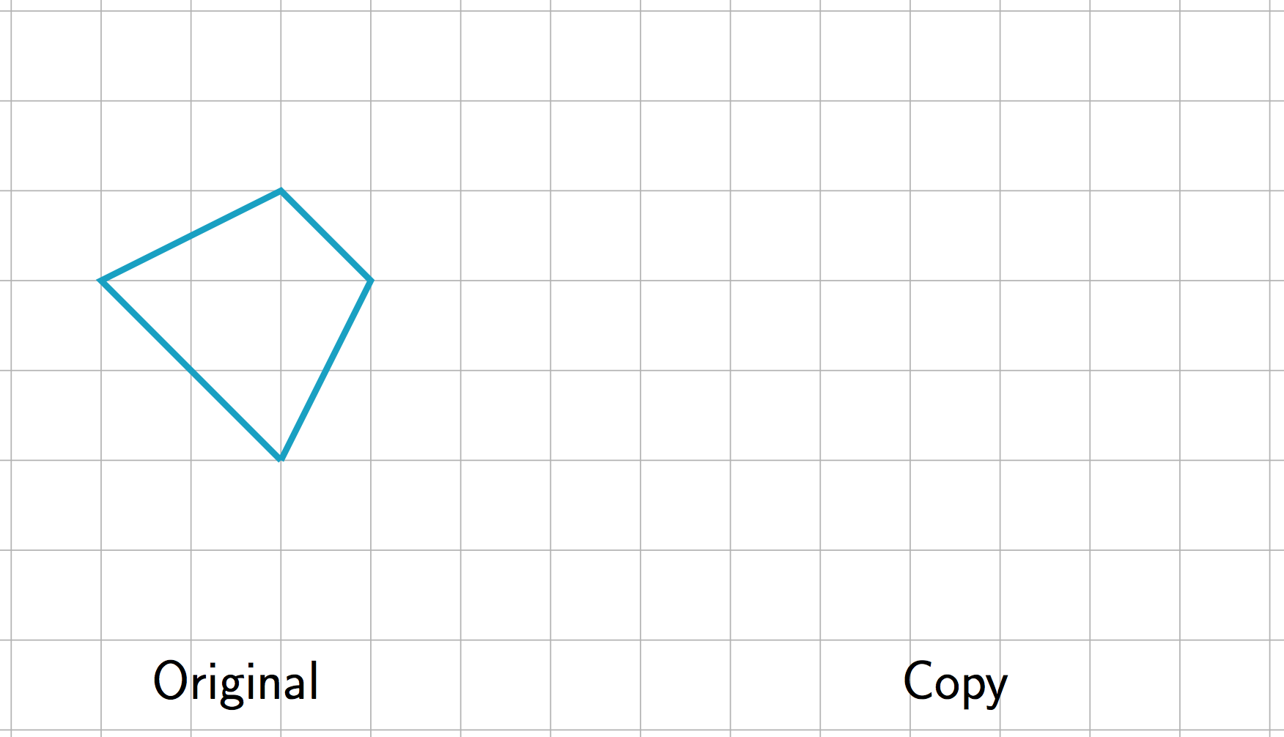
- The scale factor from the original figure to its copy is $\frac{3}{2}$. Draw the original figure.
- 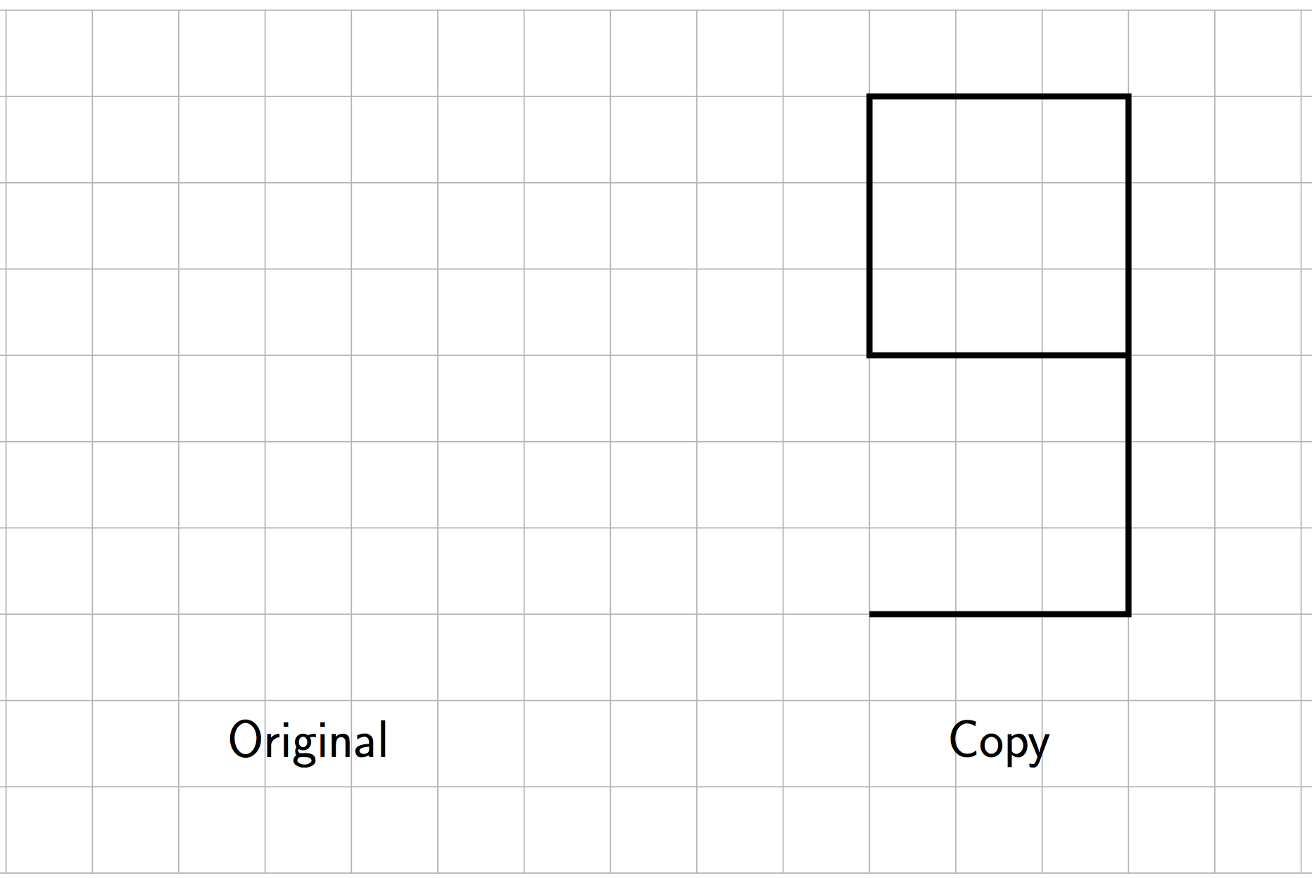
- What is the scale factor from the original figure to the copy? Explain how you know.
- 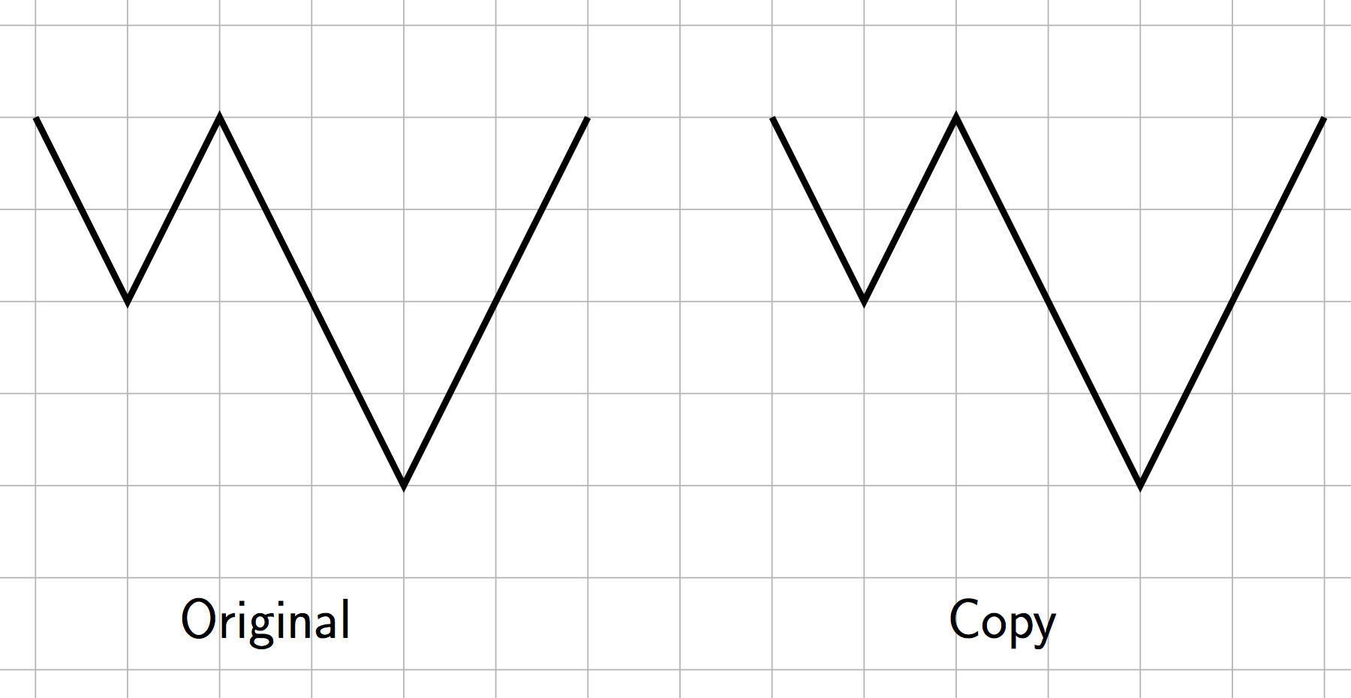
- The scale factor from the original figure to its scaled copy is 3. Draw the scaled copy.
- 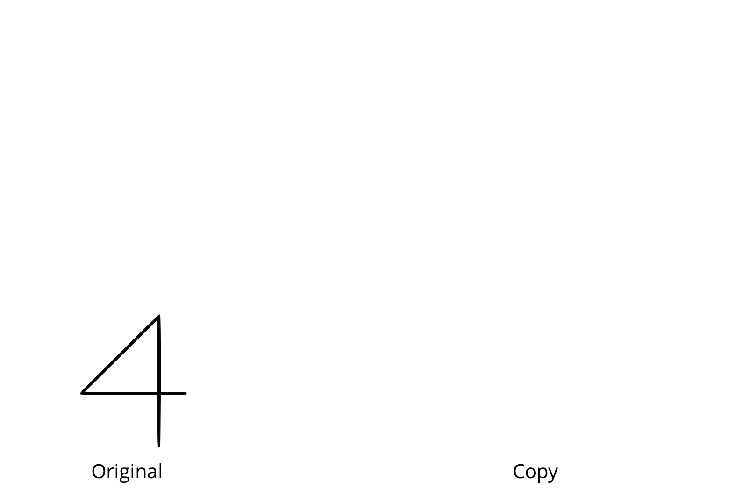
© CC BY Open Up Resources. Adaptations CC BY IM.

