Lesson 3 Practice Problems
- The box plot represents the distribution of speeds, in miles per hour, of 100 cars as they passed through a busy intersection.
- 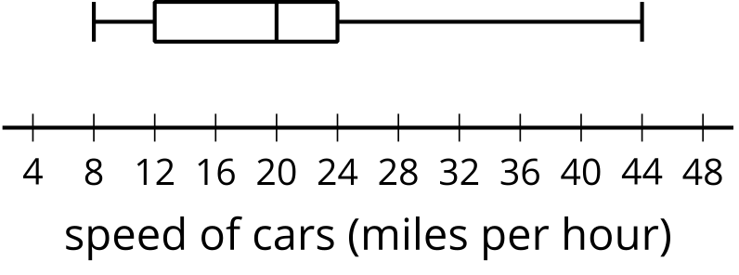
  - What is the smallest value in the data set? Interpret this value in the situation.
  - What is the largest value in the data set? Interpret this value in the situation.
  - What is the median? Interpret this value in the situation.
  - What is the first quartile (Q1)? Interpret this value in the situation.
  - What is the third quartile (Q3)? Interpret this value in the situation.
- The data set represents the number of eggs produced by a small group of chickens each day for ten days: 7, 7, 7, 7, 7, 8, 8, 8, 8, 9. Select all the values that could represent the typical number of eggs produced in a day.
  - 7.5 eggs
  - 7.6 eggs
  - 7.7 eggs
  - 8 eggs
  - 9 eggs
- The dot plot displays the lengths of pencils (in inches) used by students in a class. What is the mean?
- 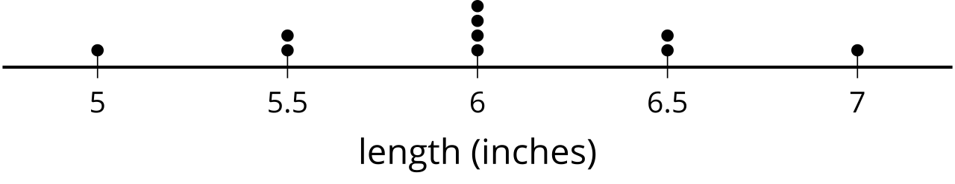
- (From Unit 1, Lesson 2.)
- The histogram represents ages of 40 people at a store that sells children's clothes. Which interval contains the median?
- 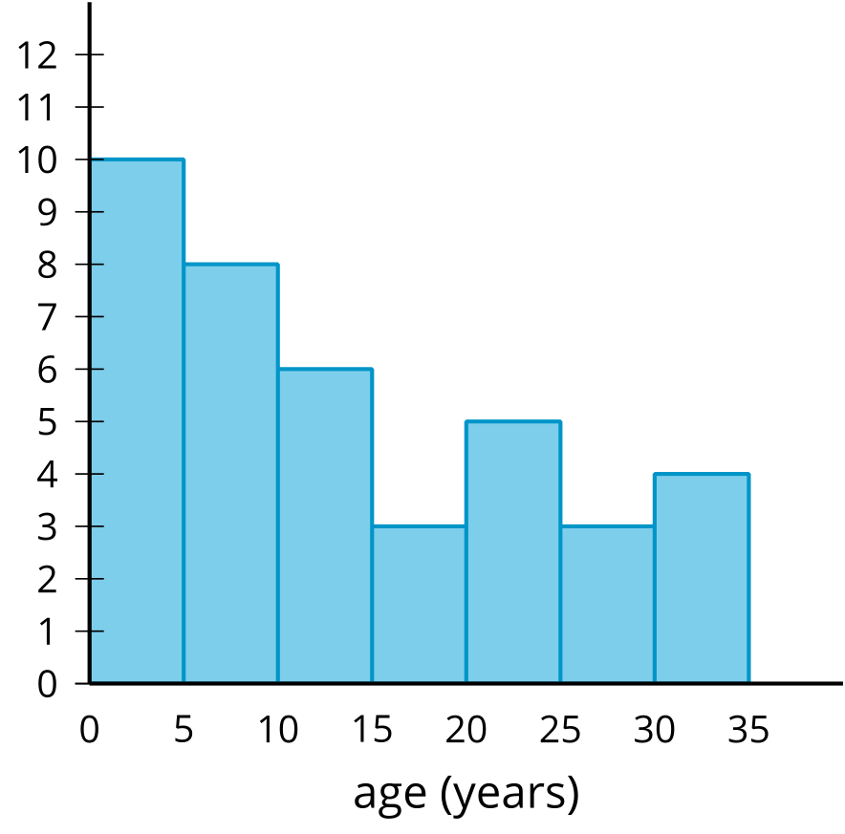
  - The interval from 0 to 5 years.
  - The interval from 5 to 10 years.
  - The interval from 10 to 15 years.
  - The interval from 15 to 20 years.
- (From Unit 1, Lesson 2.)
- The data set represents the responses, in degrees Fahrenheit, collected to answer the question “How hot is the sidewalk during the school day?”.
- 92, 95, 95, 95, 98, 100, 100, 100, 103, 105, 105, 111, 112, 115, 115, 116, 117, 117, 118, 119, 119, 119, 119, 119, 119
  - Create a dot plot to represent the distribution of the data.
  - Create a histogram to represent the distribution of the data.
  - Which display gives you a better overall understanding of the data? Explain your reasoning.
- (From Unit 1, Lesson 2.)
- Is “What is the area of the floor in this classroom?” a statistical question? Explain your reasoning.
- (From Unit 1, Lesson 1.)
© CC BY 2019 by Illustrative Mathematics®

